Structured internal project application 2025-2026

|  |  |
| --- | --- |
|  |  |
| **Project Overview** |  |
| Project name: (Short title) | Development of QMRA Assessment Toolkit |
| Staff: (who will be completing the work?) | Reza Moghaddam (Lead Developer - 170 hrs), David Wood (Model Review & Support - 40 hrs) |
| Project Manager: (usually a Group Manager) | Andrew Hughes |
| Region: | Hamilton |
| Centre: | Freshwater |
| Type: (science, operations activity, or other - explain) | Science (Applied Research & Development) |
| Budget: (attach costing prepared by your project coordinator) |  |
| Project objective: (30 words max) | Develop a Python-based QMRA assessment toolkit to standardise processes, improve reproducibility and auditability, and reduce manual work for regulatory compliance assessments. |
| Project outline: (150-300 words max) | NIWA currently undertakes QMRA projects that require significant manual effort for each assessment. Based on our recent project experience, typical QMRA projects involve 40-60 hours of manual work including dose-response model setup, exposure assessment, treatment calculations, simulation configuration, and report generation. This manual approach creates challenges in reproducibility and auditability, which are critical for regulatory compliance work.  This project will develop a Python-based QMRA assessment toolkit to standardise these processes and improve both operational efficiency and scientific rigour. The system will automate routine calculations, provide validated dose-response relationships for common pathogens, incorporate comprehensive exposure assessment capabilities, and generate standardised reporting templates. The assessment toolkit will work with user-provided log reduction values rather than calculating treatment efficacy, which is typically determined through engineering challenge tests.  The technical implementation will focus initially on norovirus as a proof-of-concept pathogen, as recommended by QMRA experts. This focused approach will validate the methodology before expanding to additional pathogens. While acknowledging the QMRA community's preference for R, Python was chosen for integration with NIWA's existing infrastructure, with modular design allowing R integration capabilities. The system will handle data-poor scenarios common in New Zealand QMRA work and accommodate the changing regulatory framework from Taumata Arowai. |
| Project outputs: (e.g., a journal paper or an App, or a safe operating procedure or guidance document for operations activities) | • QMRA Assessment Toolkit (Python application with R integration capabilities) • Technical documentation addressing reproducibility and auditability requirements • Validated pathogen database starting with norovirus dose-response relationships • Exposure assessment module for data-poor scenarios • Template reporting system for regulatory compliance |
| Project impact: (choose an SCI impact area that the project aligns with, see graphic below) | Protecting our diversity Improved environmental health |
| Alignment: (with a programme and/or National Centre outcomes or KPIs) | This project aligns with the Freshwater Centre's analytical capabilities development and supports regulatory compliance services. It enhances NIWA's technical capacity for water quality risk assessment and supports our role in environmental protection. The improved reproducibility and auditability will strengthen NIWA's credibility with regulatory bodies. |
| Outcomes for Māori: (may include partnerships, resourcing, alignment with aspirations) | Supporting improved water quality assessment capabilities that contribute to protecting water bodies important for cultural values and mahinga kai. The enhanced QMRA capabilities will support decision-making that considers cultural significance of water resources. |
| Operations alignment: (for non-science projects, how does this work contribute to inputs or enablers from the graphic below) | Not applicable |

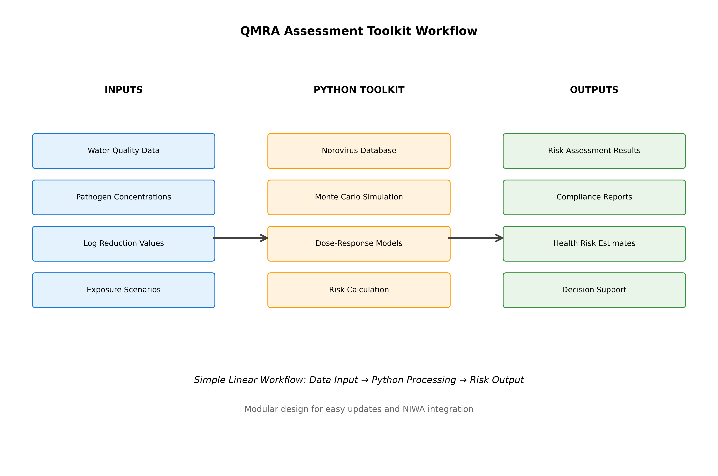

**Figure 1:** QMRA Assessment Toolkit - System Architecture & Workflow

The QMRA Assessment Toolkit processes multiple data inputs through a modular Python-based system. Input data includes water quality measurements, pathogen concentrations, user-defined log reduction values, population demographics, and exposure scenarios. The core processing engine integrates a norovirus pathogen database as the initial proof-of-concept, applies Monte Carlo simulation for uncertainty analysis, and implements validated dose-response models. The system generates comprehensive outputs including risk assessment results, regulatory compliance reports, health risk estimates, and decision support documentation for environmental health protection.

# WORK PROGRAMME AND TIMELINE

Outline the tasks to be done, who will do what and by when. Be as specific as possible.

|  |  |  |  |
| --- | --- | --- | --- |
| **Task** | **Specific activity (who, what)** | **By when** | **Hours** |
| QMRA Literature Review & Model Analysis | Review Freshwater Microbiology Research Programme Report (2002), analyse current QMRA models and methodologies, understand alternative risk modelling approaches (Reza) |  | 25 |
| Requirements & Design | System architecture definition, QMRA methodology analysis, stakeholder consultation, performance criteria development (Reza) |  | 35 |
| Core Development (Norovirus Focus) | Single pathogen database creation (norovirus), dose-response model implementation, Python framework development with R integration considerations (Reza) |  | 45 |
| Exposure Assessment Module | Implementation of comprehensive exposure assessment capabilities, handling data-poor scenarios, integration with log reduction inputs (Reza) |  | 25 |
| Advanced Features | Monte Carlo simulation engine, uncertainty quantification, statistical modelling implementation (Reza) |  | 20 |
| Testing & Validation | Performance testing against defined criteria, validation with known benchmarks, quality assurance protocols (Reza) |  | 20 |
| Model Review & Validation | Technical review of QMRA models, validation of dose-response relationships, methodology verification (David) |  | 25 |
| Documentation | Technical documentation, user guides, training materials, regulatory compliance documentation (David) |  | 15 |
| Deployment & Transfer | System deployment, staff training, knowledge transfer protocols (Reza/David) |  | 10 |

**Table 1:** Work Programme and Timeline for QMRA Assessment Toolkit Development (Total: 210 hours)

# EMERGING COLLABORATION OPPORTUNITIES

Recent developments have strengthened the business case for this QMRA assessment toolkit. New Zealand Institute for Public Health and Forensic Science (PHF) has approached NIWA to develop QMRA guidance specifically for shellfish safety assessment. PHF has confirmed their interest through direct communication with Taumata Arowai about collaborating with NIWA on this initiative.  
  
This emerging opportunity demonstrates immediate market validation for our QMRA capabilities and provides direct application potential for the assessment toolkit in shellfish safety assessment. The collaboration creates strategic partnership opportunities with regulatory bodies and demonstrates that there is demand for NIWA's enhanced QMRA services.  
  
The shellfish QMRA guidance project would serve as an ideal pilot application for our assessment toolkit, providing real-world validation while generating project revenue. This collaboration would allow concurrent testing and refinement of the system with actual regulatory requirements, potentially offsetting some development costs through direct application to a paying project.

# CHIEF SCIENTIST SUPPORT

**Chief Scientist comment:** (For example - If agreement that project required, indicate why SIP mechanism versus Centre Funds; What is/are the key output(s) and how will NIWA/National Centre/programme/individual benefit from that; note that there must be an output at the end of the project)

**Signature:**

*Updated SIP document addressing David Wood's comments - Generated on 19 September 2025*