Prerequisite to use APPIUM
- Install ANDROID SDK (Studio)[Link]-
- Install JDK (Java Development Kit) [Link]
- Install Python3 and pip3 [Link] (download and execute installer)
- Install Appium Client (run this comand in cmd : pip3 install Appium-Python-Client )
- Install Appium Desktop

Install Appium Desktop:
Step 1) Go to http://appium.io/ and click on Download Appium.
Step 2) For Windows, select the exe file and download. The file is around 162MB will take time to download based on your internet speed.
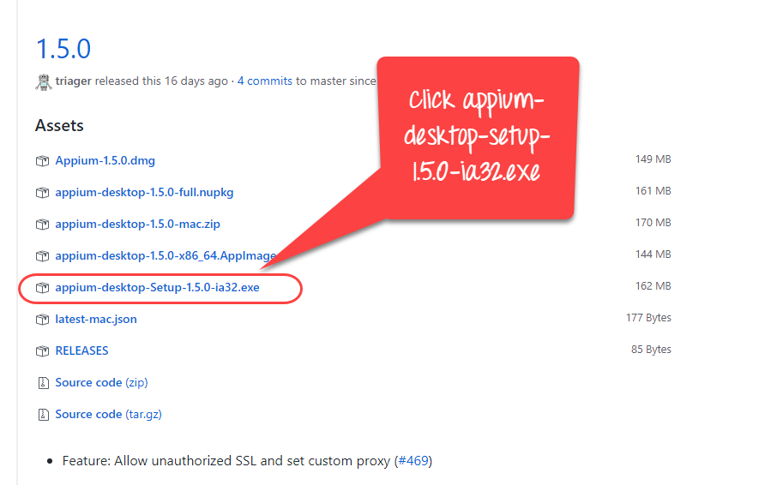
Step 3) Click on the downloaded exe.
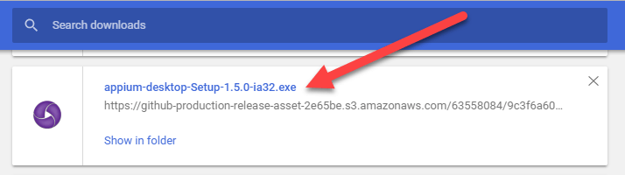
Step 4) On a Windows machine, there is no need to install Appium. It runs directly from the exe. Once you click the exe you will see the following image for few minutes.
Step 5) Next you will see the Server Start Window. It populates the default host and port option which you can change. It also mentions the version of Appium being used.
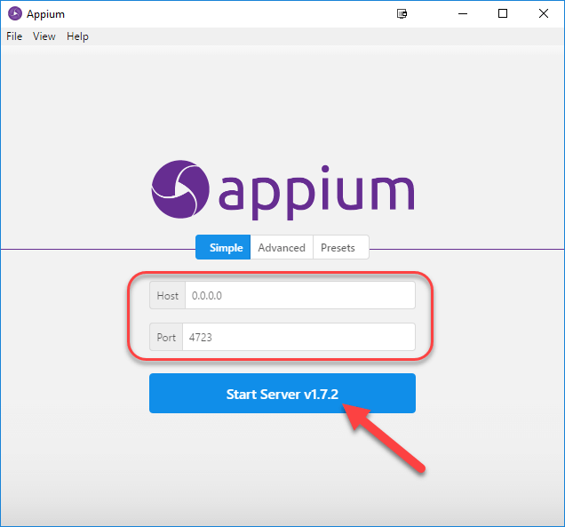

Attach Android Real device to Appium
Step 1) Install Android SDK in your system.
Go to Control panel >> System and Security >> System and from the left panel click on 'Advanced System Settings'. From 'System Properties' pop up, click on 'Advanced' tab and then click on "Environment Variables" button.
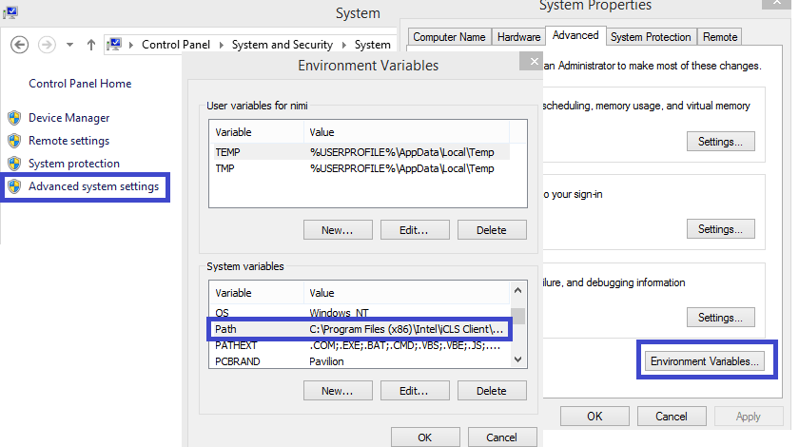
Step 2) Now, from 'Environment variables' pop up, 'double click on 'Path' and set ANDROID_HOME variable that point to your SDK directory. In the path append the whole SDK folder path.
e.g. -
C:\User\ABC\Desktop\adt-bundled-windows-x86_64-20140321\sdk
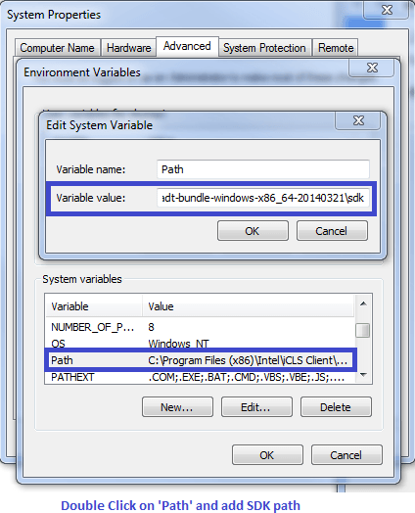
Step 3) Start your Android emulator or any attach any Android device to your system (Make sure you have Android Debugging option enabled in your Android device. To check Debugging Option. Go to Device Settings >> Developer Options >> Check "Debugging Option").
Step 4) Open Command Prompt and navigate to your Android SDK's \platform-tools\ directory (E.g. D:\adt-bundle-windows-x86_64-20130514\sdk\platform-tools).
Step 5)- Run 'adb devices' command. You can see your connected device listed in Command Prompt window. (In CMD write '>adb devices'- This command will list the connected emulator instances. E.g.: adb –s emulator-5554 install <Location of .apk file>)
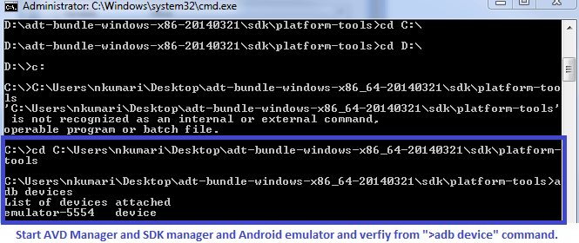
Step 6)- Run 'adb start-server' command. It will start ADB server that will be used by Appium to send commands to your Android device.
Step 7) Now, navigate to Appium directory in your system and start Appium by clicking an Appium.exe file.

Full instruction in https://www.guru99.com/introduction-to-appium.html

NEXT STEP
before run the script :
- Download tiktok aps [LINK] and put in your directory that you can acces it. E.g C:\User\ABC\Desktop\tiktok.apk
- Change the directory in script in scenario1.py with apk that you download it before. e.g ”app” : “C:\User\ABC\Desktop\tiktok.apk”
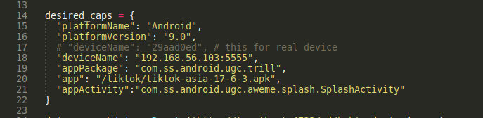
Change this

- Change android version with your device version. E.g ”platformVersion” : “10.0”
- Change device name that it get from adb devices comand. E.g ”deviceName” : “29aad0ed”
- Change username and password with yours
E.g username : “catwillwork”
password : “whenyousleep!@#”

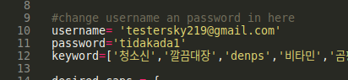
- Save the script
To run script :
- Plug your device
- Start appium server
- Open command promt
- Set directory to you save the script
- Then type : python3 scenario1.py

