Week 1–3 Deliverable 2
Planar Five-Bar CAD Sketch and Parameter Table
Bo Zhang (8571260) | Supervisor: Dr Chin-Hsing Kuo | September 2026
1. What this week freezes
This is a kinematic sketch, not a finished print. Ground link on top, two actuated cranks hanging down, two couplers meeting at the end-effector E. No GSM, gears, or springs are drawn. The numbers below are the baseline that Week 1–3 inverse kinematics and Tw will use. They can still be scaled later, but the ratios and the angle convention should stay.
2. Why these numbers
Desktop size (ground d = 180 mm, cranks 120 mm, couplers 180 mm) fits a bench frame and leaves space later for one GSM on each crank. The design is left–right symmetric so targeted poses collapse to the midline x = 0. Couplers are longer than cranks, which is the usual 5R choice: a useful workspace below the base without an immediate fully-stretched singularity on the midline.
The IMADA PS-10N is 10 N. Estimated moving mass is 0.48 kg (two cranks, two couplers, payload 300 g). If that whole mass were lifted vertically, the force would be about 4.7 N — inside 10 N, with a little margin for friction. Payload is 300 g, not 1 kg. Printed PLA masses are estimates (20 mm × 8 mm bars plus hubs); they will be replaced by weighed parts before Tw is finalised.
On the midline, the outward-elbow inverse kinematics used in the sketch is feasible for y ∈ [-285, -20] mm. The sample pose E = (0, −180) mm sits in the middle of that interval and is the first targeted-configuration candidate.
3. Parameter table (baseline)
Symbol | Meaning | Value | Note
d | Ground AB | 180 mm | Top fixed bar; joints A, B
l1 = l2 | Crank AP, BQ | 120 mm | Actuated links
l3 = l4 | Coupler PE, QE | 180 mm | Floating links
O | Origin | midpoint of AB | +x right, +y up, g = −y
θ_L, θ_R | Crank angles | from +x, CCW | Also store φ = θ + 90° from downward vertical
m_a | Each crank mass | 40 g (est.) | Replace by weighing
m_b | Each coupler mass | 50 g (est.) | Replace by weighing
s_a, s_b | COM location | mid-link | Week 1–3 assumption
m_E | Payload at E | 300 g | Hook at E; PS-10N range
shaft | Revolute pins | 8 mm | Ball bearings later
bar section | Link section | 20 × 8 mm | 3D-print starting size
GSM | Gear-spring module | not this week | Mass later added into m_a

4. Sample pose used in the drawing
E = (0, −180) mm. Inverse kinematics (outward elbows): θ_L = -125.7°, θ_R = -54.3° (from +x). From the downward vertical: φ_L = -35.7°, φ_R = 35.7°. P ≈ (-160.0, -97.5) mm, Q ≈ (160.0, -97.5) mm.
5. Drawings
Figure 1. Dimensioned skeleton at the sample midline pose.
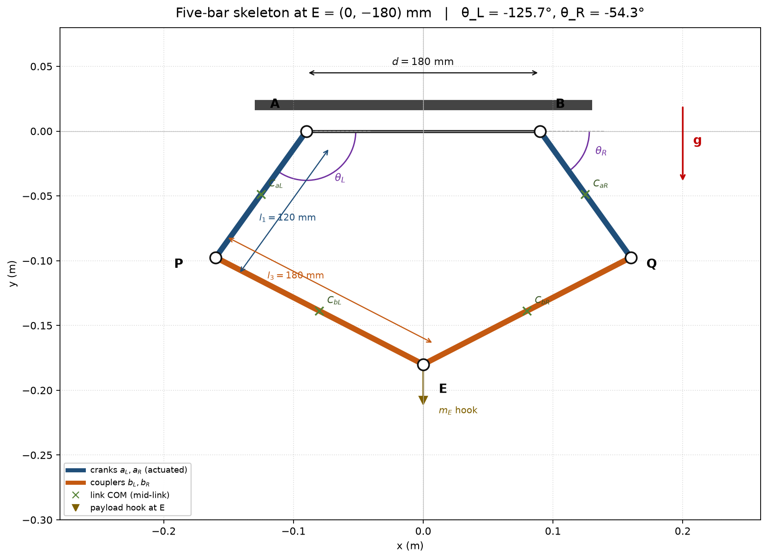
Figure 2. Layout, coordinate frame, and what is frozen this week.
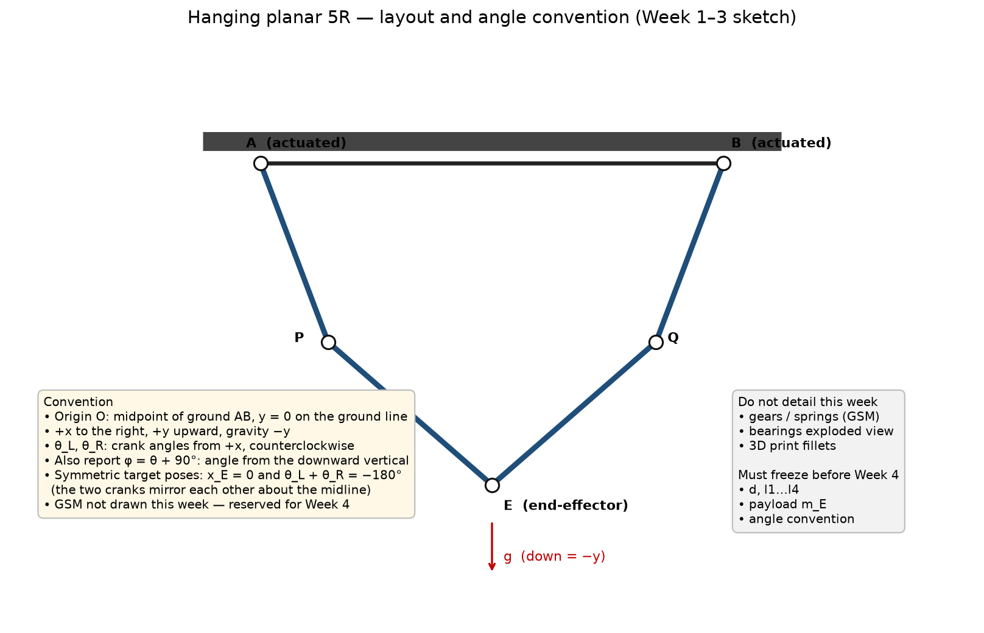
6. Files
OpenSCAD sketch (bars and holes only): cad/five_bar_week1_sketch.scad. Machine-readable parameters: docs/week1-3/five_bar_parameters.json. Next Week 1–3 task: inverse-kinematics program using these lengths, then Tw.
7. What not to change without a reason
Keep symmetry (l1 = l2, l3 = l4). Keep payload ≤ 300 g until a trial on the mechanical gauge says otherwise. Do not add GSM mass into Tw until the module size is chosen in Week 4. If a later print needs a scale factor, multiply all of d, l1, l3 by the same factor so the kinematics stay similar.

