Week 1–3 Deliverable 4
Gravitational Torques of the Hanging Planar Five-Bar
Bo Zhang (8571260) | Dr Chin-Hsing Kuo | September 2026
1. What was done
The unbalanced gravitational loads were derived for the frozen geometry and mid-link COM assumption. Because the five-bar is a closed chain, each actuator torque is not “this leg’s own weight only”. The correct statement is virtual work: T_w = ∂V/∂θ. If the cranks are left free, the force F at E that holds the mechanism satisfies J^T F = T_w. That F is what the IMADA PS-10N would read in a slow hold, before any GSM is fitted. No springs, gears, or sensors are used this week.
2. Potential and holding torque
With +y upward and datum on the ground line:
V = g ( m_a y_aL + m_a y_aR + m_b y_bL + m_b y_bR + m_E y_E )
Static motor torques that hold the pose: T_w = (T_wL, T_wR) = ∂V/∂(θ_L, θ_R).
COM locations: crank COM at mid-crank; coupler COM at mid-coupler; payload at E. Masses from the CAD table: m_a = 40 g, m_b = 50 g, m_E = 300 g. E(θ) comes from the Week 1–3 forward kinematics. ∂E/∂θ is the 2×2 Jacobian Ė = J θ̇ obtained by differentiating the two coupler-length constraints.
3. Force at E (matches the later mechanical gauge)
If the two cranks are free (no motor torque), equilibrium is J^T F = T_w. F = (F_x, F_y) is the external force that must be applied at E. On the midline, F_x = 0 and F_y is upward (positive), about 3.6–3.7 N for the present masses — inside the 10 N PS-10N range. This is much smaller than “lift the entire 0.48 kg as a free mass” (4.7 N), because part of the link weight is carried by the grounded joints A and B.
4. Checkpoint values
Pose | E (mm) | T_wL (mN·m) | T_wR (mN·m) | F_x (N) | F_y (N)
C1 CAD sample | (0, -180) | -475.49 | 475.49 | 0.000 | 3.672
C2 midline high (safe) | (0, -120) | -876.56 | 876.56 | 0.000 | 3.589
C3 midline low | (0, -250) | -244.51 | 244.51 | -0.000 | 3.632
C4 left | (-60, -180) | -462.98 | 350.13 | -0.233 | 3.727
C5 right | (60, -180) | -350.13 | 462.98 | 0.233 | 3.727

On the midline, T_wL = −T_wR and F_x = 0 (mirror). C4 and C5 swap and flip the torques: T_wL(C4) = −T_wR(C5). Analytic T_w matches a finite-difference of V(θ) to about 10^{-8}–10^{-9} N·m on these poses.
5. Singularity to stay away from
Near y ≈ −80 mm on the midline the two couplers line up (forward / Type-II singularity). The Jacobian is ill-conditioned and the motor torques blow up, even though F_y stays finite. The IK checkpoint at (0, −80) mm is therefore not used for Tw design. C2 is taken at (0, −120) mm instead. Later trajectories should stay below about y = −100 mm.
6. Midline curves
Figure 1. Unbalanced T_w and the hold force at E along x = 0 (y from −260 to −100 mm).
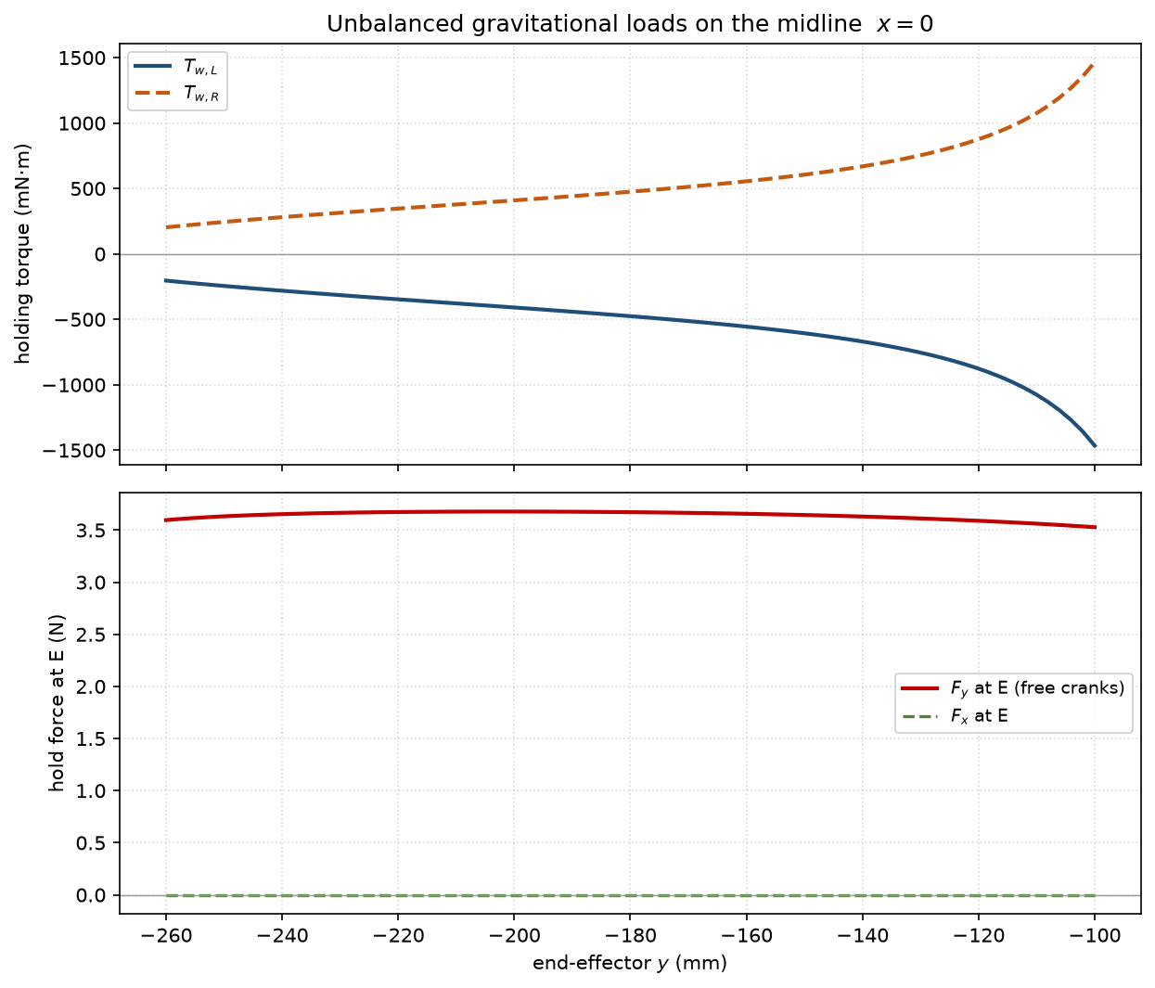
7. How to run
python3 scripts/test_five_bar_tw.py
python3 scripts/verify_five_bar_tw.py
from five_bar_statics import gravity_loads
data = gravity_loads(0.0, -0.180) # data['T_L'], data['T_R'], data['F_y']
8. Week 1–3 is now complete
- Literature notes
- CAD sketch and frozen dimensions
- Inverse kinematics, four assemblies, workspace
- Unbalanced T_w and the force-gauge prediction F at E
Week 4–6 starts GSM: spring-torque model, targeted configuration, k and ψ. Do not change d, l1, l3, m_E unless a later print requires a uniform scale.

