Try a minimal RAG with FAISS
- Install dependencies by the command:
pip install faiss-cpu sentence-transformers numpy
- Add some example documents as a corpus sample
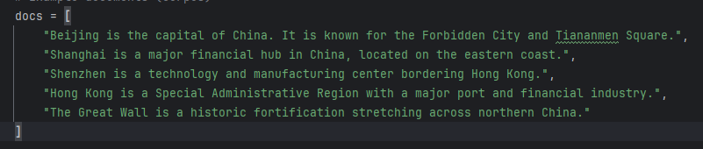
- Embedding: Turn documents into vectors by sentence-transformers
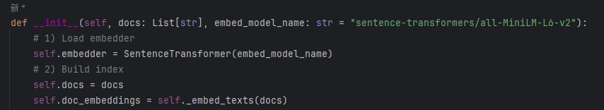
- Index with FAISS, supporting approximating cosine similarity
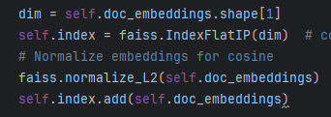
- Search() for the top_k similar documents as a return for the input query
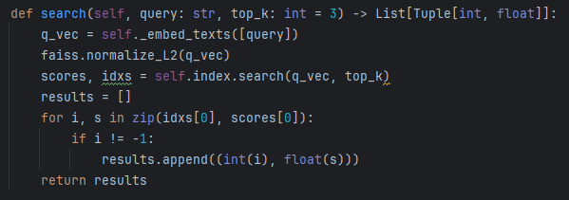
- Append retrieved documents together as context
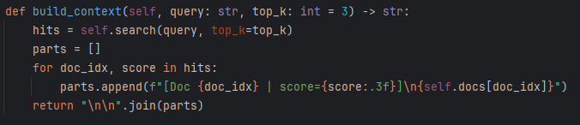
- Build the whole prompt with retrieval context and raw query, especially with the system prompt that use only provided context to test the RAG sample.
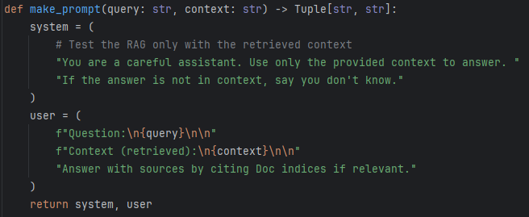
- Set a random query
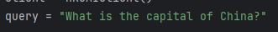
- See the result
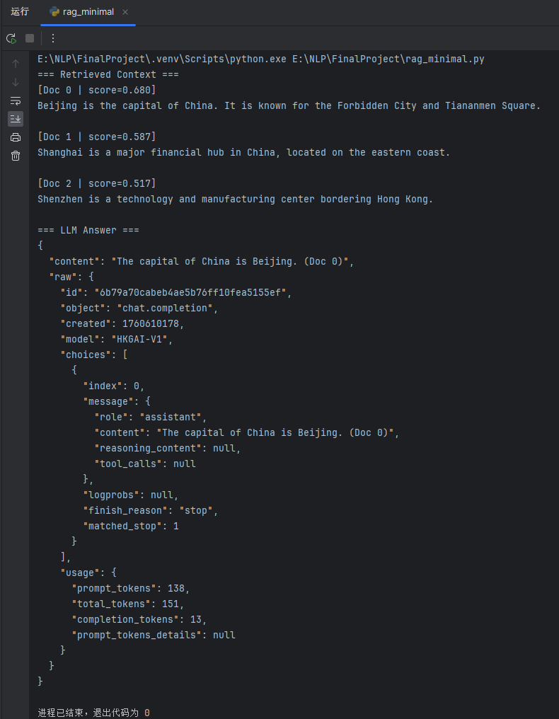
It’s clear that Doc 0 ‘Beijing is the capital of China. It is known for the Forbidden City and Tiananmen Square.’ has the highest score as 0.680, corresponds to the query "What is the capital of China?". And the LLM naturally gives the right answer with only the context given, which shows the good performance of the minimal RAG sample.

