Task 1
(1)DEBUG
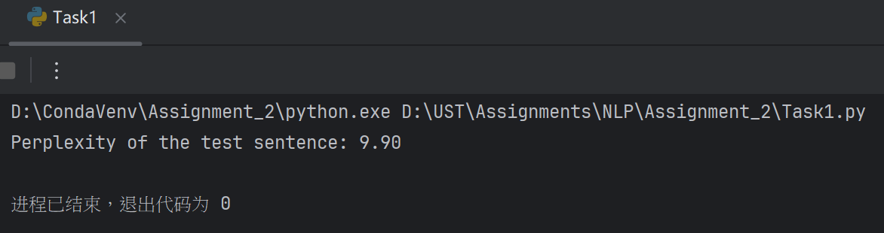
It turns out that here should be sentence[i], sentence[i+1]
As i from 0 to N-1
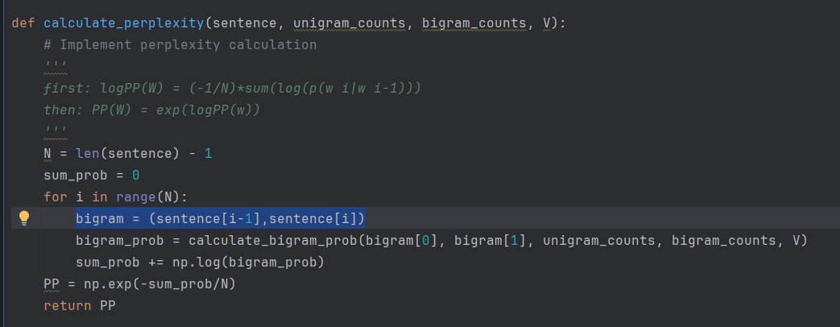

After correction:
Perplexity of the test sentence: 8.37
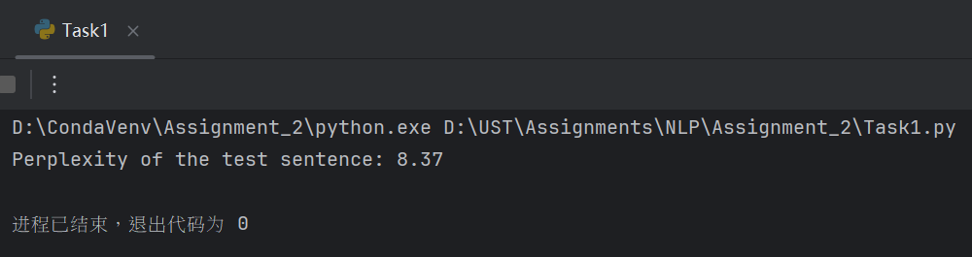

Task2
D:\CondaVenv\Assignment_2\python.exe D:\UST\Assignments\NLP\Assignment_2\Task2.py
Downloading dataset...
Dataset downloaded and extracted.
Dataset loaded. Shape: (5572, 2)
label message
0 ham Go until jurong point, crazy.. Available only ...
1 ham Ok lar... Joking wif u oni...
2 spam Free entry in 2 a wkly comp to win FA Cup fina...
3 ham U dun say so early hor... U c already then say...
4 ham Nah I don't think he goes to usf, he lives aro...
Accuracy: 0.9623318385650225

Classification report:
precision recall f1-score support

ham 0.96 1.00 0.98 966
spam 1.00 0.72 0.84 149

accuracy 0.96 1115
macro avg 0.98 0.86 0.91 1115
weighted avg 0.96 0.96 0.96 1115

Message: Congratulations! You've won a $1,000 gift card. Go to http://example.com to claim now.
Prediction: spam

Message: Hi mom, I'll be home for dinner tonight.
Prediction: ham
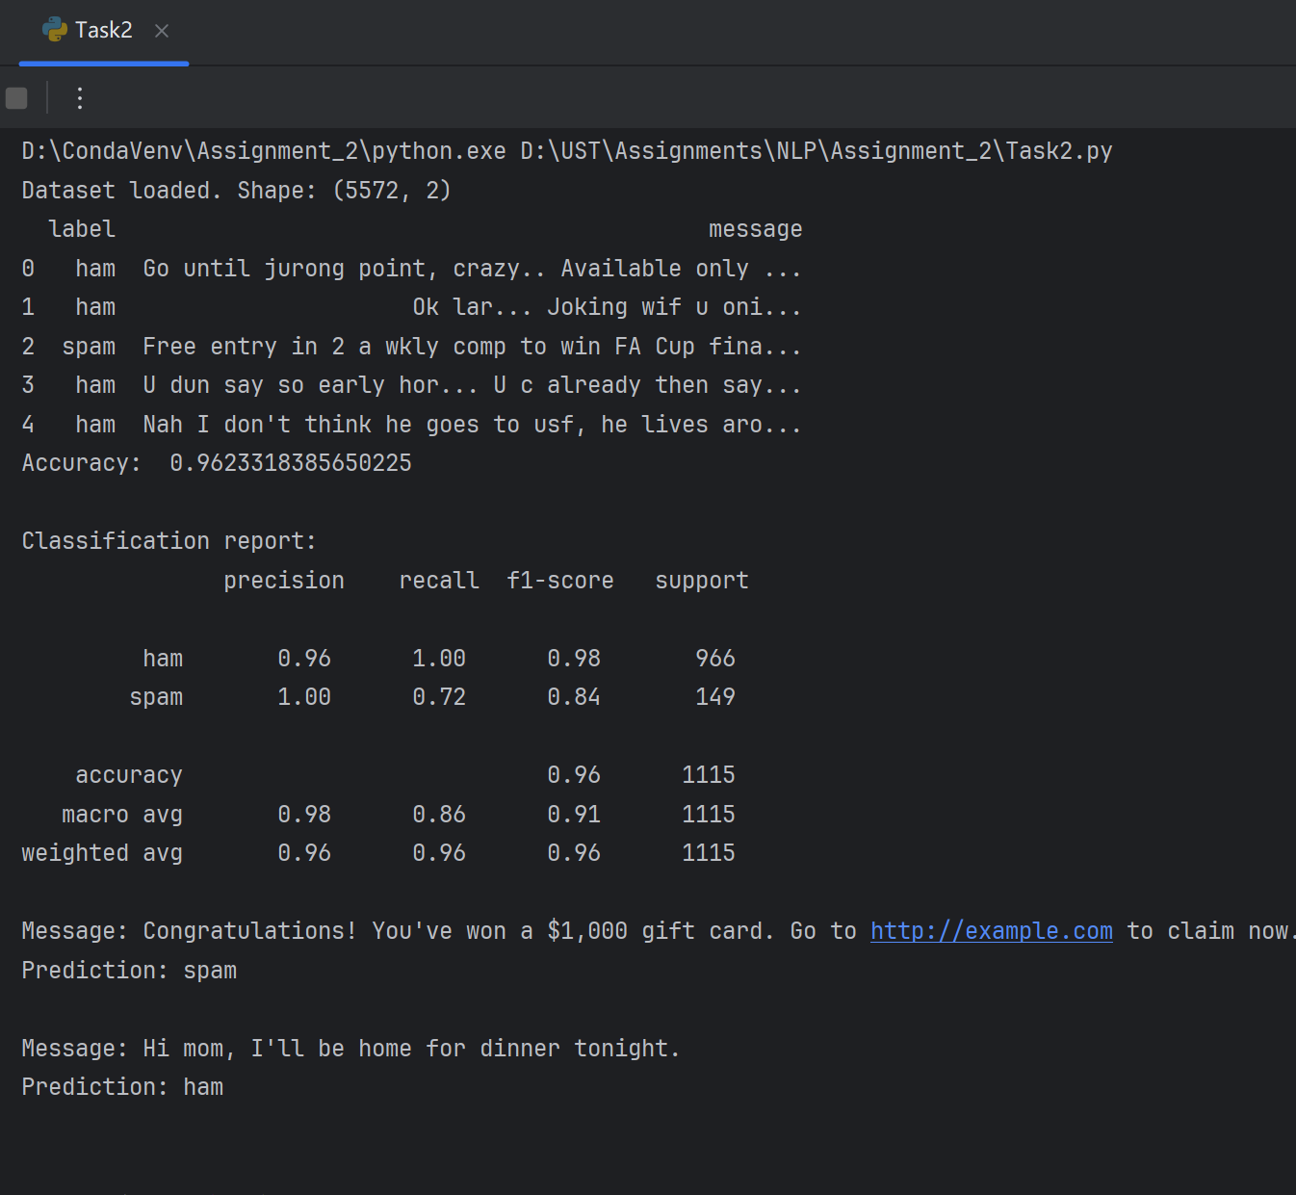

Task3
Should flatten the cosine-similarity score into 1 dimention
Change to:
D:\CondaVenv\Assignment_2\python.exe D:\UST\Assignments\NLP\Assignment_2\Task3.py
Top 3 documents for the query: 'deep learning models for vision'
Rank 1: (the 3th document) Deep learning models like convolutional neural networks are powerful for computer vision tasks. | Score = 0.5550
Rank 2: (the 17th document) Hyperparameter tuning can significantly improve the accuracy of deep learning models. | Score = 0.3276
Rank 3: (the 0th document) The field of machine learning has seen rapid growth in recent years, especially in deep learning. | Score = 0.2139
进程已结束，退出代码为 0
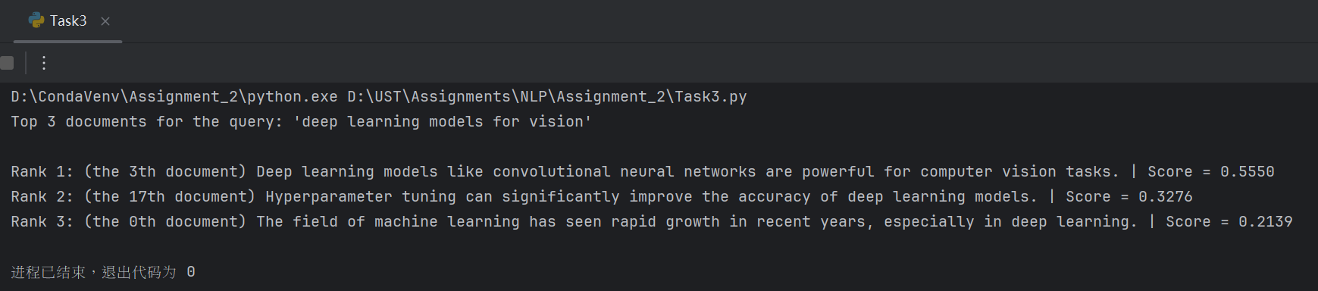

Task4
D:\CondaVenv\Assignment_2\python.exe D:\UST\Assignments\NLP\Assignment_2\Task4.py
[('the', 'DET'), ('book', 'NOUN'), ('is', 'VERB'), ('on', 'PRT'), ('the', 'DET'), ('table', 'NOUN')] | logP= -11.2
[('i', 'NOUN'), ('want', 'VERB'), ('to', 'PRT'), ('book', 'VERB'), ('a', 'DET'), ('flight', 'NOUN')] | logP= -15.903

进程已结束，退出代码为 0
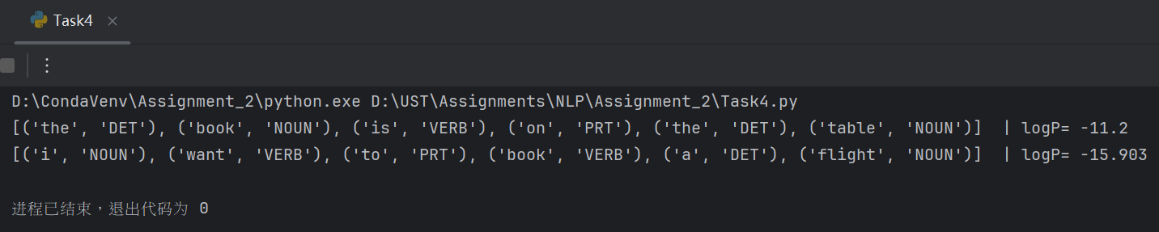

Task5
D:\CondaVenv\Assignment_2\python.exe D:\UST\Assignments\NLP\Assignment_2\Task5.py
Cosine Similarity Matrix:
doc_A doc_B doc_C
doc_A 1.000000 0.919239 0.316228
doc_B 0.919239 1.000000 0.357771
doc_C 0.316228 0.357771 1.000000

Euclidean Distance Matrix:
doc_A doc_B doc_C
doc_A 0.000000 2.645751 3.000000
doc_B 2.645751 0.000000 4.690416
doc_C 3.000000 4.690416 0.000000
