* **PROBLEM 1** (RUN LENGTH ENCODING & DECODING)

To do the Run length encoding we need to figure out the number of same consecutive pixels from an input image. I have used a ‘px’ cell for saving all the different pixels values happening sequentially and a ‘ocr’ cell for the occurring of the pixel on the same index of that cell.

‘px’

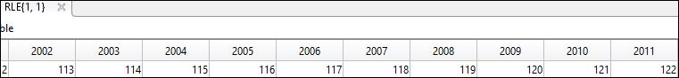

‘ocr’

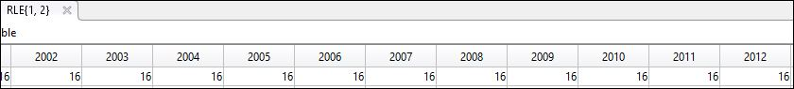

And other 2 for the image size on the RLE cells.

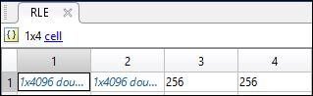

For Run length decoding I’ve go through all the different pixels on ‘px’ and repeated them according to ‘ocr’ also maintained the image size.

This picture shows the decoded image and the Compression Rate on the WORKSPACE.

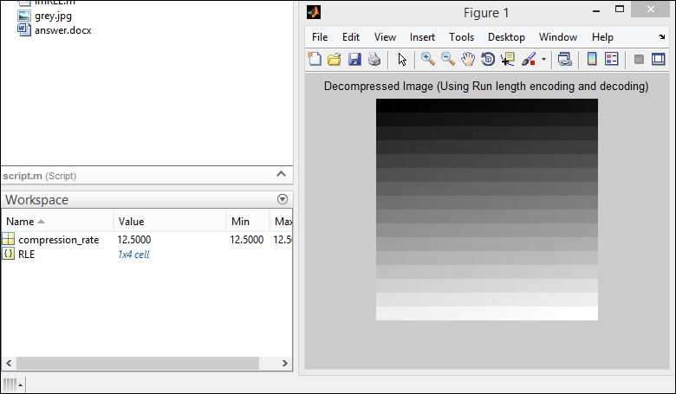

* **PROBLEM 2** (JPEG COMPRESSION)

For compressing jpeg we need to call several function. First of all we need ForwardDCT(im) functions which takes an image as input and for each (8x8) blocks it calculates DCT coefficient using DCT equation. After then it will accumulate the whole (8x8) blocks into a transformed DCT and then we quantize the matrix using quantization matrix.

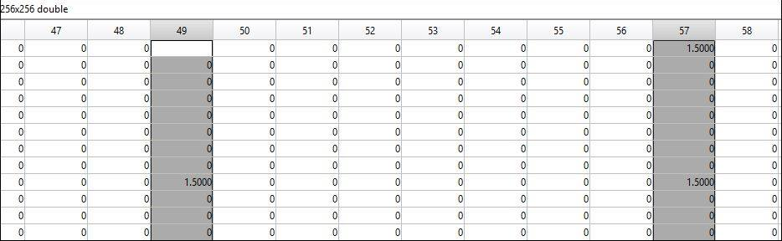

We get this matrix after applying quantization

After this we apply run length encoding (which describes in previous problem) to compress the data. So the jpeg compression is completed now.

For decompression first of all we apply run length decoder to decode the data and then we de quantize the matrix. After then we call InverseDCT(img) functions for backward mapping using inverse DCT equation. So our jpeg decompression is completed now. The result is shown below.

