**01-09-2021:**

**->Fetching data from Database:**

Fetch all the products from the backend with php. Also get other information like Category name, Manufacturer Name, Product Category Name and cart data from database.Besides, when a user click on a product then the exact product data will be displayed at the product details page. I have done this functionality also.

**->Get Related Products from Database:**

Inside product details page, fetches all the related products from database with php is done by me.

**->Do the Cart Functionality:**

When a user add a product in his cart.It updated in the database and then fetch the

updated result from database with php. Then calculate the total price of all the items

inside the cart and store that in the database.

**->Admin Panel Login Design and Functionality:**

I have designed the admin panel login form and then authenticated the login system.Without login

no one can enter the admin panel.

**->Admin panel Fully Responsive Sidebar Making:**

I have made fully responsive admin panel sidebar so that any device is suitable for the website.

Moreover, i'd made all the routes of the admin panel so that the work in future will be easier.

**->Merging the three member’s code:**

I have merged my other team-members code with me.

**Screenshots:  
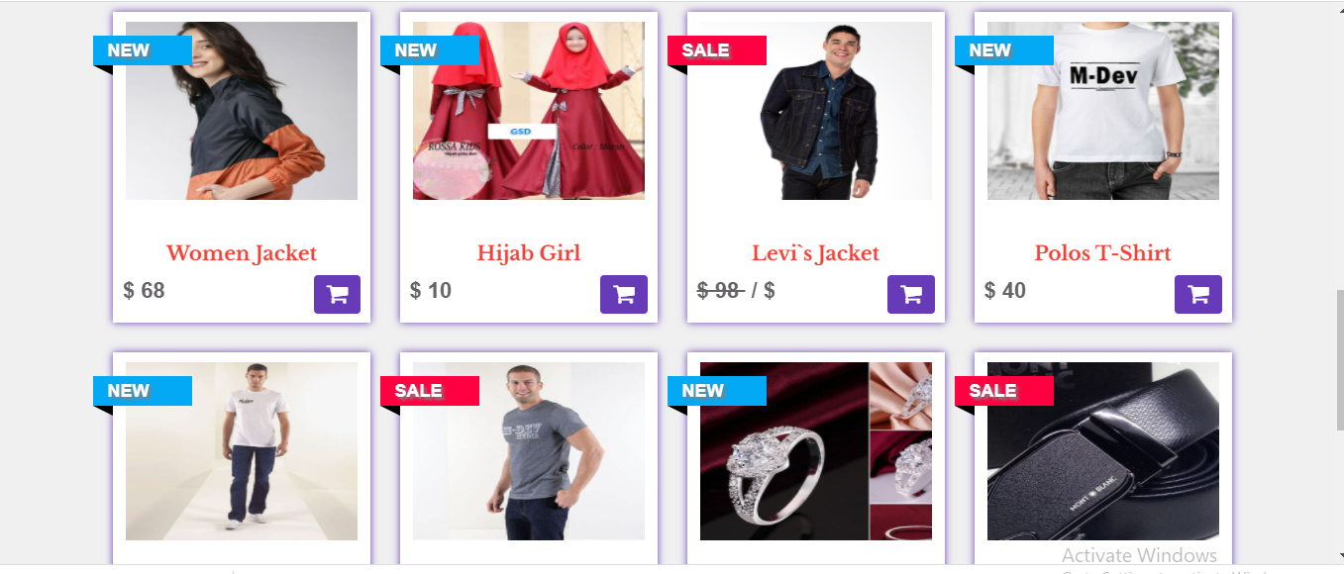 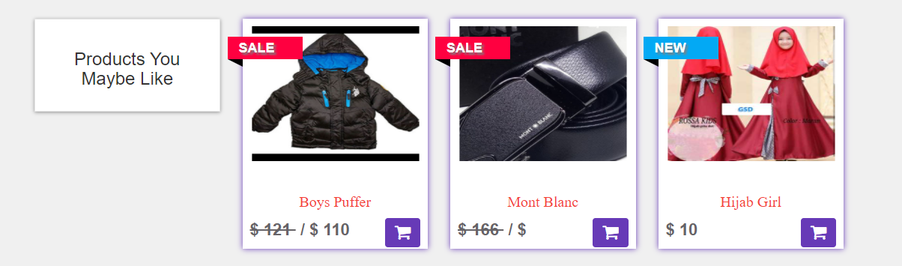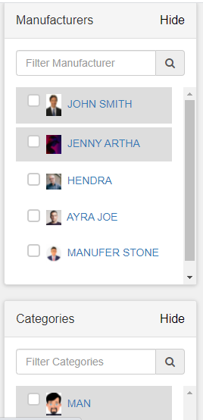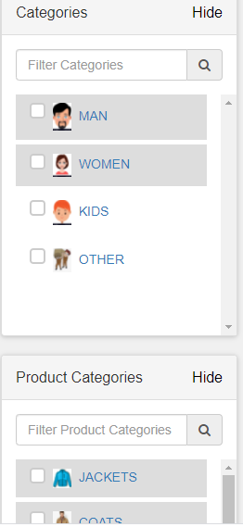**

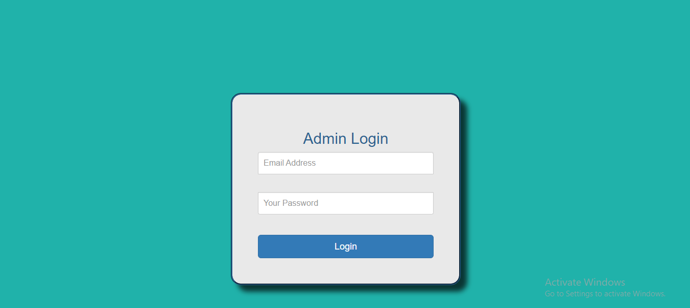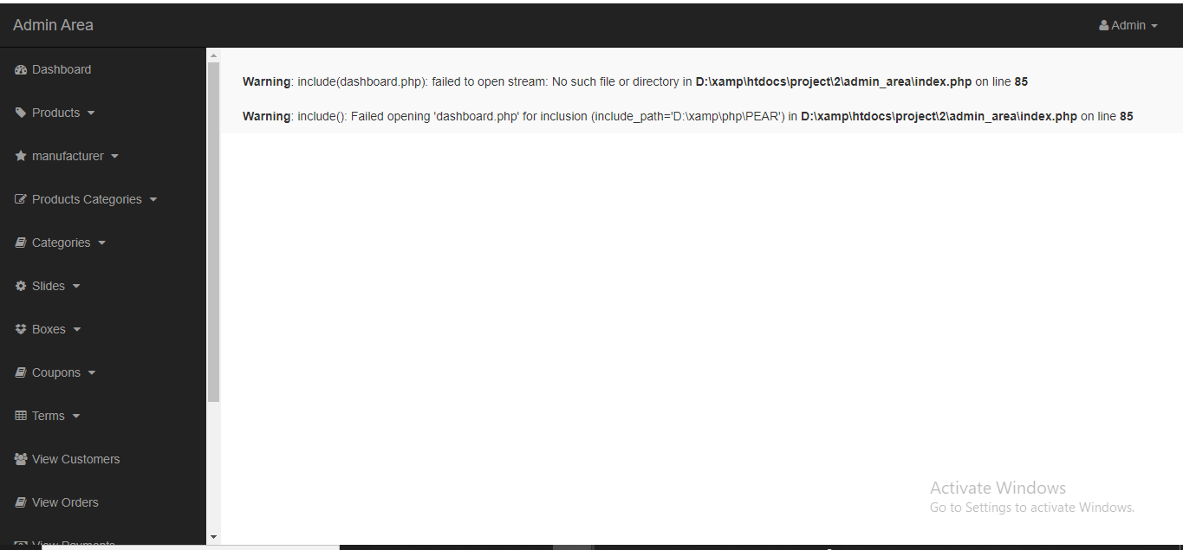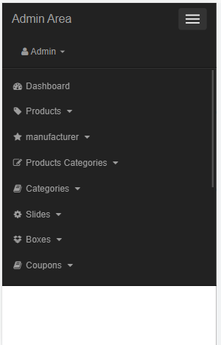

**02-09-2021:**

**->Cart Page Functionality:**

I have fetched the data from backend in the cart details page. Also execute the updating functionality of the products added at the cart. Then I apply coupon code features and execute it’s functionality.

**->My Account Page Functionality:**

When a user click on the my account button from the header, then profile page will appear. There are five functionality here:

* Showing all the orders which were being stored in database
* Pay Offline Details option
* Change Password option and it’s functionality
* Delete My Account
* Log Out

The data are getting from the database by php. And also the account editing and change password update the database by some php commands inside this page.

**->Design the admin Dashboard:**

I have designed the admin dashboard with bootstrap which is fully responsive. Here the admin can see how many products, Customers, Product categories , Orders he has in his website. Also, he can see the latest 5 orders and a short description of the admin. This info are getting from the database.

**->Insert Product Page Design and it’s functionality:**

When an admin select insert product option , insert_product.php file will render and then he can insert a new product by filling all characteristics of the product.

**->Edit Product Page Design and it’s functionality:**

If an admin wants to change any info of a particular product then he can do that by clicking the edit option inside the product view page. It will update in the database and then also change the info in the frontend.

**->Delete Product functionality:**

To delete a product, the admin just need to click on the delete option. Then a confirmation will appear in the pop up that is’t the product deleted or not.

Screenshots:

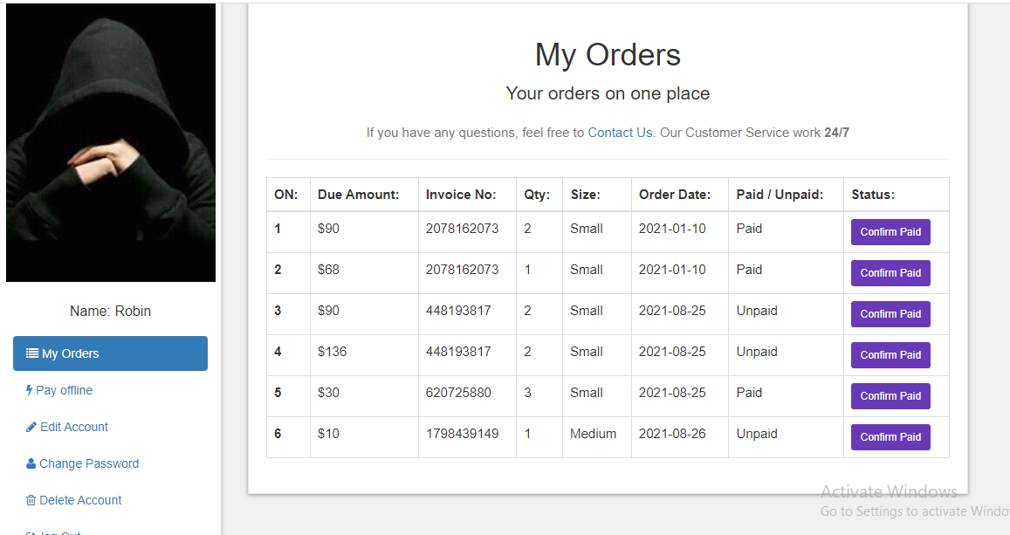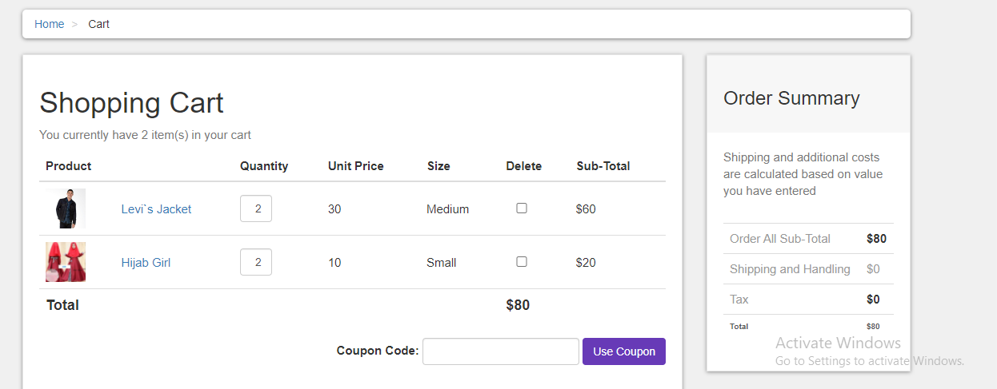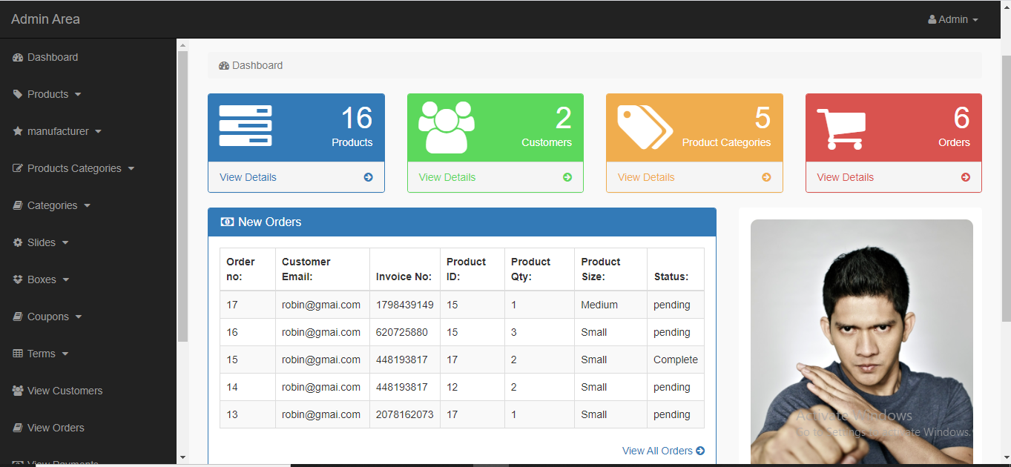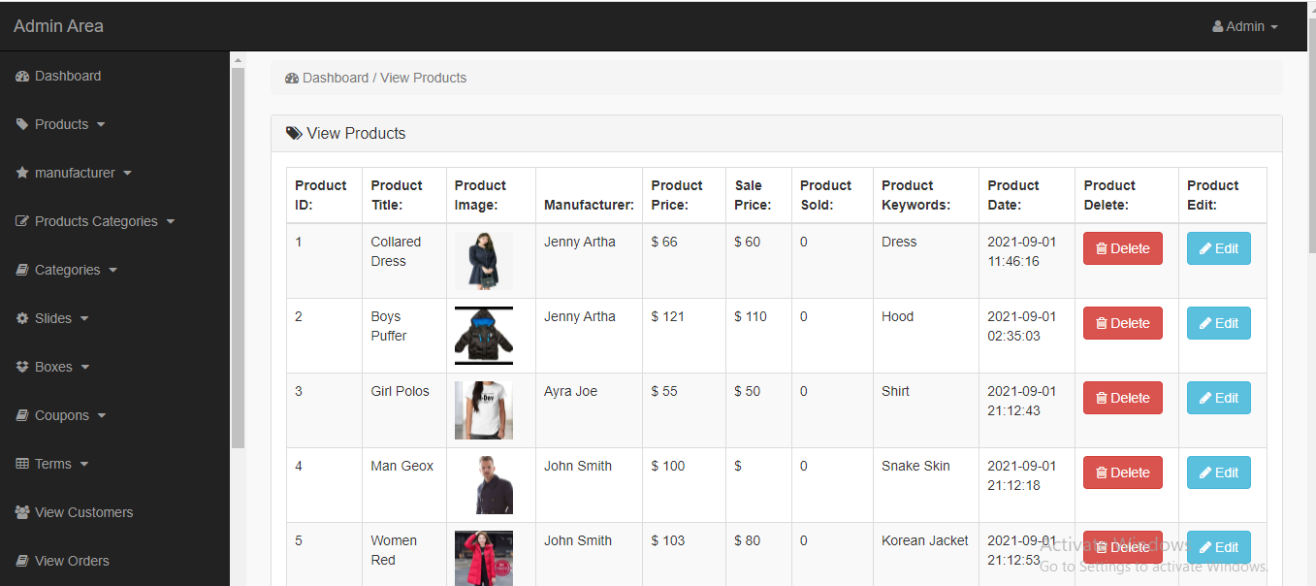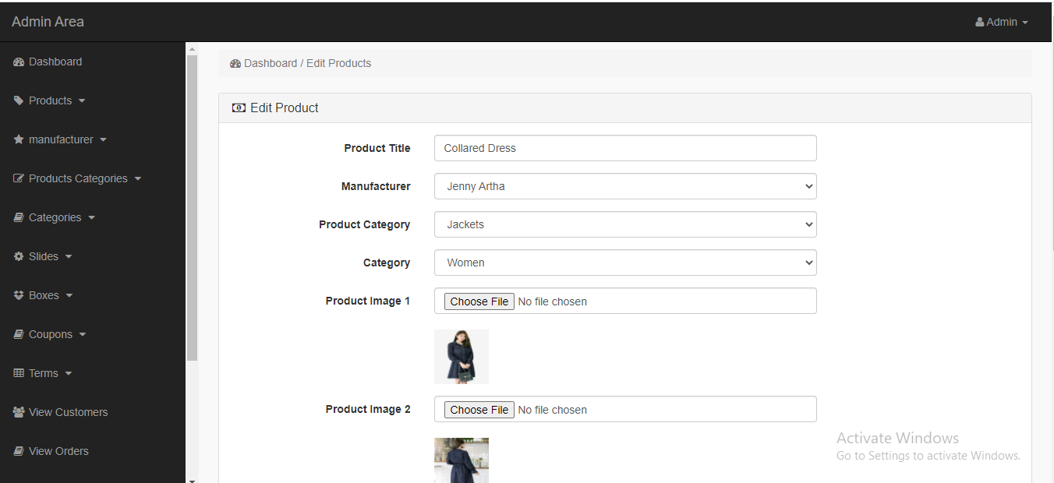

**01-09-2021:**

**->Add Manufacturer Functionality to the Admin Panel:**

From the admin panel an admin can add new manufacturer, edit current manufacturer, delete particular manufacturer. I have used a form for getting the inputs and then store them inside the database. When an specific manufacturer is select to delete, the I just get the selected manufacturer id from the database and then remove it from the database.

**->Add Product Category Functionality to the Admin Panel:**

As like as manufacturer functionality, when an admin wants to add , edit or remove any product category, then he can do that by clicking to edit product category, insert product category , delete product category.

**->Add Category Functionality to the Admin Panel:**

If an admin needs to add any new category then he can do that by click the insert new category button from the navbar. Moreover he can edit and delete any created category.

**->Add Slider Functionality to the Admin Panel:**

In our homepage we have a slider. Assume that, admin wants to update the contents of that slider, we can do that from the admin panel slides option from the sidebar.

**->Add Boxes Functionality to the Admin Panel:**

There are three box below the slider in our homepage. I have make this content dynamic so that anytime the admin of the website can update or delete that.

**->Coupon code Functionality to the Admin Panel:**

Most of the ecommerce website we can the coupon discount feature. If the admin wants to give a discount on a particular product, he can add a coupon code for that product. Every coupon code has a field named coupon price which indicates the current price of that product after the discount. And also there are

**->Terms, Customer,Oder,Payments, Admins Functionality to the Admin Panel:**

Admin can create , edit , delete terms from the Terms, Customer,Oder,Payments, Admins option in the sidebar. It makes the site dynamic.

**->CSS Editor Functionality to the Admin Panel:**

From the css editor option an admin can change any styling of the site. So, no need to go through the code for changing any types of styling.

**Discussion:**

For doing the previous task I have to learn php.I face some difficulties with the textarea portion. Then I use a third party library tinymce for making the textarea working properly. Besides, while I was getting the data from database, many times I faced some errors. Because the database name didn’t match to the database. Overcoming all these difficulties, I have done this task perfectly.

**Screenshots:**

