num_of_steps : 5 | num_of_points : 100 | result : 11.16 num_of_steps : 10 | num_of_points : 100 | result : 12.24
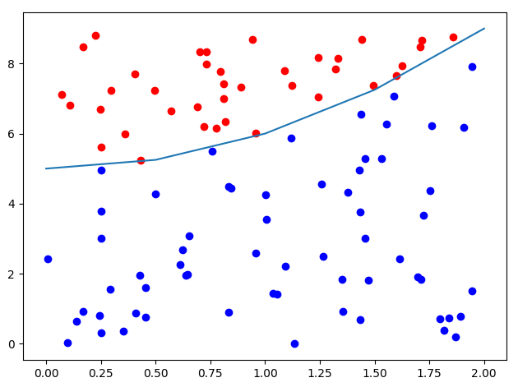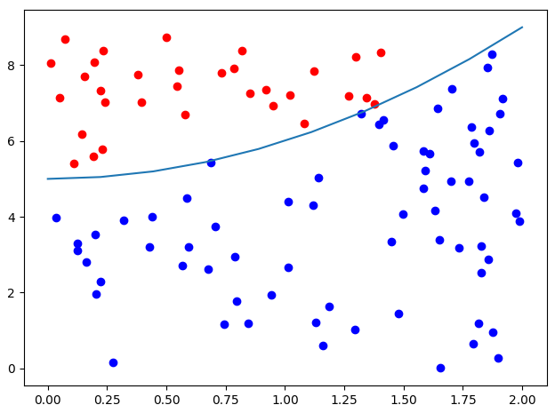

num_of_steps : 50 | num_of_points : 100 | result : 13.50 num_of_steps : 100 | num_of_points : 100 | result : 11.52
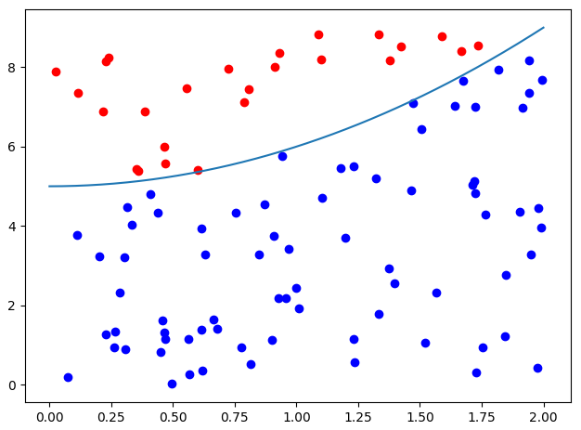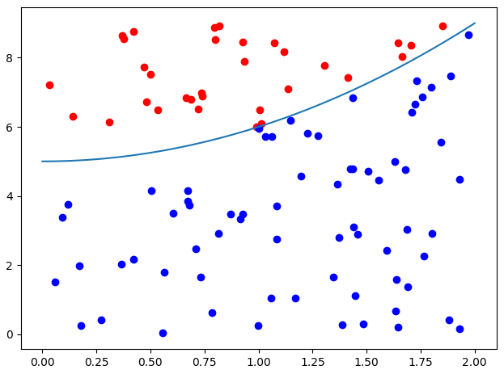

num_of_steps : 100 | num_of_points : 500 | result : 12.70 num_of_steps : 100 | num_of_points : 1000 | result : 12.85
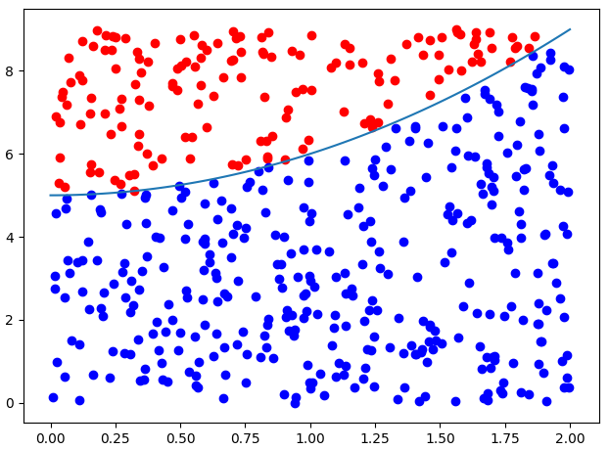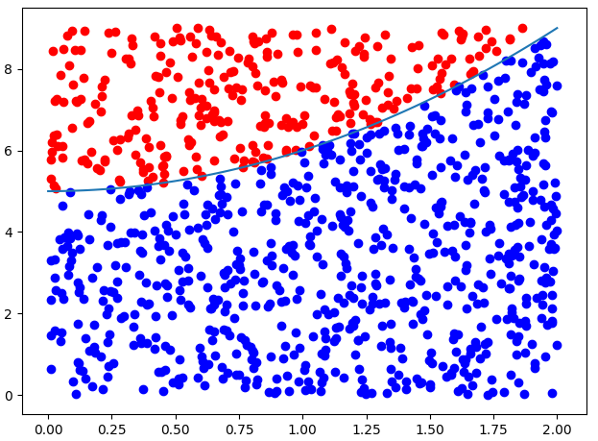

num_of_steps : 100 | num_of_points : 10000 | result : 12.71 num_of_steps : 100 | num_of_points : 100000 | result : 12.66
