Evolutionary Algorithm Analysis using LLM-Guided Mutation
Name: Beatrice Fadeyibi
Course Title: Analysis of Algorithms
Course Code: CS5381

1. Introduction
This project implements an evolutionary algorithm comparing three approaches: No Evolution, Random Mutation, and LLM-Guided Mutation.

2. Setup
Population: 10
Generations: 6
Mutation: Random & LLM

3. Results
No Evolution: 28.5618
Random Mutation: 29.3102
LLM Mutation: 99.0096
LLM shows significant improvement over other methods.

4. Graph Analysis

No Evaluation:

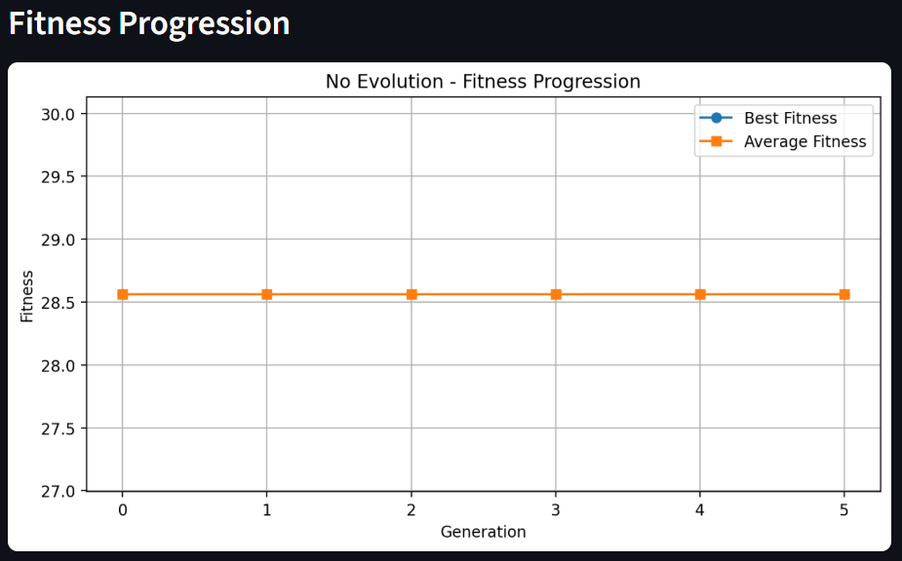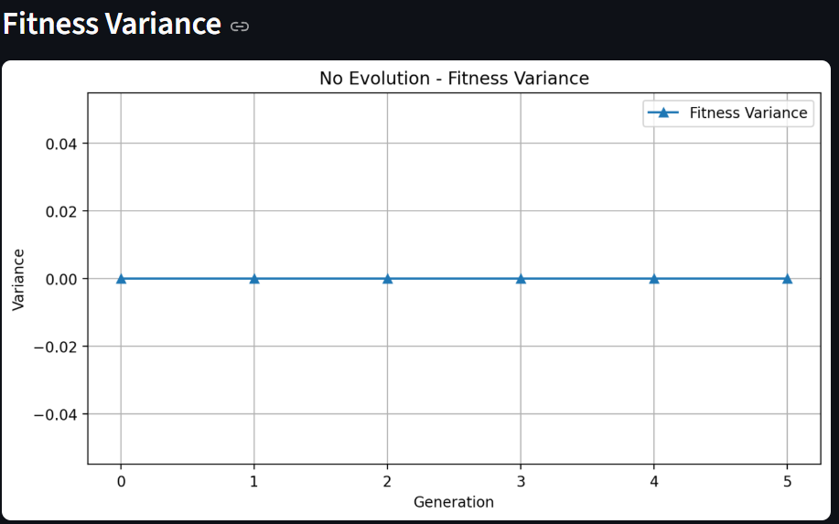
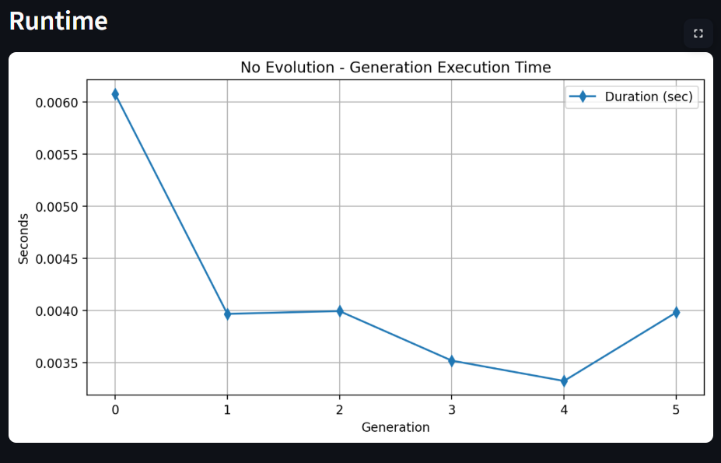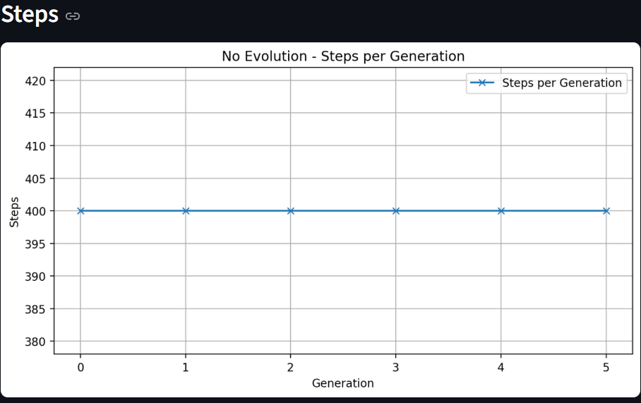

Random Mutation:

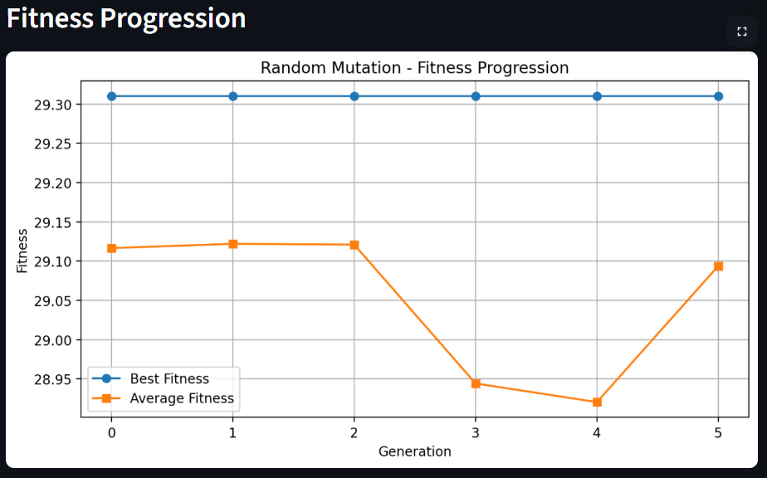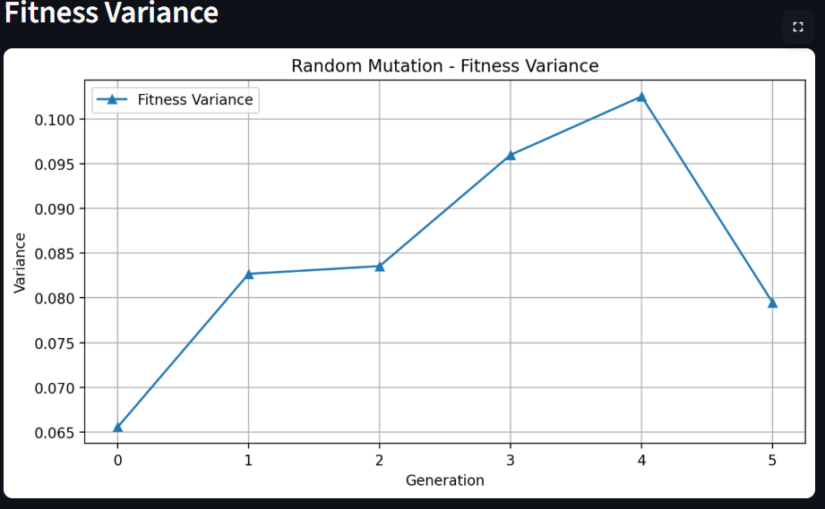
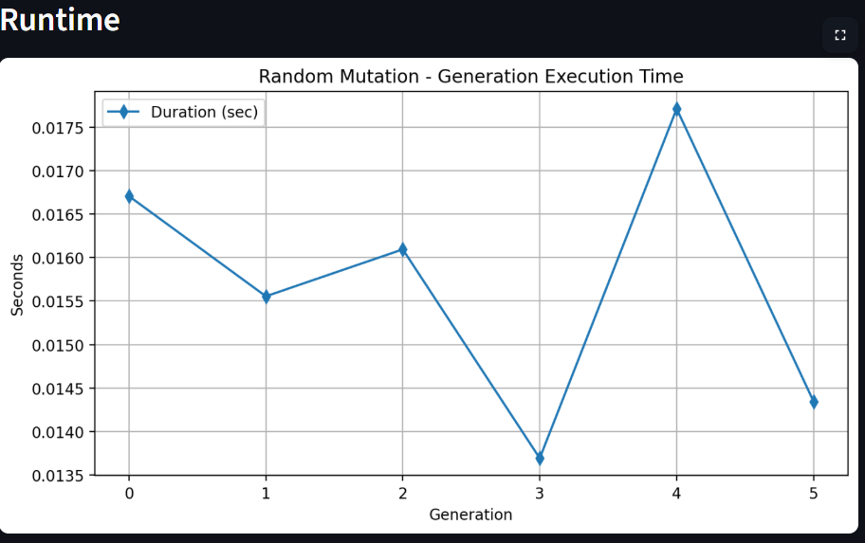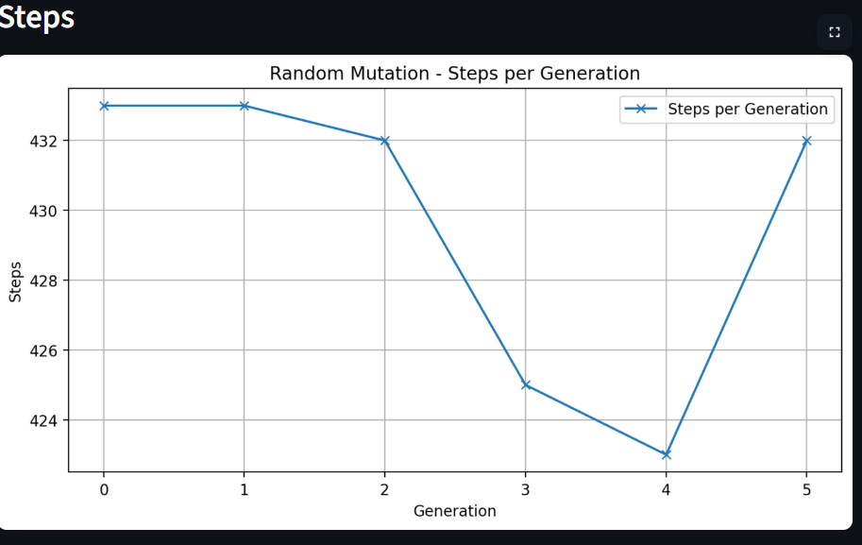

LLM-Guided Mutation:

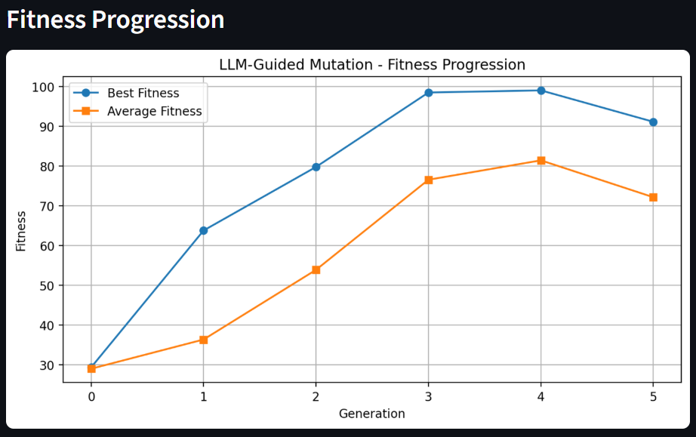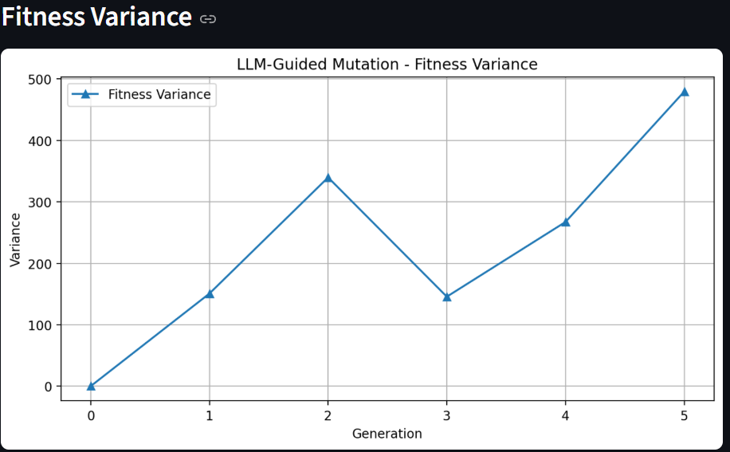

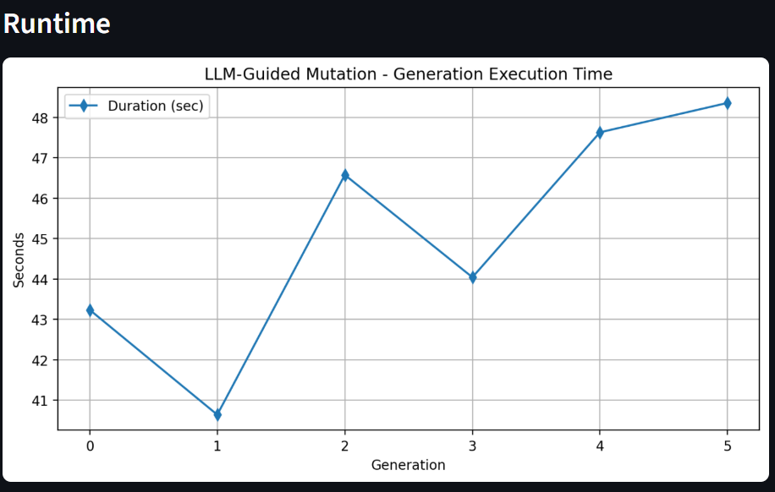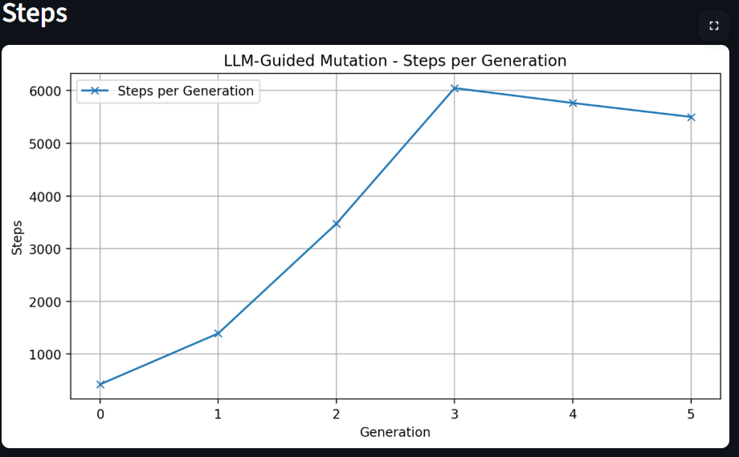

Comparison Graph:

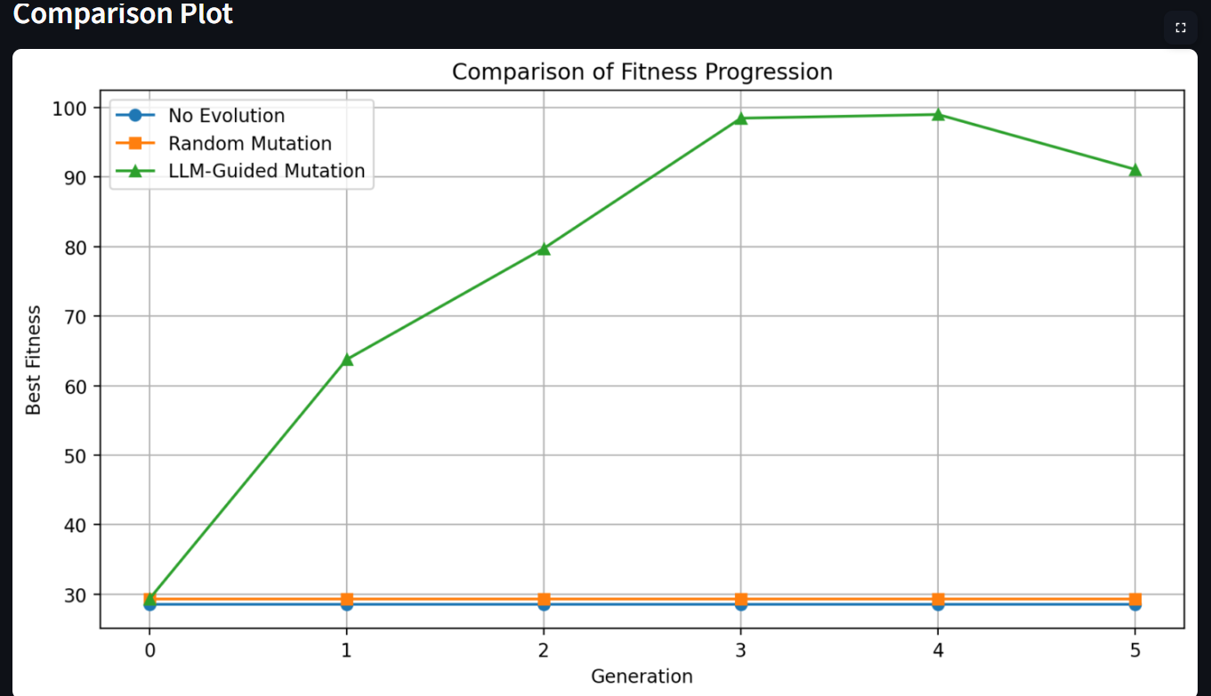

5. Observations
- LLM-guided mutation shows rapid improvement, especially in the early generations, quickly outperforming other methods.
- Random mutation achieves only marginal gains, indicating limited ability to explore meaningful improvements.
- No evolution remains constant across generations, as expected, since no optimization is applied.
- Overall, the LLM approach achieves significantly higher fitness values, demonstrating its effectiveness in guiding the search process.
6. Runtime
- Random Mutation: Very fast due to simple, lightweight operations with no external dependencies.
- LLM-Guided Mutation: Slower because of API calls and processing overhead.
- Trade-off: There is a clear trade-off between performance and time. LLM achieves better results but at the cost of increased runtime.
7. Conclusion
The project shows that LLM-guided evolution achieves the best performance and fastest improvement compared to random mutation and no evolution, but at the cost of higher runtime due to API calls.
