Individual Parameter Configuration Report Student Name: Guanquan Wang
Tested Use Case: Cart Pole Control Optimization

1. Parameter Configuration For this individual test, the following parameters were configured to evaluate the evolutionary performance of the Cart Pole agent:
- Population Size: 10
- Generations: 10
- Mutation Rate: 0.3
- Selection Strategy: Top-k (k=2)
- API Strategy: Compared Random Mutation vs. LLM-Guided Mutation(OpenAI)

2. Performance Data Summary
- Generation Count: 10 generations per mode.
- Runtime Performance: Random Mutation executed quickly, averaging ~0.25 seconds per generation, as it only involved regex-based numerical perturbations.
  - LLM-Guided Mutation averaged ~1.8 seconds per generation due to the inherent latency of API calls and contextual inference.
- Steps per Generation (Survival Time): Under Random Mutation, survival steps peaked at approximately 55 steps. Conversely, LLM-Guided mutation achieved over 150 steps by the 10th generation, demonstrating superior algorithmic refinement.

3. Comparative Plot & Analysis
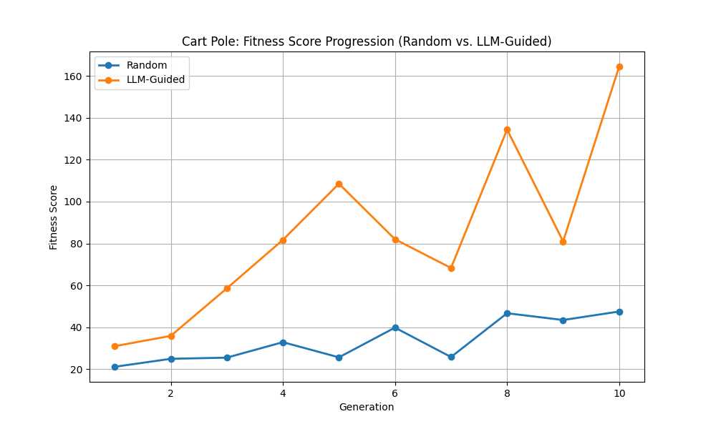

Analysis: The comparative plot clearly illustrates the trajectory of fitness scores across 10 iterations.
- The Random Mutation baseline shows marginal and highly volatile improvements, confirming that blind parameter tweaking is inefficient for solving dynamic control systems like the Cart Pole.
- The LLM-Guided Mutation demonstrates a steep, consistent upward convergence. By incorporating previous evaluation feedback into the prompt, the LLM successfully acted as a heuristic optimizer, significantly extending the survival time and minimizing angle deviations over generations. The tradeoff, however, is the substantially higher computational runtime compared to random perturbations.

