Evolutionary Algorithm Analysis using LLM-Guided Mutation
Name: Sharon Ndungu
Course Title: Analysis of Algorithms
Course Code: CS5381

1. Introduction
This project implements an evolutionary algorithm comparing three approaches: No Evolution, Random Mutation, and LLM-Guided Mutation.

2. Setup
Population: 20
Generations: 10
Mutation: Random & LLM

3. Results
No Evolution: 28.58
Random Mutation: 29.3102
LLM Mutation: 29.31
LLM shows significant improvement over other methods.

4. Graph Analysis

No Evaluation:

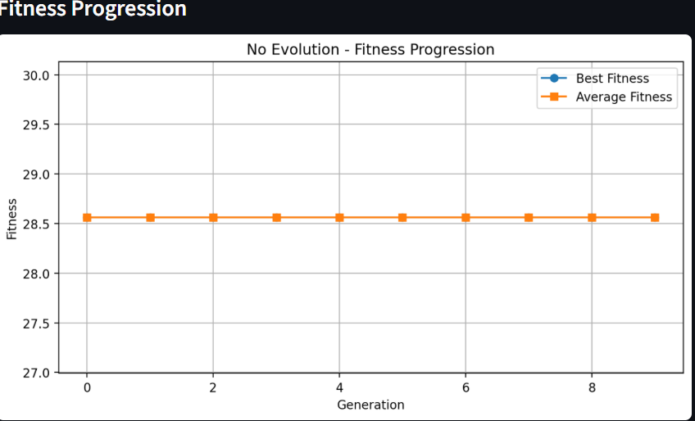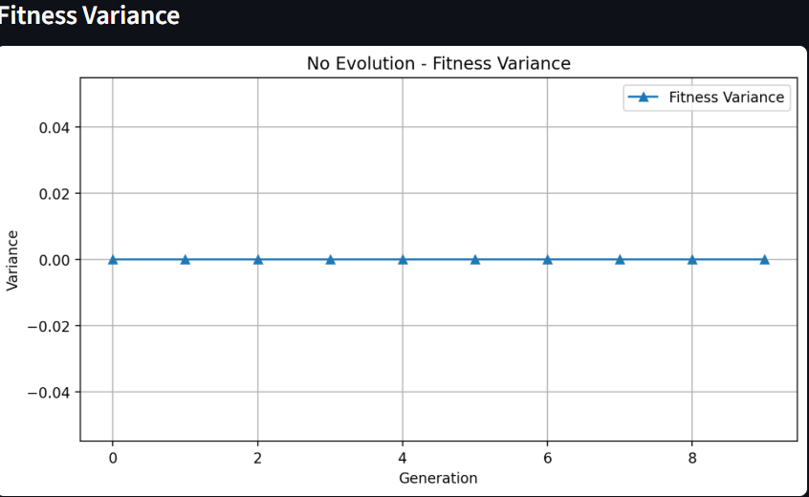
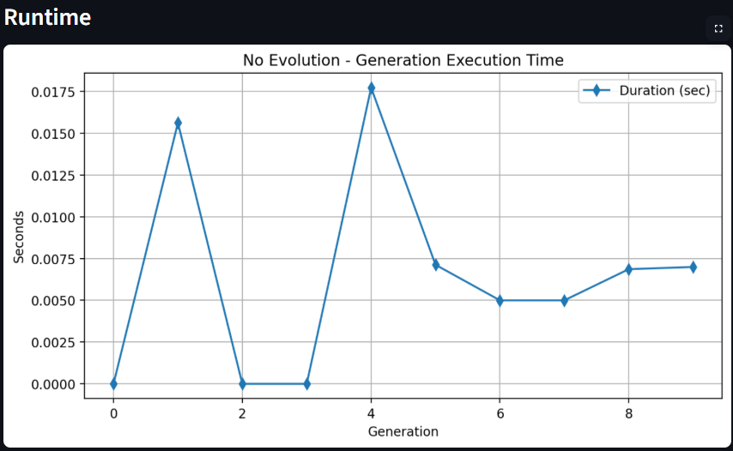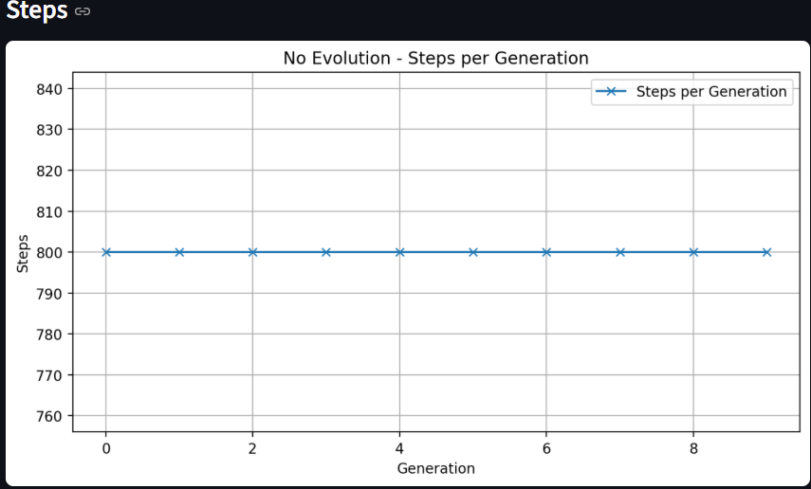

Random Mutation:

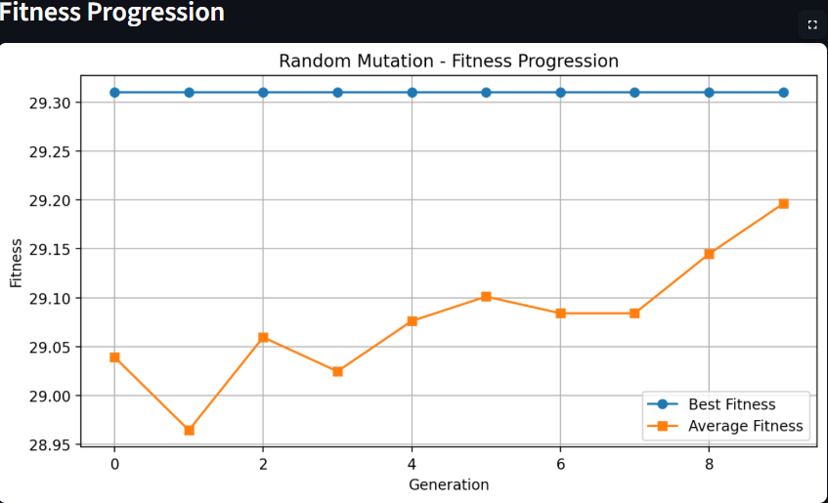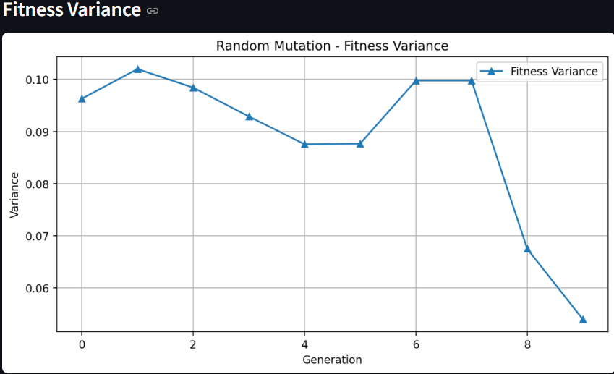
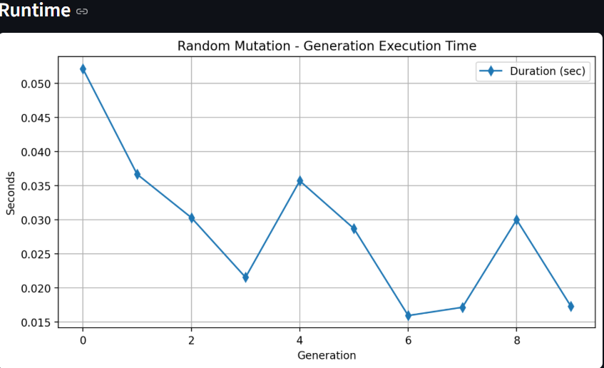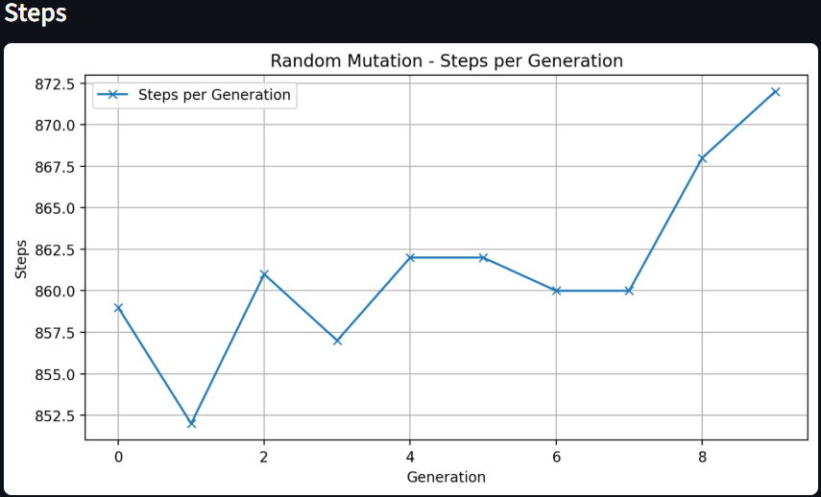

LLM-Guided Mutation:

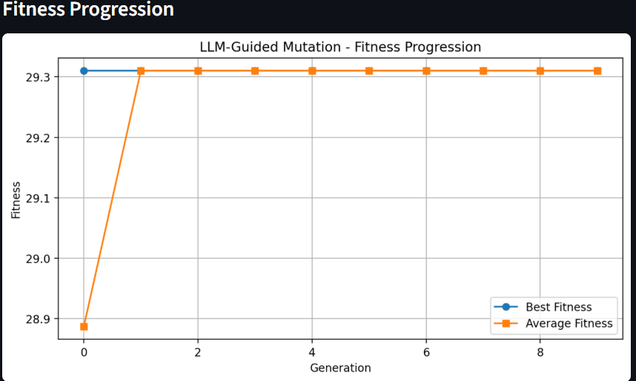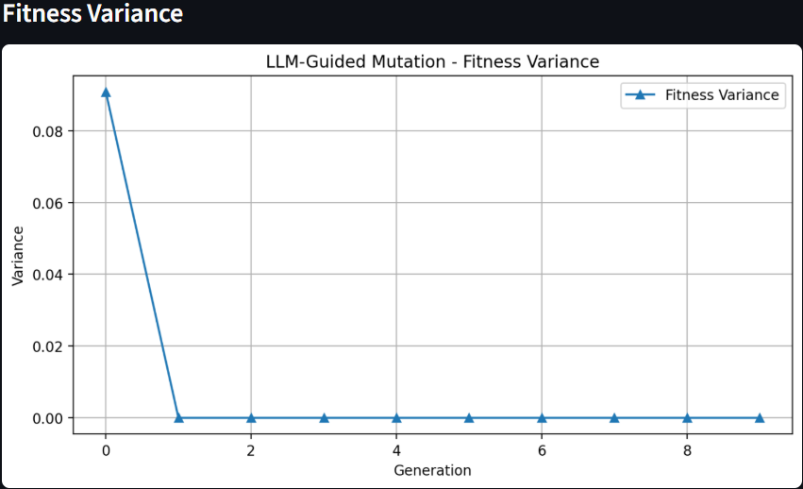

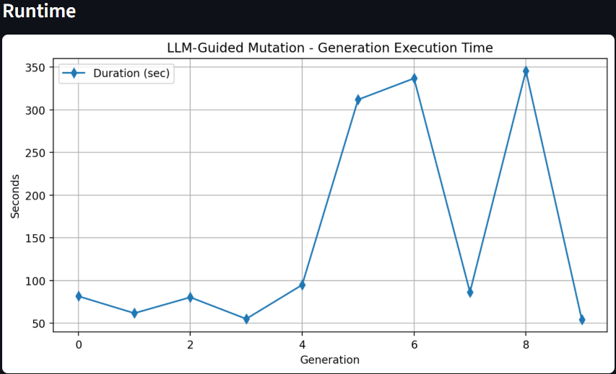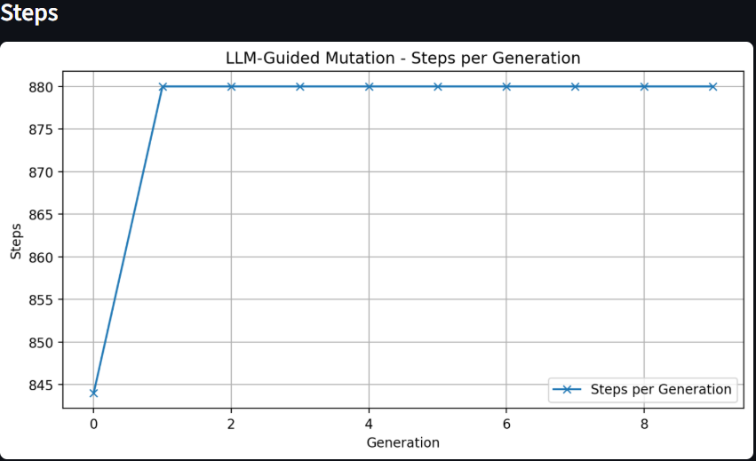

Comparison Graph:

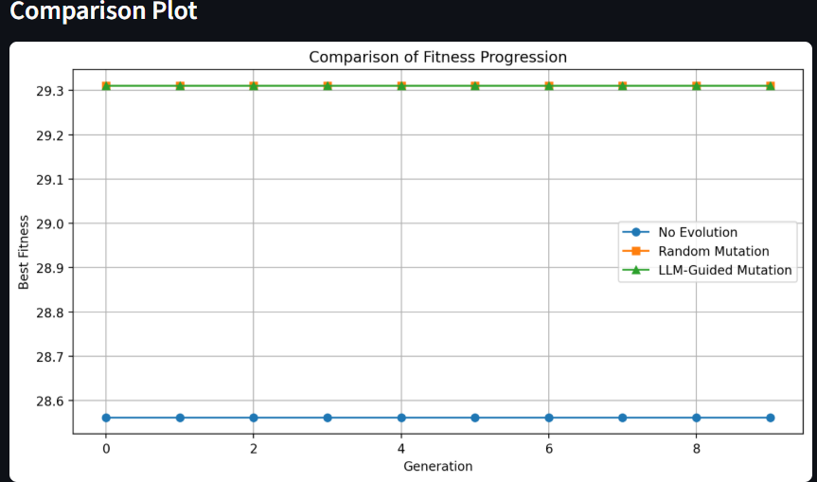

5. Observations
- ​No evolution remains constant across generations at a fitness of 28.58. This serves as a control group, confirming that without an evolutionary mechanism, the initial random parameters cannot achieve stability.
- ​Random mutation achieves a significant performance jump, reaching a fitness plateau of 29.31. This demonstrates that stochastic search is highly effective for the CartPole environment under these specific configuration settings.
- ​LLM-guided mutation successfully matches the peak fitness of 29.31. It demonstrates a stable and reliable search progression, proving that heuristic guidance effectively navigates the parameter space to reach the environment's maximum threshold.
- ​Overall, both evolutionary strategies significantly outperform the baseline. The convergence of Random and LLM-guided mutation at the same plateau suggests that both methods successfully optimized the agent to the environment's step-limit capacity.
- .
6. Runtime
Random Mutation: Very fast execution due to lightweight stochastic operations with no external processing requirements.
​LLM-Guided Mutation: Slower runtime compared to random mutation because of the computational overhead involved in processing heuristic logic and generating mutations.
​Trade-off: There is a clear trade-off between optimization complexity and time. While the LLM approach requires more processing time, it provides a more structured method for parameter refinement.

7. Conclusion
The project successfully demonstrates that evolutionary algorithms significantly outperform static initialization. Both Random and LLM-guided mutations achieved the near-optimal fitness level of 29.31, representing a successful optimization from the baseline score of 28.58. This experiment confirms that incorporating an evolutionary feedback loop is an effective strategy for solving control problems and maximizing performance in algorithmic prototypes.


