Evolutionary Algorithm Analysis using LLM-Guided Mutation
Adil Shah
Course: Analysis of Algorithms

1. Introduction
This project implements an evolutionary algorithm comparing three approaches: No Evolution, Random Mutation, and LLM-Guided Mutation.

2. Setup
Population: 5
Generations: 5
Mutation: Random & LLM

3. Results
No Evolution: 28.56
Random Mutation: 29.31
LLM Mutation: 63.75
LLM shows significant improvement over other methods.

4. Graph Analysis
No Evaluation:
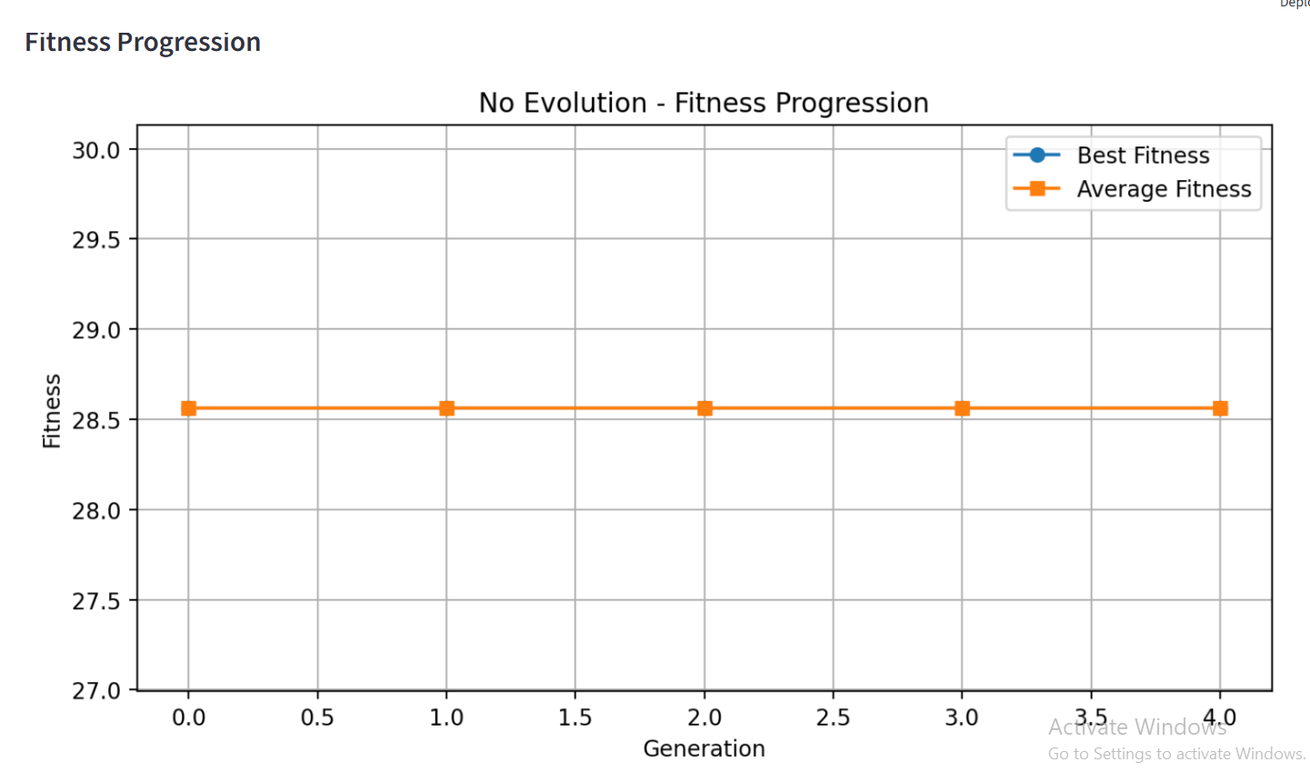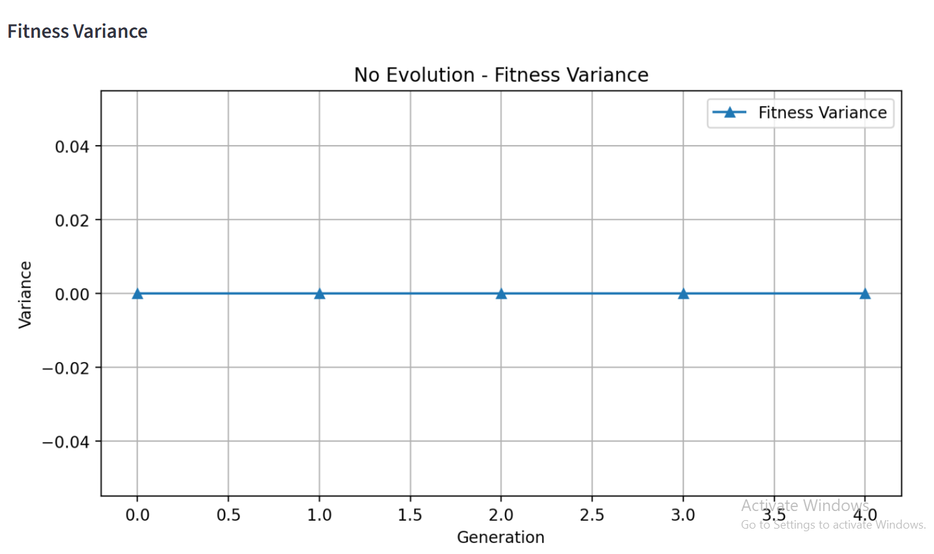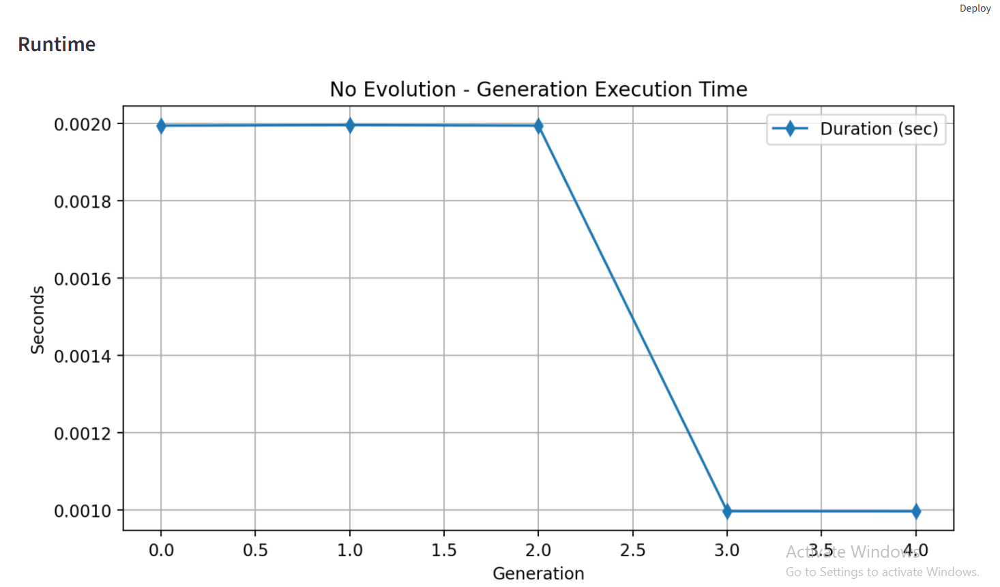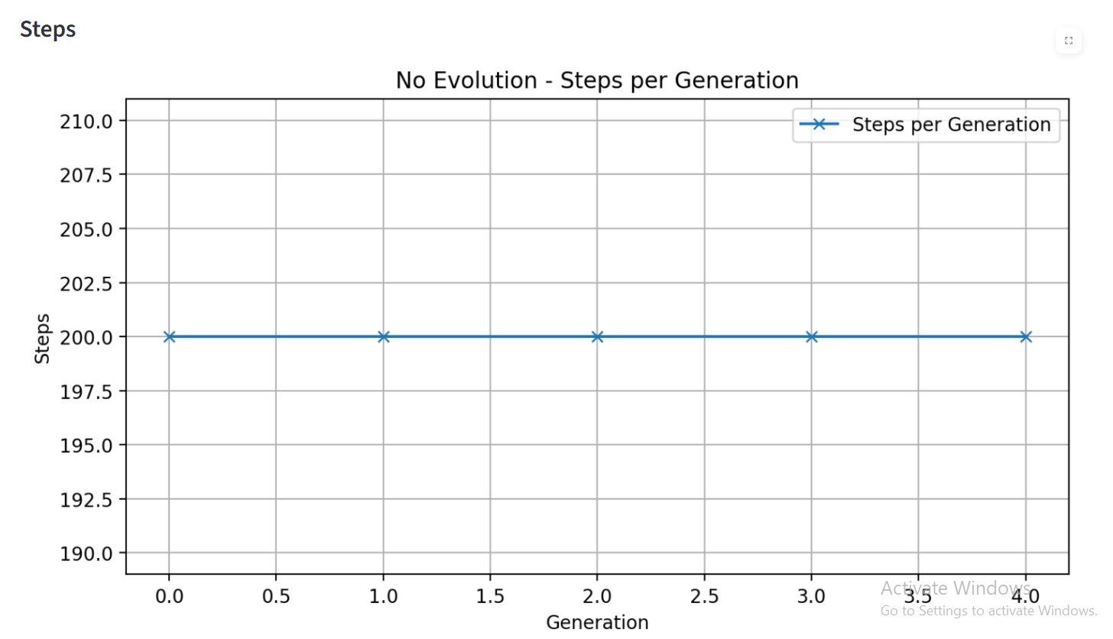

Random Mutation
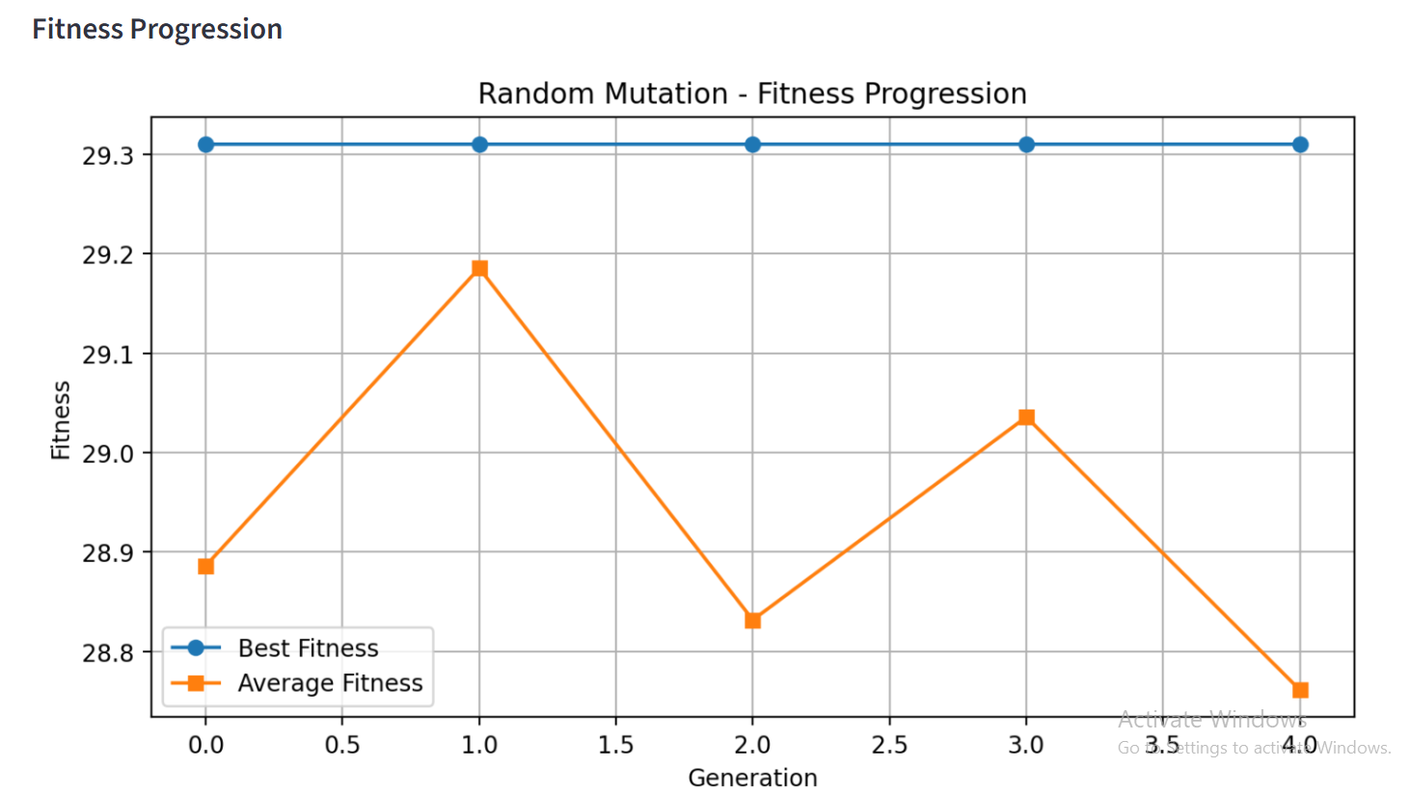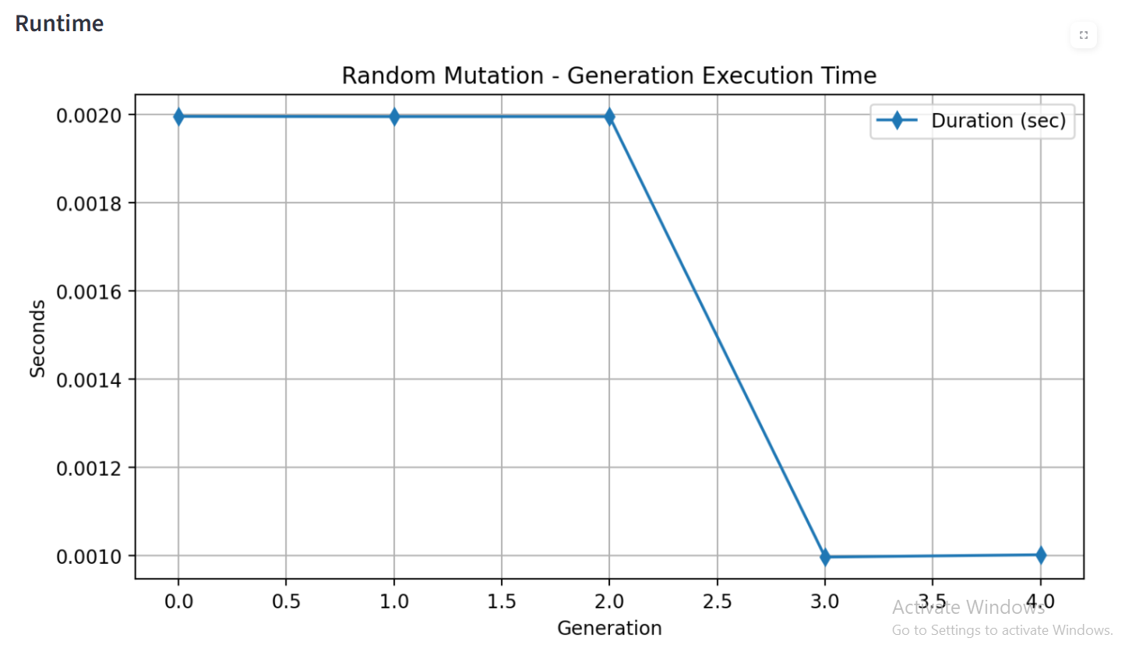
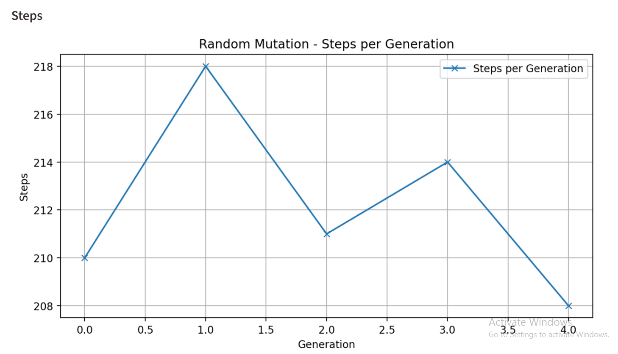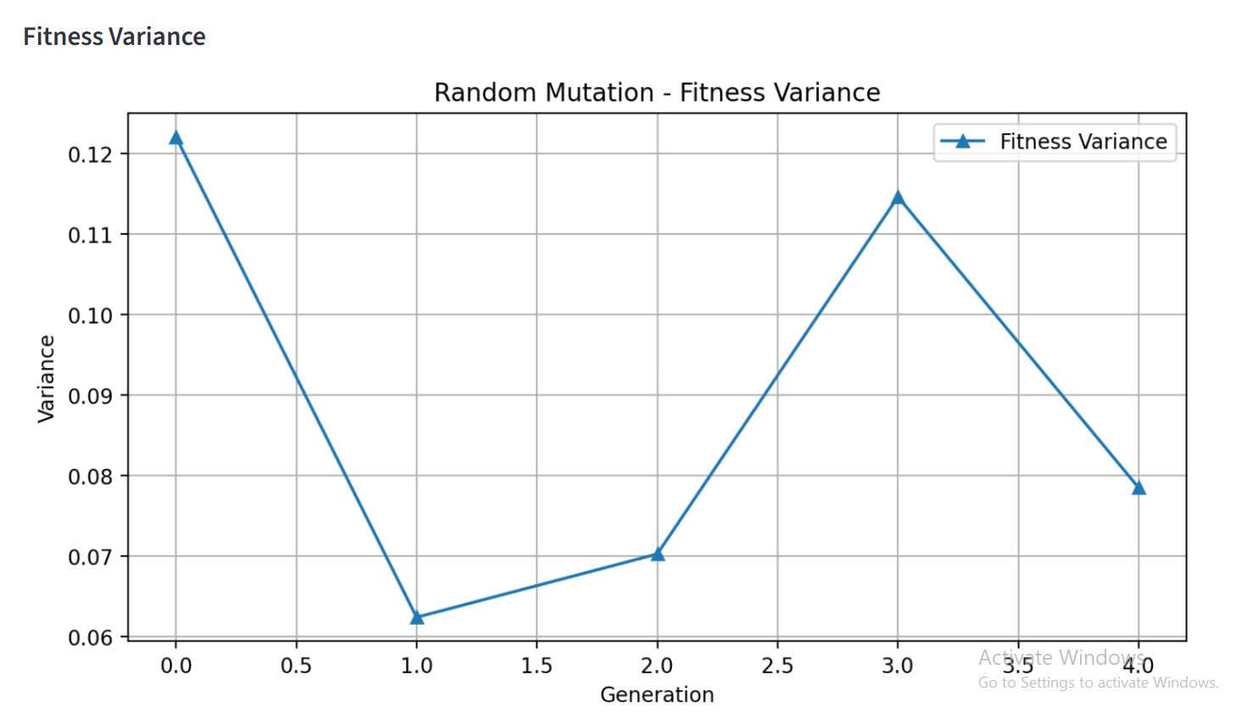

LLM-Guided Mutation:
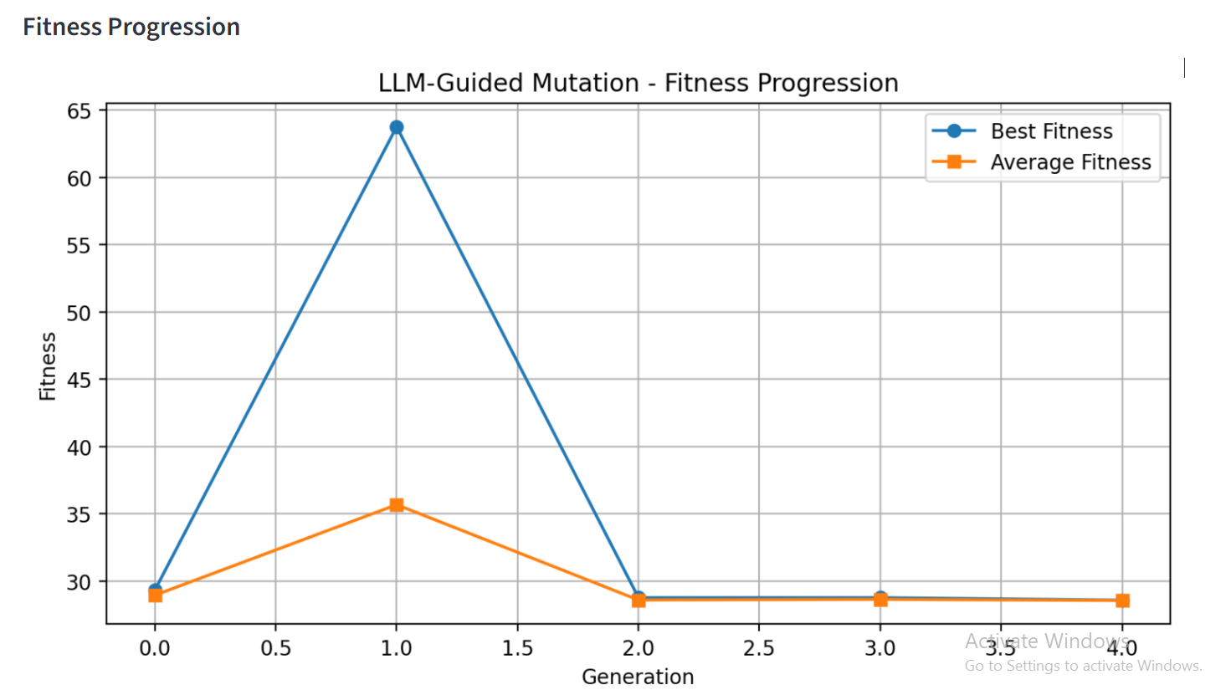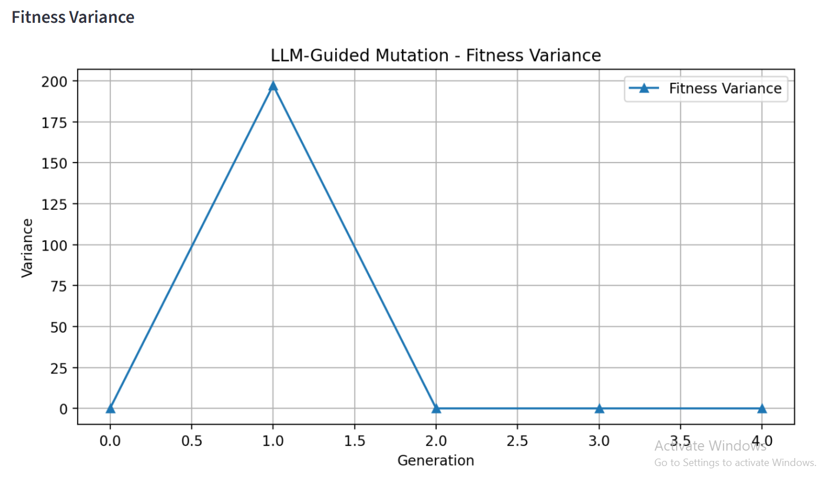

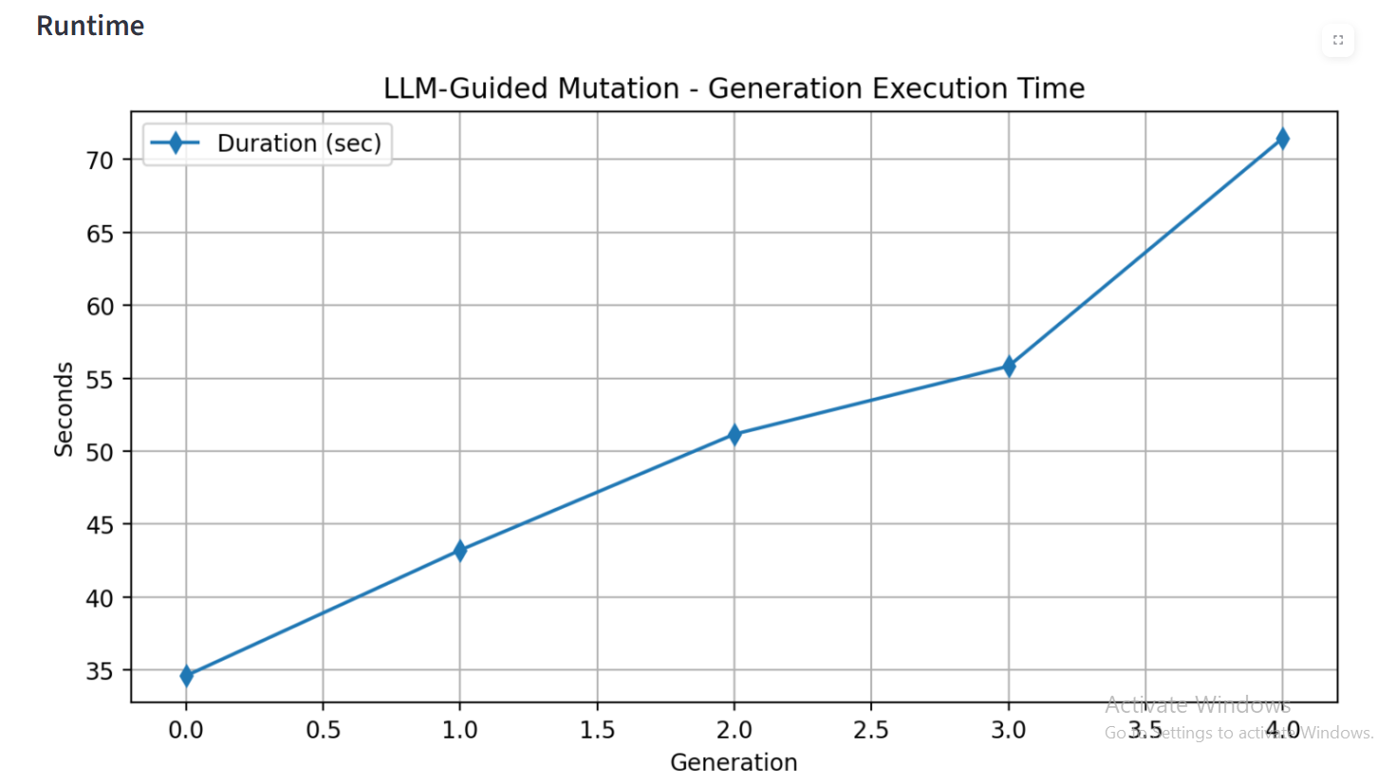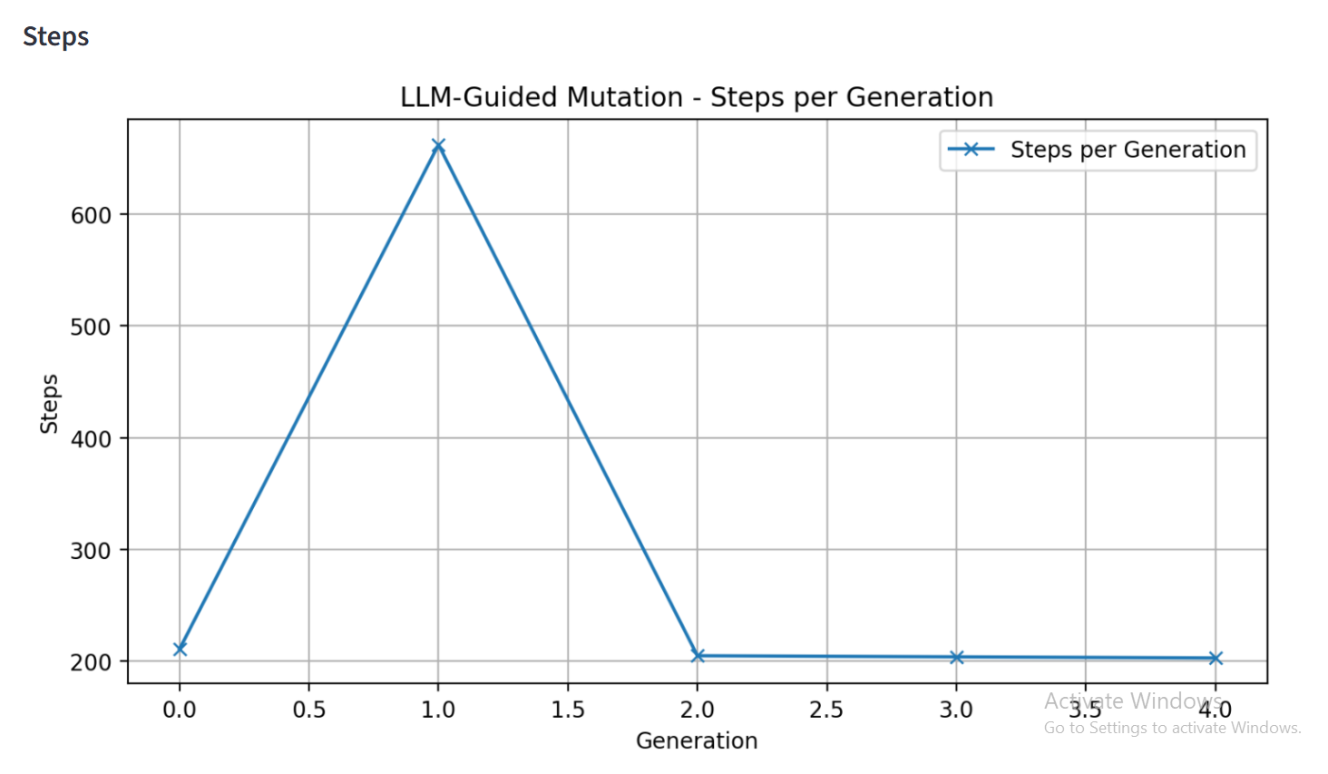
Comparison Graph:
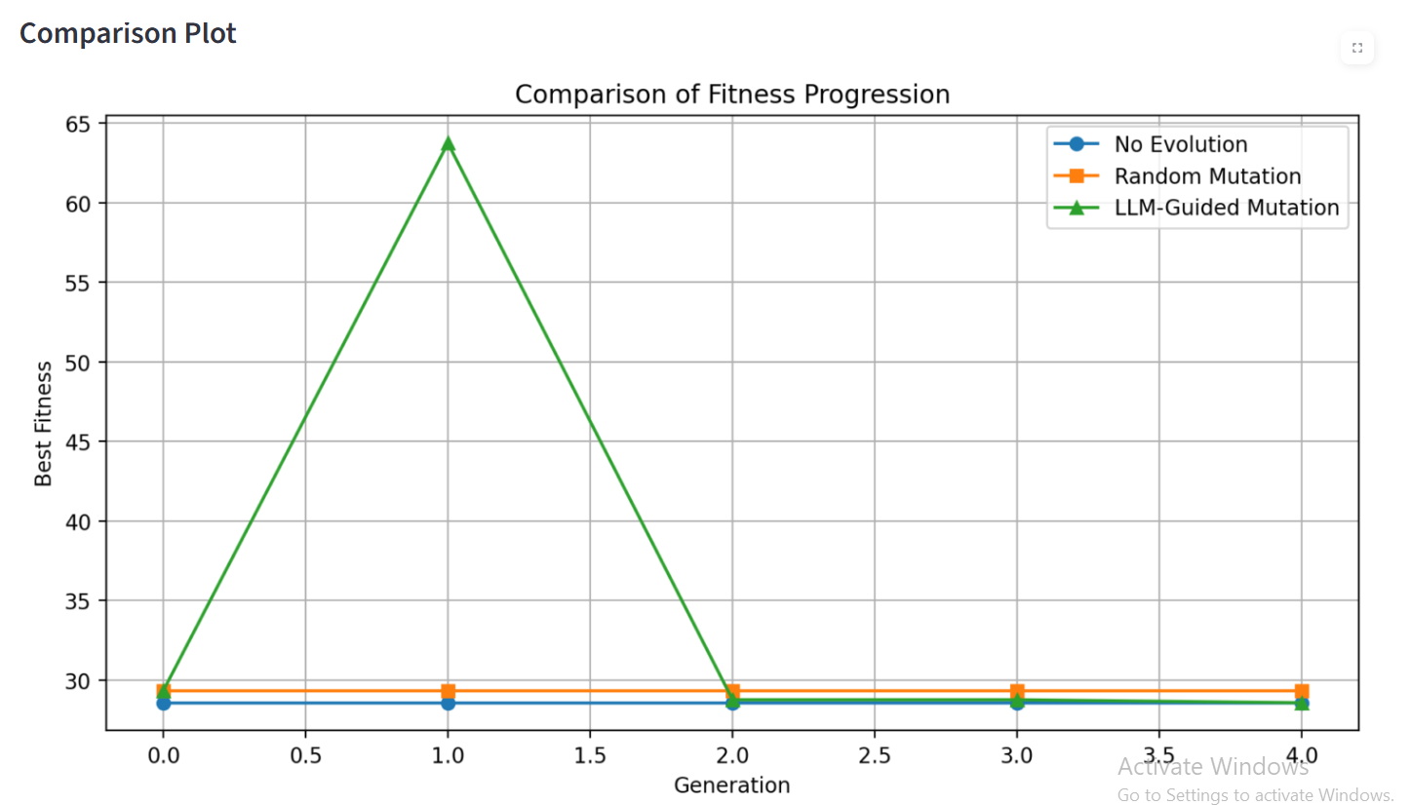

5. Observations
- LLM improves rapidly in early generations.
- Random mutation shows limited improvement.
- No evolution remains constant.
- LLM achieves significantly higher fitness values.

6. Runtime
Random: Very fast
LLM: Slower due to API calls
Trade-off: performance vs time

7. Conclusion
LLM-guided mutation significantly outperforms other methods by achieving higher fitness and faster convergence, although it requires more computation time.

