**Inheritance**

Inheritance is a golden rule and powerful feature in OOP(Object Oriented

Programming) ***It allows defining a Derived Class(Child Class) which takes all***

***functionalities(attributes and methods) of the Base class(Parent Class). Also, we can add more features in the child class according to our preference.***

The best mechanism to reuse a code while building software or a system is inheritance. Otherwise, there will be a number of duplicate codes that can add more complexity.

**Note:** A child class can access all the properties of a parent class. For example, Even if a child doesn’t have a constructor and a parent class has one, The child class will create objects despite not having a constructor.

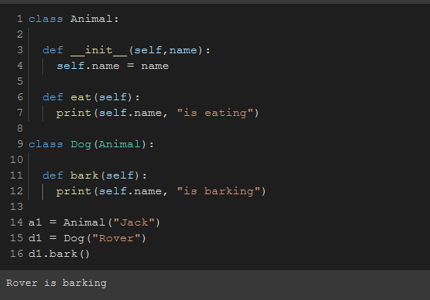

To check if something is a subclass of something, We can use the **“issubclass()”** function to check.

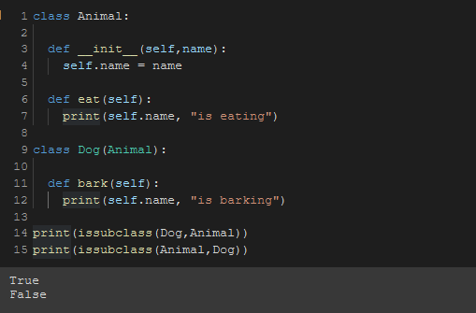

## We can get rid of the extra instance variables of the child class by using the parent class’s constructor.

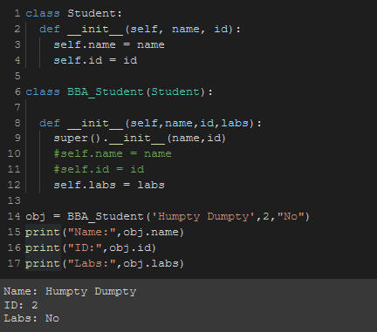

## 

## **Types of Inheritance in Python**

Types of Inheritance depend upon the number of child and parent classes involved. There are four types of inheritance in Python:

* **Single Inheritance:** Single inheritance enables a derived class to inherit properties from a single parent class, thus enabling code reusability and the addition of new features to existing code.

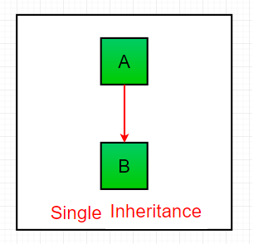

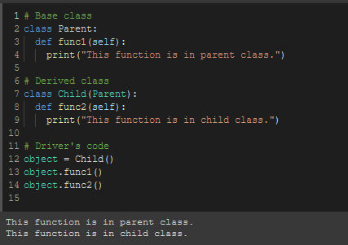

* **Multiple Inheritance:** When a class can be derived from more than one base class this type of inheritance is called multiple inheritances. In multiple inheritances, all the features of the base classes are inherited into the derived class.

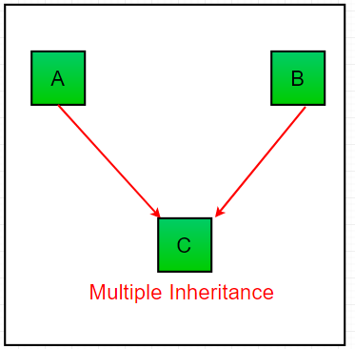

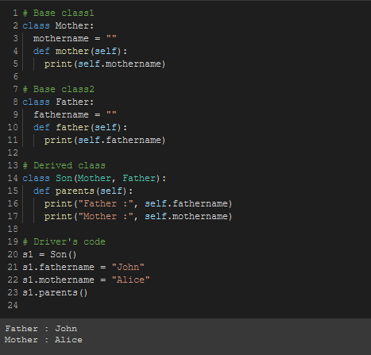

In multiple inheritances, The child has first priority and then parents.

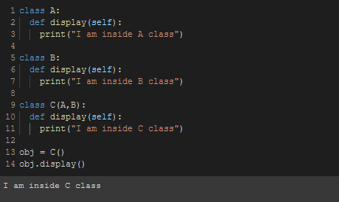

* **Multilevel Inheritance:** In multilevel inheritance, features of the base class and the derived class are further inherited into the new derived class.   
  This is similar to a relationship representing a child and a grandfather.

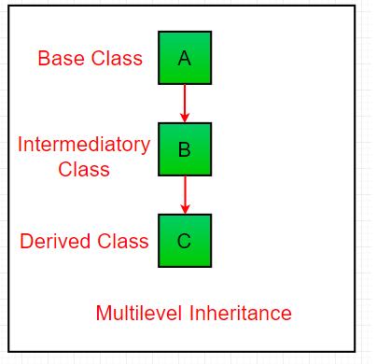

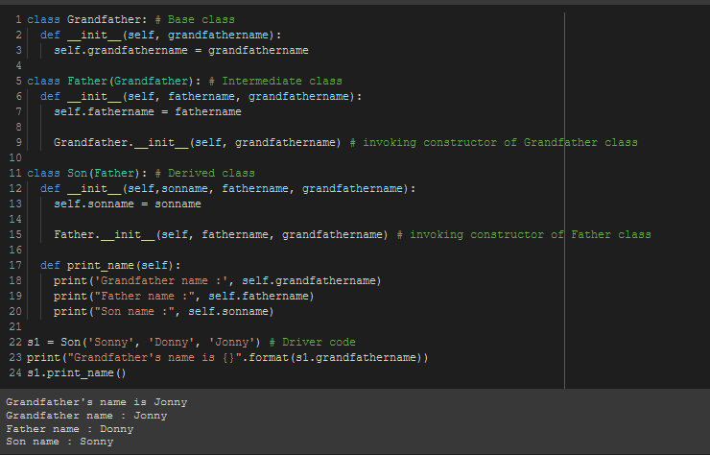

* **Hierarchical Inheritance:** When more than one derived class are created from a single base this type of inheritance is called hierarchical inheritance. In this program, we have a parent (base) class and two children (derived) classes.

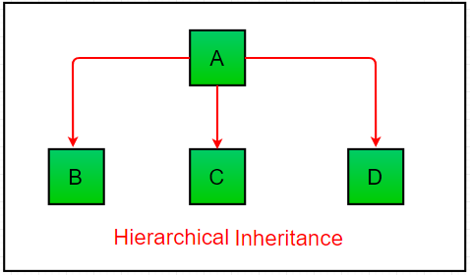

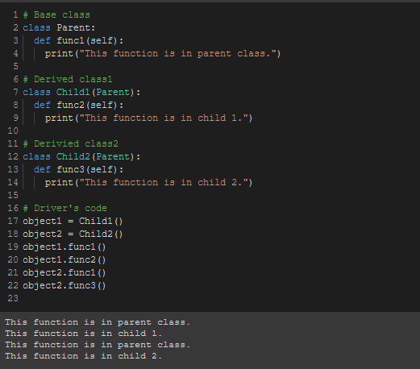

* **Hybrid Inheritance:** Inheritance consisting of multiple types of inheritance is called hybrid inheritance.

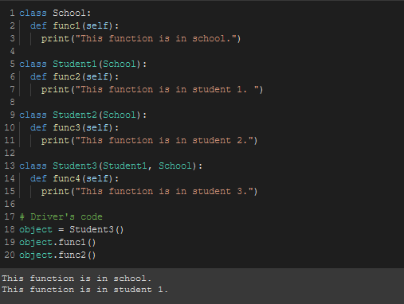

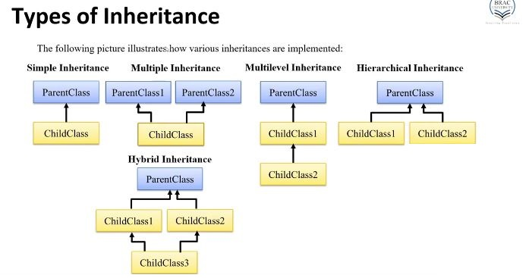

**Using properties of child class:**

We can use the parent class’s properties in the child class shown below.

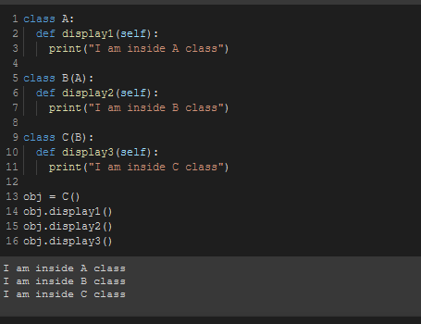

Similarly, we can also call the parent class’s properties inside the child class using the **“super()”** method inside an instance method.

