8/10/2026
DOCKER
- Open Docker Desktop
- Open command promt
- To check whether it is working or not the first command is
- 1.) docker --version
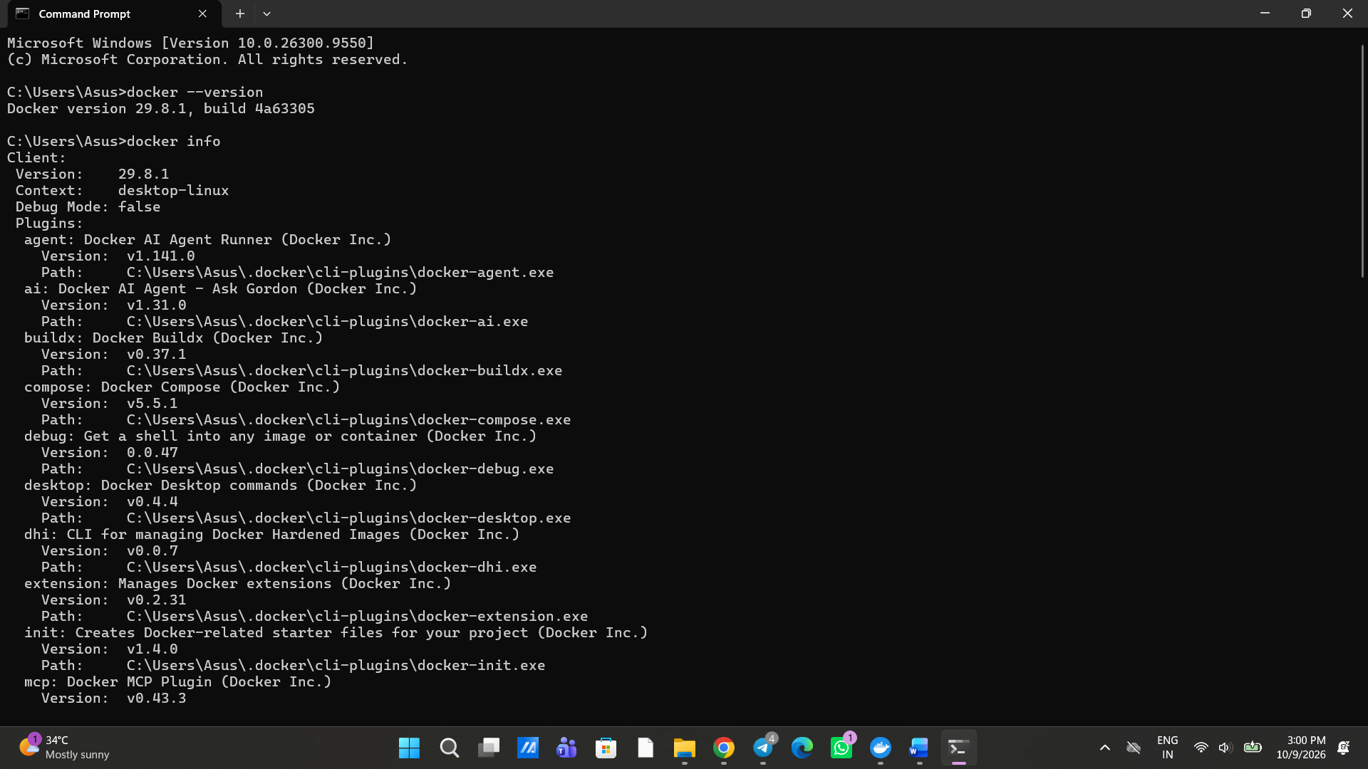2)docker info
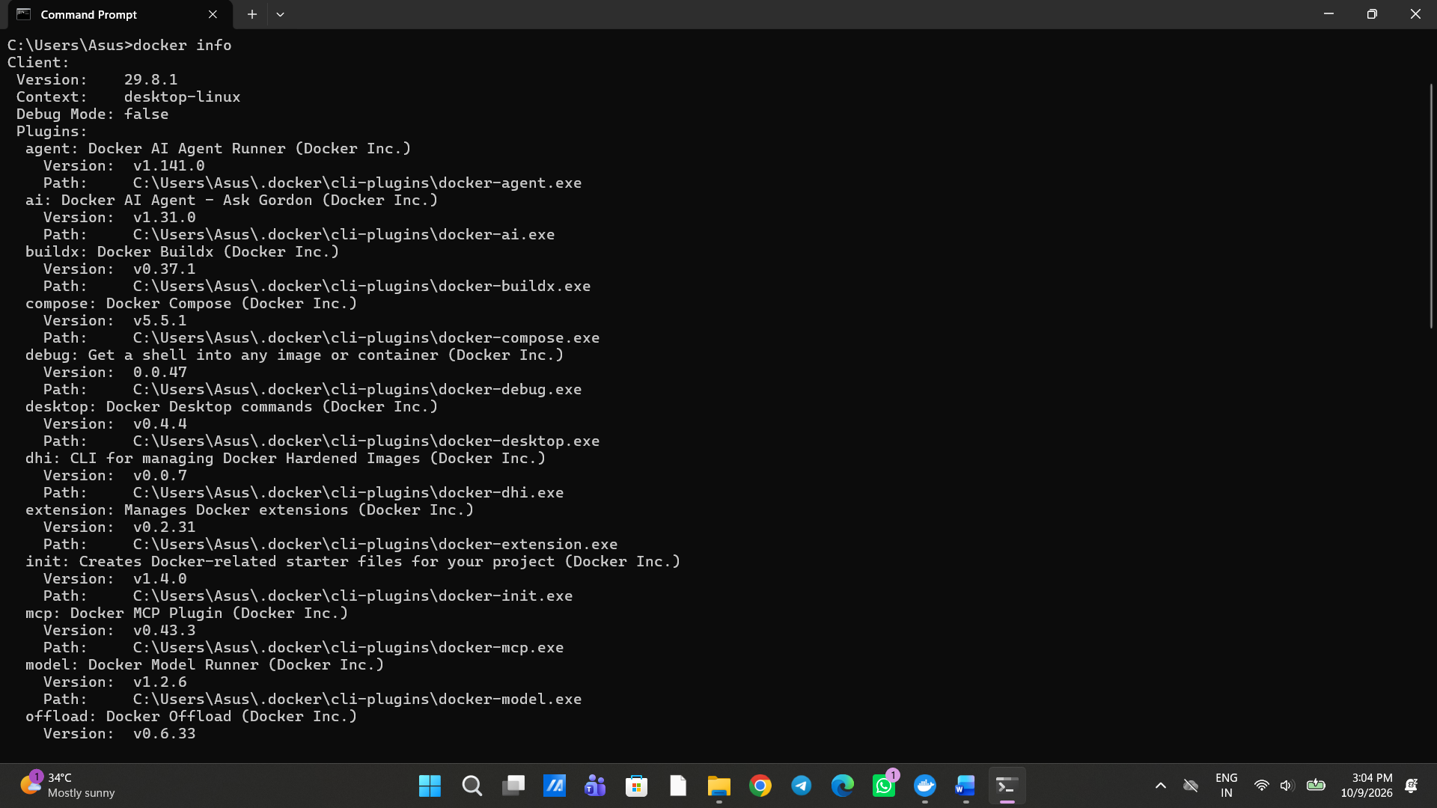Now we are creating an image called hello world
Using this cmddocker run hello-world
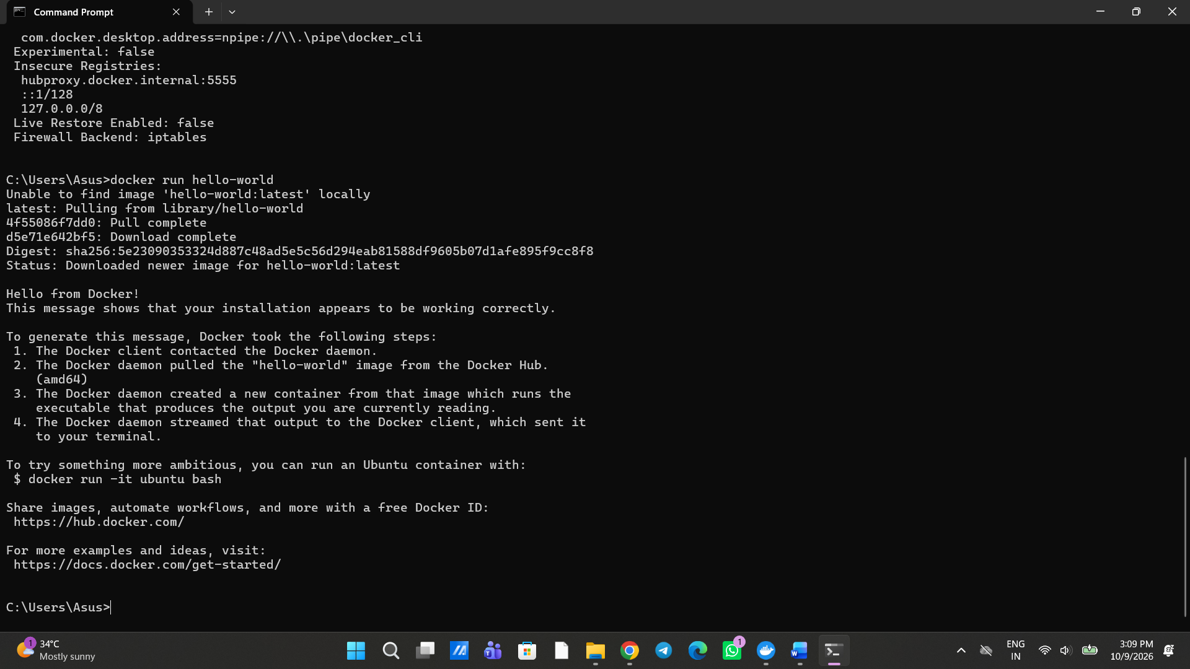the out put is shown in images
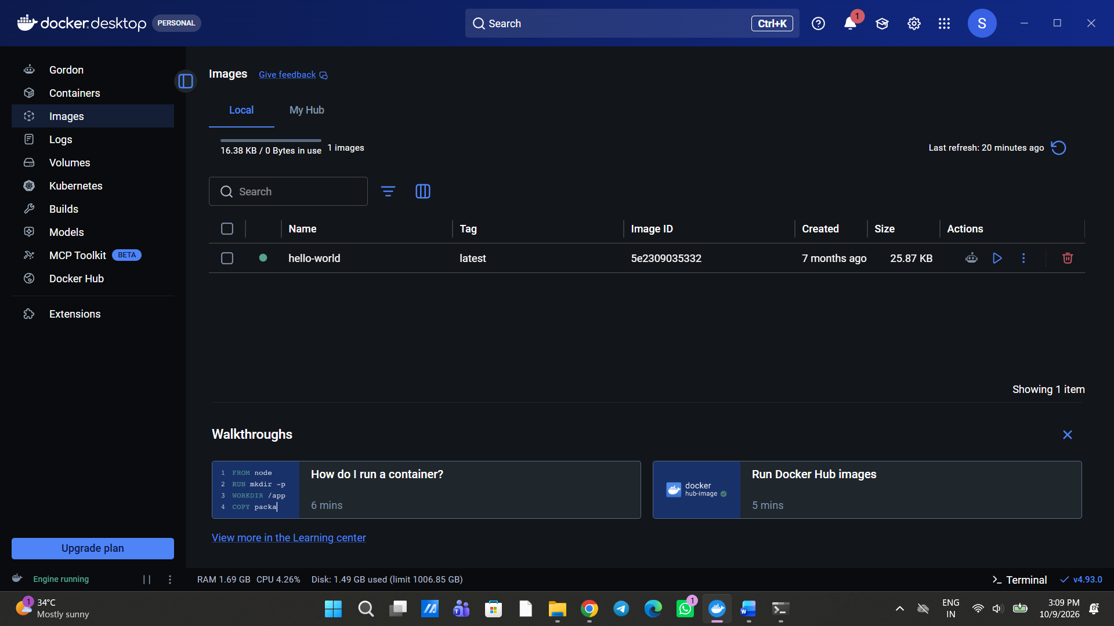Now we are going to pull an image from another git hub link
https://github.com/suryakiran1993/soa-docker-demo
Now we are going to clone that
Go to Soa Workspace and click on cmd in that folder
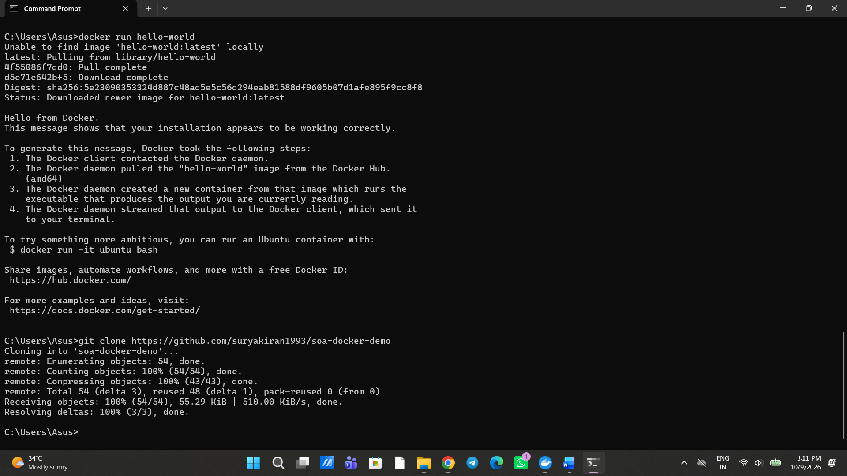
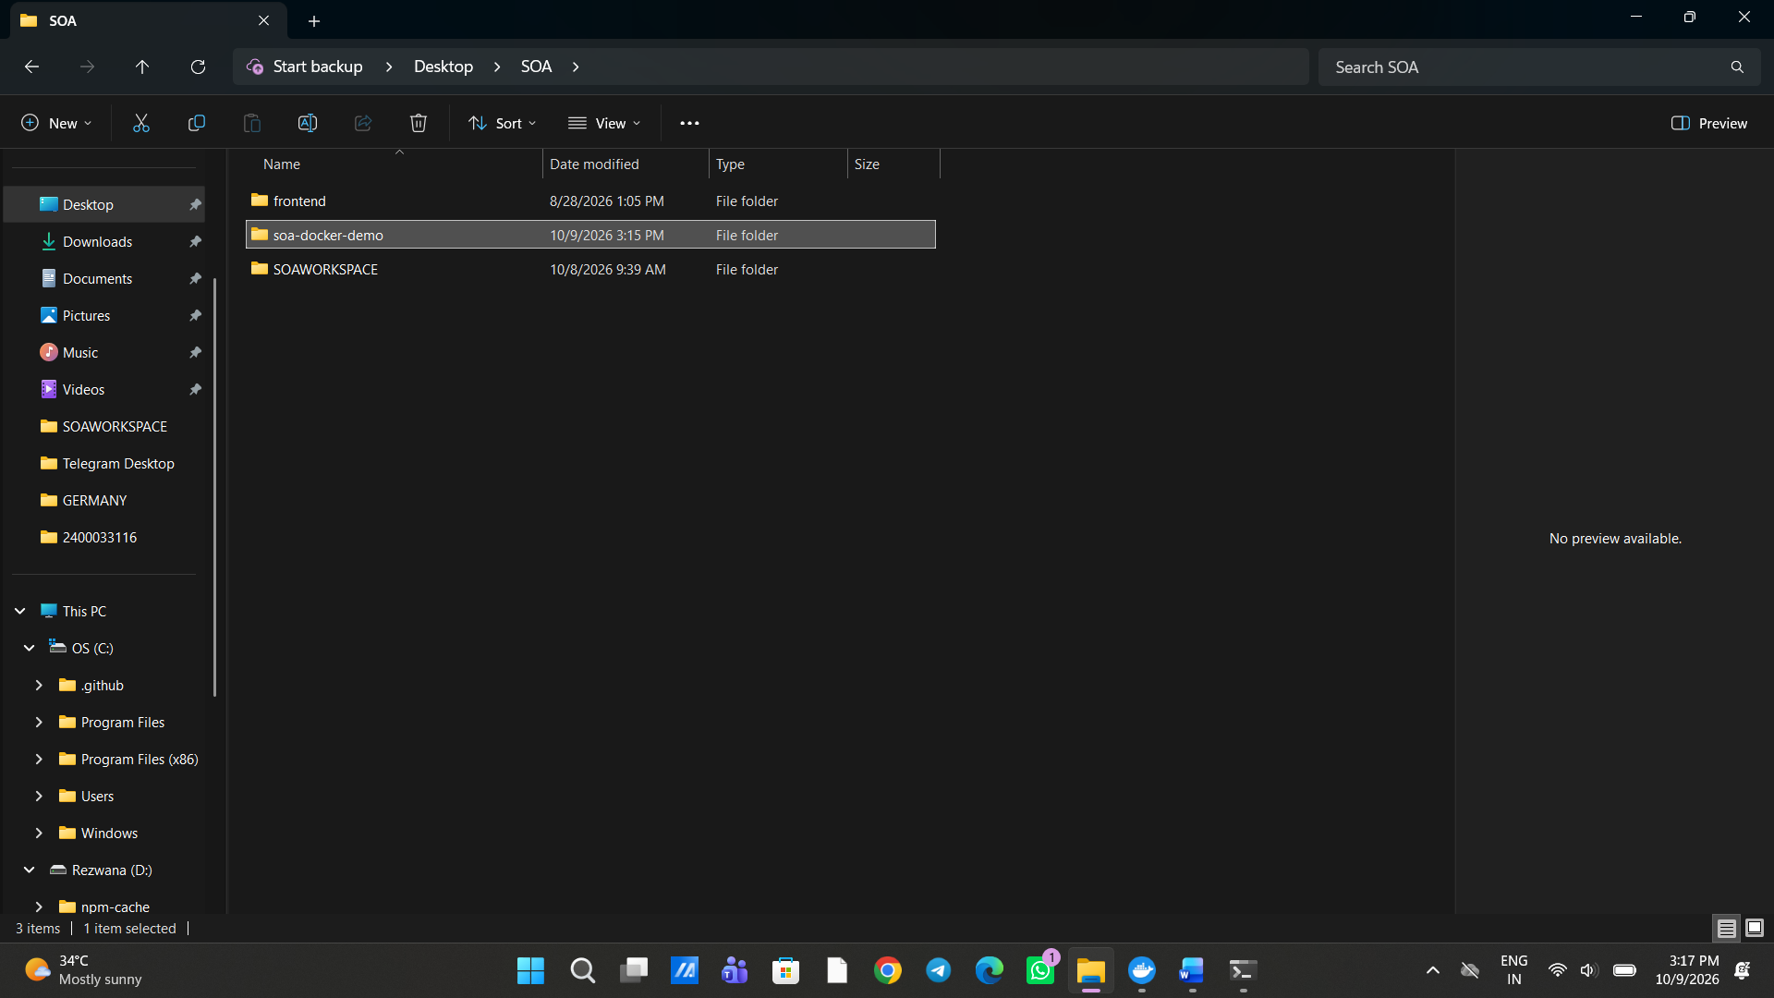after opening that folder you will find another 2 folder that is
1)docker-backend-springboot
2)docker-frontend-reactapp
Now open docker-frontend-reactapp and delete the .gitignore so that the previous logs or commits that are made by sir is not reflected in our system
Now open docker-frontend-reactapp and install the node modules usingthis cmd
npm install
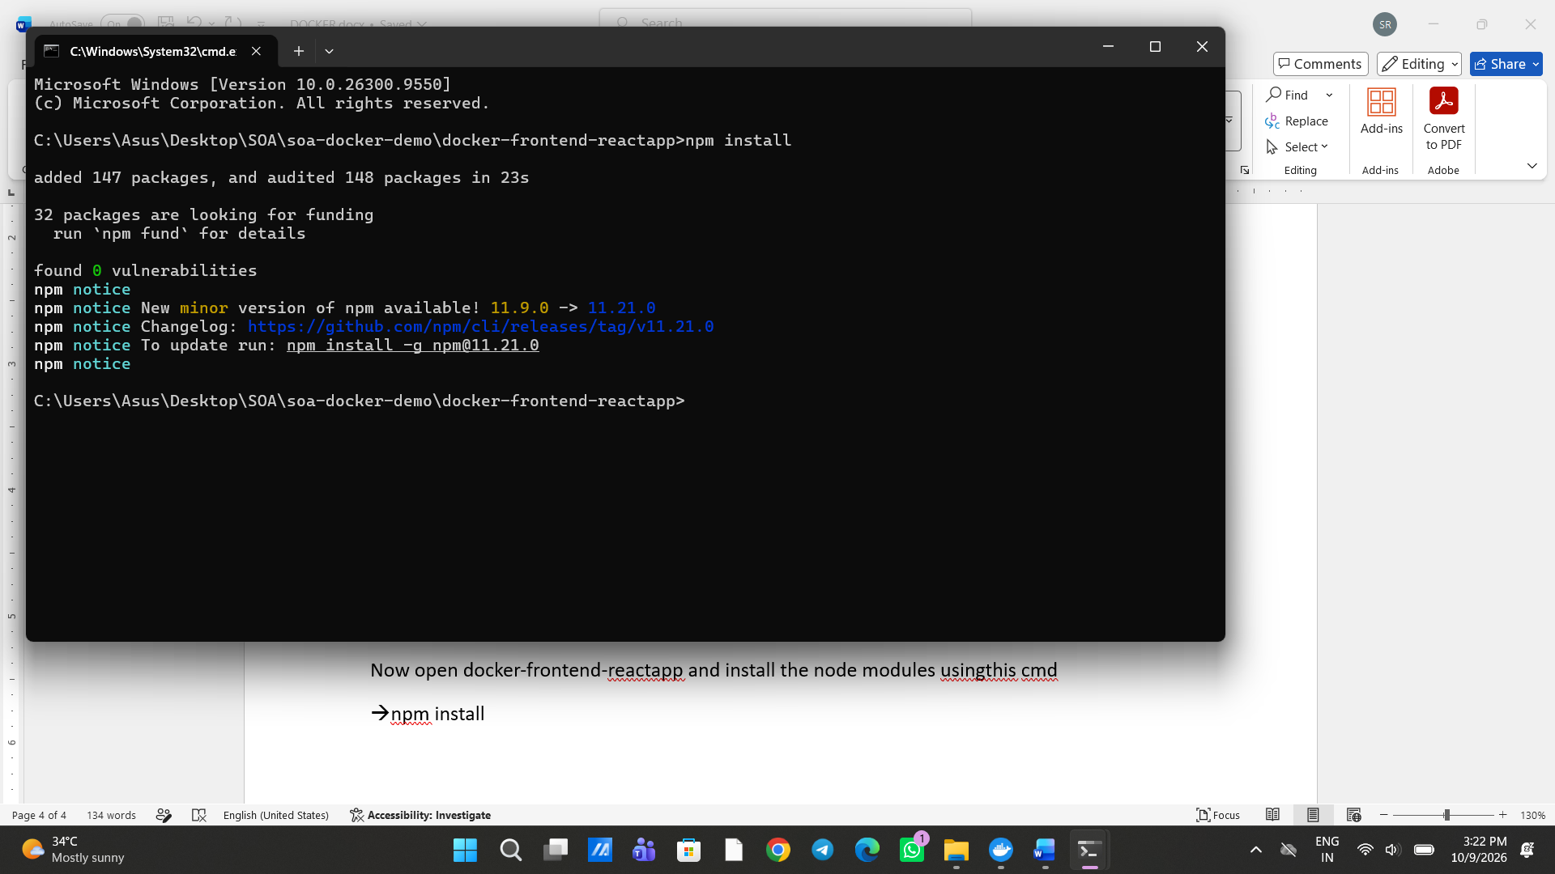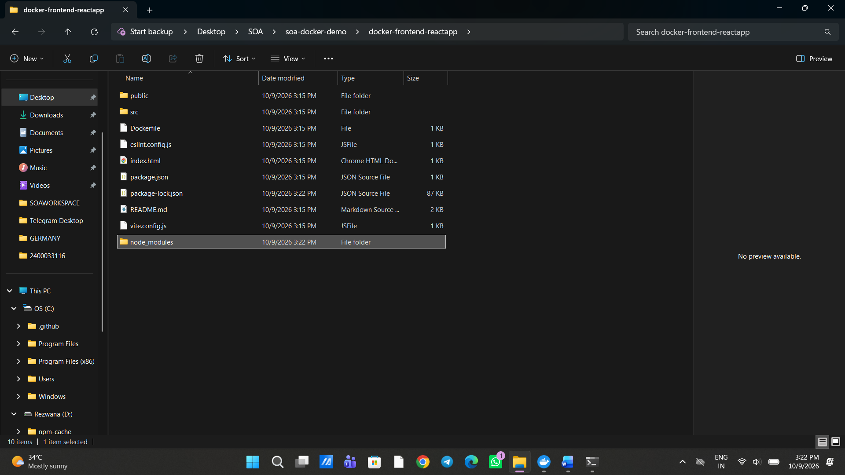installed successfully
- Now we are going to run this in local
- The command is npm run dev
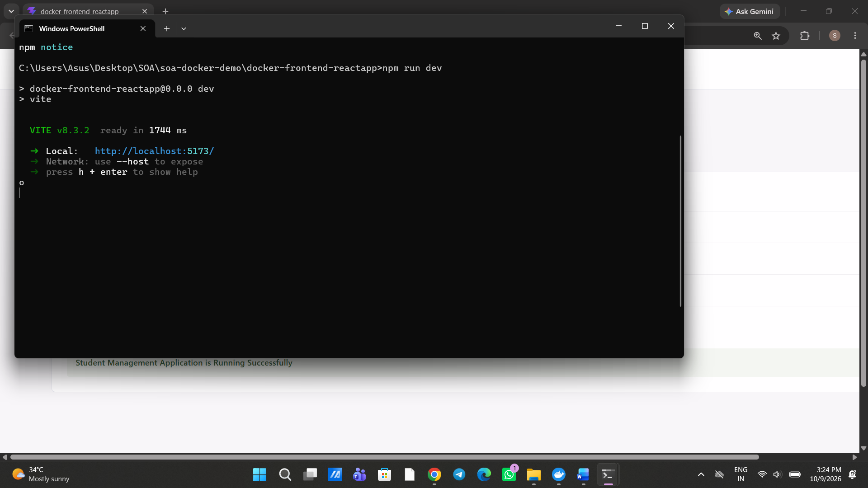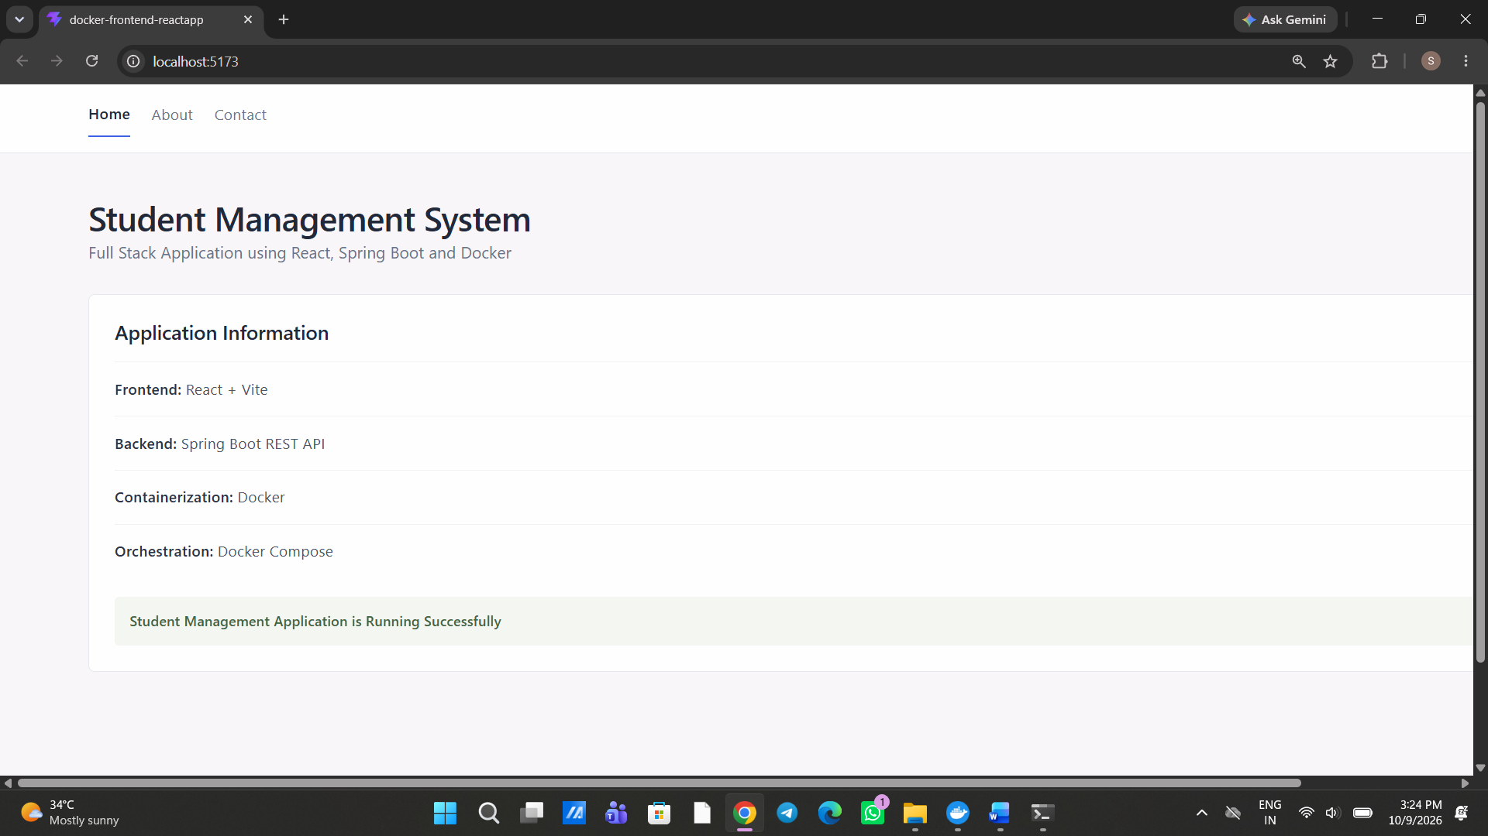this is the frontend output
The command docker ps -a is used to see all status of all images in docker hub
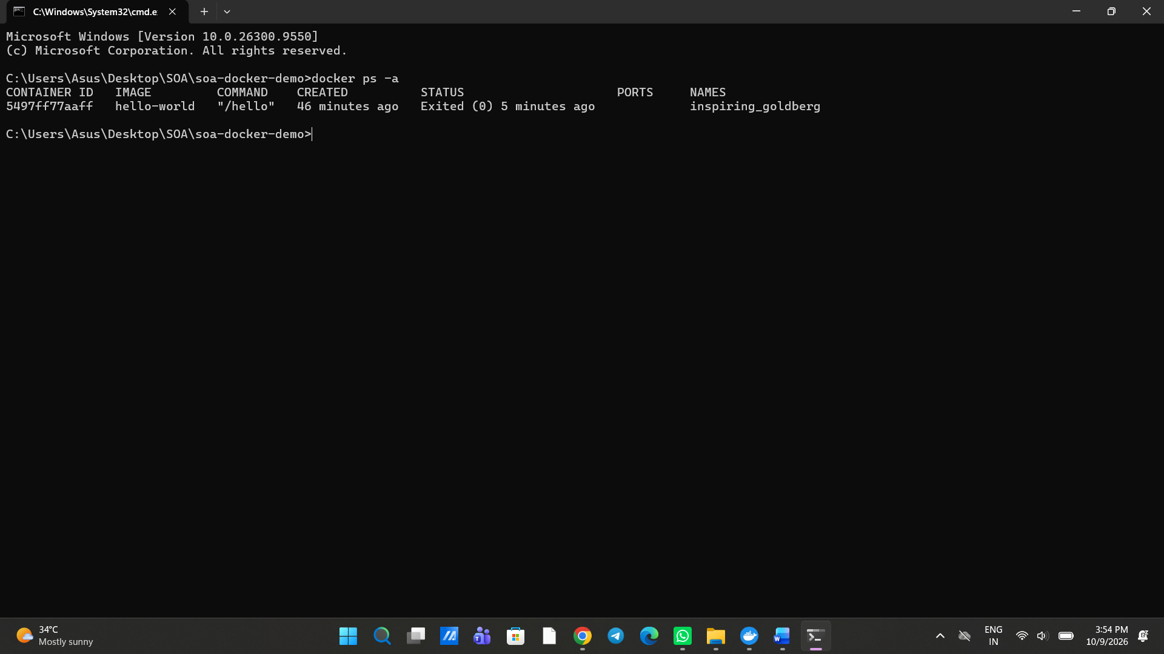The command docker ps is used to see the present running images
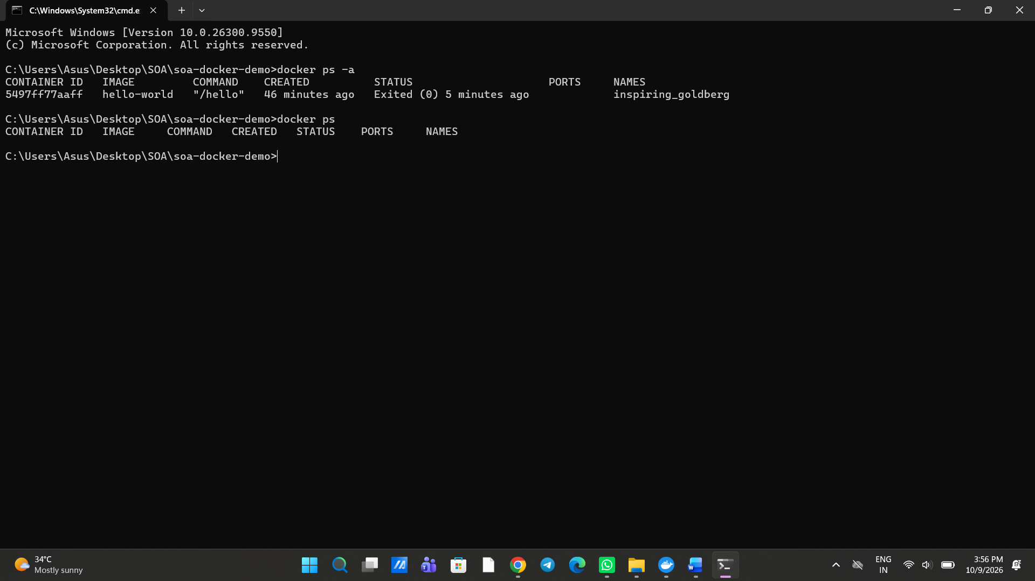

Now open the soa-docker-demo in VS code and then Open terminal
- cd .\docker-frontend-reactapp — Purpose: Navigate into your React frontend project folder.
- docker build -t soa-frontend . — Purpose: Build a Docker image named soa-frontend using the Dockerfile and files in the current directory.
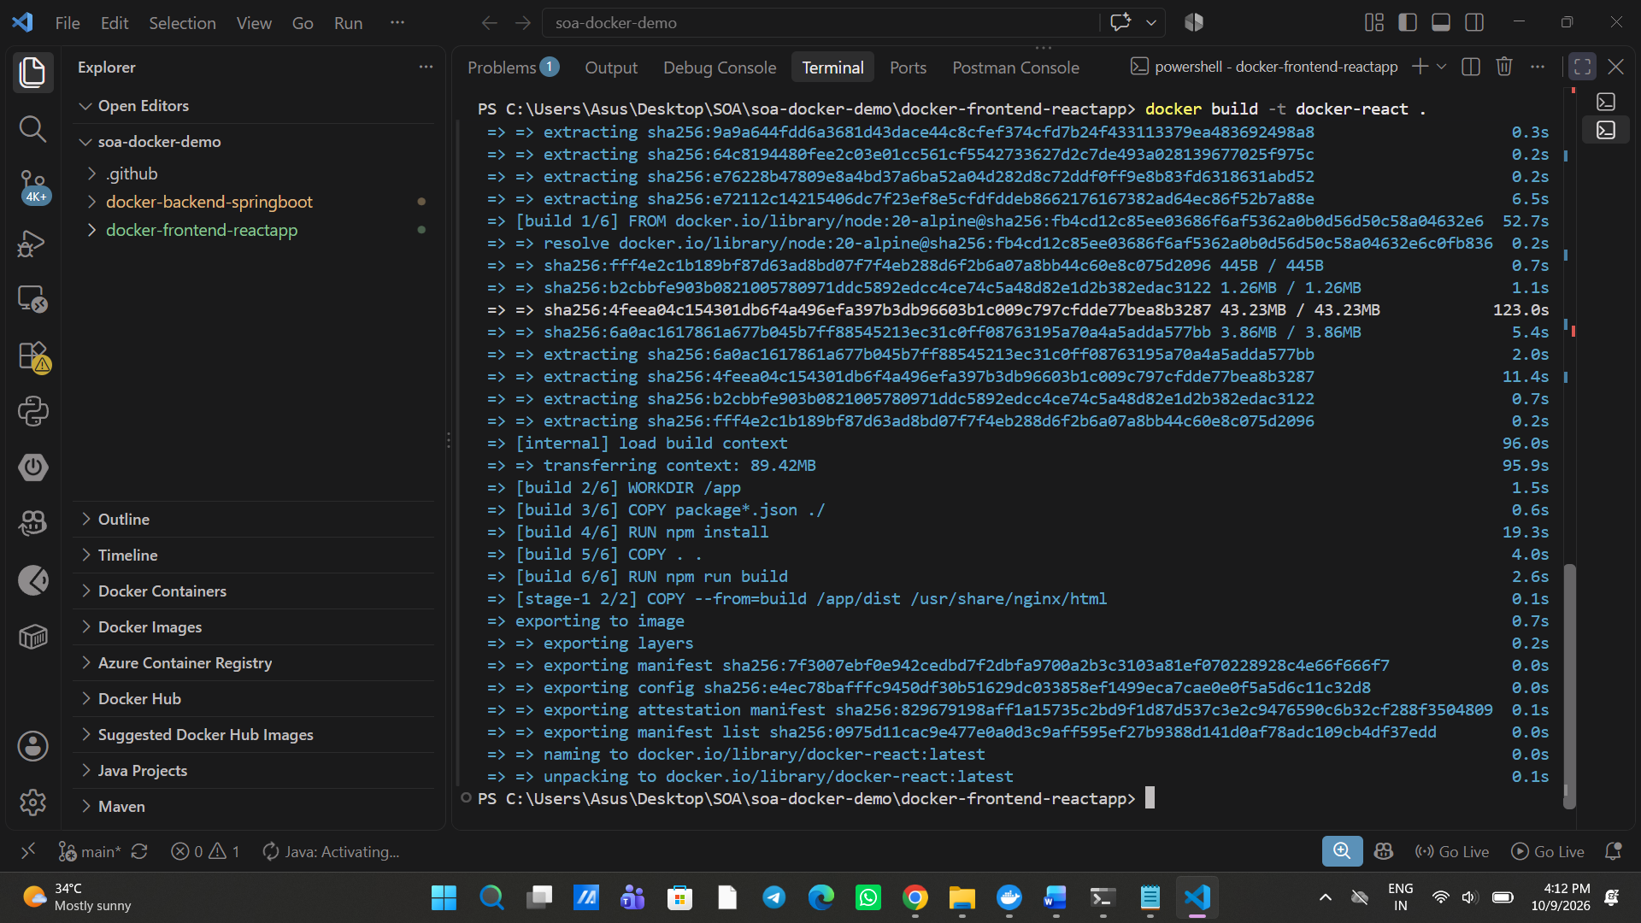Now open docker and go to images
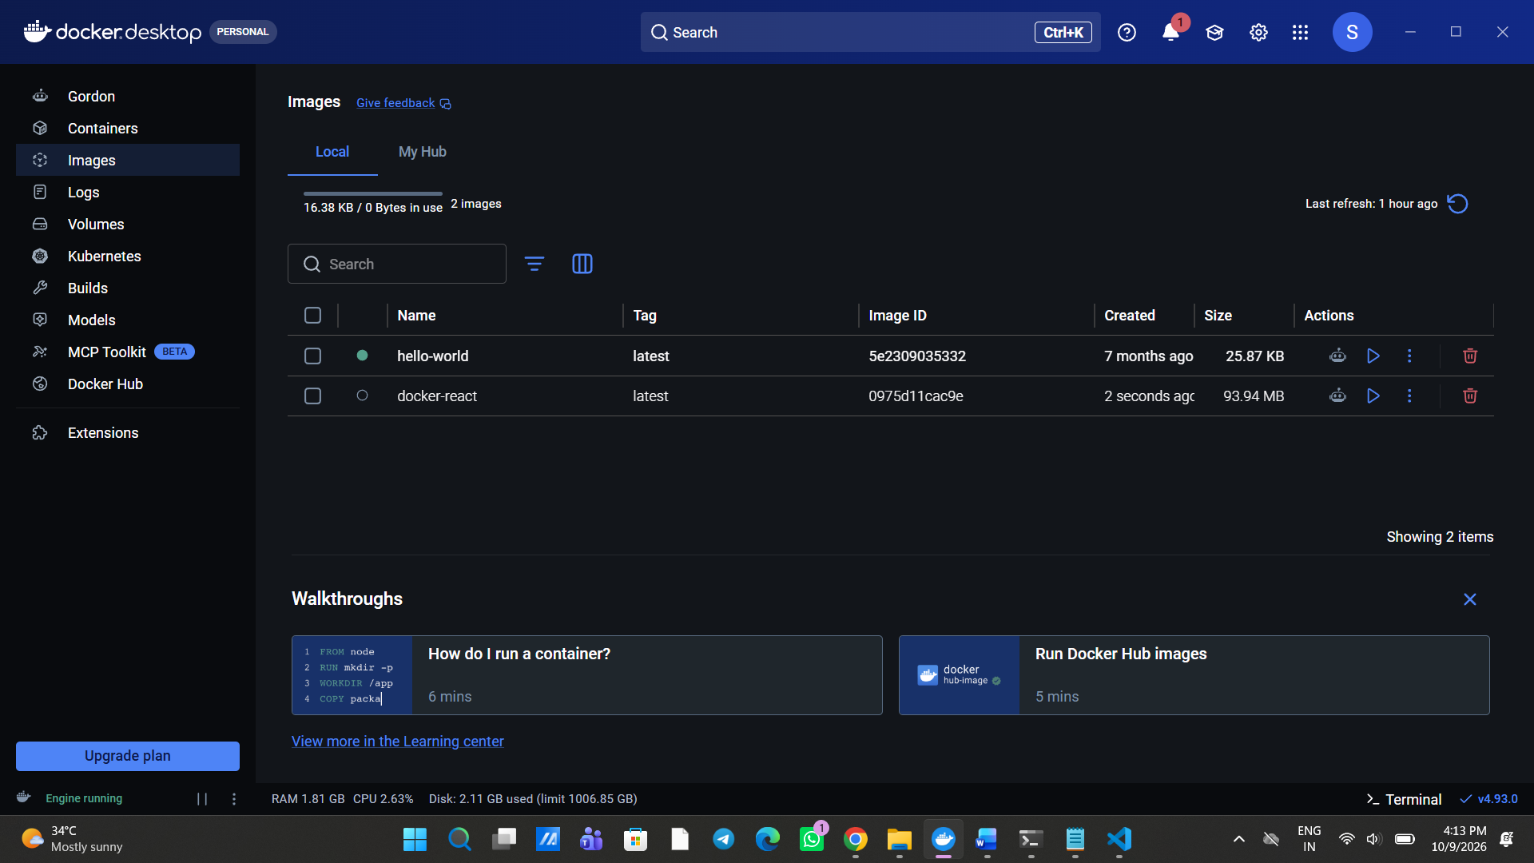
running an images is called as an container
docker run -d -p 3000:80 docker-react
Purpose: Run the docker-react image in the background and map port 3000 on your computer to port 80 in the container.
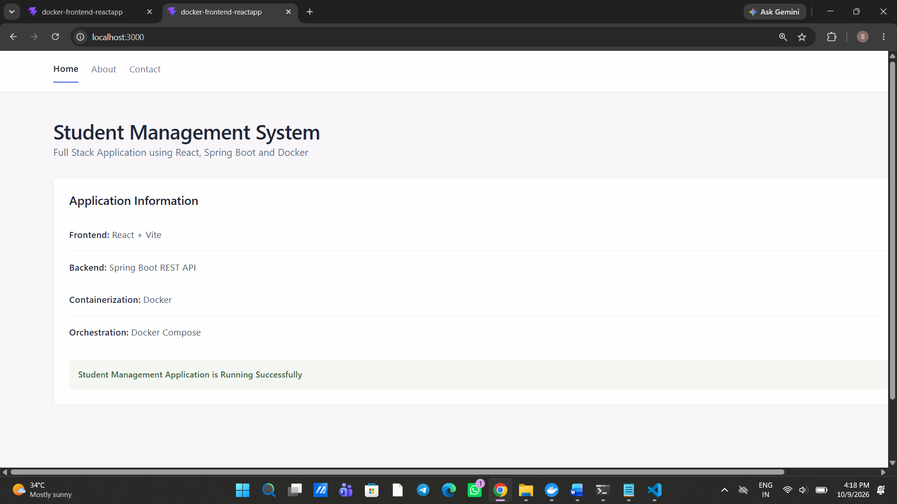Now we are running the frontend using a different port (3000)
1) docker ps — Displays currently running containers.
2) docker ps -a — Displays all containers, including stopped ones.
3) docker stop CONTAINER_ID — Stops a running container.
4) docker ps — Checks which containers are still running.
5) docker start CONTAINER_ID — Starts a stopped container again.
6) docker ps — Verifies that the container is running.
7) docker rm CONTAINER_ID — Removes a stopped container.
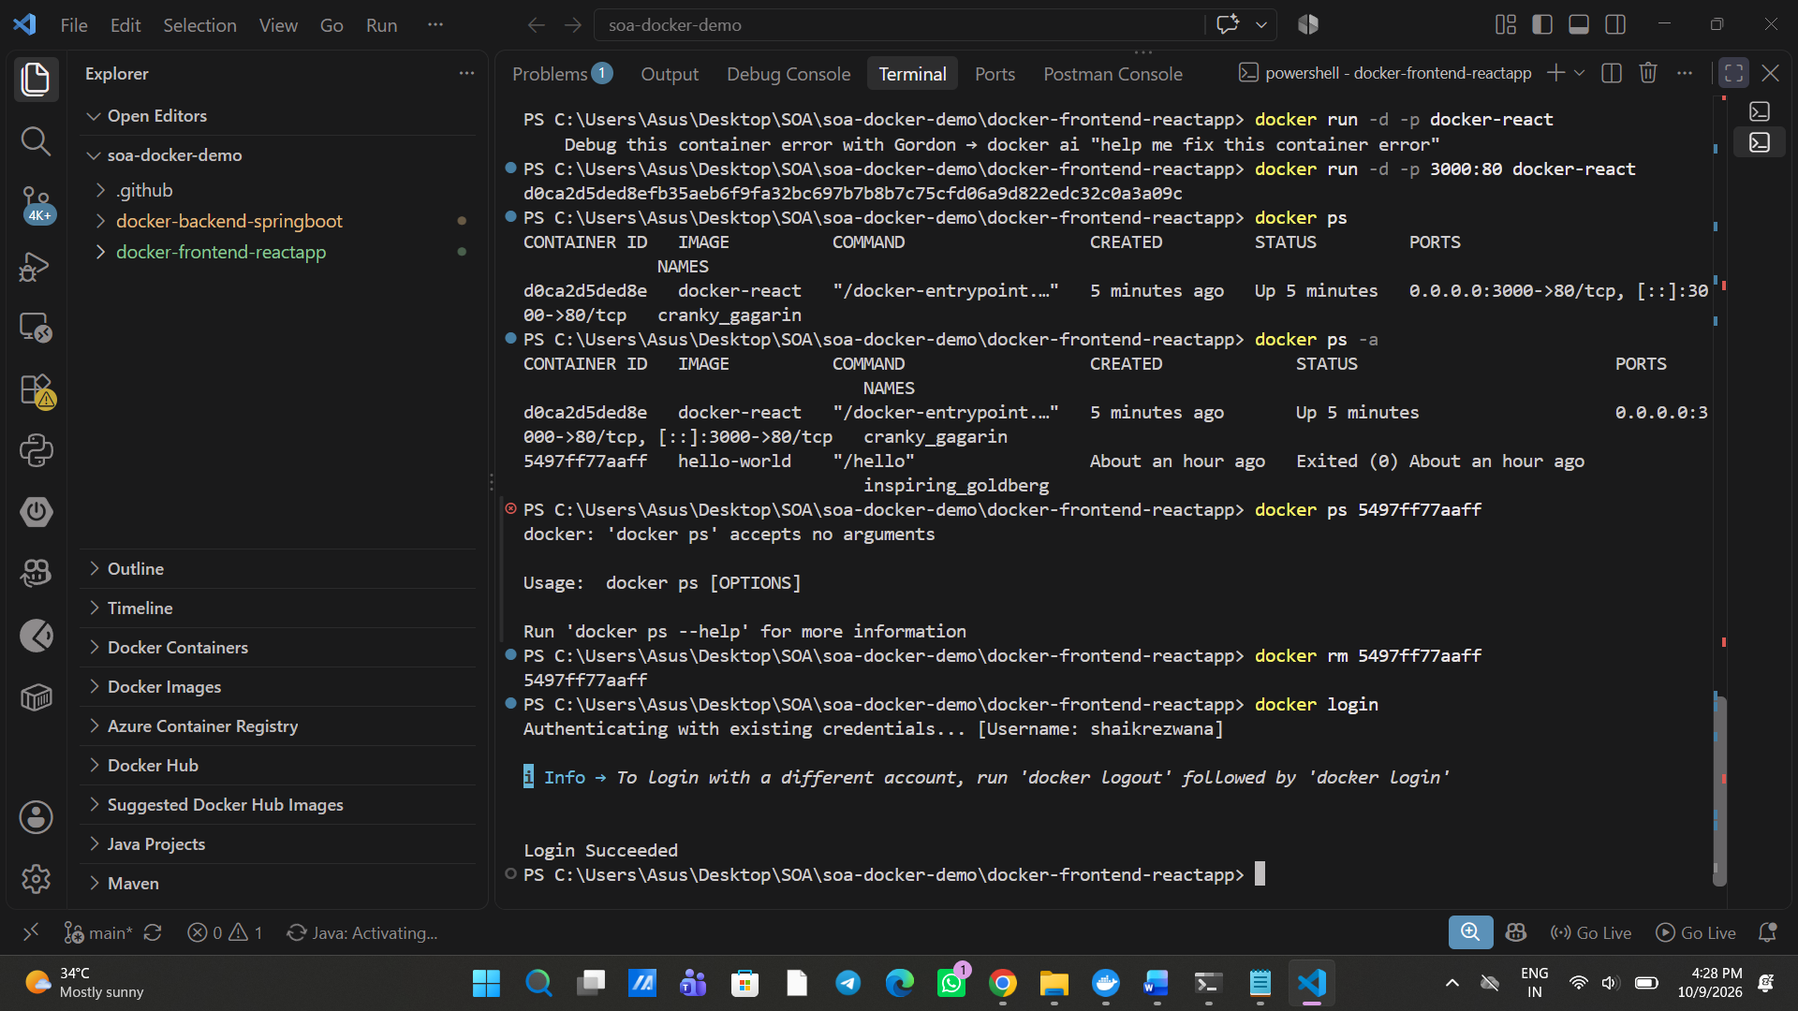Now we are logging into Git to make sure that the same username is used
1. Tag the image
docker tag docker-react shaikrezwana/docker-frontend:latest
Purpose: Assign a Docker Hub repository name and tag to your existing image.
2. Push the image
docker push shaikrezwana/docker-frontend:latest
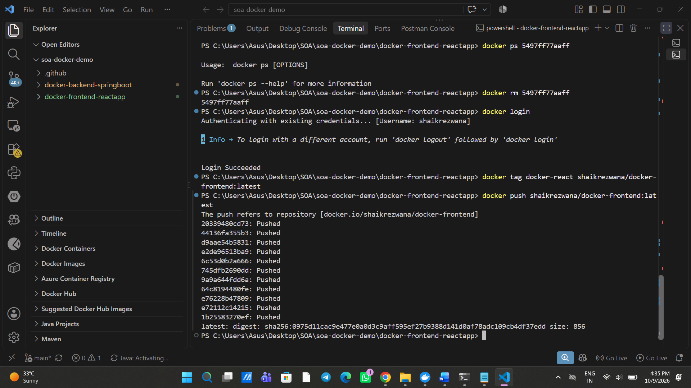Successfully done. Now we can check the pushed image in MyHub
port range--- 1 to 65535
Till here, frontend is completed so now lets do in backend
1)cd .\docker-backend-springboot\-we will go into this folder
2)docker build -t docker-springboot .
Purpose: Build a Docker image named docker-springboot using the Dockerfile in the current directory.
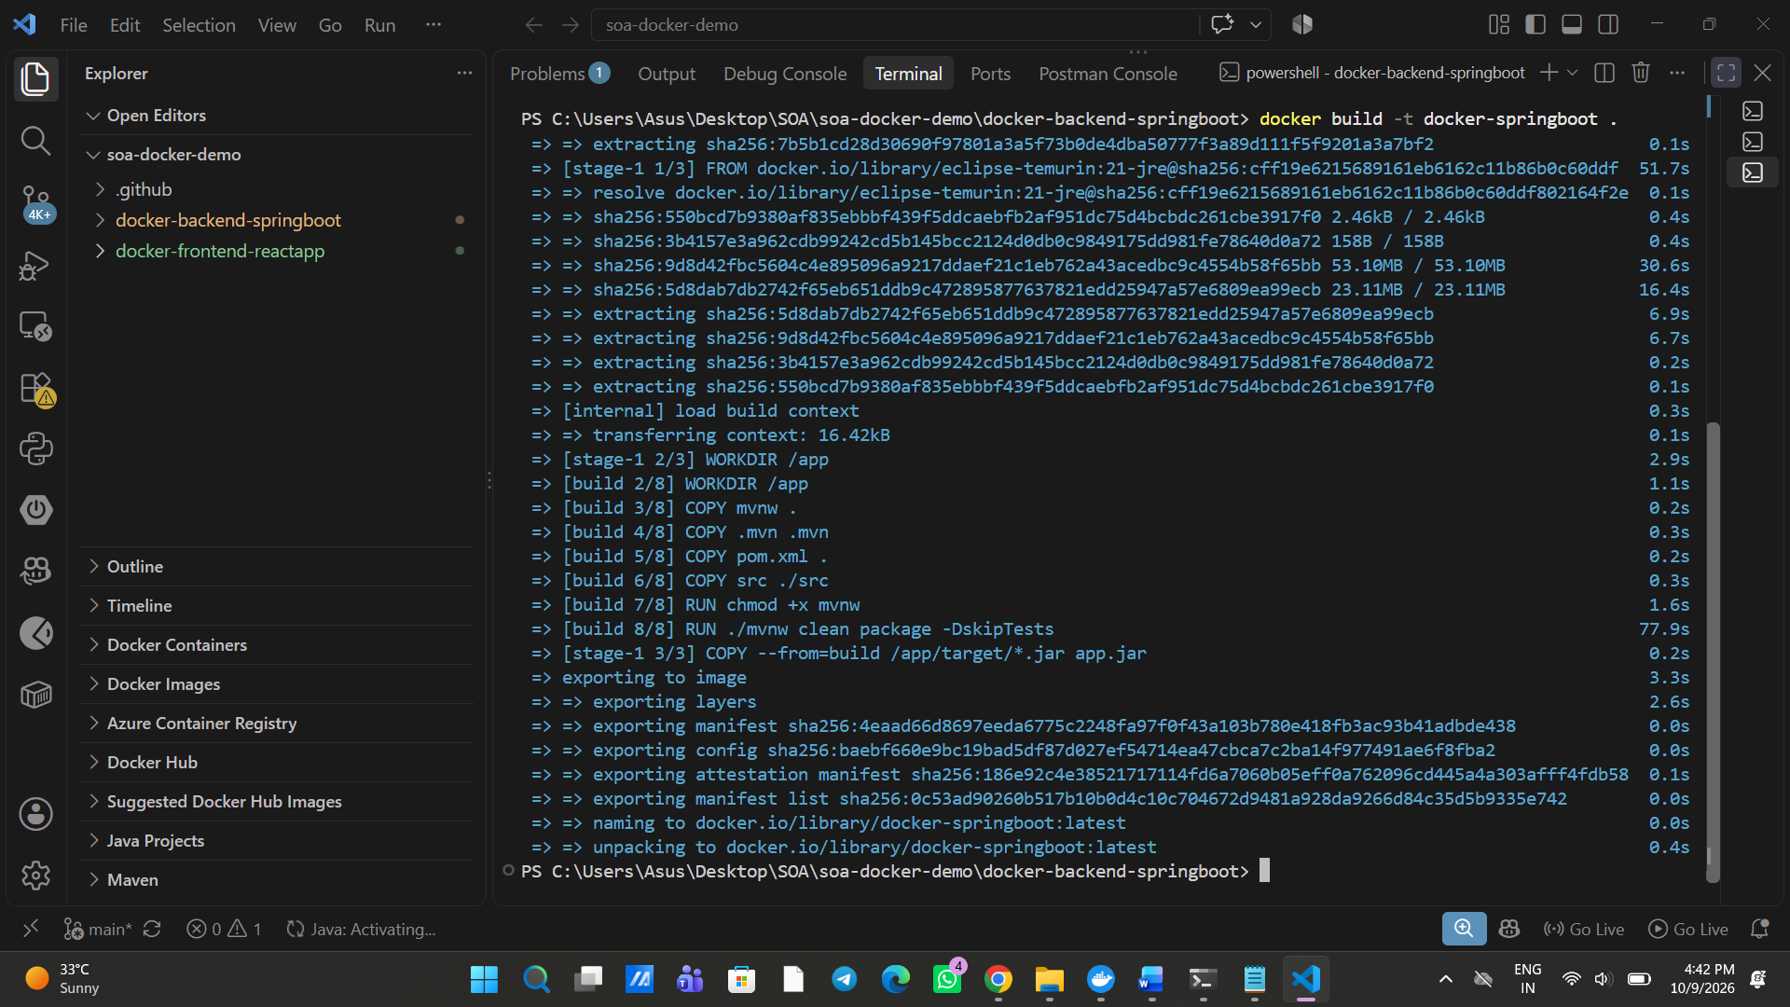3)docker run -p 9999:80 --name frontend docker-react
Purpose: Create and run a container named frontend, mapping your computer's port 9999 to port 80 inside the container.
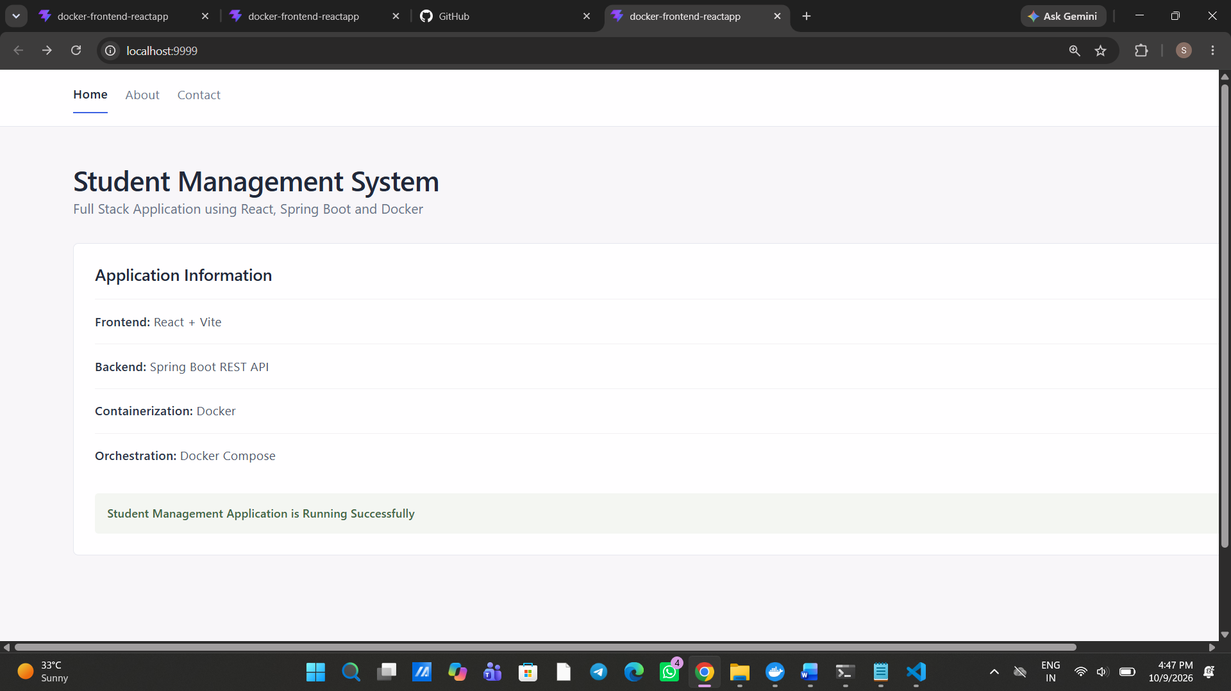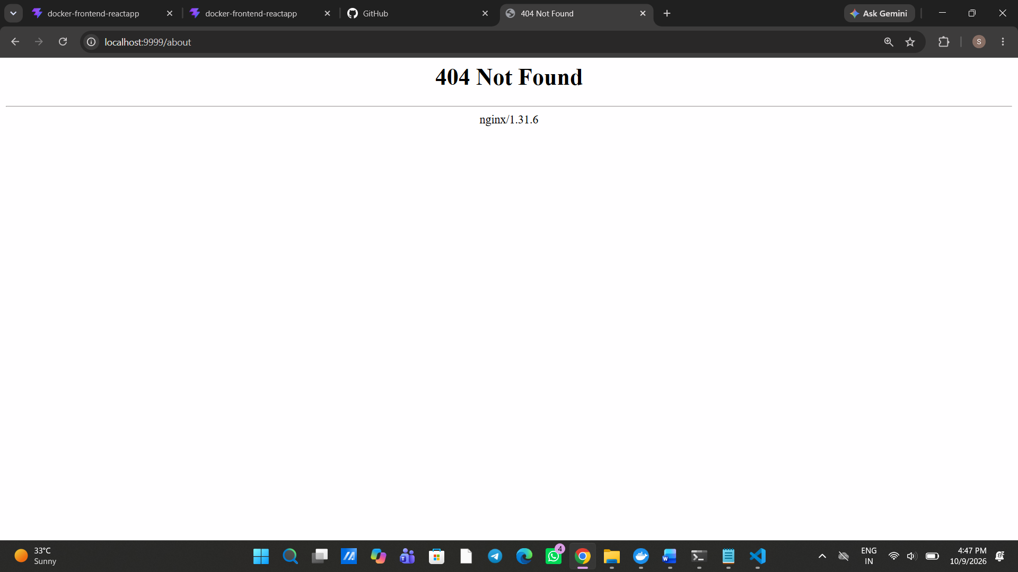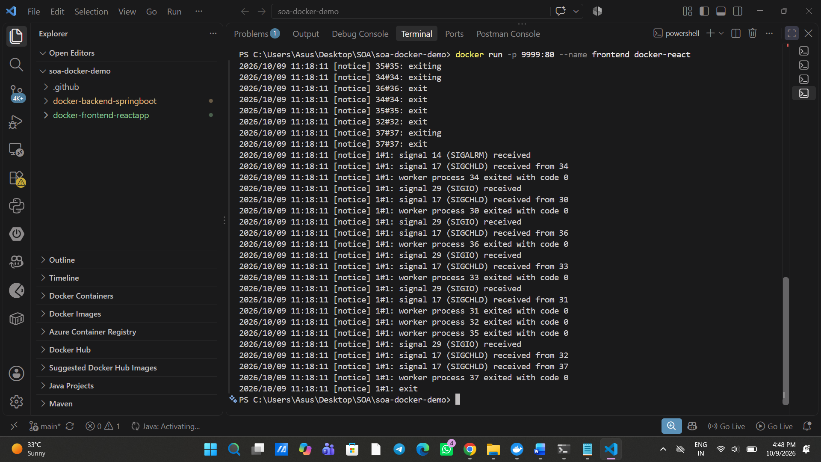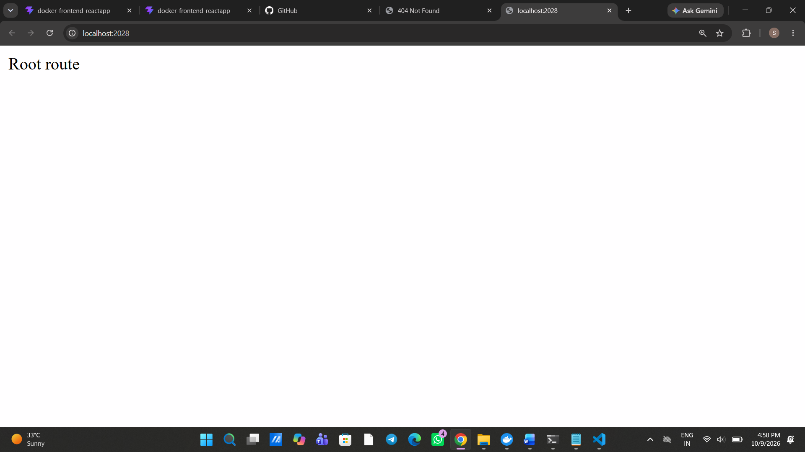docker run -d -p 2028:2028 docker-springboot
Purpose: Run the docker-springboot image in the background and map port 2028 on your computer to port 2028 inside the container.
Assuming your application runs on localhost:2028:
Purpose | Correct URL
Home page | http://localhost:2028/
Home endpoint | http://localhost:2028/home
Display by name | http://localhost:2028/display/name/klu
Display by ID | http://localhost:2028/display/id/100
Display using a query parameter | http://localhost:2028/display?name=klu
These are the outputs
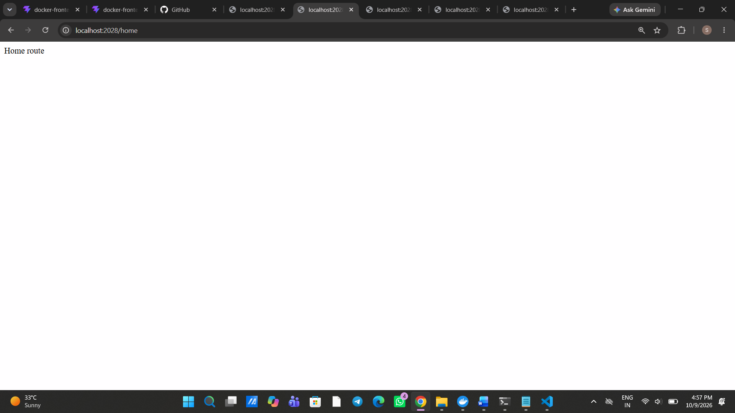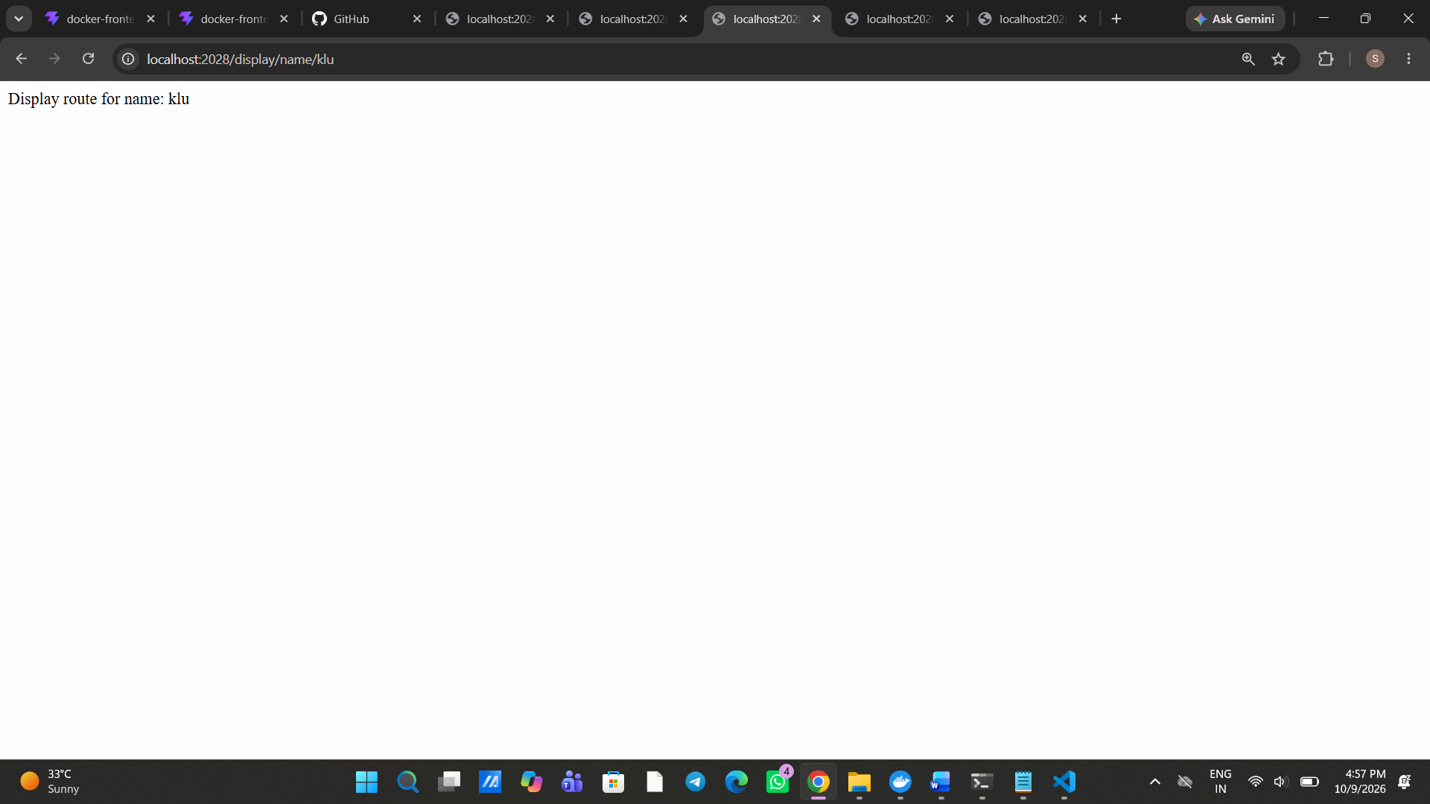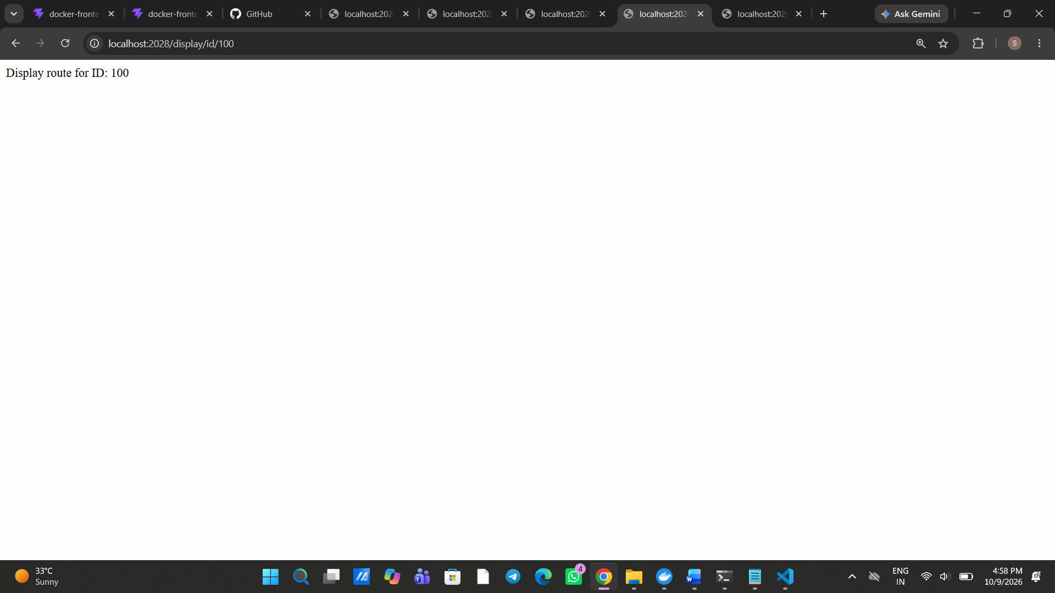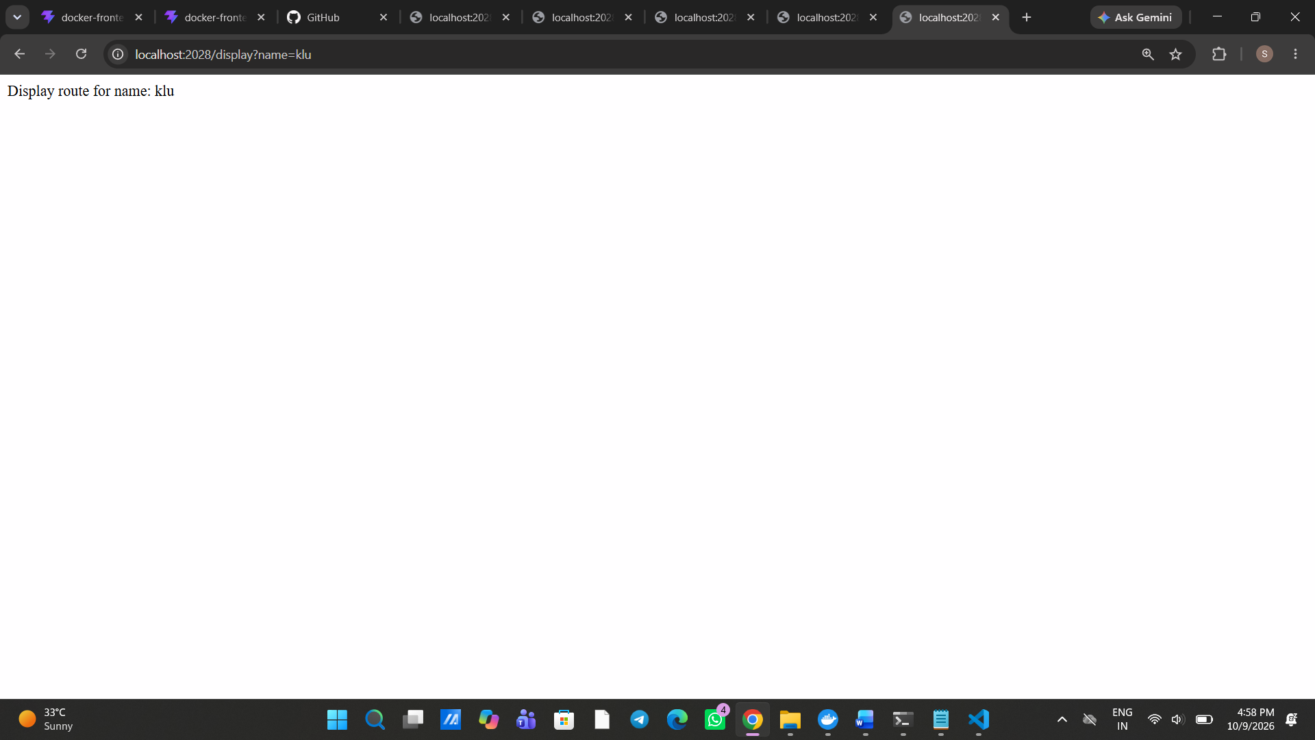So these are the outputs of the following urls
The purpose of docker run -p 2000:2028 docker-springboot is to run the Spring Boot application in a Docker container and access it through port 2000 on your computer, which forwards requests to port 2028 inside the container.
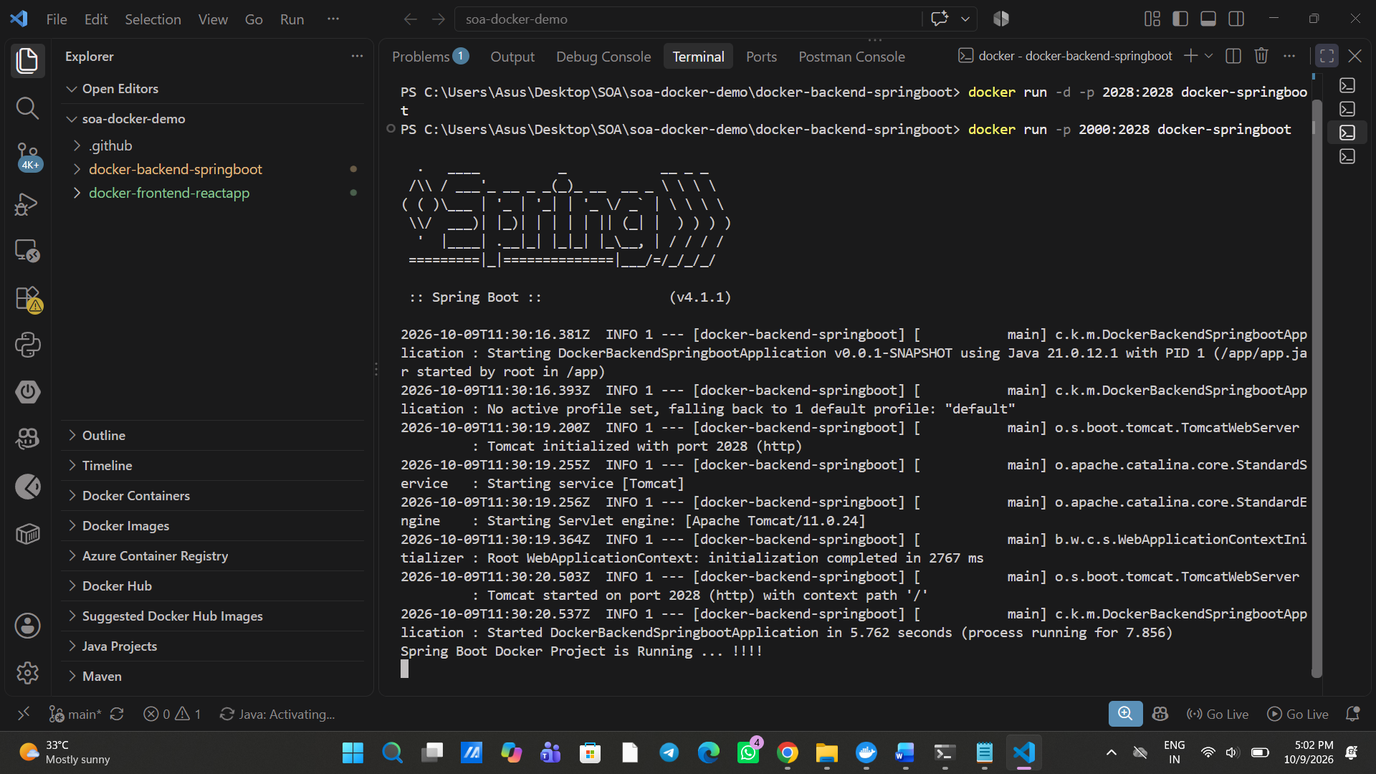 1) docker ps -a — Displays all Docker containers, including running and stopped containers.
2)docker start <container_id> — Starts a stopped Docker container using its container ID.
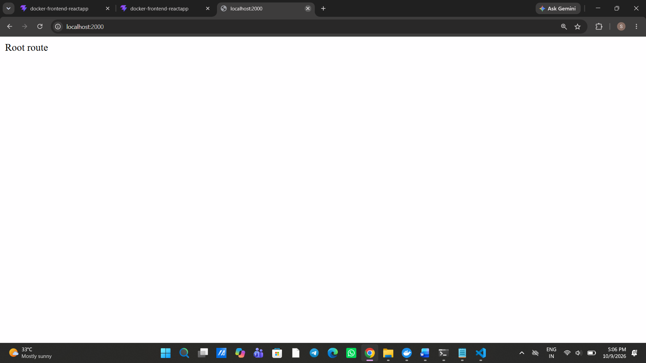Purpose: Tags your local Spring Boot Docker image with your Docker Hub username so you can push it to Docker Hub.
docker tag docker-springboot your-dockerhub-username/docker-backend:latest
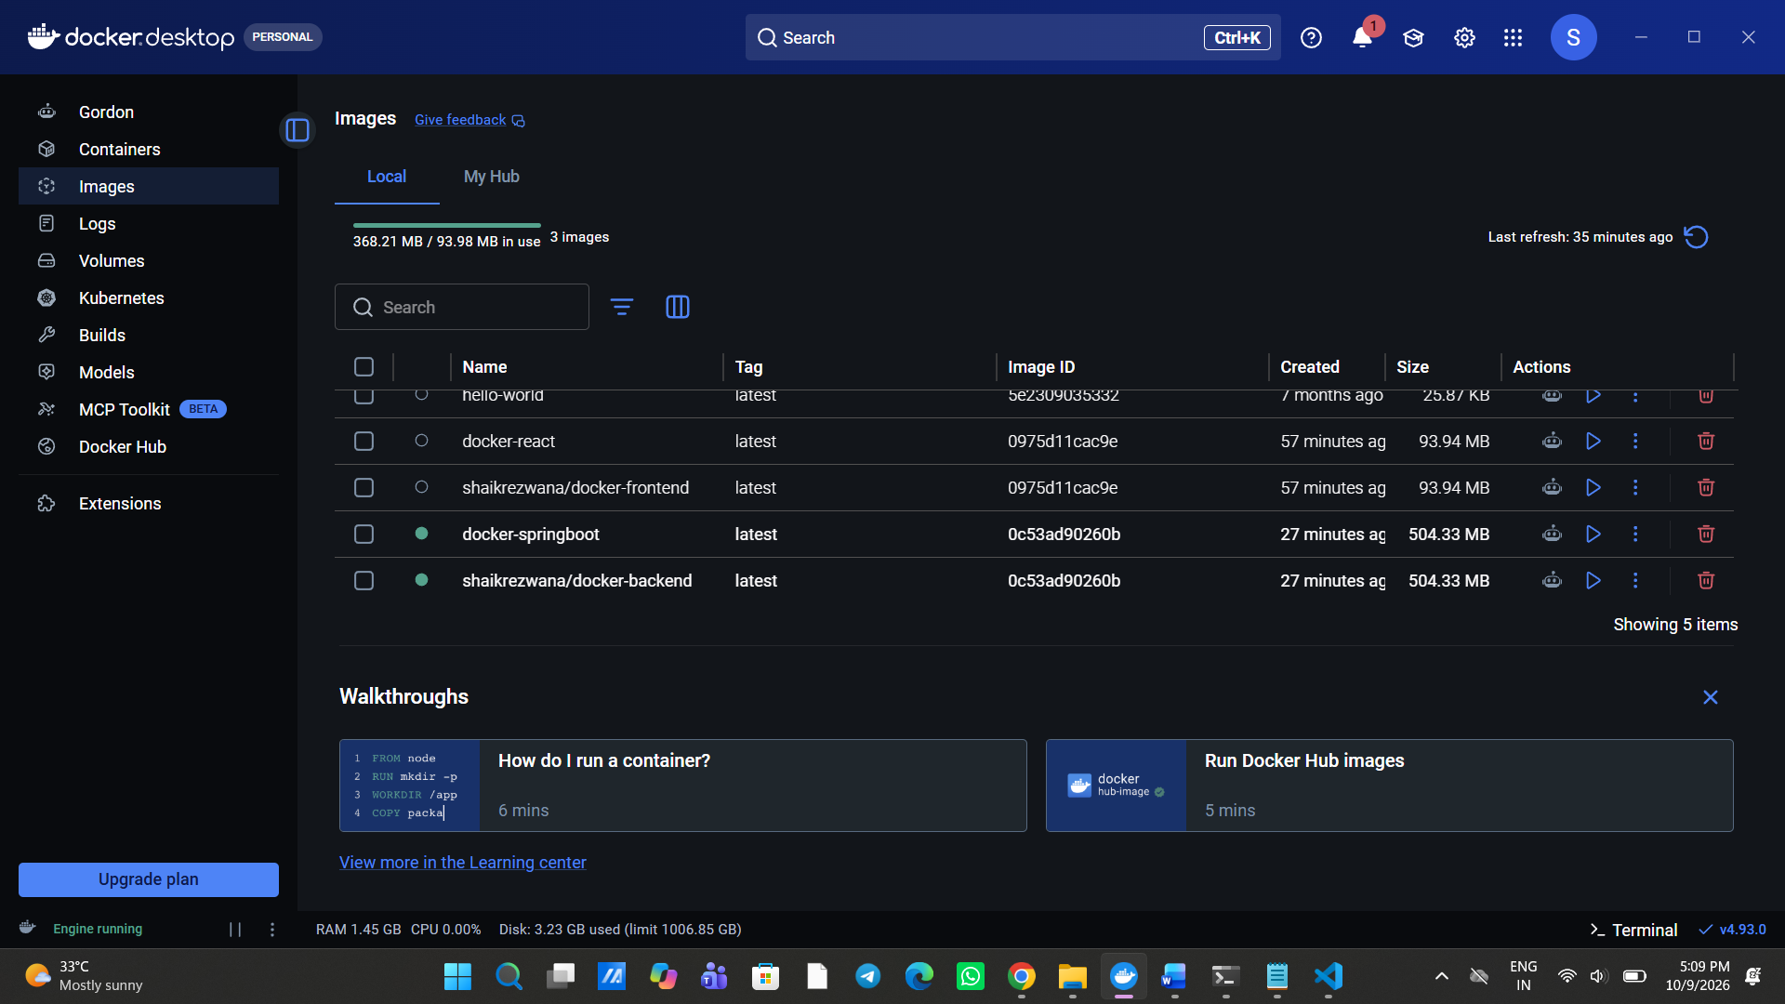total 5 images are displayed
Now lets push these into the docker hub
Before pushing, we need to check the authentication
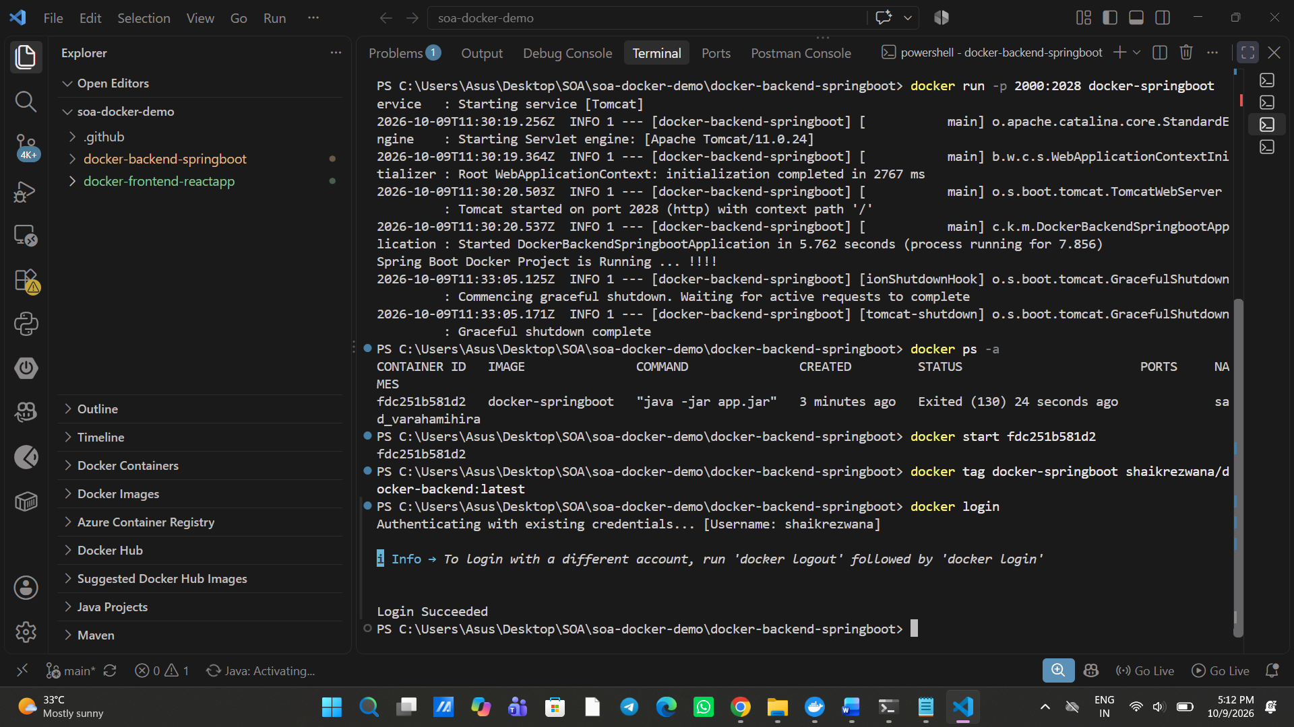here my login is successful now we can push
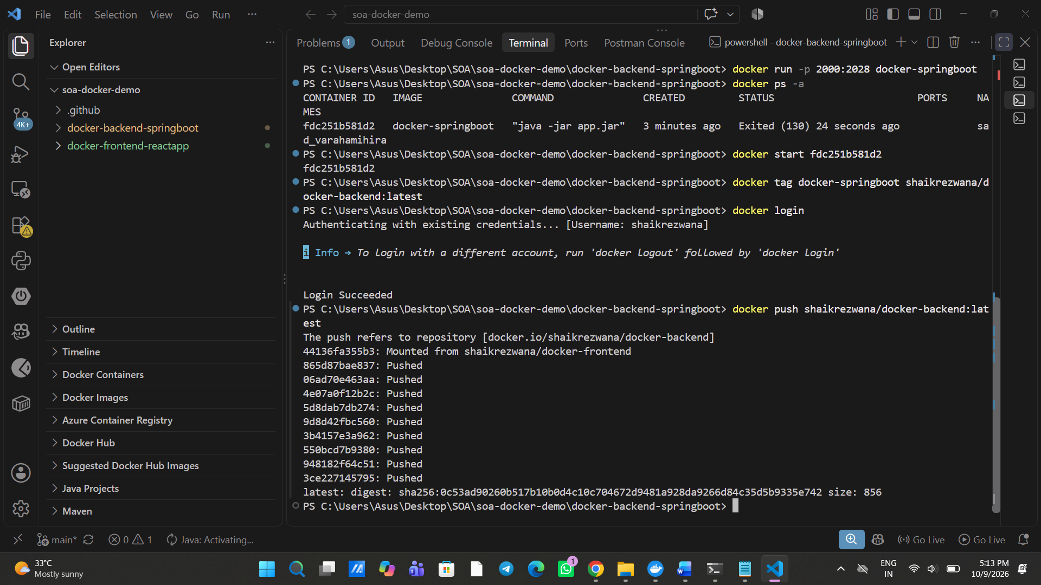Successfully pushed into my hub


