The user interface was designed using Figma. The following images are key screens from the clickable prototype, illustrating the application's user flow and core functionalities.

**Figma Prototype Link:** <https://www.figma.com/design/40ppaVqeaA0ij7iD21jJwX/BloodLink?m=auto&t=YtjEWWr25mnmI1Cn-1>

**Home Page**

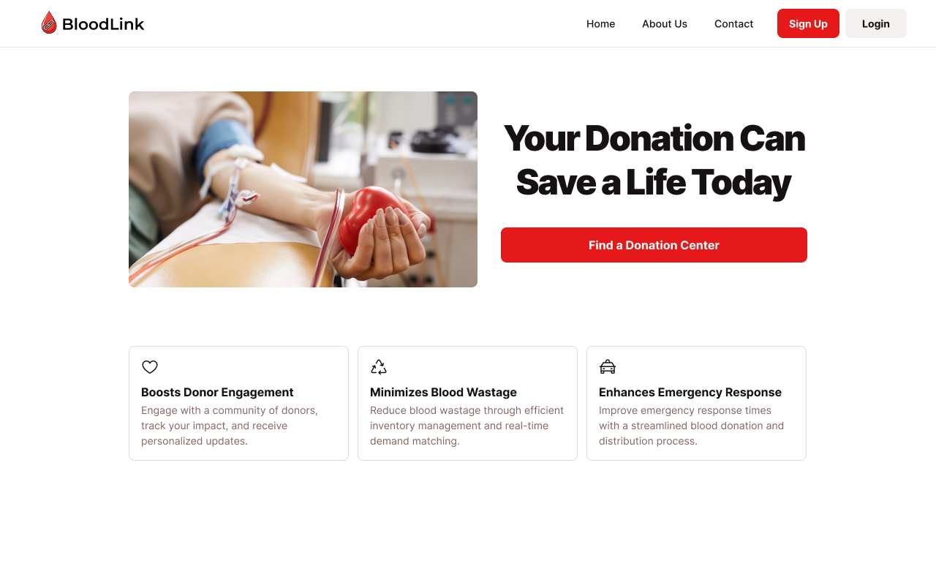

**Signup Page**

**Login Page**

**Donor Dashboard**

**Donor - Find & Book Appointment**

**Donor - Donation History & Impact**

**Hospital Staff Dashboard**

**Hospital Staff - Track Delivery Status**

**Blood Bank Staff Dashboard**

**Blood Bank Staff - Organize Blood Drives**

**Blood Bank Staff Page**

**Admin Dashboard**

