**5. GIT WORKFLOW**

For the "BloodLink" project, our team used a structured Git workflow on GitHub to manage development and collaboration.

**5.1 Central Repository and Branching Strategy**

A central repository was created on GitHub (https://github.com/Rezwoan/BloodLink) to host the project. The main branch was used as the primary branch for the stable version of our application. Each team member was assigned a personal developer branch (e.g., ayexha-dev, nusrat-dev, etc.) to work on their tasks independently.

**5.2 Development and Collaboration Process**

Our workflow consisted of the following steps:

1. Each member cloned the repository and worked within their assigned developer branch.
2. Changes were committed regularly with messages describing the work done.
3. The developer branches were pushed to the remote repository on GitHub.
4. Pull requests were used to merge the developer branches into the main branch. This allowed the project lead to review the code before integrating it into the main codebase.

**5.3 Evidence of Collaboration**

The commit history on our GitHub repository provides clear evidence of collaboration, with multiple commits, branches, and merges from all group members. A screenshot of the commit history will be added to this section.

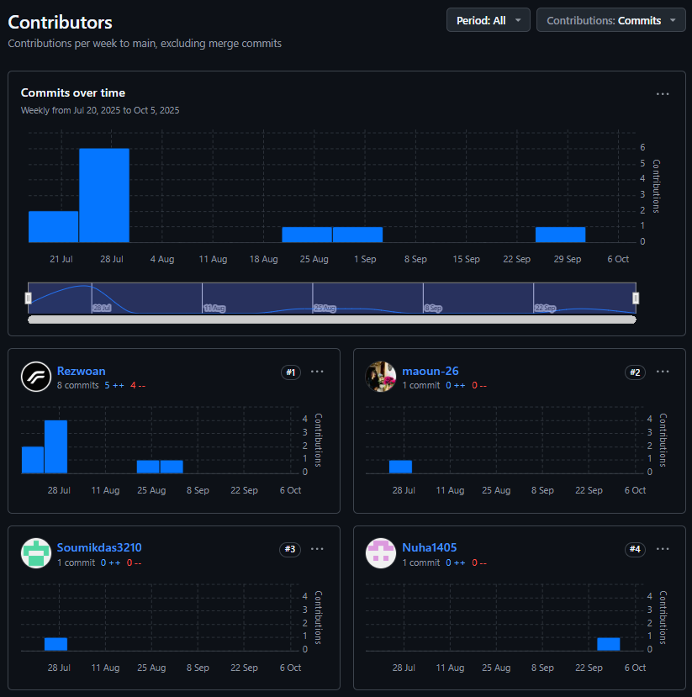

**5.4 Repository Organization**

To maintain a clear project history, all developer branches were kept after being merged. This tracks the project's workflow from initialization to completion.

The project repository can be found at the following link: <https://github.com/Rezwoan/BloodLink>