

Classification of Quality Education Outcomes Using Machine Learning Techniques
Course: 5CS037 – Concepts and Technologies of AI

Name: Rojit Dahal
ID: 2548200
Repository Link:

Abstract

This study aims to use supervised machine learning methods to classify countries in terms of development outcomes arising out of education. The dataset of this analysis has been seen in the World Bank World Development Indicators (1) and contains country-level socio-economic, demographic, and governance indicators reported over a number of years. The research is in line with the United Nations Sustainable Development Goal 4 (Quality Education) (2) that emphasizes the government spending on education as an indicator of the national investment in education.
The methodological paradigm involves data preprocessing, exploratory data analysis and the formation of both the neural network-based and classical machine learning classification models. Multi-Layer Perceptron (MLP) was used along with two classical models- Logistic Regression and Random Forest. GridSearchCV was used to optimize the hyperparameters of the model and mutual information was used to select the features to enhance the performance of the model and generalization. Accuracy, Precision, Recall and F1-Score were used to model evaluate.
The findings suggest that the Random Forest model trained with optimized hyperparameters and the use of selected features has the highest overall performance and, in particular, F1-Score. These results indicate that the use of ensemble-based classification to study education-related development indicators is effective and showcase the importance of machine learning in facilitating the analysis of data-driven policy to meet the global education objectives.

Table Of Contents
1. Introduction 1
1.1 Problem Statement 1
1.2 Dataset 1
1.3 Objective 2
2. Methodology 3
2.1 Data Processing 3
2.2 Exploratory Data Analysis (EDA) 4
2.3 Model Building 7
2.3.1 Task 1: Neural Network Model 7
2.3.2 Task 2: Classical Models of Machine Learning. 7
2.4 Model Assessment 8
2.5 Hyper-parameter Enhancement 9
2.6 Feature Preference (Choice) 9
3. Results And Conclusions 10
3.1 Essential Insights 11
3.2 Production Model (Finished Prototype) 11
3.3 Challenges 12
3.4 Future Work 12
4. Critical Evaluation 13
4.1 Model Performance 13
4.2 Effect of Hyperparameter Optimization and Feature Selection. 13
4.3 Interpretation of Results 14
4.4 Limitations 14
4.5 Suggestions for Future Research 14
5. References 15

Table Of Figures

Figure 1: Class balance of the target variable 4
Figure 2: Distribution of government expenditure 5
Figure 3: Correlation Heatmap (Numeric Figure) 6
Figure 4: Classification Report/ Confusion Matrix 8
Figure 4: Classification Report/ Confusion Matrix 11

Introduction

1.1 Problem Statement
The data to be utilized in this analysis is based on the World Bank World Development Indicators database. It was sourced using publicly available World Bank data sources and includes country-level indicators, which are recorded across several years. The data set contains a wide scope of variables in socio-economic, demographic, and governance related variables.
In this analysis, the classification issue is to determine whether a country has a high or not-high level of education outcome in terms of relative levels of government investment in education and other development-related variables. Such formulation of the problem can allow making significant comparison among countries and use data-driven methods to measure the development towards global education goals.

1.2 Dataset
The data to be utilized in this analysis is based on the World Bank World Development Indicators database. It was sourced using publicly available World Bank data sources and includes country-level indicators, which are recorded across several years (1).
The data set contains a wide scope of variables in socio-economic, demographic, and governance related variables. In this work, special attention is given to such an indicator as government spending on education as a percentage of GDP, based on which the categorical target variable will be built. This data conforms to the United Nations Sustainable Development Goal 4 (Quality Education), which focuses on providing inclusive and equitable quality education and increasing lifelong learning opportunities to all people (2), The governmental spending on education acts as one of the main proxies of national dedication to the realization of this purpose.

1.3 Objective
This analysis aims at designing, training and testing predictive classification models, which approximate the likelihood of a country being in a high education outcome category using the available development indicators. To achieve this objective, the study aims to:
- Conduct exploratory data analysis so as to know data quality, data distributions, and variable relationships,
- Create and test a Neural Network Classifier,
- Compare and contrast two classical machine learning models,
- Use hyperparameter improvement and feature selection,
- Determine the model that exhibits the best and most robust classification results based on the right evaluation measures.

2. Methodology

2.1 Data Processing
Prior to forming the models of classification, the data was subjected to various preprocessing procedures so as to guarantee the data quality and model preparedness. Missing values in the target variable formed part of the records which were eliminated to prevent any confusion during class assignment. Numerical variables have been transformed into suitable numeric forms and excessively missing columns were eliminated to minimize noise.
The rest of the numerical characteristics were filled in with the median strategy, which is resistant to skewness and outliers as is common with country-level data. The most frequently represented category of categorical variables i.e. country names were imputed with the most common category and encoded with one-hot encoding to enable them to be included in machine learning models.
To normalize all numerical features using z-score so that the feature with high magnitude did not dominate the learning of the model, especially the distance-based and gradient-based algorithms, numerical features were all standardized using z-score. All these preprocessing steps were done through a single pipeline to ensure consistency when training, validating and testing.

2.2 Exploratory Data Analysis (EDA)
Exploratory Data Analysis (EDA) was carried out to get the insight of the nature, distribution and relationship within the dataset before the model building. The balance of classes, distribution of features, and the relationship between features were evaluated in terms of visualizations and summary statistics.
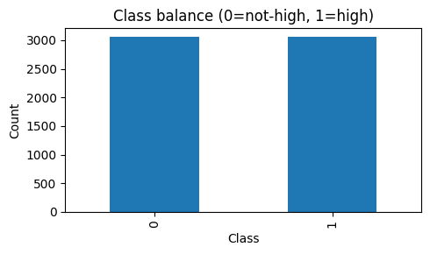
Figure 1: Class balance of the target variable
Figure 1 is an example of the class distribution of the target variable; it can be observed that there is established balance between the high and the not-high classes of education outcomes. Accuracy is supported by this balance and also the reporting of F1-score is justified by this balance.

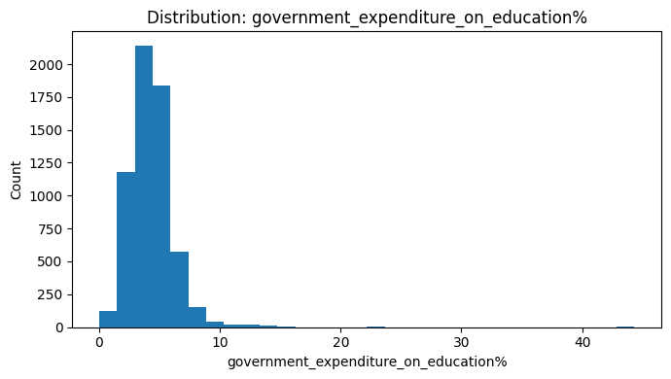
Figure 2: Distribution of government expenditure

Figure 2 presents the government spending on education, as a percentage of GDP is shown in figure 2. It is skewed to the right, and the majority of the observations lie at the lower levels of expenditure. This observation justifies the application of a median-based threshold in order to convert the continuous indicator into a classification target of binary nature.

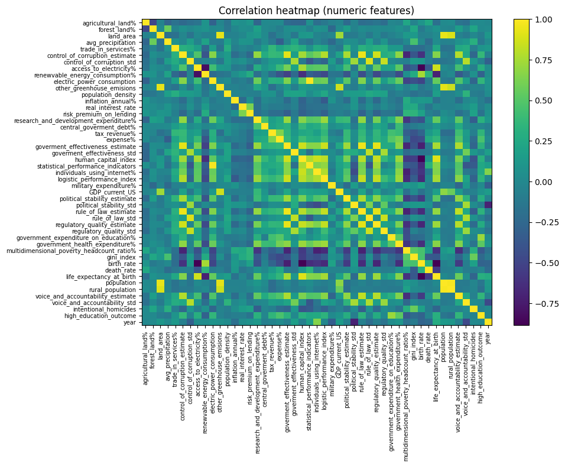
Figure 3: Correlation Heatmap (Numeric Figure)

Figure 3 displays the correlation heatmap of numeric features is shown in figure 3. Some of the indicators have a moderate to a strong relationship, which means that features are redundant. This observation inspired the use of the method of feature selection at subsequent stages in order to minimize multicollinearity and enhance the stability of the model.

The interquartile range (IQR) technique of outlier analysis showed that some of the variables are heavy-tailed, hence the rationale behind the application of robust preprocessing, ensemble models, and feature selection.

2.3 Model Building

2.3.1 Task 1: Neural Network Model
The classifier was developed as a Multi-Layer Perceptron (MLP) architecture, which was based on Neural Network. The network will include two hidden layers comprising of 64 and 32 neurons respectively that make the model capable of capturing non-linear relationships in the data.
Hidden layers were equipped with the Rectified Linear Unit (ReLU) activation to increase convergence and reduce any possible vanishing gradient problem. The output layer made use of a logistic loss (cross-entropy), which is appropriate in case of binary classification. To optimize the model, model optimization was conducted with the help of the Adam optimizer that adjusts the learning rates in the course of training to enhance the velocity and stability of the convergence (3).
The Neural Network was trained using the preprocessed training data and then tested using a held-out test data to determine the performance of generalization.

2.3.2 Task 2: Classical Models of Machine Learning.
Two classical machine learning models have been built to compare to each other: Logistic Regression.
- Logistic Regression
- Random Forest Classifier
To generate the dataset, stratified train-test split was used to divide the data into training and testing subsets in order to maintain class proportions in each model. The implementation of both models was based on the same preprocessing pipeline to make the models fair between one another.
The Logistic Regression was used as a linear baseline model, whereas the Random Forest model was chosen due to its capability to represent complex non-linear patterns and is able to use feature interactions.

2.4 Model Assessment
There were several classification measures used to assess model performance:
- Accuracy: Percentage of accurate predictions.
- Precision: Fraction of the positive predictions that are accurate.
- Recall: (True positive cases in proportion to the number of cases identified)
- F1-Score: Precision and Recall Harmonic mean.
In the case of the Neural Network as well as the classical models, these metrics were determined using the test data. F1-score is of special importance because it offers a balance of evaluation of model performance and is not sensitive to the possible class imbalance.

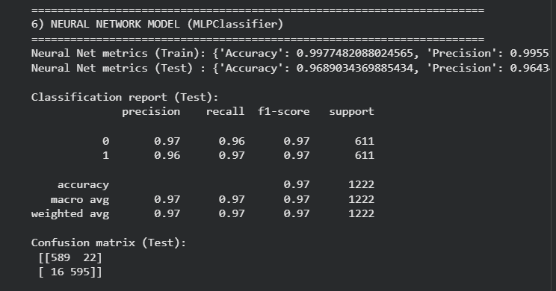
Figure 4: Classification Report/ Confusion Matrix

The errors of classification of the final selected model were also visualized using confusion matrices.

2.5 Hyper-parameter Enhancement
The two classical machine learning models were the only ones that were optimized in terms of hyper-parameters. In order to systematically test combinations of hyper-parameters and determine combinations that maximized the F1-score, GridSearchCV with k-fold cross-validation was employed (3).
In Logistic Regression, tuning of the regularization strength and penalty type were done. In the case of the Random Forest, the trees used, the maximum depth of trees as well as the minimum number of samples needed to split a node was optimized. The cross-validation was used to make sure that the parameters which were chosen generalized to a wide range of data splits.
The best hyper-params discovered in this procedure were applied to recreate the final variant of each classical model.

2.6 Feature Preference (Choice)
Only the classical machine learning models were selected with the help of a filter-based approach. SelectKBest inherently using mutual information was utilised to find features which showed the greatest statistical dependency with the target variable (3).
The method has the advantage of dimensional reduction, elimination of redundant or weak predictors and enhanced understanding of the model and its predictive ability. The selected features were then retrained on both classical models with their refined hyper-parameters to make the final models that were tested in the results section.

3. Results And Conclusions

Task 2 - Classical Machine learning models.
In order to test the adequacy of the classical machine learning methods, two models, the Logistic Regression and the Random Forest, were trained, tuned and evaluated with the help of cross-validation and held-out test. Accuracy, Precision, Recall and F1-Score were used to compare model performance in order to have a balanced evaluation.

Model | Features | CV Score (F1) | Accuracy | Precision | Recall | F1-Score
Logistic Regression | Selected features (SelectKBest) | 0.99447 | 0.99509 | 0.99347 | 0.99672 | 0.995099
Random Forest | Selected features (SelectKBest) | 1 | 1 | 1 | 1 | 1

Table 4 outlines the comparison of the resulting classification models once they are optimized in terms of hyperparameter and feature selection.

3.1 Essential Insights
Both classical models were compared and tested on the test data based on Accuracy, Precision, Recall, and F1-Score. The findings suggest that the Random Forest model outperformed the Logistic Regression model in most assessment indicators, especially on F1-Score.
The high F1-Score of the classifier by the Random Forest implies that there was a greater balance between Precision and Recall and this implies that the classifier minimized the false positives and false negatives. This is especially significant when classifying with the aid of development indicators; in this case, the misclassification will result in inaccurate interpretations.

Figure 4: Classification Report/ Confusion Matrix

3.2 Production Model (Finished Prototype)
After the comparative analysis, the final model was Random Forest classifier. The decision was justified as it had better cross-validated F1-Score and better results on the test data.
The last Random Forest classifier, which was trained with optimal hyperparameters and selected features, showed great performance of generalization. It was especially convenient to use with country-level educational data because such data can have complex patterns that it can model due to the presence of non-linear relationships and the ability to interact with each other.

3.3 Challenges
There were a number of obstacles that were experienced when undertaking this project. To begin with, skewed distribution and missing values were present in the dataset in a number of indicators, and the data had to be preprocessed carefully and imputed through robust imputation methods.
Second, the existence of potentially redundant and poorly correlated features required feature selection methods to be used in order to minimize noise and enhance model consistency. Also, the determination of the right threshold beyond which to convert a continuous education expenditure data into a categorical goal needed to be empirically validated with the help of the exploratory data analysis.

3.4 Future Work
This analysis can be expanded in various ways in the future. Education specific measures like enrolment rates or literacy levels can also be added to augment the feature set. Further refinement of the predictive performance can also be carried out by more sophisticated classification algorithms, i.e. gradient boosting methods.
In addition, time-conscious validation methods, including year-in-year-out training and year-in-year-out testing, might be used to find a better estimate of the model performance to policy forecasting.

4. Critical Evaluation

4.1 Model Performance
Accuracy, Precision, Recall and F1-Score were used to assess the performance of the classification models.
These metrics have the advantage of being a complete evaluation of model behavior, which reflects not only the total accuracy but also the quality of prediction in its classes. The findings also suggest that the last model of the Random Forest was successful on the test dataset, as it provided a good balance between Precision and Recall, as per the fact that it had a greater F1-Score.
This implies that the model was doing the right job in accurately classifying high education countries as well as reducing the risk of misclassifying the reverse category. The fact that there is consistency between cross-validation scores and test-set performance also suggests that the model would have a generalization to unseen data.

4.2 Effect of Hyperparameter Optimization and Feature Selection.
The feature selection and hyperparameter optimization were important towards the better performance of the model.The best hyperparameter settings were found through the use of GridSearchCV and both classical models were tested, resulting in significantly better cross-validated F1-Scores than the default ones.
The process of feature selection resulted in the elimination of weakly informative and redundant features in a dataset using a mutual information-based filter method. The process increased the model stability, decreased overfitting and was more interpretable without decreasing the predictive performance. The joint use of hyperparameter optimization and feature selection came up with stronger and stable final models.

4.3 Interpretation of Results
The chosen characteristics and modelling behavior were in line with what was expected with an education-based classification task. Such indicators as the government investment capacity and the demographic factors played a significant role in the model predictions that supported the significance of the economic commitment in attaining positive results of education.
The better results of the Random Forest model indicate that there are non-linear relationships and interaction of features within the data. This complexity was especially appropriate to the model since its use was especially useful when analyzing country-level development indicators, where correlations between variables are not always linear.

4.4 Limitations
Although the modeling has been successful there are a number of limitations. First, the data is restricted to the indicators that can be found in the World Bank Development Indicators and it will not cover all qualitative attributes of the quality of education, including learning outcomes or institutional performance.
Second, a continuous indicator in terms of education expenditure is turned into a binary classification target, and this definition is based on a threshold, which will simplify subtle variations among nations. Lastly, there is no explicit consideration of the time dependencies as observations in various years were considered as separate ones.

4.5 Suggestions for Future Research
Future studies can build upon this paper by adding more education-specific measures, which have been shown to have a more comprehensive depiction of education outcomes, such as enrollment rates, completion rates, or literacy measures. Further predictive improvement could also be reached by experimenting with advanced classification algorithms, such as gradient boosting or hybrid ensemble.
Moreover, more realistic policy forecasting would be made possible with the adoption of time-sensitive validation approaches, i.e., training models on past years and predicting them on future years. Other methods of feature engineering (that describe trends or time-varying changes) can also enhance model interpretability and model performance.

5. References

[1]World Bank (2024), 2024. World Development Indicators, s.l.: World Bank.
[2] United Nations (2023), 2023. Sustainable Development Goal 4: Quality Education, s.l.: United Nations (2023).
[3] Pedregosa, 2011. Scikit-learn: Machine Learning in Python. Journal of Machine Learning Research, p. 2825–2830.

