Basketball Client Retention Prediction Using Machine Learning
A Data Science Project Using Real Client Engagement Data
Roman Espindola | Syracuse University

Executive Summary
This project applies machine learning techniques to predict whether a basketball coaching client will book another training session based on historical engagement, behavioral, and demographic data. Using first-party data collected from my very own small coaching business, I engineered time-based and cumulative behavioral features and implemented a leakage-safe machine learning pipeline.
Two models were evaluated using GroupKFold cross-validation to prevent client-level data leakage: Logistic Regression and Random Forest. The Random Forest model significantly outperformed the logistic baseline, demonstrating stronger predictive power and better ranking ability. Feature importance analysis revealed that engagement frequency, session timing, and cumulative spend were the strongest drivers of client retention.

Business Problem & Objective
Client retention is critical for the sustainability of service-based businesses. For a basketball coaching operation, understanding which behaviors predict continued engagement enables proactive outreach, optimized scheduling, and improved revenue stability.
The objective of this project was to build a machine learning model capable of predicting whether a client would book another session using only information available at the time of prediction.

Data Description
This is a small dataset consisting of session-level records collected from my basketball coaching business that I had from 2023-2025. I was responsible for client information entry within a MS Excel sheet. Each record includes demographic attributes, session details, and revenue information.
A binary retention label ('Booked_Again') was engineered by identifying whether a subsequent session existed for a given client. This framing converts retention into a supervised classification problem.

Feature Engineering & Data Preparation
Extensive feature engineering was performed to capture meaningful behavioral signals while preventing data leakage. All time-dependent features were constructed using shifted or cumulative operations so that future information was never used in prediction.
Key engineered features included:
- Session frequency and order
- Time since previous session
- Cumulative hours and cumulative spend to date
- Running averages of hours and spend (shifted)
- Calendar-based features (month, day of week)

Modeling Strategy & Validation
To ensure realistic performance estimates, GroupKFold cross-validation was used with Client_ID as the grouping variable. This guarantees that data from the same client never appears in both training and test sets within a fold.
Two models were evaluated:
1. Logistic Regression with class balancing
2. Random Forest with balanced subsampling
Models were evaluated using F1-score, Precision, Recall, and ROC-AUC.

Model Performance Comparison
Model | F1 | Precision | Recall | ROC-AUC
Logistic Regression | 0.510 | 0.447 | 0.600 | 0.483
Random Forest | 0.633 | 0.713 | 0.600 | 0.667

Model Selection & Interpretation
The Logistic Regression model achieved moderate recall but performed worse than random guessing in terms of ROC-AUC, indicating an inability to capture the underlying decision boundary. In contrast, the Random Forest model demonstrated substantial improvements across all key metrics.
The Random Forest was better suited for this problem due to its ability to model non-linear interactions, handle mixed feature scales, and capture threshold-based engagement patterns common in small behavioral datasets.

Feature Importance Analysis
Feature importance analysis from the Random Forest model revealed that behavioral engagement variables were far more predictive of retention than demographic attributes. Session timing, frequency, and cumulative spend dominated the importance rankings.
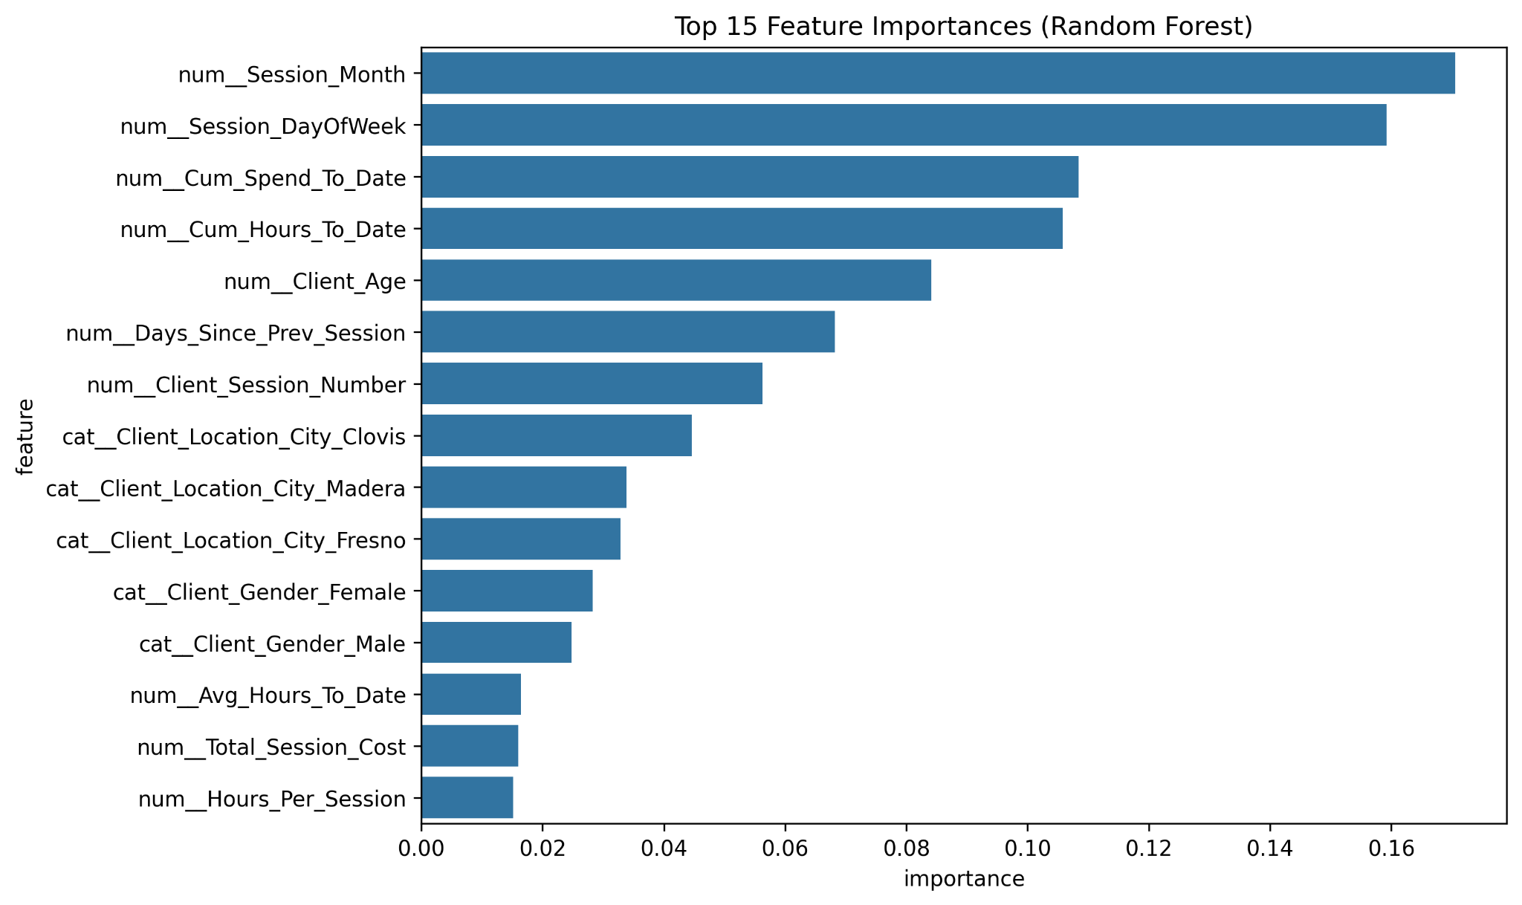

Business Implications
These results suggest that client retention is driven primarily by engagement behavior rather than static demographics. Coaches and service providers can leverage these insights to identify at-risk clients early and intervene through targeted scheduling, follow-ups, or loyalty incentives.

Limitations & Future Work
The primary limitation of this analysis is dataset size. While GroupKFold validation mitigates overfitting risk, future work would benefit from additional data. Potential extensions include incorporating session outcomes, training intensity metrics, and deploying the model as a live retention monitoring tool.

Conclusion
This project demonstrates an end-to-end application of machine learning for retention analytics using real-world business data. By combining careful feature engineering, leakage-safe validation, and interpretable modeling, the final Random Forest model provides both predictive value and actionable business insight.

