The available airframe types are from the PX4 official document

<http://dev.px4.io/en/airframes/airframe_reference.html>

Change the ModelParam_uavType variable in “Init.m” to select desired airframe.

ModelParam_uavType = 1: Tricopter Y+

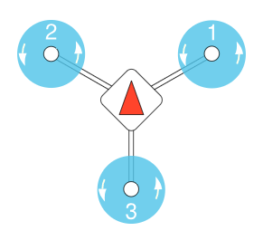

ModelParam_uavType = 2: Tricopter Y-

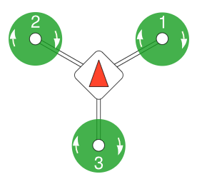

ModelParam_uavType = 3: Quadrotor X

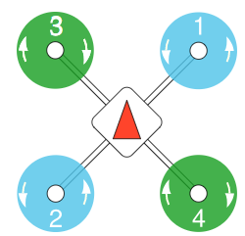

ModelParam_uavType = 4: Quadrotor +

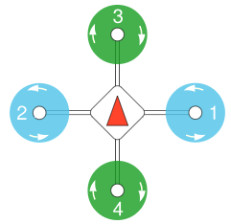

ModelParam_uavType = 5: Hexarotor x

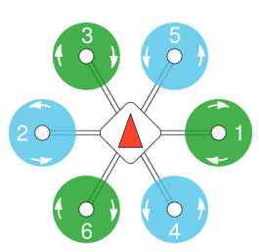

ModelParam_uavType = 6: Hexarotor +

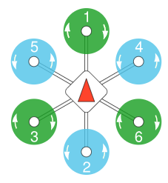

ModelParam_uavType = 7: Hexarotor Coaxial

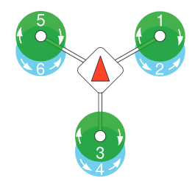

ModelParam_uavType = 8: Octorotor x

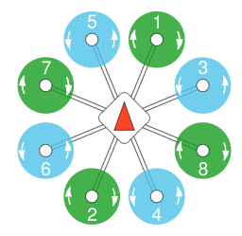

ModelParam_uavType = 9: Octorotor +

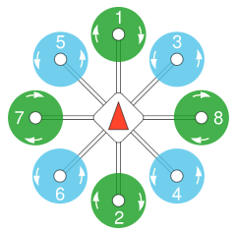

ModelParam_uavType = 10: Octorotor Coaxial

