FitHub Dashboard Code Design
Prepared by Abdulrahman Aladadi
Purpose: This document explains the dashboard part of the FitHub application for the Project Data and Code Design milestone. The dashboard focuses on calories, macronutrients, and weekly calorie history.

Data Files
File Name | Purpose | Main Columns
dashboard_summary.csv | Stores the main numbers shown on the dashboard summary card. | user_id, user_name, calorie_goal, calories_consumed, calories_remaining, daily_goal_percent, day_streak
macronutrients.csv | Stores the user progress for protein, carbs, fat, and fiber. | macro_name, consumed_grams, target_grams, progress_percent
calorie_history.csv | Stores weekly calorie intake for the dashboard chart. | day, calories_consumed, goal

Model Classes
DashboardSummary: Stores the main calorie and streak information for the dashboard. It can calculate calories remaining and the daily goal percentage.
MacroNutrient: Represents one macro item such as protein, carbs, fat, or fiber. It stores consumed grams, target grams, and calculates the progress percentage.
CalorieHistoryEntry: Represents one day of calorie history. It stores the day label and calories consumed for that day.

Controller Class
DashboardController: Coordinates the dashboard data and sends it to the future dashboard UI. It holds a DashboardSummary object, a list of MacroNutrient objects, and a list of CalorieHistoryEntry objects. For this milestone, it contains sample loading methods and calculation methods as a skeleton.

Overall Code Structure
MVC Structure: The model classes hold the dashboard data and calculations. The controller class manages the flow between the data and the dashboard screen. The UI should request prepared information from the controller instead of calculating calorie or macronutrient values directly.

UML Diagram
The diagram below shows how the DashboardController connects to the model classes used by the dashboard page.
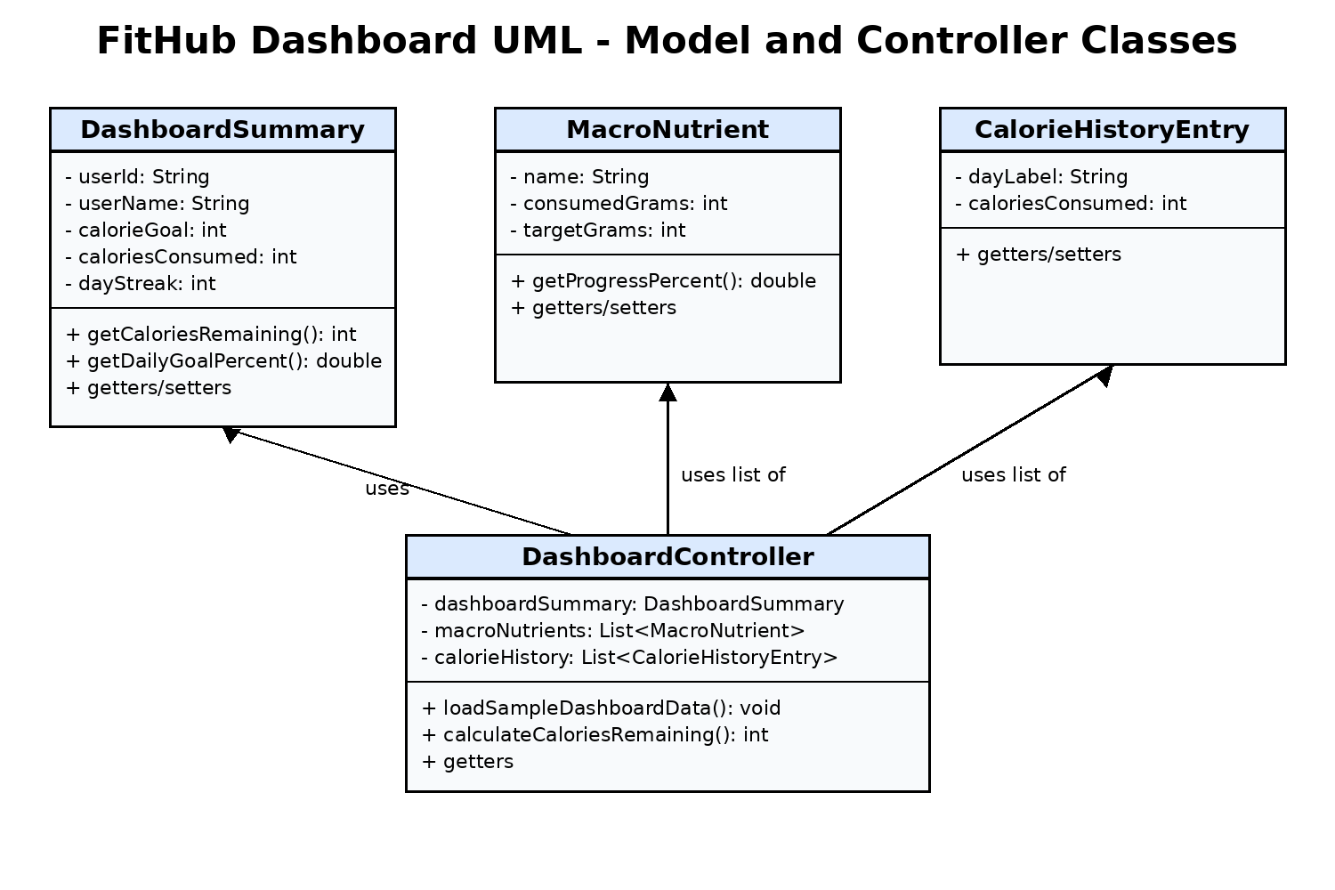

Files Added for My Part
- src/model/DashboardSummary.java
- src/model/MacroNutrient.java
- src/model/CalorieHistoryEntry.java
- src/controller/DashboardController.java
- data/dashboard_summary.csv
- data/macronutrients.csv
- data/calorie_history.csv

