AI Agent Strategy Guide
Mobile Repair Business — Growth & Automation Playbook

40 AI Agent Ideas  20 Online + 20 In-Store | £2,314 Avg/week  Current Weekly Sales | £3,500 Target  Weekly Revenue for Expansion
£1,818 – £2,834  Sales Range (Worst – Best Week) | 59% Cash / 41% Card  Payment Split | 15 Strategies  Identified Scaling Best Practices

PART 1 — 20 AI Agent Ideas: Online / Digital
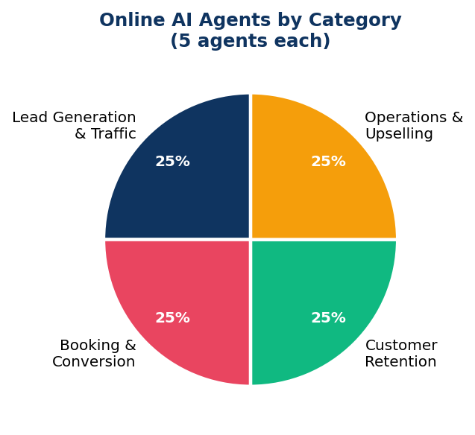  Online Agents by Category | 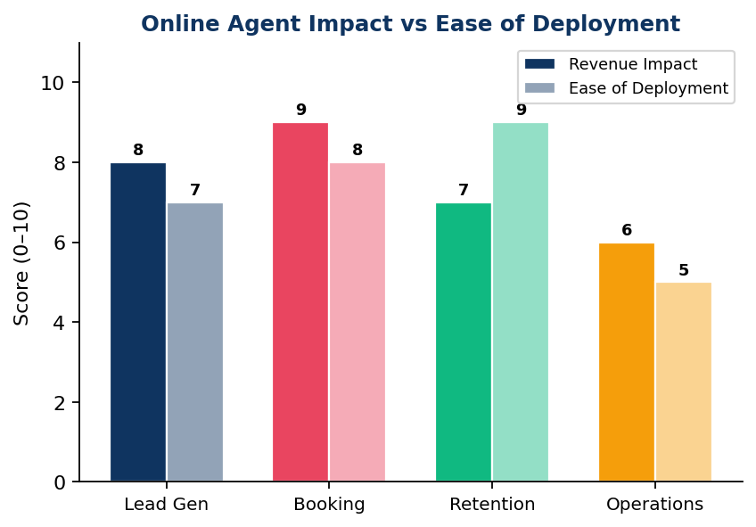  Revenue Impact vs Ease of Deployment

Lead Generation & Traffic (Agents 1–5)
# | Agent Name | Description
1 | ★ Repair Cost Estimator Bot | Widget where customers describe their problem and get an instant price estimate, capturing their contact info in exchange.
2 | Is It Worth Repairing? Advisor | Compares repair cost vs. replacement cost for any device, building trust and driving decisions toward booking.
3 | Social Media Comment Responder | Auto-replies to comments and DMs on Instagram/Facebook with helpful info and a booking link.
4 | Local SEO Content Generator | Produces weekly blog posts such as 'iPhone screen repair in [City]' to rank on Google searches.
5 | Google Review Responder | Drafts personalised responses to every review, improving local ranking signals.

Booking & Conversion (Agents 6–10)
# | Agent Name | Description
6 | ★ 24/7 Booking Chatbot | Handles enquiries and books appointments outside business hours, capturing leads that would otherwise be lost.
7 | Abandoned Quote Follow-Up Agent | If someone gets a quote but doesn't book, sends a timed follow-up via SMS or email.
8 | Device Triage Agent | Asks diagnostic questions to qualify jobs before they arrive, saving technician time.
9 | Waitlist & Cancellation Filler | Automatically fills cancelled slots by texting customers on a waitlist.
10 | Warranty Upsell Bot | After booking, pitches protection plans or screen protectors with a one-click add-on.

Customer Retention (Agents 11–15)
# | Agent Name | Description
11 | ★ Repair Status Updater | Sends automated SMS/WhatsApp updates at each stage: received, in repair, ready for collection. Reduces inbound support calls.
12 | Post-Repair Check-In Agent | Messages customers 7 days after collection to ask how the device is working and request a Google review.
13 | Annual Device Health Reminder | Reaches out to past customers yearly — 'Your repair was 12 months ago — time for a checkup?'
14 | Loyalty Points Tracker | Tracks repeat customers and automatically applies discounts or sends referral codes.
15 | Recall & Parts Update Notifier | Alerts past customers if a known fault is discovered for their device model.

Operations & Upselling (Agents 16–20)
# | Agent Name | Description
16 | Parts Inventory Assistant | Monitors stock levels and flags when common parts are running low, and can auto-order from suppliers.
17 | Job Profitability Analyser | Logs each repair type, calculates margins, and suggests which jobs to promote or deprioritise.
18 | Competitor Price Monitor | Scrapes competitor websites weekly and alerts if pricing needs adjusting to stay competitive.
19 | Referral Campaign Manager | Automatically sends referral links to happy customers and tracks conversions with small rewards.
20 | Insurance Claim Helper | Guides customers through claiming phone repairs on their home insurance, removing a common barrier to booking.

⚑ Where to start online: Agents 1, 6, and 11 — the Estimator Bot drives traffic, the 24/7 Booking Chatbot converts it, and the Repair Status Updater reduces support call volume.

PART 2 — 20 AI Agent Ideas: Physical Shop Floor
  In-Store Agents by Category | 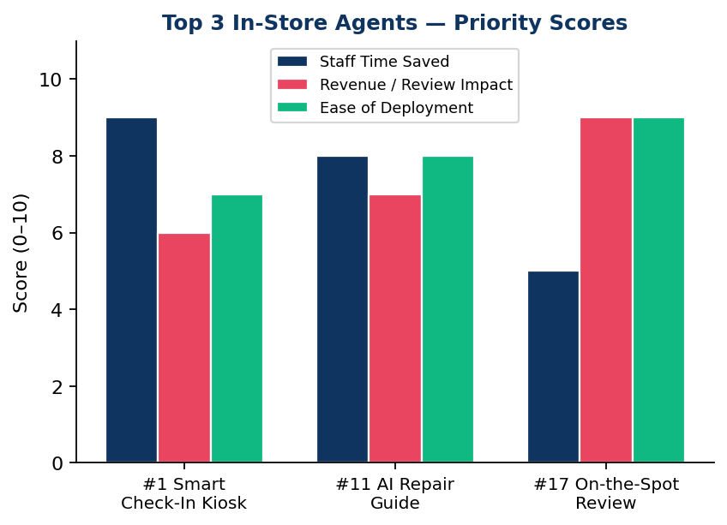  Top 3 In-Store Agents — Priority Scores

Customer Check-In & Reception (Agents 1–5)
# | Agent Name | Description
1 | ★ Smart Check-In Kiosk | Tablet at the front desk where customers tap their device model, describe the fault, and receive a repair ticket — no staff needed for intake.
2 | Queue Management Agent | Displays estimated wait times and texts customers when their repair is next, so they can step out instead of waiting.
3 | Walk-In Triage Assistant | Runs a quick diagnostic questionnaire and tells the customer their likely repair time and cost before speaking to a technician.
4 | Multilingual Reception Bot | Greets walk-in customers in their preferred language — especially valuable in diverse urban areas like London.
5 | Appointment Check-In Agent | Recognises returning customers by phone number, pulls up their history, and alerts the technician they have arrived.

In-Store Sales & Upselling (Agents 6–10)
# | Agent Name | Description
6 | Accessories Recommender Screen | A display showing 'Customers with your phone also bought…' — cases, chargers, screen protectors — while they wait.
7 | Trade-In Value Agent | Customers enter old device details into a kiosk and instantly receive a trade-in quote, encouraging a refurbished handset upsell.
8 | Insurance Add-On Pitcher | After the repair is logged, automatically presents a 30-second pitch for a protection plan on a tablet.
9 | Bundle Deal Suggester | If a customer books a screen repair, the agent flags that a simultaneous battery replacement saves labour cost.
10 | Refurbished Phone Browser | An in-store touchscreen kiosk showing current refurbished stock with specs, prices, and a reserve button.

Technician Support (Agents 11–15)
# | Agent Name | Description
11 | ★ AI Repair Guide Assistant | Technicians type a fault description and the agent instantly pulls up the best repair walkthrough, known issues, and part numbers.
12 | Fault Diagnosis Agent | Technician inputs symptoms and the agent cross-references known faults to suggest the most likely cause.
13 | Parts Lookup & Ordering Agent | Scans a device model and tells the technician which parts are in stock and which need ordering, with one-tap ordering.
14 | Repair Time Estimator for Techs | Based on job complexity and current workload, tells the technician how long to quote — keeping promises realistic.
15 | Quality Control Checklist Agent | After a repair, walks the technician through a pass/fail checklist before handing the device back to the customer.

Customer Handoff & After-Service (Agents 16–20)
# | Agent Name | Description
16 | Repair Summary Explainer | When handing back the device, a screen or printout explains in plain English what was fixed and provides aftercare tips.
17 | ★ On-the-Spot Review Requester | As the customer pays, a tablet prompts them to leave a Google review while they're still feeling positive about getting their phone back.
18 | Payment Plan Agent | For larger repairs, calculates and presents a simple 'pay in 3' instalment option and sends the agreement to their phone.
19 | Data Backup Reminder Kiosk | Before repairs begin, alerts the customer if their device has no recent backup and offers a paid backup service on the spot.
20 | Uncollected Device Manager | Tracks devices not collected after repair and sends escalating reminders (day 3, 7, 14) via SMS, flagging when to apply storage fees.

⚑ Top 3 in-store: Agent #1 Smart Check-In Kiosk (frees up staff), Agent #11 AI Repair Guide (faster technicians), Agent #17 On-the-Spot Review Requester (Google reviews drive local foot traffic).

PART 3 — Financial Analysis: Key Findings
Metric | Value | Notes
Average weekly total sales | £2,314 | Range: £1,818 – £2,834
Cash vs card split | 59% / 41% | Cash-heavy — track carefully
Best week | £2,834 | Mar 2–8
Worst week | £1,818 | Mar 30–Apr 5
Highest-earning days | Sat & Sun | Consistently highest cash takings
Weekly salary cost | £800 (fixed) | ~35% of total weekly revenue

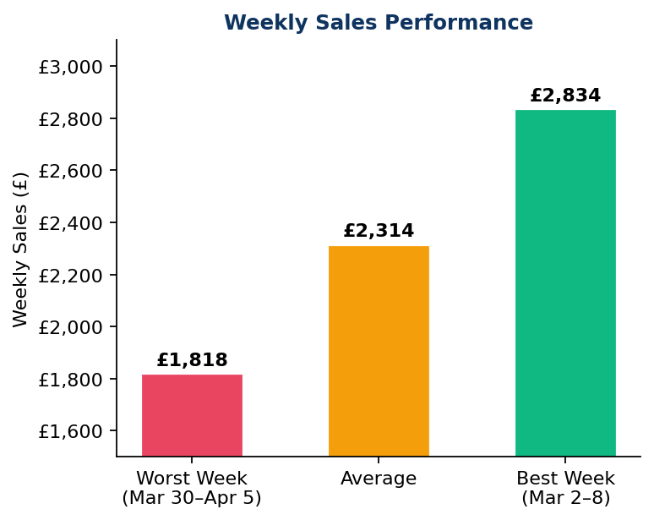  Weekly Sales Performance | 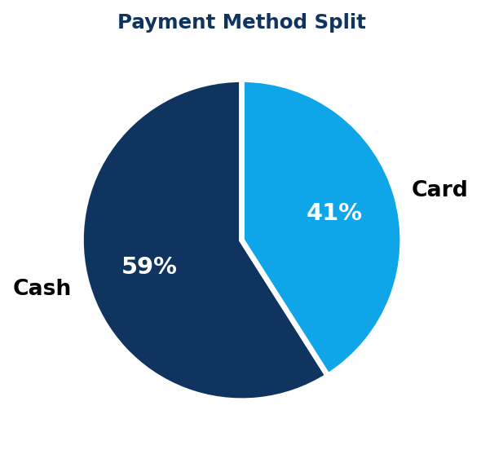  Payment Method Split | 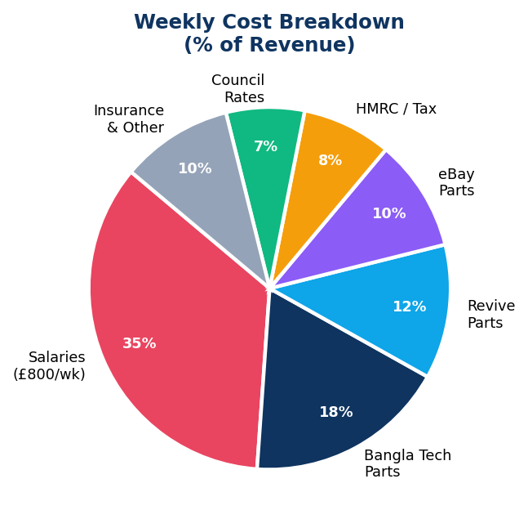  Weekly Cost Breakdown

Most Common Expenses
Expense | Amount / Frequency | Priority Action
Salaries | £800/week (fixed) | Dominant cost — ~35% of revenue; review full-time vs part-time split
Bangla Tech | Almost every week | Most frequent parts supplier — negotiate bulk / 30-day terms
Revive | Regular | Second most frequent supplier — bundle orders with Bangla Tech negotiations
eBay | Regular | Used for phones, screens, batteries — consider a dedicated seller account
HMRC Tax | Periodic — £255 | Set aside weekly; do not allow it to create a cash shock
Council Rates | Periodic — £80–£178 | Fixed overhead — budget monthly
Insurance / Ria | Periodic | Track separately to understand true operational cost

Financial Concerns
⚑ Cash Flow Risk: End-of-week cash is often dangerously thin — several weeks show negative cash balances before personal top-ups. A minimum cash reserve of £1,600 (2 weeks of salary) is essential to prevent operational disruption.
⚑ External Cash Dependency: The business is heavily reliant on personal cash injections to cover high-expense salary weeks. Separating business and personal finances is a critical first step.
⚑ Side Venture Not Separated: Perfume stock appears as a side venture within the same books. Track it separately to accurately measure core repair business profitability and avoid distorted P&L figures.
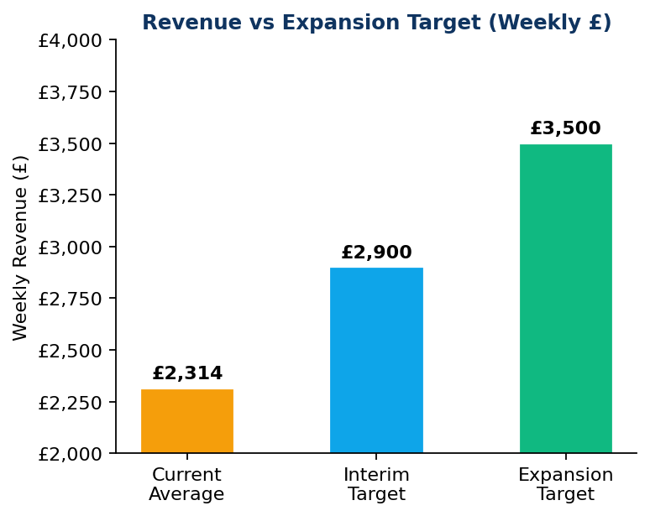
Current Weekly Revenue vs Targets — £2,314 current → £3,500 to unlock second location

PART 4 — Scaling Strategy: 15 Best Practices
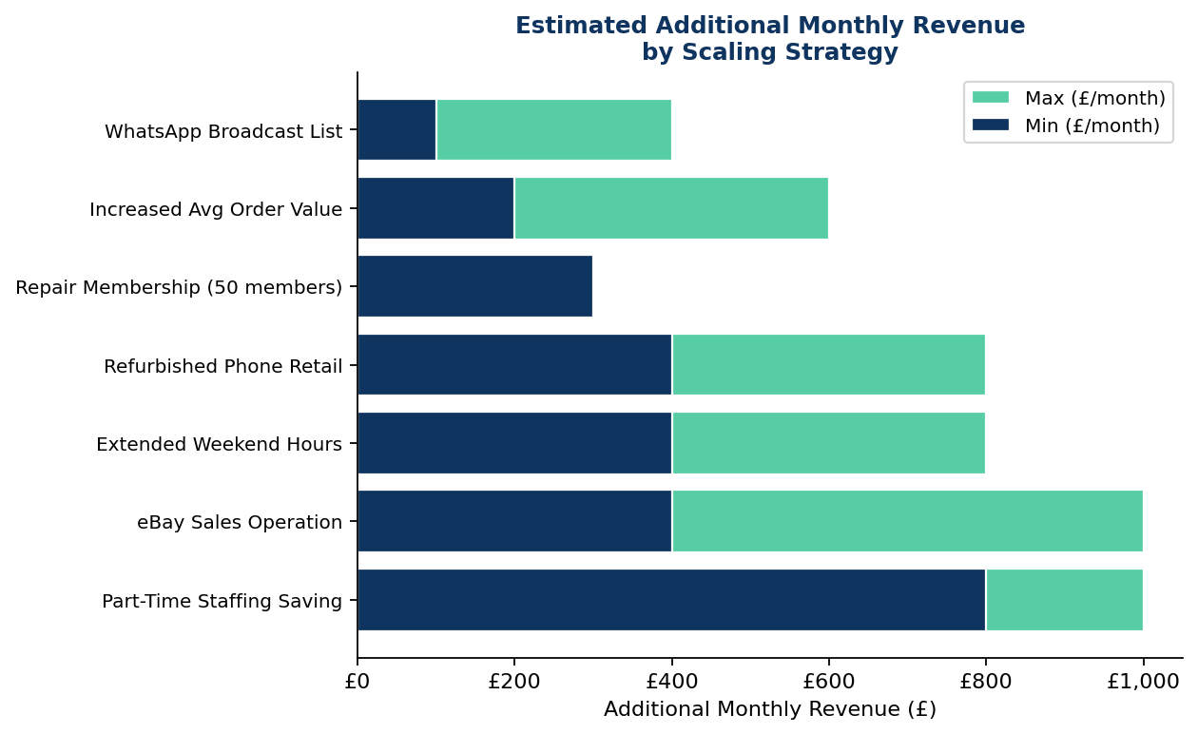
Estimated Additional Monthly Revenue by Scaling Strategy (Min and Max)
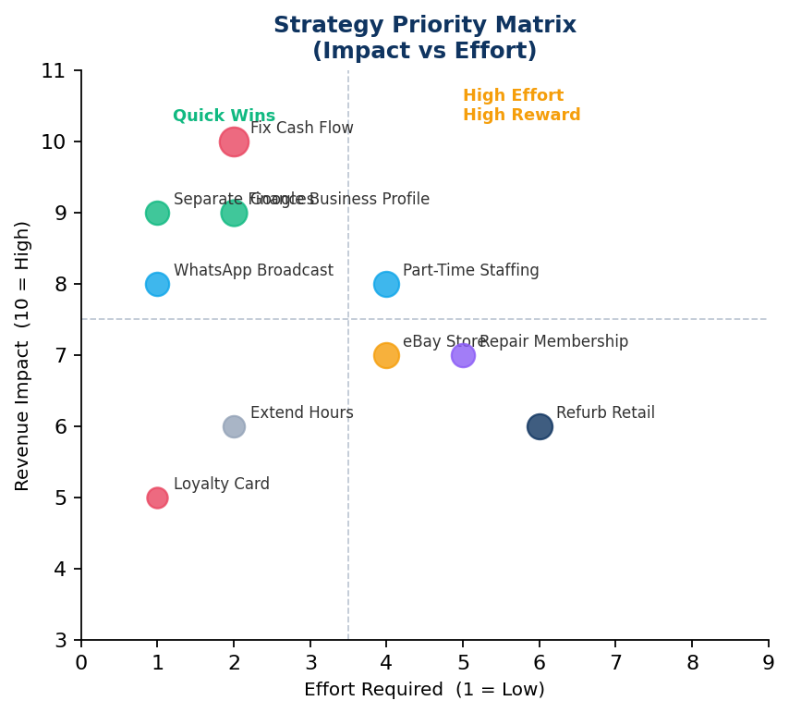
Strategy Priority Matrix — plot of Revenue Impact vs Effort Required
# | Strategy | Detail
1 | Fix the Cash Flow Crisis First | Separate business and personal finances immediately. Build a cash reserve equal to 2 weeks of salary (£1,600). Rule: if end-of-week cash is below £200, no discretionary spending that week.
2 | Negotiate Bulk Supplier Pricing | Approach Bangla Tech and Revive for monthly accounts with 30-day payment terms and volume discounts. Place one bulk order per month for the top 10 most-used parts.
3 | Increase Average Order Value | Train staff to offer battery + screen repairs together. Target an average transaction value of £80+ versus the current estimated £40–60.
4 | Launch a WhatsApp Broadcast List | Message 200+ past customers instantly at zero cost. One broadcast per week (tip, offer, or reminder) keeps the shop top of mind and drives repeat visits.
5 | Formalise the eBay Sales Operation | Set up a proper eBay store for refurbished phones, spare parts, and accessories. Even 5–10 eBay sales per week at £20–50 margin = £400–1,000/month additional revenue.
6 | Introduce a Monthly Repair Membership | £6–8/month provides: priority service, one free screen protector fitting, and 10% off all repairs. 50 members = £300/month in guaranteed recurring income.
7 | Launch a Refurbished Phone Retail Line | Formalise phone-flipping with a dedicated float of £500–1,000 in stock. Buy at £40–80, sell at £100–150. Potential: £400–800/month additional margin.
8 | Extend Trading Hours on Weekends | Saturdays and Sundays consistently show the highest takings. Extending to 7pm could capture £50–100 extra per day — £400–800/month additional revenue.
9 | Target the Bengali/South Asian Community | Market in Bengali via WhatsApp broadcast lists, local Facebook groups, and leaflets in local shops. Community trust translates into referrals at near-zero marketing cost.
10 | Hire Part-Time Instead of Full-Time | If one person is full-time and one is weekend-only, the weekly salary bill drops from £800 to £550–600 — freeing £800–1,000/month for reinvestment into the business.
11 | Register on eBay as a Seller | Extend reach nationally with a dedicated eBay store for refurbished phones, spare parts, and accessories. Complements Strategy 5 with a formal, branded storefront.
12 | Introduce a Simple Loyalty Card | A stamp card (10 repairs = one free screen protector fitting) costs almost nothing to print but significantly increases return visit rates and customer lifetime value.
13 | Build a Google Business Profile | A fully optimised profile with 20–30 genuine reviews is the single highest-ROI marketing action available. Each 5-star review drives an estimated 1–3 additional customers per month.
14 | Separate Business Finances Completely | Use a dedicated business bank account and a bookkeeping app (QuickBooks Self-Employed at £8/month, or free Wave). Enables proper P&L visibility and makes tax returns significantly faster.
15 | Plan for a Second Location After £3,500/week | The current average of £2,314/week needs to reach £3,500 consistently before a second location is financially viable. Achievable through the combined strategies above.

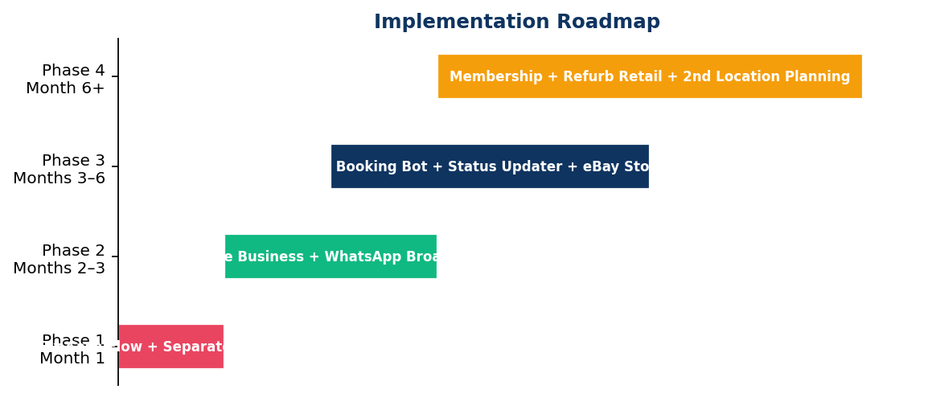
Implementation Roadmap — Four-phase plan from Month 1 to Month 6+

