Accenture Bootcamp

JAVA/Software engineering

**RECIPEDIA**

Android mobile application

development project.

Development team:

Romans Jefremovs

Daniel Gurjev

Kristaps Rezgalis

Riga, 2018

**Table of content**

Glossary 3

1. Business requirements 3

2. Product and Technical requirements 4

3. System design 4

3.1. Functional demands 4

3.2. Database design 4

3.3. Visual design 4

**Glossary**

Android OS - Android Operating System.

Mobile application - is a computer program designed to run on a mobile device such as a phone/tablet.

User - a person using mobile application.

1. **Business requirements**

Recipedia is a mobile application (app) created with the purpose to help user to cook food. Choosing one of many recipes contained in the app user can open it and find all necessary information about the cooking process as well as the list of necessary ingredients required to cook the food.

Recipedia can be very helpful program for those who haven’t any or have little experience in cooking.

The app doesn’t need any special programs or device features to download and use it. The program can run on smartphones with basic configuration and Android OS 4.0 or later version. This feature of Recipedia provides possibility to use it on almost 90% of devices running Androis OS.

1. **Product and Technical requirements**

Recipedia was built for Android OS version 4.0. Later versions of Android OS must support it as well without any limits. The app doesn’t have any special technical requirements. It doesn’t use any additional programs or devices such a camera, microphone, picture collection etc.

To download and install the application a device must be connected to the internet. Later using the application the device can run offline.

1. **System design**
   1. **Functional demands**

The application has built on the Android platform. The Android platform has several conveniences in comparison with other mobile platforms:

• The official programming language, Java, is similar to what we know (C#);

• The majority of phones run on Android;

• Android is backwards compatible: so developing for Android 4.0 will cover all phones running 4.0 and up. According to Wikipedia [Wik11], about 90% of Android devices run Android 4.0 or higher;

• Android applications can be developed in any of the three major Operating Systems: Windows, Linux or Apple OS;

Since Java is the official language used in Android development, we have chosen to use this language. We use Android Studio to develop our application on. It has all necessary instruments and plug-ins for creating, testing and version controling Android applications. The Android Sutdio has a usefull function which helps to test the app directly on the mobile device running Android AS. Otherwise it is possible to test the application in the emulator. On top of this, Android Studio is officially supported by Google (the developer of Android). Any questions regarding the IDE or the Android platform can be asked on their forums.

* 1. **Database design**

The databases creating code is implemented into Mobile application code. Installing Recipedia for the first time the database will be created on a device automatically. At the time all the necessary information, including pictures in BLOB format will be uploaded in to the database.

The database in first period of applications lifetime will contain only one table and 6 columns.

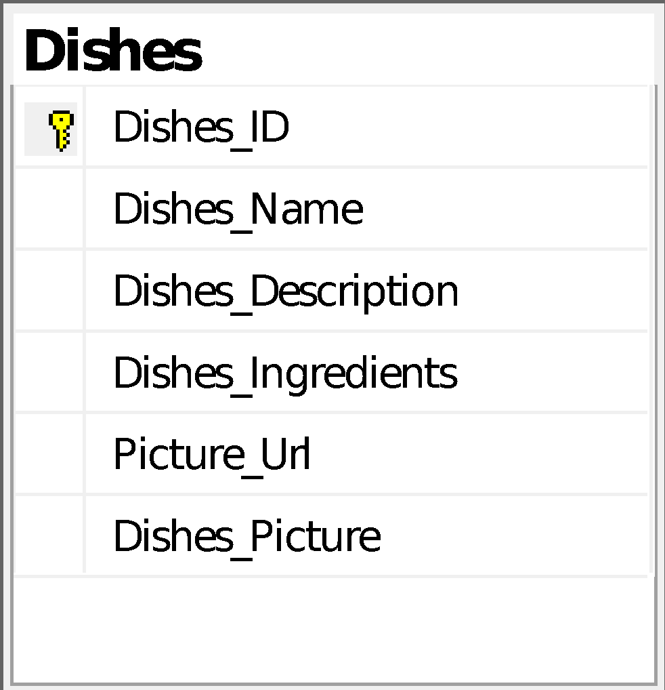

1. Database “Recipedia” diagram.

In the future it is possible to change design of the database adding additional tables and columns.

* 1. **Visual design**

The application has a simple architecture and interface design created in Android Studio (see 1. pic. Main menu).

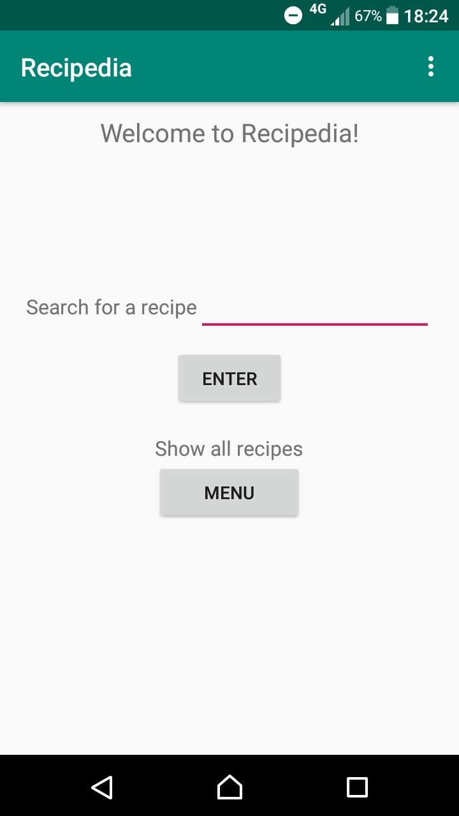

1. pic. Main menu

The application code consists of eight classes: GetImageFromInt, MainActivity, MenuScreen, MyAdapter, MyDatabaseHelper, Recipe, RecipeScreen, SearchScreen. There are also five main layouts: menu_main, menu_layout, recipe_layout, row_layout and searchscreen_layout. For example, recipe_layout includes all the recipe information like the name, list of ingredients, a picture and a description of the recipe (see 1. pic. Recipe info).

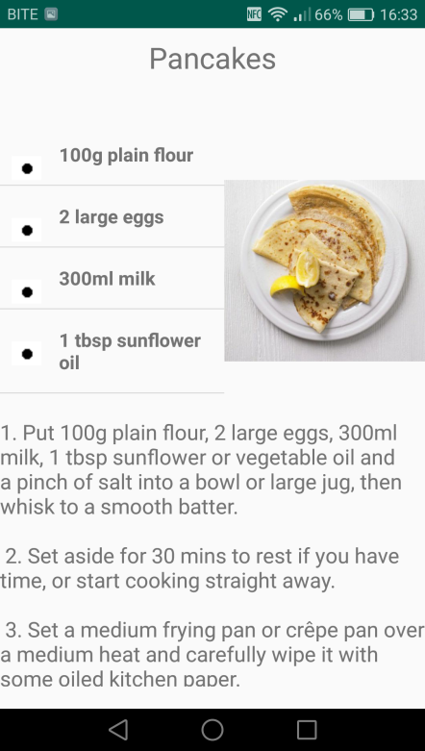

1. pic. Recipe info