**Revised Database Architecture**

Title: FAMS: Financial Assistance Management System for ABC Municipality Utilizing C4.5 Algorithm

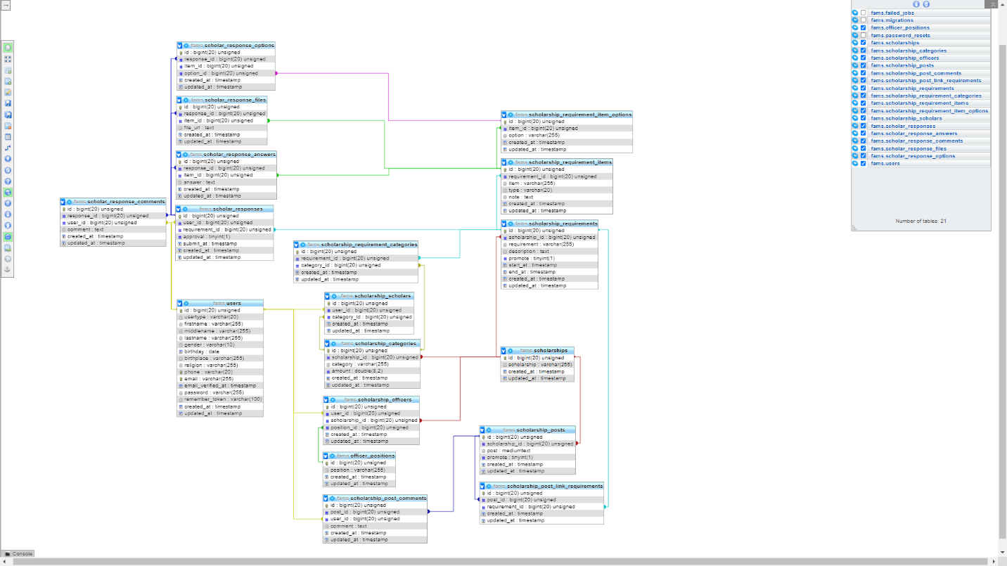

**Some queries that is essential for the delivery of such reports or analysis**

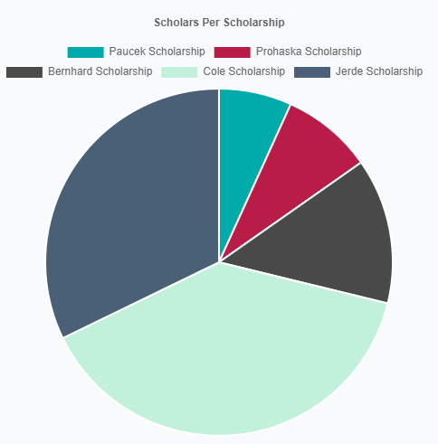

SELECT s.scholarship as label, COUNT(u.id) AS data

FROM users u

INNER JOIN scholarship_scholars ss ON u.id = ss.user_id

    INNER JOIN scholarship_categories sc ON ss.category_id = sc.id

    INNER JOIN scholarships s ON sc.scholarship_id = s.id

WHERE u.usertype = 'scholar'

GROUP BY s.id

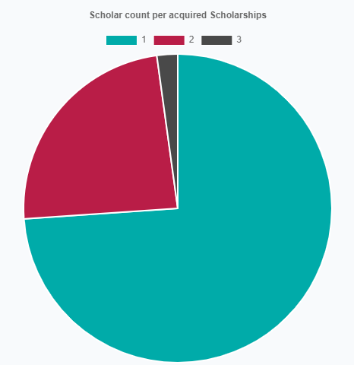

SELECT DISTINCT(COUNT(u.id)) as label, (

    SELECT COUNT(u2.id)

    FROM users u2

    WHERE (COUNT(u.id)) = (

        SELECT COUNT(u2.id)

        FROM scholarship_scholars ss2

        WHERE ss2.user_id = u2.id

        )

    ) AS data

FROM users u

    INNER JOIN scholarship_scholars ss ON u.id = ss.user_id

GROUP BY u.id

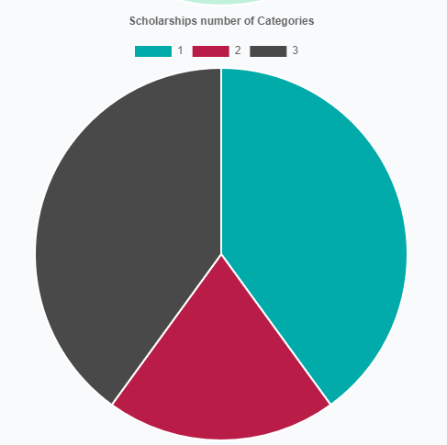

SELECT DISTINCT(COUNT(sc.scholarship_id)) AS label, (

    SELECT COUNT(s.id)

    FROM scholarships s

    WHERE COUNT(sc.scholarship_id) = (

        SELECT COUNT(sc2.id)

        FROM scholarship_categories sc2

        WHERE sc2.scholarship_id = s.id

        )

    ) AS data

FROM scholarship_categories sc

GROUP BY sc.scholarship_id

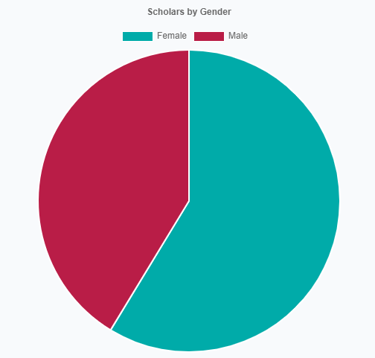

SELECT COUNT(DISTINCT(u.id)) AS data, u.gender AS label

FROM users u

    INNER JOIN scholarship_scholars ss ON u.id = ss.user_id

WHERE u.usertype = 'scholar'

GROUP BY u.gender