PROJECT RESEARCH
Analysing Global Cyber Threat Trends Using Distributed Honeynets
Rihards Ozols – C00281617
BSc (Hons) in Cybercrime and IT security

1. Abstract 2
2. Introduction 2
3. Technology Review 3
3.1 Honeypots and Honeynets 3
3.1.2 Types 3
3.1.3 Comparison 4
3.2 Honeypot Configuration 4
3.2.1 Security Config 5
3.2.2 Keypairs 5
3.2.3 Pricing 6
3.2.4 Pricing Current Project 7
4. Literature Review 8
4.1 Infrastructure 9
4.1.1 Cloud Providers 9
4.1.2 Honeynet Software 12
4.1.3 Presenting Large Data Sets 14
4.1.4 Dashboard Design 15
4.2 Features of Project 16
4.2.1 Cloud Providers 16
4.2.2 Tools: Used 17
4.2.3 Tools: Explained 17
4.3 Related studies 21
4.3.1 Expectations according to previous studies 21
4.3.2 Insights from Existing Honeypot Studies and Cloud Provider Safety 22
4.3.3 Research Questions 24
5. Table of Figures 25
6. References 25

1. Abstract
This project investigates global attack patterns and behaviours observed through the deployment of a distributed honeynet architecture across multiple regions and cloud service providers. The aim is to analyse how the frequency, type, and persistence of cyber-attacks differ based on geographical region and cloud platform. I came across this idea through a conversation with my lecturer; I found the topic interesting and motivating that I will be the first in the college to conduct a finale year project on this matter.
This project will consist of the development, configuration, testing and deployment of honeypots across various cloud providers that share four common data regions where the deployment of honeypots will provide accurate, up-to-date and real-time results through the in-depth analysis of nearly 3 months’ worth of real attack data.
The analysis report section at the end of this project will hopefully provide a valuable insight into the attacker’s mind in 2025/2026, It aims to justify whether the frequency and persistence of attacks on certain regions correlate across all cloud platforms or vary independently from one cloud platform to another. The data gathered from this study can be used to improve future honeynet deployments and organisational defensive posture if they are aware what risks their region or cloud pose to their organization.

2. Introduction
In this project research paper, I will present a comprehensive account of what tools, processes, keywords and methodologies that will be use throughout this research project’s lifespan, from the architecture design of the multi-cloud honeynet systems with a step by step to its setup to the data collection process and analysis of logs. This paper of the research project will include traditional honeypot, their configuration and pricing models, research papers conducted on hosting honeypots on different cloud providers and their findings, research papers on different honeynet software, and papers on presenting large data problems. The approach adopted for setup of honeypots and for data capture and logging, it will also outline the dashboards that I plan to create and the metrics that will be monitored and present the hypotheses and research questions that guided this project from the beginning.

3. Honeypots & Recommended Configurations
This section will go over honeypots and recommended configurations based on my research of past honeypot studies, recommendations made by developers of different software and my own findings from experimenting with different configurations and price ranges.

3.1 Honeypots and Honeynets
A honeypot is a system that is purposefully designed to be vulnerable to attract attackers so their behaviour can be studied and used to possibly mitigate future attacks.
A honeynet is a network that consists of multiple honeypots that pretends to be a real environment to attract attackers and track their behaviour across multiple systems.

3.1.2 Types
Honeypots can be categorised into high-interaction and low-interaction pots, these come with their own pros and cons.

High Interaction
High-interaction honeypots are vulnerable systems that mimic real systems closely. According to [4] high-interactions honeypots “simulates all aspects of an operating system” which would give a threat actor a lot of wiggle room to potentially launch further network attacks. Since high-interaction honeypots provide a deeper level of interaction, the capture more information on an attacker such as lateral movement, data exfiltration attempts and attack sequences.

Low Interaction
Low-interaction honeypots provide a limited amount of interaction compared to the high-interaction honeypots. They emulate specific services such as SSH login or a HTTP server. Low-interaction honeypots simulate only services that cannot be exploited to get complete access to the honeypot which makes them safer to host and easier to deploy but provide less detailed information on attackers.

3.1.3 Comparison
For this project it will be low-interaction honeypots that will be distributed across multiple cloud providers and regions. They use fewer resources and allow for the deployment of many instances across multiple providers at a lower cost. This allows for a broad coverage without introducing a large overhead.
As low-interaction honeypots restrict access and don’t offer full compromise of the Operating System, it minimises the risk of a honeypot being used to launch and attack against the cloud instance itself.
During this project there is a huge focus on safety and cost, the low-interaction pots will allow for the observation of attacks at scale and offer a deep insight into the risks of hosting on different services or locations without compromising the instances or posing a significant overhead.
The risk of high-interaction honeypots was emphasized in a study done in 2015 [21]. This paper focused on gaining a deeper insight into an attacker’s behaviour through high-interaction honeypots, where the authors stated that because high-interaction pots are “real systems with vulnerabilities” they are at risk of being compromised and that they require “constant monitoring” to be contained safely.
A study done in 2022 [13] deployed multiple low-interaction and medium-interaction honeypots that were deployed for 11 months. The analysed traffic found that low-interaction pots were attacked much more than the medium ones. This proves that you can obtain a viable quantity of data from a low-interaction honeypot with manageable risk and reduced resources.
This highlights my reasoning for choosing low-interaction honeypots to be the backbone of my research.

3.2 Honeypot Configuration
Honeypot configurations are important as they determine how effective your honeypot will be in attracting attackers and keeping them engaged as well as how safely it operates.
Proper configurations ensure the honeypot looks realistic and attractive, if it’s too vulnerable, attackers may ignore it.
Misconfigured honeypots can become a liability, attackers could use it to attack your network and overwhelm your systems.

3.2.1 Security Config
Here are the configurations used for Honeypots that will be distributed across all providers and regions. The following rules have been taken from [3] and [22].

Fig.1
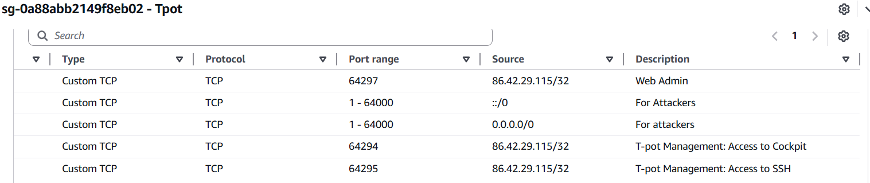

Screenshot of security rule configurations on AWS: example
= Public IP Address

Web Admin Rule: This rule allows inbound TCP connections from the local machine’s public IP address to the honeypot on only port 64297, this allows for access the Web UI for T-Pot.
For Attackers Rule: This rule allows TCP traffic from any IPv6 and IPv4 addresses to the honeypot on ports ranging from port 1 to port 64000, This is done to maximize what attackers will hit, this gives me the best chance to log and analyse as much of the attacker’s behaviour as possible.
T-pot Management: Access to Cockpit Rule: This rule is designed to restrict access to the management interface of my honeypot so that only the local machine can access the management UI.
T-pot Management: Access to SSH Rule: This rule allows TCP connections to port 64295 from only the local machine, this is the SSH access port to our honeypot, it has been changed from port 22. To port 64295.

3.2.2 Keypairs
Keypairs, are fundamental to authentication, encryption and are a core part to the safe configuration of a honeypot.

How does a key pair work?
A keypair is generated, a private and public key. The holder of the private key is the local machine and the server hosting the honeypot holds the corresponding public key. Upon connecting to the honeypot, the server verifies the private key against its public key and checks for a match.
As the private key is not shared and cannot be derived from the public key, this ensures strong authentication compared to the likes of only a password login.
A good security practice would be to move the generated keypair to a secure location such as a directory on the local machine with strict permissions such as chmod 700 on the folder and chmod 600 on the key file, essentially meaning the owner only has access to the private key file.[1]

3.2.3 Pricing
For the deployment of a honeypot the price I on four different factors,
- Cloud Provider
Cloud providers charge different prices per region as each region has different overheads, operating costs and infrastructure.

- Location
Depending on what Cloud provider you choose the hourly price of hosting a honeypot will vary across different regions, this is due to many factors such as;

- Popular regions being used more, which lowers availability, hence increasing the cost.
- Older regions are more developed and are better established so the price is typically lower than newer or smaller regions.
- Hight cost of running data centres in specific regions would increase the hourly rate.
- Latitude and environmental differences, cooling is a major cost for a large company who are running a huge amount of machines.

- Virtual Machine Specifications
After you have chosen a provider and selected an appropriate region, your honeypot price can still rise depending on how powerful the machine specification is.
Here are some of the factors that will influence the price of your honeypot.
- CPUs, they are the highest cost driver, the more CPUs you use the more money you will need to pay
- RAM, Memory-heavy Virtual Machines will drive your costs up
- Storage, if you are using extra storage such as and SSD or NVMe be ready to pay extra

- Duration
The duration of the deployment period is where things begin to get expensive.
There are two main types of ways you can pay for your honeypots.

Pay-as-you-go
Most providers do a ‘pay-as-you-go’ service where you pay for every minute the honeypot runs. This could be beneficial for short term studies, but things can get expensive quickly. For example, running a honeynet for one hour would incur a small cost of 10 cents, but running that honeypot for 720 hours (30 days) would cost 72 euro, the longer it runs the more you will pay.

Long-term subscription
Many providers such as AWS or GCP offer discounts if you commit to a specific amount of time ranging from 1 to 3 years.
These discounts range from 40-75% but they only apply if the machine runs for all the commitment period

3.2.4 Pricing Current Project
The pricing for this project is based on the hourly rates provided by AWS, Azure, and Google Cloud for hosting three honeypots on each platform across the regions of Virginia, Frankfurt, and Singapore. Each virtual machine meets the minimum system requirements for T-Pot, consisting of 2 CPUs and 8 GB of RAM. All honeypots are deployed using these recommended specifications and will run for a total duration of 80 days.

Fig.2
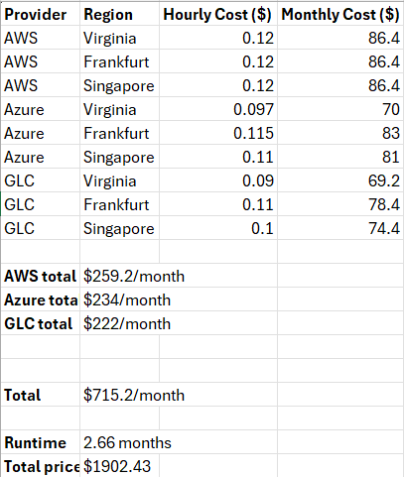
Pricing model for honeynet project

In the years since the deployment of these honeypots (deployed in 2020), cloud providers architecture, default security features and attacking tools have evolved tremendously, this reduces its relevance to our current objectives of determining the safest provider today to being very limited.

4. Literature Review
The Literature Review section will review the foundation on what guides this study, it includes the architecture of providers, software and dashboards that was derived from developers that created the platforms and aspects of varies studies, it will go into detail on how the tools work and how they were used in past studies. It will also include the outcomes we can expect to see according to previous studies that have some similarity, whether its region or cloud provider, It will also include an evaluation of the existing findings related to honeypot research and how that is linked to cloud provider security and lastly some research questions based off my findings from previous studies to help guide this project.

4.1 Infrastructure

4.1.1 Cloud Providers
AWS
Amazon Web Services (AWS) is the oldest and largest public cloud provider. It offers EC2 computing, S3 storage, databases, machine learning and much more services. It has a massive global presence with many availability zones and around the clock support. According to [10] in 2024 AWS holds the largest market share in the public cloud market sitting at a 37.7% market share.
This global presence brings a lot of traffic to the AWS cloud. This makes it an strong candidate for hosting honeypots and gathering information on threat actors from all over the world. A primararily targeted services in AWS across studies at [5] and [12] has proven to be the SSH service
According to the comparative study of honeypots on different cloud platforms mentioned above [5] AWS received the second largest number of attacks in a 3-week deployment period, but the most targeted service across all AWS honeypots were SSH brute force attacks.
The second mentioned study [12] explicitly analysed open ports in AWS and observed 11,193 unique SSH session over a 70-day deployment period, they stated “the highest concentration for unique IP addresses is on the ports that provide shell access to the adversary, namely port 22/ssh”. This shows how misconfigured or exposed SSH ports on AWS are targeted by attackers more often than other ports on AWS.

Azure
Azure is Microsoft’s cloud platform, it is integrated with Microsoft products such as Windows server, Active Directory and Office 365. It provides a varied list of cloud services such as but not limited to
IaaS (Infrastructure as a Service) which includes virtual machines, networks and storage
PaaS (Platform as a Service) which includes databases and container platforms
SaaS (Software as a Service) integrations which is a built in connection to Microsoft’s Office 365 and Active Directory
Considering Microsoft is household name, Azure is a natural choice for large companies already using Microsoft products, but with that said it comes in at a strong second in the public cloud market with a 23.9% market share according to [10].
When choosing a cloud platform to host your vulnerable machine, it is important to find one that will produce large amounts of attackers and provide the needed quantity of data for an accurate comparison. Azure VMs have proven attractive to attackers, especially on low-interaction honeypots.
A study at [13] deployed honeypots for a duration of 11 months on the Azure cloud and found persistent attacks on the low-interaction honeypots. Their deployment was aimed to supply a concrete analysis of how attackers behave over long periods of time in a public cloud environment. The long deployment ensures to avoid biases of ordinary short-term deployments and the immutable log store used ensured that written log entries could not be tampered with, increasing the reliability of their data further. The persistence of attacks on low-interaction honeypots suggested that many attackers on azure are automated scanners that continue to return to known Azure IPs, scanning for exposed services. The files that attackers dropped on the honeypots, the authors of this paper used LDA topic modelling to figure out what kind of payloads were most common. The LDA analysis reveals that attackers are not just bots that are only scanning the network, but actually dropping payloads such as cryptominers, RATs and more. This shows us that Azure is a reliable cloud provider to produce an accurate and in-depth analysis of an attacker’s malicious activity.

Google Cloud Platform
Google Cloud Platform (GCP) is Google’s cloud platform, it is known for its strong analytics, data and machine learning capabilities. According to [11] it exclaimed that GCP is a leading in big data queries (BigQuery), Machine Learning, Artificial Intelligence and containers such as Kubernetes and GKE. The National Institutes of Health (NIH) in the US relies on GCP for varies different biomedical purposes and in [11] stated in regard to GCP “a platform optimized for data-intensive science, artificial intelligence and machine learning workloads” emphasising how GCP is not a generic cloud but it is specialized for handling large data loads and Artificial Intelligence and Machine learning tasks.
Although Microsoft’s GCP has proved to be ideal for scientific computing it takes third place with 9% market share in the IaaS public cloud market according to [10].
A comparative study of honeypots on different cloud platforms at [5] argues that different cloud providers see different attack behaviour, suggesting that that cloud platform choice matters for honeypot deployment. It found that GCP resulted in the most attacks amounting to 581,116 attacks which were 49% of attacks. This suggests that GCP is the most targeted cloud platform among the three giants, AWS, Azure and GCP. This information can be interpreted by users as GCP being the most likely to be attacked and perhaps not the ideal place for a small business to host their servers on unless they have the necessary protections in place.

Cloud Provider Comparison
According to the study done at [5] where the global distribution of honeynets across AWS, Azure and GLC was examined, each provider was different in the regards to incoming attack traffic and exploitation attempts.
AWS showed consistently high numbers of automated attacks against SSH and Telnet, particularly on Cowrie. From the data gathered in this study AWS is a major host for password guessing bots and AWS deployed SSH services attract much higher numbers of brute-force traffic compared to other providers
Azure honeypots experienced higher numbers of exploits targeting older vulnerabilities, this study shows that Azure got a much higher number of attempts to exploit legacy vulnerabilities particularly targeting older SMB stacks. There were 3,371 occurrences of RealVNC in Azure compared to 1,924 in AWS, there were 1,894 occurrences of RDP in Azure compared to only 150 in AWS.
Google Cloud recorded the highest number of total attacks although it has the smallest market share of the three giants. GCP recorded 49% of all attacks. This contradicts assumptions that the attackers focus mainly on the largest provider which in this case is AWS, However according to [14], a study where the authors analyse how attackers scan cloud address space, They argue that not all blocks are scanned equally, and stated that “ attackers have altered their behaviour in response to new deployment patterns by targeting services on non-standard ports. This supports the idea that newer IP address space is more visible and attractive to scanners. Their findings included that scanners prioritise IP ranges that look like real cloud hosts. Newly allocated cloud IPs are populated with active severs, this leaves an activity footprint which resembles real hosts to attackers. The same study observed that GCP rotates and announces new IPv4 ranges more frequently than AWS or Azure. Since GCP IP ranges are newer this could explain why some IP block received more scans and eventually exceeded AWS as the most targeted provider.

Cloud Provider Summary
AWS, Azure and GCP are three major cloud providers, with each offering their own strengths and attracting different types of attack behaviour. AWS is the largest cloud provider with the biggest cloud market share, it experiences a large volume of automated brute force attacks, especially against SSH. Azure is the second largest provider; it is integrated with Microsoft services. It attracts higher quality payload activity, clearly seen in longer deployments. GCP, has the third highest market share but lowest among the three, despite this it still receives high if not the highest number of hits.

4.1.2 Honeynet Software
Honeynet software provides a system where you can run different honeypots, there are many types of honeynet software, and some provide more detail in specific areas than others would. The software mainly provides an environment where services such as SSH and the web are emulated, commands of attackers are logged, different malware is collected and put together in a more user-friendly dashboard. These are some of the most popular honeynet software available today.

T-Pot
T-Pot is an all-in-one honeypot platform created by Deutsche Telekom [3], it packages different software into one system, software included in T-Pot ranges but not limited to Cowrie, Dionaea, Conpot and ElasticPot. T-Pot also includes dashboards that use Kibana to operate
This project uses T-Pot as it includes multiple honeypots in one package, this avoids bias to one singular piece of software and provides a greater angle to analyse from. As mentioned above, It also provides modifiable dashboards that enhance data collection by placing all the logs together and painting a clear picture of what they mean.
The downsides of T-Pot include that it is a very resource heavy piece of software to run which requires stronger virtual machines. This makes it an expensive choice in software which can lead to costs piling up rather quickly.
More on the system requirements of T-Pot can be found at [3].

Cowrie
Cowrie is a high-interaction SSH and Telnet pot, it emulates a shell environment, so it mainly logs commands made by attackers, captures malware, and prepares detailed logs of any intrusions. Cowrie is one of the most popular honeynet software tools today, this is proven by the fact it is included in most studies that talk about honeypots, including [5], [6] and [7]. It is mentioned to be the most attractive software to attacks in [5] when the researchers stated, “Cowrie was the most attacked honeypot with 102k connections in the 14-day span”.
Cowrie is great for capturing large amounts of real-world brute force and general malware traffic due to its popularity and makes it very common among researchers as it gives them a vast amount of behavioural coverage. In paper [5], the research shows its dominant visibility for SSH brute-force interactions compare to other software such as Dionaea, Conpot and Glastopf that was also used in their study. Paper [6] also found that far more SSH honeypots were running Cowrie instances compared to other SSH implementations that they used. This paper shows Cowries large presence as an SSH honeypot in the wild talks about how its popularity makes it a primary target for attackers
The limitations with Cowries include that its limited to SSH or Telnet and does not monitor other protocols and due to its popularity skilled attackers began fingerprinting it and detecting that it is a fake environment

MHN
MHN is a honeypot management system, it does not actually act as a honeypot software per say, it manages multiple pot sensors and collects their data and displays it in a more readable format.
It is similar to T-Pot in the sense that it uses multiple software such as Cowrie, Dionaea, Snort and more but unlike T-Pot it is not actively maintained as it is an older framework.
In the beginning of this project, it was planned to use MHN as the management software running the honeypots, but after further research it was found that it only supports old versions of Operations systems such as CentOS 7, Ubuntu 12.04 LTS, Ubuntu 14.04 LTS and Ubuntu 16.04 LTS. This made it rather difficult to set up due to incompatibilities. MHN also proved to be insecure if exposed to the internet due to the outdated components.
Studies in 2021 such as [8] which integrated MHN sensors on Raspberry Pi devices and uncovered that the sensors become overloaded under large attack volumes, this would be detrimental in a research project as overloaded sensors may miss or drop attack data.
As mentioned above, the original set up of this project involved the use of MHN software, which led to many issues regarding compatibility and available support. This issue was highlighted in a study by a student who encountered a similar issue at [9], he noted that MHN features are not compatible with newer versions of Ubuntu, leading to several issues when attempting to deploy MHN.

Honeypot Software Summary
T-Pot is an in-depth and maintained platform that bundles up several tools to be used and studied at your disposal, but it is demanding when it comes to resources making it costly to deploy and run. Cowrie is a popular SSH/Telnet honeypot. It consistently attracts high volumes of attacks and had detailed logging for commands, but it is limited to SSH/Telnet protocols and can possibly be fingerprinted by skilled attackers. MHN was once a commonly used and updated management framework, but now it is outdated and dependent on legacy operating systems and is prone to errors and compatibility issues.

4.1.3 Presenting Large Data Sets
After the deployment and the collection of the attack logs their will there will be a new challenge to overcome. The presentation of all the gathered raw data into a readable visualized format. Honeypot data should never be presented as raw logs as it will not make sense to the reader and won’t serve their purpose of providing an insight into the threat actors mindset. According to a study [18] there are four challenges that you face when trying to visualize large amounts of data:
- Data Variety
The Variety of data such as the timestamps of events, attacking IP addreses, entered commands and software used, all these have different formats and different meanings. This makes it difficult to build a visualization model that works perfectly for all logs.

- Data Volume
Honeypots run for weeks or even months and considering they are being attacked 24/7 from all over the world, the volume of collected data is often very large. This can clutter visualization and make it difficult to make precise and reasonably sized graphs to present the collected data.

- Data Velocity
As mentioned above, honeypots run 24/7 and they don’t receive traffic over long period of time. The traffic comes in bursts, large spikes and possibly floods that last for hours, exhausting your CPU. Examples of these would include botnets scanning all the IPv4 address space or SSH brute-force attacks. This can impact the real-time aspect of the dashboard and cause them to freeze.

- Data Value
The Value of data absorbed in honeypots is the definition of finding a needle in a haystack. It’s mainly populated by bot or automated traffic, although this is also useful to see what regions are being targeted and from where, it does not give us the individual attacker or attacker group information we would like as often as we get information about the automated traffic. The value of the data is hard to determine when there is thousands of events but not much guidance other than known IPs on which event was triggered by a sophisticated attacker.

Solution
The Vis4Sec (Visualization for Security) framework is the solution to Nielsen’s four challenges [18]. It is a guide for how to prepare and show security data. To summarize the contents of the guide, here are the proposed steps to overcoming these challenges:
- Gather the logs from all honeypots
- Ensure all data uses the dame format
- Ensure to include useful content to help identify data such as Country, IP reputation, Attack type etc.
- Group events by IP address, IP reputation, Attack type etc, by grouping them into categories it is easier to visualize
- Create reader-specific visualizations. Depending on who you are presenting the data to, it should be accurate to their needs. You can cut information that is not relevant to improve the quality of visualization charts.
This study describes the Vis4Sec framework, for more detailed information please see [18].

4.1.4 Dashboard Design
To design an efficient dashboard, you first need to choose an appropriate dashboarding tool that you will use to visualize all the attack logs gathered from the honeypots, popular tools include Kibana and Grafana. Kibana works best for attack logs and gathering security data from honeypots, Grafana is good for monitoring and comparing traffic and would be a good secondary tool paired with Kibana. Once you have a dashboarding tool up and running, before you can examine the traffic you need to develop a good foundation on how to present your attack data.

Here are some good practices derived from [19] on setting up your dashboard to both look good and present only valuable information.
- You should not bunch all different types of information into one chart or graph, one purpose per dashboard is the best way to go. If you mix everything together the data becomes hard to read and the dashboard, take longer to load as they are pulling a lot more information than they should.
- Arrange dashboards logically depending on information. The first few dashboards should contain general information such as attack counts and attack volume, then the lower you scroll the more detailed the dashboard begin to get. It’s good to start off with an overview, then move onto patterns and then to finish the dashboards off a detailed section that contains events, raw logs or even payloads for example.
- Keep the visuals simple and relevant to the data they are presenting. For example, line charts for attack rates over time or maps for geographic locations. Complex visualizations can be more confusing for the reader and offer less clarity.
- Using Filters within dashboard adds an element of control and understanding for the reader and would be a great addition through range sliders for ports or to check certain time windows, or even a mini search bar to locate keywords.

4.2 Features of Project
The success of this project hinges on the effective deployment and operation of the honeypots, as well as the reliable capture and analysis of the log data they generate. To achieve this, three key components must work in harmony to deliver a successful outcome.
- Reliable Cloud Providers
- The proper use of monitoring tools
- The successful capture of logs using logging tools.

4.2.1 Cloud Providers
It’s important to have reliable cloud providers that will provide high amounts of attack traffic, A substantial amount of data is needed to for the unbiased analysis and comparison of attack data originating from different regions and providers.
The chosen cloud providers for this research project are AWS, Azure and Google Cloud Platform.

4.2.2 Tools: Used
T-Pot – T-pot is an open-source honeypot platform, It includes monitoring and visualizing tools such as Attack Map, Kibana and Elasticvue.
Attack Map – The Attack Map is a visual dashboard that shows incoming attack traffic and the source location of the attacks directed at your honeypots.
Kibana – Kibana is used for visualising, exploring and analysing raw events data that is stored in the Elastic Stack
Elasticvue – Provides a direct interface to the underlying Elasticsearch cluster, letting you browse indices, inspect and edit individual documents, and run search queries against raw log-data extracted from the honeypot. This will be used to ensure log availability and collection

4.2.3 Tools: Explained
T-Pot
T-Pot is an open-source honeypot platform that have been developed by Telekom Security. It supports over 20 different honeypot types that emulate different services or protocols to the unsuspecting attacker and is integrated with Elastic Stack to gather the produced logs and visualize them. It includes monitoring and visualizing tools that will be discuss in further detail as they are a vital part of the successful analysis of the data I gather over the next couple of months, more information can be found at [3].
For the setup of T-Pot [2], you need to initialize a honeypot on a cloud provider. When configuring the pot, you need to meet the minimum requirements to run T-Pot on your Virtual Machine, 2 CPUs and 8GB of RAM. Once the honeypot is online and your security rules are configured, you need to install T-Pot from a GitHub repository [3], then create a user and password combination that will be used later use to access the Web user interface.
To Access the Web UI, you need to connect to port 64297 and you will be greeted by the T-Pot user-friendly dashboard
Fig.3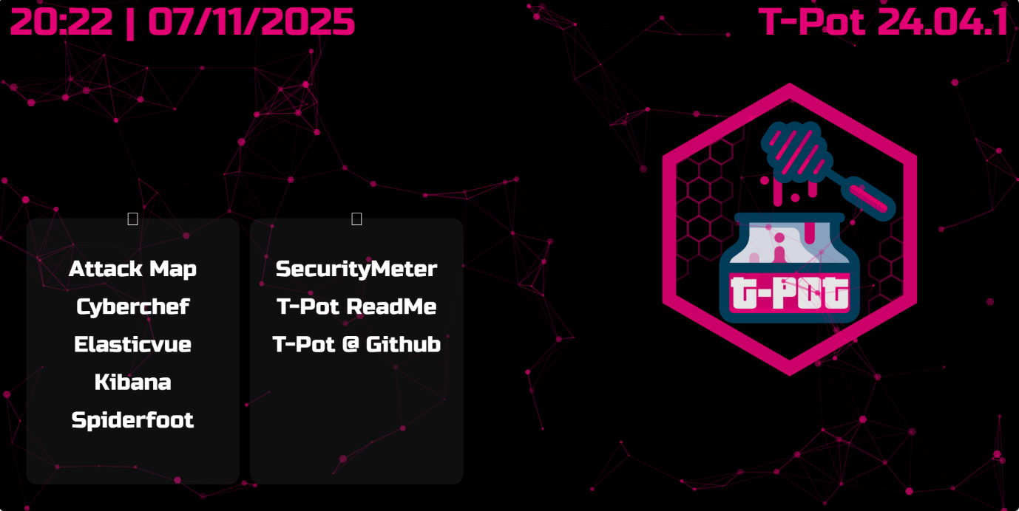
Screenshot of T-Pot dashboard

The tools used to complete this project are the Attack Map, Elasticvue and Kibana.
Attack Map
The Attack Map is a visual dashboard that shows incoming attack traffic and the source location of the attacks directed at your honeypots.
Fig.4
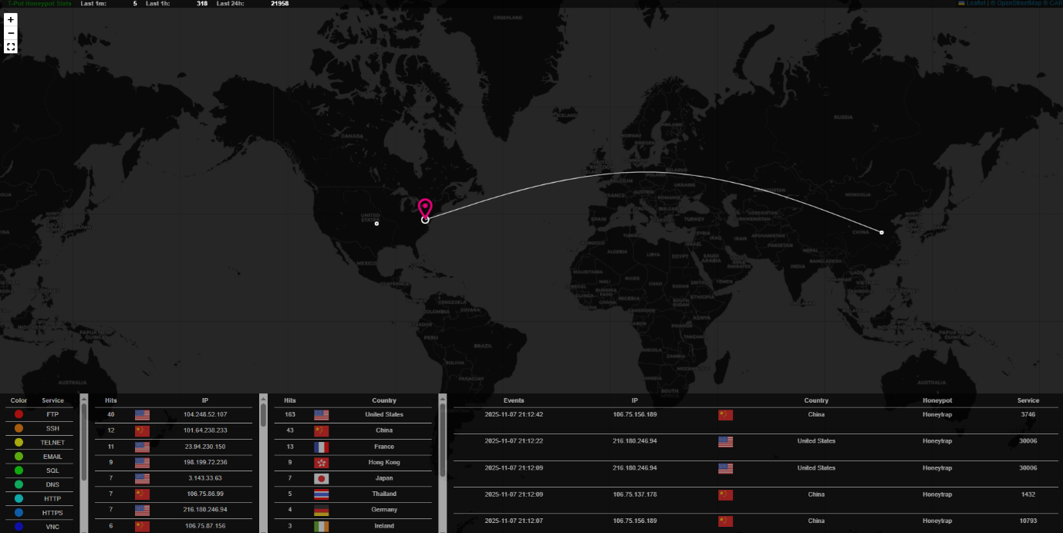
Screenshot of Attack Map: example
It provides a near real-time visualization of incoming attack traffic being received by your honeypots, showing you what location they are coming from and what ports/services are being targeted. The standout feature of this tool would be the geographical view of the attackers IPs; you can see the line that’s marked on the map that begins in the attacker’s location and extends to the location of your honeypot. This tool helps monitor trends and volumes of attacks over short windows which would be beneficial if you are tracking a real-world cyber event that occurred near your configured honeypot and would like to see how that has affected your traffic in real-time. This tool also makes it easier to explain to people with less knowledge of computers such as stakeholders and help the visualize the threats and where they are coming from.

Kibana
Kibana is used for visualising, exploring and analysing raw events data that is stored in the Elastic Stack.
It provides many pre-built dashboards for the data your honeypots produce, so rather than manually searching through raw logs, you can view charts, graphs, timelines and maps that summarise attackers, services attacked, source IPs, the volume of attacks and many more metrics.
The following Kibana dashboard and its metrics were taken from a test honeypot I set up in an AWS data centre based in North Virginia, USA for 24 hours to give you a better understanding of T-Pot and with real.
See Fig.5, Fig.6 and Fig.7 for an example of a live dashboard.
Fig.5
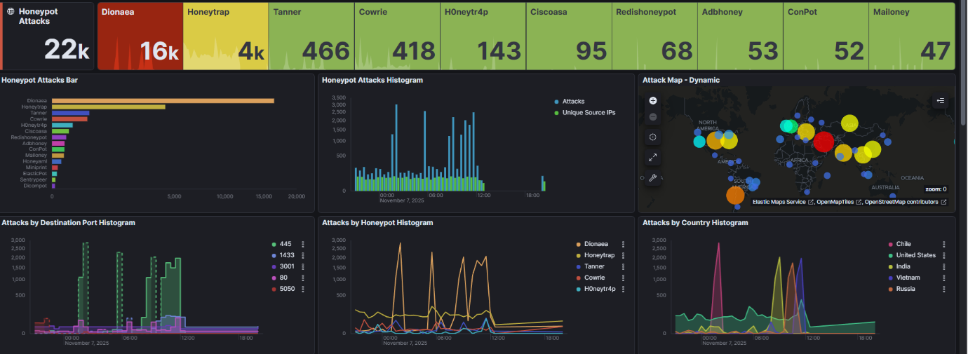
Screenshot of Kibana dashboard: example 1

Fig.6
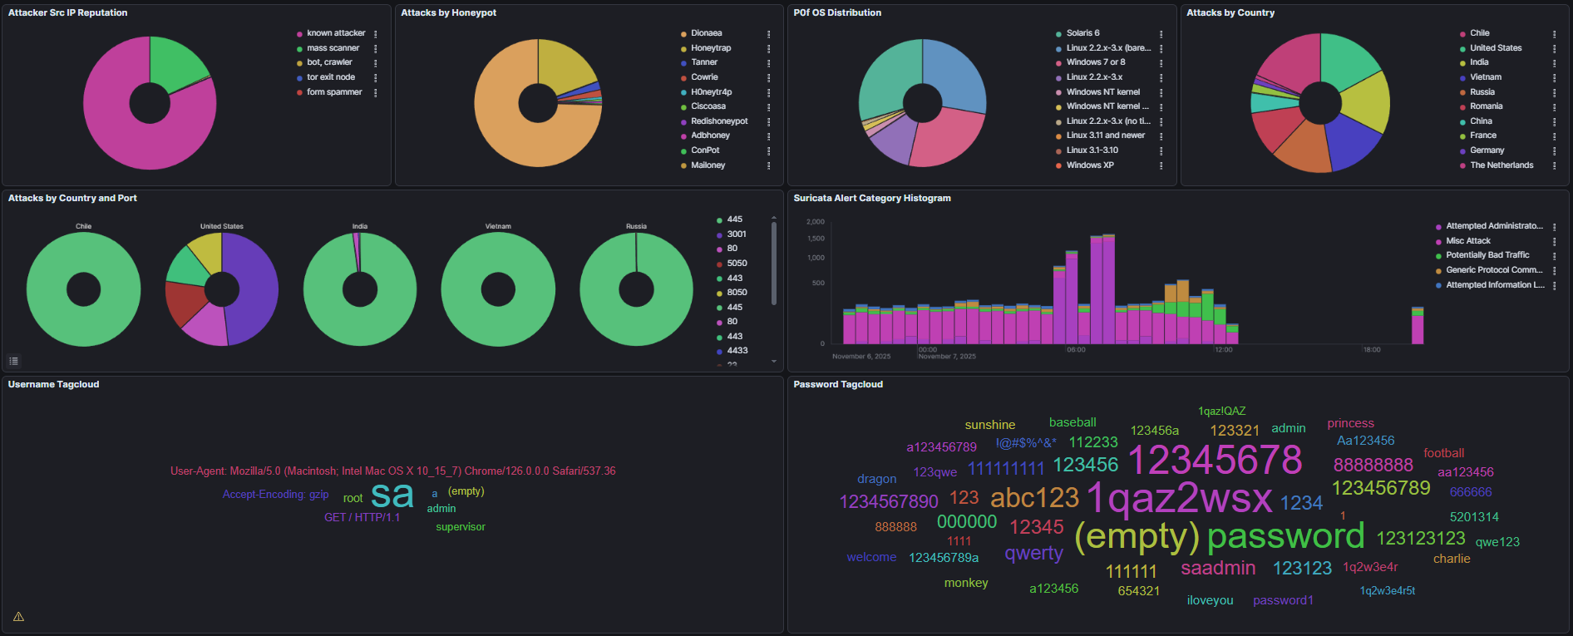
Screenshot of Kibana dashboard: example 2
Fig.7
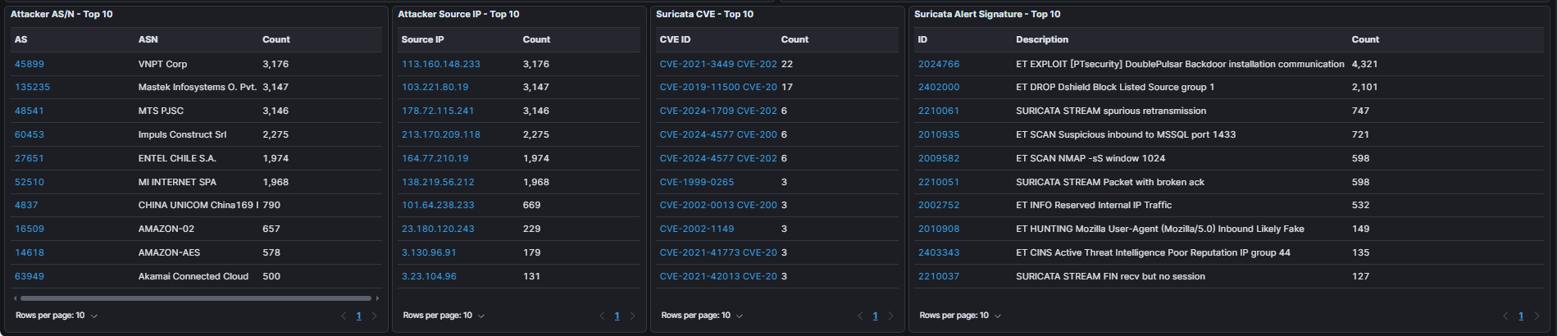
Screenshot of Kibana dashboard: example 3
The visualization of raw logs supports improved trend monitoring and pattern detection, allowing you to identify rises in activity, unexpected source IPs and new targeted ports. Much like the Attack Map described earlier, dashboards offer a far more digestible way to present these metrics to less technical audiences such as stakeholders or management.
Elaticvue
Elaticvue is used as a GUI for interacting with the Elaticsearch cluster that stores all the honeypot logs and data
Fig.8
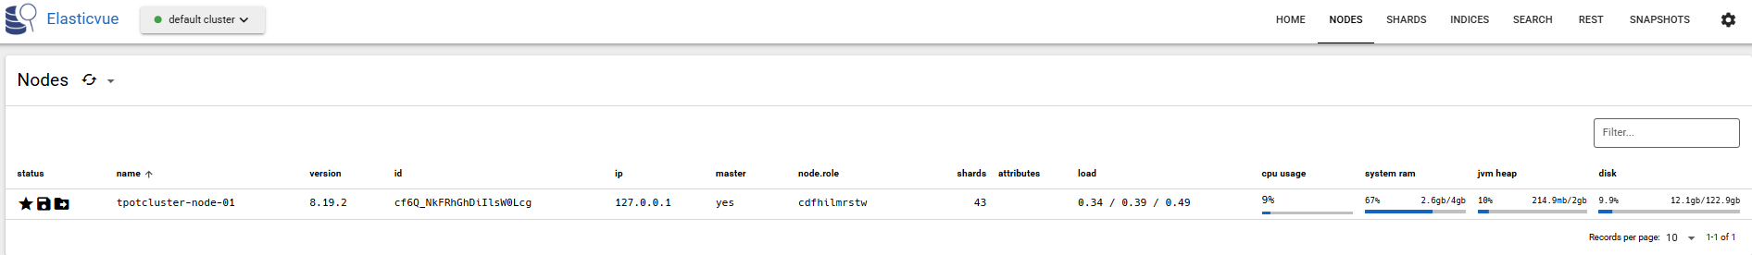
Screenshot of Node menu in Elasticvue

Elasticvue allows you to browse indices, view documents and inspect shards and cluster health.
In T-Pot all honeypot events are indexed into Elasticsearch, and Elasticvue gives you a way to search and explore raw log data that has been extracted from the honeypot. This gives you a more in-depth view on logs than the pre-built dashboard from Kibana. If you have spotted an anomaly in Kibana, you can use this tool to dive deeper into the data and inspect records, check timestamps etc. This tool will also be used to ensure you don’t run out of storage on your nodes.

4.3 Related studies
This section will include, the outcomes we can expect to see according to previous studies that have some similarity, It will also include an evaluation of the existing findings related to honeypot research and how that is linked to cloud provider security and lastly some research questions based off my findings from previous studies to help guide this project.

4.3.1 Expectations according to previous studies
It is expected that Virginia will mainly get source traffic from China, Russia and the United States, as according to studies done over the last decade such as [5] in 2021 and [16] in 2012 the Virginia data centre would mainly receive traffic from China, Russia and the US across all providers. According to previous studies[17] It’s expected that Frankfurt will get the most EU traffic across all cloud providers as it hosts the DE-CIX (Deutscher Commercial Internet Exchange), this is an internet exchange point where different internet providers, cloud companies and CDNs connect directly with one another to exchange internet traffic. It is one of the largest IXPs in the world [17]. This makes it a gold mine for attackers to constantly scan and probe the internet exchange points due to their high value and visibility. Another expectation that we can prepare for is that the platform with the highest amount of traffic will be the Google Cloud Platform , a study at [14] in 2023 observed that GCP rotates and announces new IPv4 ranges more frequently than AWS or Azure and based on the same study the authors found that the newly allocated cloud IP ranges tend to leave an activity print due to the highly populated active servers making it resemble real hosts. This makes it a more popular target for attackers.

4.3.2 Insights from Existing Honeypot Studies and Cloud Provider Safety
The importance of choosing the correct honeypot software is detrimental to a successful and safe study that will provide an accurate answer to the safest provider and location to deploy your network. For example the studies done at [8] found that MHN sensors deployed on certain devices such as Raspberry Pis became overloaded under large attack volumes. This is a big problem as overloaded sensors will compromise the conclusions of the research, they leads to dropped packets, incomplete logs which results in a misleading analysis as an underrepresentation of traffic might make a region or provider seem safer than they actually are.
As noted in [9], MHN also has compatibility issues with modern versions of Ubuntu and CentOS, leading to an unstable setup. This further stretches the importance of selecting the correct software for the analysis. The software would need to be up to date, actively updated and able to handle large volumes of varies types of traffic to ensure an accurate conclusion. T-Pot addresses these points and excels in aspects where MHN falls short. A paper published in 2024 [20], which implemented complex honeypot systems and used T-Pot to measure how well it can “fake” network resources and services to attract attackers. The study found that its multi-service emulation is key to “attract a wide array of cyber attacks”. The authors stated that since T-Pot captures traffic through multiple honeypots, the data is valuable to be able to provide a deep analysis of attacker behaviour. This further backs up the point that the choice of software will determine the accuracy of your results.
Using multiple cloud providers and varies regions in the set up of honeypots is essential for understanding the scope of threats and determining the differences in attack types across all platforms and eventually deciding on the safest cloud provider and region. As Different provider have their own network architecture, popularity, exposure, user distribution and default security settings which influence the types of attacks they experience as seen in [5], [13] and [20]. Regions within a provider experience different exposure as well as seen in [20]. According to the mentioned studies to achieve a complete picture of the threat actors’ activities and determine the safety of a platform, deploying honeypots with the correct tools, across multiple providers and geolocations is the only way to achieve concrete results.

On the paper [13] authors deployed six honeypots on Azure’s cloud, over a 11-month period to ensure to avoid any biases caused by a short-term deployment period. The log store used in the study ensured that written log entries could not be tampered with, increasing the reliability of their data further. The authors observed countless payload attempts such as cryptominers, RATs, attempts to modify SSH keys and attempts to download secondary malware to progress with the virus. This highlights that Azure traffic does not just consist of bots but is exposed to real and malicious payloads. Although this study doesn’t compare cloud providers, the volume of the attempts to deliver a payload aligns with Azure’s large and targeted cloud platform and gives us a foundation for comparison with the findings of the study at [5] who’s research paper made 5 years ago also deployed low-interaction honeypots but across several providers: AWS, Azure and GCP.
On this paper [5], conducted in 2020 and released in 2021, it is examined how attacker activity differs when deploying honeypots across Amazon Web Services(AWS), Google Cloud(GCP) and Microsoft Azure which are major cloud providers, these honeypots were hosted across multiple regions. The deployment was done over only a three-week period which limits the reliability of the findings and do not reflect long-term behaviour. They observed that attacks varied by cloud provider and noted that GCP received the highest number of attacks, 49% of all attack traffic (581,116 attacks out of 1,169,995). At the time, GCP had the smallest market share among the three cloud providers which might have made it look like an easier target. They also found that most of the identified attacks exploited vulnerabilities that date back to as early as 1999, rather than zero day or recent vulnerabilities. These decade old vulnerabilities are publicly available, cheap and still work with organizations that neglect updating or patching old systems.
They found that there were significant differences in attack frequency and variation across all their providers despite implementing the honeypots with identical configurations and time periods, this would indicate that the provider choice and region influence how likely you are to be attacked.
The paper emphasises attack volume and behaviour differences and not the defensive posture of the providers, features such as the number of malicious IPs that are flagged due to their reputation are not present in the study and could not give an accurate account on the providers risk posture nor an in-depth analysis of provider payloads.
My study primarily focuses on the safety of hosting on different cloud providers, which also considers attack volume and behavioural differences of the attackers. However, what really sets this study apart will be conducted over the period of 30 days which allows for the capture of more stable trends, rather than a short snapchat as done in [5]. By extending the deployment period, it reduces bias that is introduced by short-term events and provides more reliable data for the comparison on provider’s safety and exposure. Although their research and findings are reliable, the world of technology has progressed in leaps and bounds over the last 5 years and it would not be wrong to say these findings on attack volume behavioural differences observed on AWS, Azure and GCP are outdated. This is where my study will come forth to fill that gap and provide up-to-date statistics on how the named providers differ in their susceptibility to attacks.
Comparing these studies proved to be important for the research on cloud provider safety. Study [5] suggests that Azure is probed less frequently by attackers when deployed over a short period of time (3 weeks), but the study [13] suggests that when Azure is deployed over a long period (11 months), it attracts real and high-risk payload activity rather than just scanning bots. Unfortunately [13], did not include the number of hits Azure received over the 11-month period but [5] included in their paper that Azure received 340,735 hits over the 3-week period compared to GCP who received 581,116 hits. This demonstrates that Azure may not receive the highest quantity of attacks, but it makes up with the quality of payloads deployed by attackers. These findings will be compared with my own honeypot deployments, as the safest provider cannot be determined by just the quantity of attacks, but instead the complexity and persistence of them.

4.3.3 Research Questions
While conducting this study there is a couple of points that we aim to answer. These questions are listed below:

- How does the age and turnover of cloud IP prefixes influence attacker behaviour across AWS, Azure and GCP?

- How do total attack volumes differ across AWS, Azure, and Google Cloud when identical honeypots are deployed?

- How do AWS, Azure, and GCP compare in attack patterns across regions, and which provider-region combination shows the lowest exposure?

- Which cloud provider receives the highest rate of malware payload attempts, and does this correlate with their perceived risk?

- Which cloud provider demonstrates the lowest overall attack exposure and risk, and is therefore the safest for hosting a production server?

5. Table of Figures
Fig.1: Screenshot of security rule configurations on AWS: example
Fig.2: Pricing model for honeynet project
Fig.3: Screenshot of T-Pot dashboard
Fig.4: Screenshot of Attack Map: example
Fig.6: Screenshot of Attack Map: example 2
Fig.7: Screenshot of Attack Map: example 3
Fig.8: Screenshot of Node menu in Elasticvue

6. References
[1] Loshin, P., 2022. SSH key management best practices and implementation tips. TechTarget. Available at: https://www.techtarget.com/searchsecurity/tip/How-does-proper-SSH-key-management-protect-your-network
[2] Sefer, A., 2023. T-Pot Installation and Use. Medium, 18 August. Available at: https://alisefer.medium.com/t-pot-installation-and-use-f359b9f39a93
[3] Telekom Security (n.d.) T-Pot – The All-in-One Multi-Honeypot Platform. Available at: https://github.com/telekom-security/tpotce

[4] Provos, N. (2004) A Virtual Honeypot Framework. In Proceedings of the 13th USENIX Security Symposium (pp. 1-14)
[5] Kelly, C., Pitropakis, N., Mylonas, A., McKeown, S. & Buchanan, W.J., 2021. A comparative analysis of honeypots on different cloud platforms. Available at: https://doi.org/10.3390/s21072433
[6] Vetterl, A., Clayton, R., & Rieck, K. (2018). Identification and fingerprinting of SSH/HTTP honeypots at Internet scale.
[7] Anisi, B. (2016) State-of-the-art Evaluation of Low and Medium Interaction Honeypots for Malware Collection, M.Sc. thesis, Edinburgh Napier University. Available at: Academia.edu.
[8] Subardono, A. & Hariri, I. K. (2021) ‘Monitoring and Analysis of Honeypot System Performance using Simple Network Management Protocol (SNMP)’. Available at: https://doi.org/10.22146/jise.v2i1.1778
[9] Rafique, U. (2021) Cloud-based Research Honeypots: Technical Report. Undergraduate thesis, National College of Ireland. Available at: https://norma.ncirl.ie/5032/1/umarrafique.pdf
[10] Gartner (2025) Gartner Says Worldwide IaaS Public Cloud Services Market Grew 22.5% in 2024. Available at: https://www.gartner.com/en/newsroom/press-releases/2025-08-06-gartner-says-worldwide-iaas-public-cloud-services-market-grew-22-point-5-percent-in-2024
[11] National Institutes of Health (2024) Science on Google Cloud Platform – HPC Playbook. Available at: https://cloud.nih.gov/resources/guides/science-at-cloud-providers/science-on-gcp/GCPHPCPlaybook.pdf
[12] Lanka, P., Varol, Ç., Burns, K. & Shashidhar, N. (2023) Magnets to Adversaries—An Analysis of the Attacks on Public Cloud Servers. Electronics. Available at: https://doi.org/10.3390/electronics12214493
[13] Agrawal, R., Stokes, J. W., Rist, L., Littlefield, R., Fan, X., Hollis, K., Coppedge, Z., Chesterman, N. & Seifert, C. (2022) Long-Term Study of Honeypots in a Public Cloud, in Proceedings of the 52nd Annual IEEE/IFIP International Conference on Dependable Systems and Networks. Available at: https://doi.org/10.1109/DSN-2022.00051
[14] Izhikevich, L., Tran, M., Kallitsis, M., Fass, A. & Durumeric, Z. (2023) ‘Cloud Watching: Understanding Attacks Against Cloud-Hosted Services’ Available at: https://doi.org/10.1145/3618257.3624818
[15] Mahmoud, R.-V. & Pedersen, J. M. (2019) Deploying a University Honeypot: A case study. CEUR Workshop Proceedings. Available at: https://ceur-ws.org/Vol-2443/paper03.pdf
[16] Brown, S., Lam, R., Prasad, S., Ramasubramanian, S. & Slauson, J. (2012) Honeypots in the Cloud. University of Wisconsin-Madison. Available at: https://pages.cs.wisc.edu/~sbrown/downloads/honeypots-in-the-cloud.pdf
[17] DE-CIX (2024) Europe’s largest Internet. Available at: https://www.de-cix.net/en/about-de-cix/media/press-releases/new-record-at-de-cix-frankfurt-europes-largest-internet-exchange-hits-18-terabits-per-second-data-throughput

[18] Hanauer, T., Hommel, W. & Metzger, S., 2018. A process framework for stakeholder-specific visualization of security metrics. Available at: https://doi.org/10.1145/3230833.3232855
[19] Kibana Dashboards. Elastic.co. Available at: https://www.elastic.co/docs/explore-analyze/dashboards
[20] Mohd Fuzi, M. F., Mazlan, M. F., Jamaluddin, M. N. F. & Abd Halim, I. H. (2024) ‘Performance Analysis of Network Intrusion Detection Using T-Pot Honeypots. Available at: https://doi.org/10.24191/jcrinn.v9i2.477
[21] Vasilomanolakis, E., Karuppayah, S., Kikiras, P. & Mühlhäuser, M., 2015. A honeypot-driven cyber incident monitor: Lessons learned and steps ahead. In: Proceedings of the 8th International Conference on Security of Information and Networks. Available at: https://doi.org/10.1145/2799979.2799999
[22] T-Pot setup guide: Security configurations: Setting Up a Honeypot in AWS and Analyzing Cyber Attacks (Check pinned comment for 2022 update)

