PROJECT SPECIFICATION
Analysing Global Cyber Threat Trends Using Distributed Honeynets
Rihards Ozols – C00281617
BSc (Hons) in Cybercrime and IT security

1. Abstract 1
1.1 Introduction 2
2. Background 2
2.1 Problem statement 3
2.2 Deliverables 3
2.2.1 Core Deliverables 3
Non-system-specific Core Deliverables 4
2.2.2 Secondary deliverables 4
3. Project Plan 4
3.1 Methodology 5
3.2 Phases & Timeline 5
Phases 5
Timeline: 6
3.3 Milestones 8
4. Analysis 9
5. References 9
5.1 Table of Figures 10

1. Abstract
For this dissertation there will be nine honeypots deployed, with three per provider, each located in a different geographic region. All systems were configured identically using T-Pot and connected to the Elastic Stack for centralised log collection and analysis. The selected regions were Virginia (US), Frankfurt (Germany), and Singapore, chosen due to their widespread use, strong digital infrastructure, and high network visibility across all providers. Using the same regions across all providers ensures a fair comparison, as it controls for geographic bias and allows differences in results to be more confidently attributed to provider characteristics rather than location alone.
To maintain consistency and validity throughout the study, several controls were implemented. These included identical system configurations across all deployments, the use of the same honeypot software (T-Pot), deployment in matching geographic regions, consistent firewall rules and port exposure, and the use of identical tools for data collection and analysis.
A key gap in existing research is the lack of controlled, simultaneous comparisons across multiple providers and regions using identical configurations over an extended period. Many previous studies focus on a single provider, vary deployment conditions, or operate over short timeframes, making direct comparison difficult. This dissertation addresses that gap by deploying identical low-interaction honeypots across AWS, Azure, and GCP in matched geographic regions over a longer continuous deployment period, enabling a more reliable and comprehensive comparative analysis of global attack behaviour.

1.1 Introduction
This report will outline the technical specifications of the system, including the architecture of the honeynets, the tools and frameworks used, and the methodology for data collection and analysis. It will also examine the behaviour of attackers in terms of frequency, persistence, targeted services, and geographic origin.

2. Background
What is a honeynet
A honeynet is a network deliberately set up to mimic a real operational network with systems, services and applications but it’s isolated and monitored so that any traffic that passes through it, is assumed suspicious.
Its primary purpose is to attract attackers or exploit attempts, allowing us to observe attacker behaviour, tools, techniques and motivations in a controlled environment.
The deployment of honeypots has been the means of observing the malicious attacker’s behaviour, strategy and mindset and has aided in the understanding of emerging threats. Early honeypot research such as [2], focused on single-node traps for collecting exploit payloads and understanding the attacker’s methodologies. Over time, this evolved into honeynets, an interconnected networks of honeypots designed to emulate realistic infrastructure and observe broader attack strategies. Modern research has examined the distribution of attack traffic across geographic and infrastructural boundaries. Studies at [1] and at [3] demonstrated that statistical analysis of honeypot data could identify systemic attack features, such as characteristic byte distributions or packet frequencies. Later work in 2015[4], introduced honeypots in virtualized and cloud environments, identifying unique attacker behaviours that emerge from differences in IP reputation and hosting provider policies. However, few studies have conducted simultaneous cross-region (Virginia, Frankfurt and Singapore) and cross-provider comparisons, especially across commercial cloud platforms (AWS, Azure, GCP).

2.1 Problem statement
While honeypots and honeynets have long served as valuable tools for understanding attacker behaviour and emerging cyber threats, existing research has largely focused on localized or single-provider environments. Although prior studies have explored aspects such as exploit payload analysis, attack frequency distributions, and virtualized honeypot deployments, there remains a significant gap in comparative analysis across diverse cloud platforms and geographic regions.
When deciding where to host a public-facing website or application, the usual guideline is to host it in your own region (for example: host in Asia if you are based in Asia, host in the Americas if you are there). What we want to investigate is whether hosting in a more secure region rather than locally, offers enough security benefits to justify the extra cost.
This project fills that gap by deploying uniform honeynet environments across multiple providers to assess how attacker behaviour and strategies differs depending on geographic region and platform type.

2.2 Deliverables

2.2.1 Core Deliverables
Virtual Machines (VMs)
The project establishes virtual machine (VM) infrastructure, with each VM designed to host honeynet environments across multiple regions and cloud providers. The honeynets will be hosted on AWS, Azure, and Google Cloud using T-Pot software and placed across strategically picked regions that the cloud providers share.

Dashboard Visualisations
The dashboard is fully built, data feeds from the honeynets and other sources are connected to produce visualizations

Data collection
Have a successful deployment and run period of honeynets, Data extracted from logs and transferred into dashboard.

Non-system-specific Core Deliverables
Methodology
In this section I describe the environments and regions selected for my honeynets and the rationale behind those choices. I outline the strategy for data collection and analysis and explain how I intend to present the results of my findings.
Analysis
The analysis will involve processing the data captured by the honeynet VMs to identify patterns of attacker behaviour, tools used, exploited services and geographic sources of attacks. I will examine timestamps, IP addresses (both attacker and honeynet), targeted ports/services and duration of sessions to build a timeline and profile of each intrusion. Then I will compare across regions and providers to determine whether attacker strategies differ by location or cloud environment. Finally, I will visualise key findings (for example graphs of attack frequency by hour/day, heat-maps of origin countries, and service-target distribution) on my dashboard and interpret how these insights can improve future honeynet deployments and organisational defensive posture. I will also address all questions and hypotheses that I presented in the beginning of this report

2.2.2 Secondary deliverables
Weekly checklist
A standardized weekly checklist will be completed for all honeynet nodes to ensure all honeypots are online and reachable, Log forwarding to the central server is functional, Disk/storage usage is below any critical thresholds and backup scripts executed successfully.

Project Journey Report
This report will be completed at the end of my project and will talk about any issues or complications I encountered while trying to compile this research project, I will mention technical constraints that could’ve influenced my findings and things I would do differently if I had to start this project from scratch.

3. Project Plan
In this section, I will outline the platform selected for hosting the honeynet environments, explaining how it operates and justifying the choice of cloud providers and geographic regions. I will then describe the overall architecture of the honeynets, along with an estimation of the associated operational costs.
Following this, I will discuss the selection of specific network ports used within the deployment, with the aim of gaining deeper insight into attacker behaviour and how it may vary based on geographic origin.
Finally, I will present the dashboarding tools used for data visualisation, and provide an overview of the project phases, including a detailed timeline and the key milestones intended to guide the progression of the study.

3.1 Methodology
The cloud providers I chose are AWS, Azure and GCP, I've selected these because they each differ in terms of security frameworks and infrastructure, providing a broad spectrum of environments in which to deploy my honeynets. Although they are based on opposite side of the world from one another, they share a couple of major data centres that are well distributed across the globe.
Each cloud provider will host three low-interaction honeypots using the T-Pot framework for a total of 80 days. These honeypots will be distributed across three Cloud providers and three locations: Virginia, Frankfurt, Tokyo, and Singapore. The cost of hosting these honeypots vary across each cloud provider and will be further investigated in the coming weeks.
Each honeypot will expose common high-interest ports (e.g., 22, 23, 80, 443, 445, 3389) and emulate vulnerable services to attract attackers.

3.2 Phases & Timeline

Phases
Phase One – Planning and design
Finalize the virtual machine specifications and determine the distribution of honeypots across selected cloud providers and regions. Identify three cloud providers and three common major data centre locations shared between them. Select the appropriate software for deploying the honeynets and define which network ports will be exposed.
Additionally, determine the type of honeypots to be used, considering whether low-interaction or high-interaction solutions are more suitable for the objectives of the study

Phase Two – Build and Test
Install MHN, Kibana and configure stack on ELK. Set up test honeypot on each cloud provider for 2-3 days and check if logs are being collected, stored and backed up correctly.

Phase Three – Deploy and Monitor
Deploy identically configured honeynets across all selected regions and cloud providers. Monitor storage usage and verify that log data is being consistently collected and backed up.
Initiate a weekly checklist to ensure the continued stability, availability, and proper operation of all deployed honeypots.
Phase Four - Operate, Collect & Work on dashboard
Operate the honeynets for a total duration of 4.5 weeks. Continue with weekly monitoring to ensure system stability, while also reviewing existing honeynet studies to gain deeper insights that will inform the analysis phase. Ensure storage health and data integrity are consistently maintained throughout the deployment.
While the honeynets are running, focus on developing the Kibana dashboard to effectively visualise and present the collected data and key findings.

Phase Five - Analyse & Compare
Shut down all honeynet deployments and consolidate the collected log data for analysis. Examine key metrics and analyse patterns as and anomalies to develop insights into attacker behaviour, and perform a comparative evaluation across the different cloud providers and regions.
Phase Six – Finalize
Conduct a dedicated research phase reviewing previous studies on honeypots and honeynets to provide context and support for the analysis. This will involve examining existing literature to identify common methodologies, findings, and limitations, allowing for a more informed comparison with the results of this project.
Following this, produce the final report and present the overall conclusions of the study. Provide a detailed account of the tools, data, platforms, and software utilised throughout the project. Summarise key findings using visualisations, including charts and screenshots generated from Kibana.
Additionally, outline the data handling procedures implemented to ensure secure storage and reliable backups. Conclude with a comprehensive comparison of results, highlight key takeaways, and prepare supporting materials for presentation.

Timeline:
Figure 1 Breakdown of Phases - Timeline
PHASE | WEEKS | PHASE | KEY TASKS
1 | 1-2 | Planning & Design | VM specs, tools selection, honeynet architecture
2 | 3-5 | Build & Test | Deploy test honeynets on selected regions and let them run for a couple of days to check logs are being collected and backed up correctly
3 | 6-7 | Deploy & Monitor | Go live on all cloud providers with 9 honeypots distributed across 3 regions – Ensure logs are being collected
4 | 8-20 | Operate, Collect & Work on dashboard | Weekly monitoring of honeynets, ensure they are still up and not out of storage  Make dashboard
5 | 21-25 | Analyse & Compare | Shutdown honeynets – Gather all logs – Analyse findings – evaluate hypothesis – compare regions/providers
6 | 26-28 | Finalize | Present findings in final report

Figure 2 - Phases and planned completion dates
Start Date | End Date | Days | Phase
30/10/2025 | 13/11/2025 | 14 | Phase 1
14/11/2025 | 28/11/2025 | 14 | Phase 2
29/11/2025 | 06/12/2025 | 7 | Phase 3
06/12/2025 | 24/02/2026 | 80 | Phase 4
24/02/2026 | 31/03/2026 | 35 | Phase 5
31/03/2026 | 14/04/2026 | 14 | Phase 6

Figure 3 - Gantt Chart of Timeline
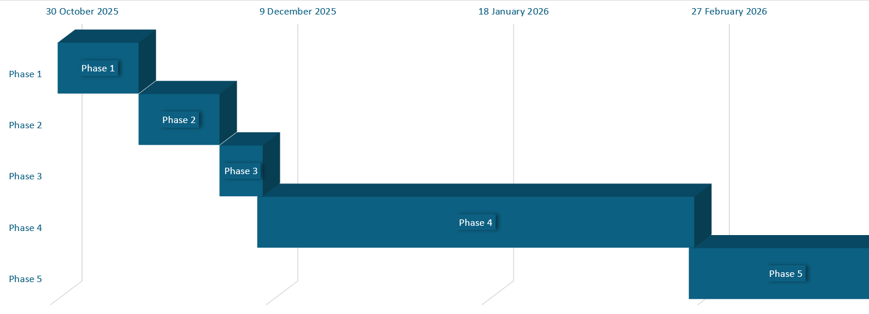

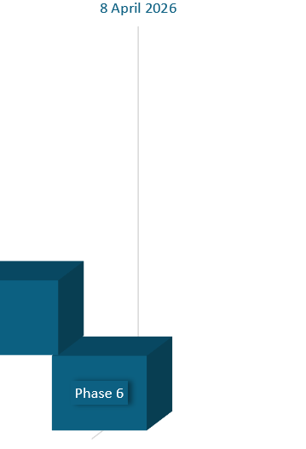

3.3 Milestones
Honeynets Operational
The honeynet infrastructure is fully configured, deployed, and operational. All honeypots are active, network monitoring is in place, logging mechanisms are functioning correctly, and initial test traffic has been successfully captured to verify the setup.

Dashboard Completion
The dashboard has been fully developed, with data feeds from the honeynets and additional sources successfully integrated. Visualisations, including charts and diagrams, are functioning as intended, allowing for further refinement and enhancement throughout the project.

Log Collection
The ELK stack has been successfully configured to ingest and process logs within Kibana. Log data has been securely stored, backed up, and remains accessible following the honeynet deployment period. Adequate storage processes are in place, and sufficient log volume has been collected to support detailed analysis.

Analysis
The collected logs have been processed and examined to compare attack across different providers and regions.

Research Paper
This will be a paper where I will be reviewing existing studies to identify common methods, key findings, and limitations, allowing for a clearer comparison with this project’s results

Final Report
A comprehensive final report has been compiled, addressing all project objectives and requirements. All content is appropriately referenced, and clear, evidence-based conclusions are presented.

4. Analysis
My analysis will commence with the formulated research questions, followed by a set of subsidiary questions to support the investigation. I will test several hypotheses throughout the study. Upon the completion of the honeynet deployment and receipt of all log data, I will evaluate aspects such as attack types, attack volume and complexity, and whether attacks are prolific or persistent. I will then address each research question and hypothesis, drawing comparisons across different providers, geographic regions and provide diagrams and graphs from my dashboard to support these comparisons.

5. References
[1] Cukier, Berthier, Panjwani, Tan. (2006). A Statistical Analysis of Attack Data to Separate Attacks . In Proceedings of the 2006 International Conference on Dependable Systems and Networks (DSN’06). IEEE. 10.1109/DSN.2006.9
[2] Spitzner, L. (2003). Honeypots: Tracking Hackers. Addison-Wesley.
[3] Zdrnja, B., et al. (2008). Observing Internet Attacks Using Low-Interaction Honeypots. IEEE Transactions on Information Forensics and Security.
[4] Almeshekah, M., et al. (2015). Designing Deception: The Role of Human and Technical Factors in Deceptive Security Tools. IEEE Security & Privacy.

5.1 Table of Figures
Figure 1 Breakdown of Phases - Timeline 7
Figure 2 - Phases and planned completion dates 8
Figure 3 - Gantt Chart of Timeline 8

