

Form3
Design
Title :

GROUP MEMBER:
No. | Student Name | Student ID
1. | …. (Leader)
2. | …. (Member 1)
3. | …. (Member 2)

Advisor : ……………………….

Submitted for
Capstone Design Project
to Faculty of Computer Science
President University

TABLE OF CONTENT

STATEMENT OF ORIGINALITY

In my capacity as an active student at President University and as the author of the Capstone Design Project stated below:
Name : 1. Student Name – NIM
2. Student Name – NIM
3. Student Name – NIM
Faculty : Computer Science
I hereby declare that my Capstone Design Project entitled “TITLE” is to the best of my knowledge and belief, an original piece of work based on sound academic principles. If there is any plagiarism detected in this final project, I am willing to be personally responsible for the consequences of these acts of plagiarism and will accept the sanctions against these acts in accordance with the rules and policies of President University.
I also declare that this work, either in whole or in part, has not been submitted to another university to obtain a degree.

Cikarang, January 2024

Signer 1 | Signer 2 | Signer 3
Student Name – NIM | Student Name – NIM | Student Name – NIM

SCREENSHOT OF ZEROGPT

PART 3
DESIGN

Consists of:
- SYSTEM DESIGN
- HIERARCHICAL / ITERATIVE DESIGN
- STANDARDS USED
- FUNCTIONAL TESTING

- SYSTEM DESIGN

Provide all the necessary information about how you would design the system. This includes the mock-up design for interfaces. The System Design must explain in general about the design of the application starting from the architecture, the connection to storage and other components.

Such diagram could act as an example, though you must also provide the detailed explanation
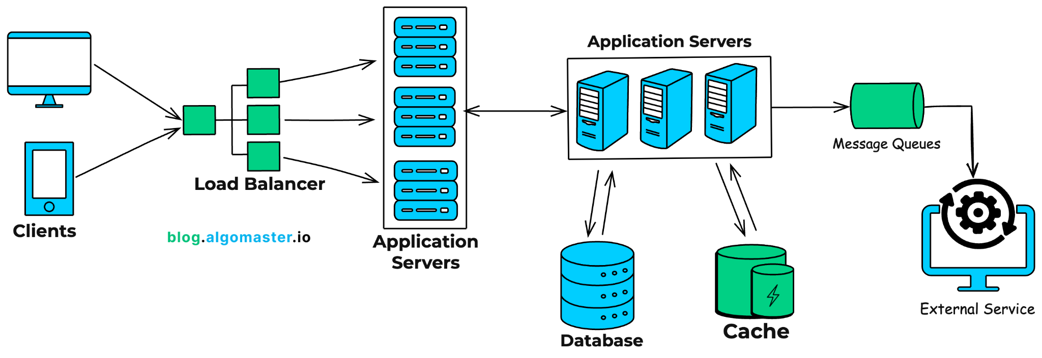

- HIERARCHICAL/ITERATIVE DESIGN

- Provide Block Diagram / Data Flow Diagram / similar from highest to lowest level. Your lowest level should include primitive software functions circuits with discrete components, Integrated Circuits, or off-the-shelf modules. This is different from section A, in this section you put the detailed diagrams.

- Provide clear interface information between block diagrams. (example: Global variable, message passing, parameter passing).

- Implement steps in Software Engineering Design as your design documentation.

- Provide the details of component references and libraries used.

- Provide clear and correct modelling by using existing modelling standards such as:
Flowcharts, Algorithm(?), UML (Structure Diagrams, Behavioral Diagrams), example: Class Diagram, Use Case Diagram, Activity Diagram, Sequence Diagram, Entity Relationship Diagram

- STANDARDS USED

List the standards used in the application such as voltage levels, data formats, form factors, etc.
This includes standards such as JSON format, UML version, the API used (RPC, REST), also the formatter if any.
Represent in a table

- IMPLEMENTATION AND TESTING SCENARIO

Provide a detailed description of how you want to implement the system, also provide all the possible scenarios of how you want to test the system.

Examples: the log in system is implemented using two-factor authentication. To test the authentication process, the user has to enter the username and password, then wait for the OTP before accessing the system. You must also put the alternatives such as, if the user enters the wrong username and/or password, the system will show an error message.

Put the scenarios in a table, with detailed elaboration

REFERENCES

