Lab 16 – Numpy

**1. Create a 1D array with elements from 1 to 10.**

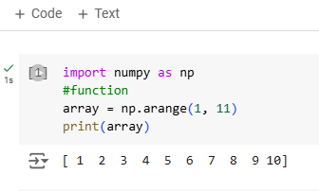

**2. Create a 2D array of size 3x3 filled with zeros.**

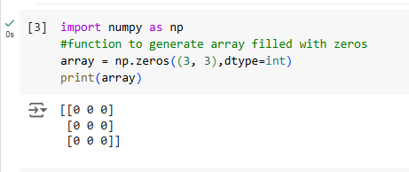

**3. Find the maximum and minimum values in an array.**

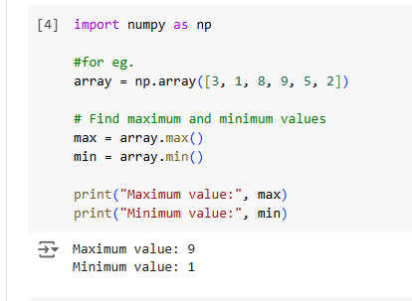

**4. Reshape a 1D array into a 2D array of shape 2x5.**

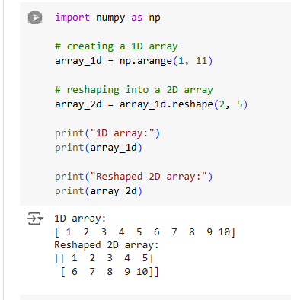

**5. Generate a 1D array of 5 random integers between 10 and 50.**

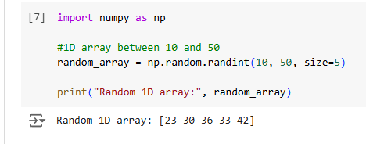

**6. Convert the below list into numpy array then display the array**

**Input: my_list = [1, 2, 3, 4, 5]**

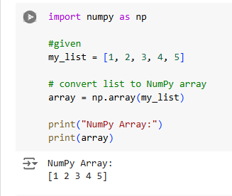

**7. Convert the below list into a numpy array then display the array then display the first and last index and then multiply each element by 2 and display the result.**

**Input: my_list = [1, 2, 3, 4, 5]**

