**Lab 23 – Matplotlib bar plot and histogram**

**1. Visualize the daily temperature changes over time in a city and give your**

**conclusion**

**Input:**

days = list(range(1, 32))

# Daily temperature data (replace with your own data)

temperature = [65, 68, 70, 72, 75, 76, 78, 80, 81, 79, 75, 72, 70, 68, 67, 69, 70, 73, 75, 76, 78,80, 81, 82, 83, 82, 80, 78, 76, 74, 71]

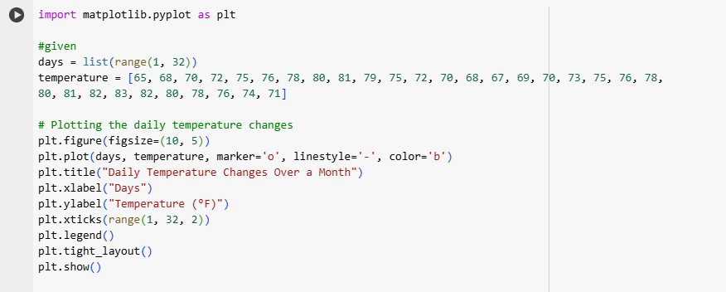

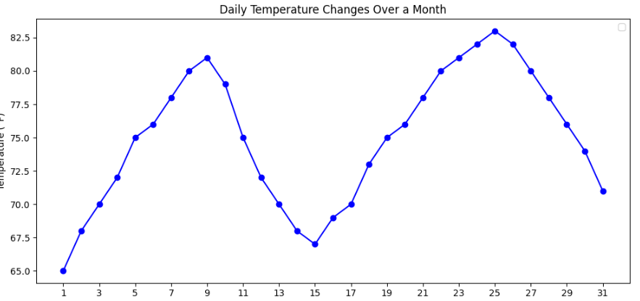

**Conclusion:** The temperature follows a upward trend for first few weeks. After reaching the peak the temperature declines which suggests a transition from warmer to cooler weather i.e changing seasons or local climate patterns.

**2.Create a line plot to visualize the daily closing prices of a stock over a year and give your conclusion.**

**Input: days = list(range(1, 78))**

**# Daily closing prices of a stock (replace with your own data)**

**stock_prices = [100, 105, 110, 115, 112, 120,**

**118, 125, 128, 130, 132, 135,**

**138, 140, 142, 144, 145, 148,**

**150, 155, 160, 158, 162, 165,**

**170, 172, 175, 178, 180, 182,**

**185, 188, 190, 192, 195, 198,**

**200, 198, 195, 193, 190, 188,**

**185, 182, 180, 178, 175, 172,**

**170, 168, 165, 162, 160, 158,**

**155, 152, 150, 148, 145, 143,**

**140, 138, 135, 132, 130, 128,**

**125, 123, 120, 118, 115, 112,**

**110, 108, 105, 103, 100]**

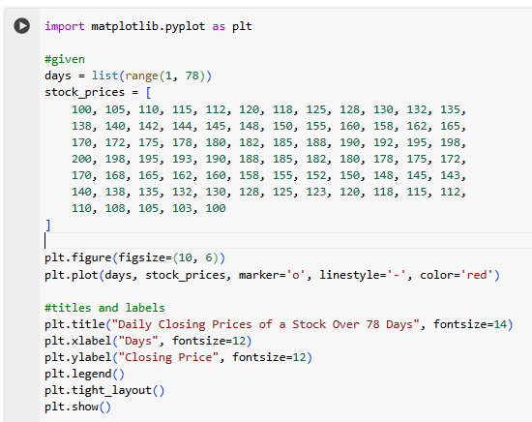

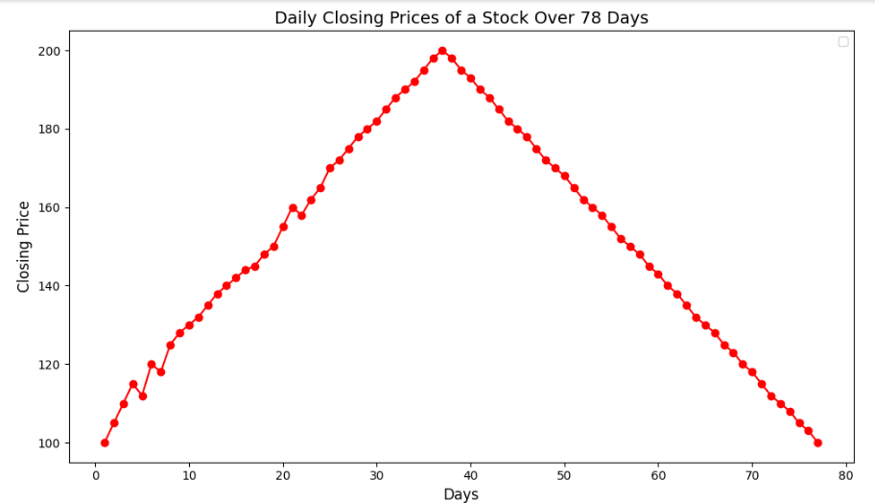

**Conclusion:** There is a steady increase in stock prices in the early days reaching a peak. After hitting the peak the stock prices begin to decline gradually. The prices exhibit a cyclic pattern, with a rise followed by a gradual decline.

**3. Create a bar chart to represent monthly expenses in different spending**

**categories and give your conclusion.**

**Input:**

**categories = ['Rent', 'Groceries', 'Utilities', 'Entertainment', 'Transportation']**

**# Monthly expenses in dollars (replace with your own data)**

**expenses = [1200, 400, 200, 150, 250]**

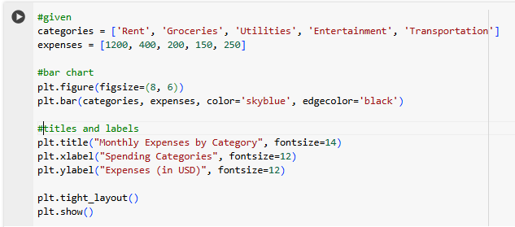

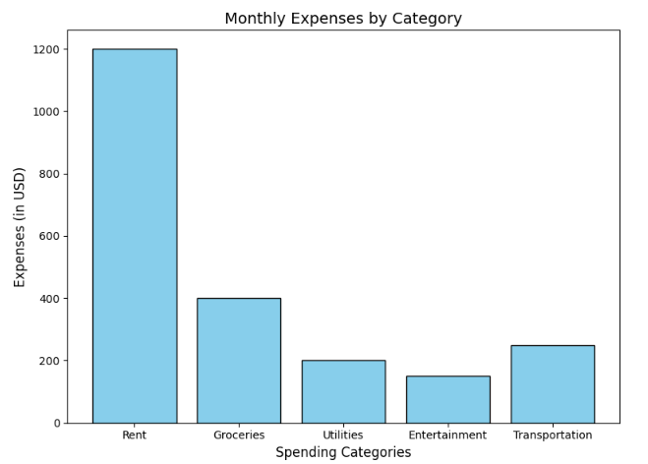

**Conclusion:** The highest expense category at $1,200, accounting for a significant portion of monthly spending.The second-largest category, costing $400.Utilities, Entertainment, and Transportation have relatively lower expenses, at $200, $150, and $250, respectively.

**4. Create a histogram to represent the distribution of product prices in a retail store and give your conclusion.**

**Input: product_prices = [24.99, 34.99, 49.99, 64.99, 39.99, 54.99, 79.99, 99.99, 29.99, 44.99, 59.99, 69.99, 84.99, 109.99, 119.99, 89.99, 74.99, 124.99, 69.99, 54.99]**

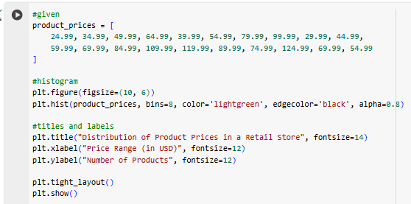

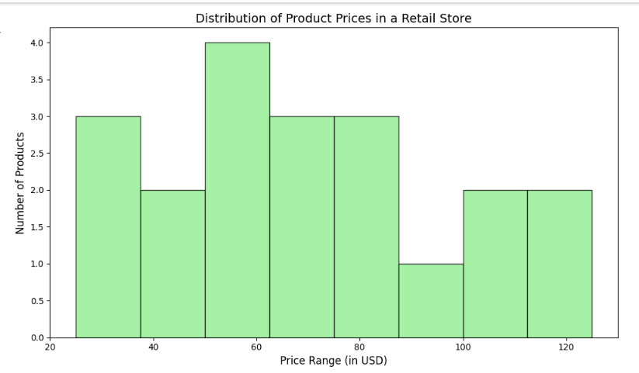

**Conclusion:** Most products are in the mid-range price categories, particularly between $30 and $70.A smaller number of products are priced above $100, indicating a limited selection of premium items.Products below $30 are sparse which suggests that the store focuses more on mid to higher-priced goods.