Lab 24 – Matplotlib plot and formatting

**1.Analyze the relationship between the size of houses (measured in square**

**footage) and their selling prices in a particular neighborhood. You have collected**

**data on various houses in that neighborhood.Create a scatter plot using the**

**below data and share your conclusion/analysis.**

**Input:** square_footage = np.array([1200, 1400, 1600, 1800, 2000, 2200, 2400, 2600, 2800,3000])

selling_prices = np.array([250, 290, 315, 380, 410, 450, 500, 525, 570, 610])

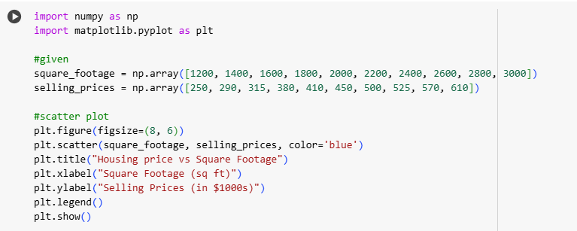

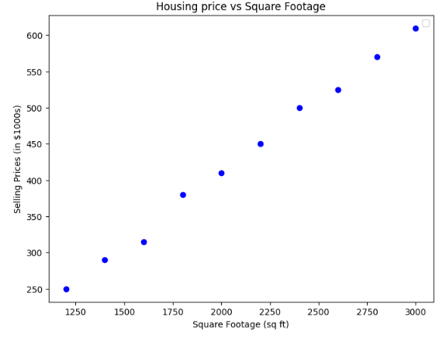

**2.Create a pie chart to visualize the distribution of your monthly income by**

**source. You have collected data on the various sources of your income, such as**

**salary, freelance work, investments, and rental income. Share your**

**conclusion/analysis.**

**Input:**

income_sources = ['Salary', 'Freelance', 'Investments', 'Rental', 'Other']

monthly_income = [5000, 1500, 1000, 600, 400]

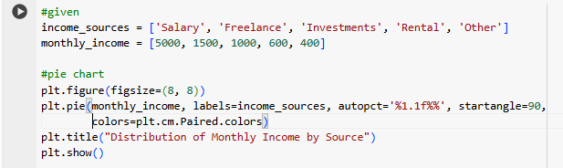

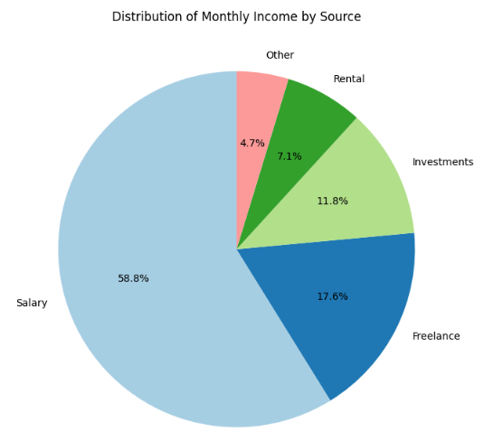

**3.Create a pie chart to illustrate the distribution of a company's revenue**

**across its various business segments. You have collected data on the revenue**

**generated by each segment, such as Product A, Product B, Services, and**

**Licensing. Share your conclusion/analysis.**

**Input:**

segments = ['Product A', 'Product B', 'Services', 'Licensing']

revenue_percentages = [45, 25, 15, 15]

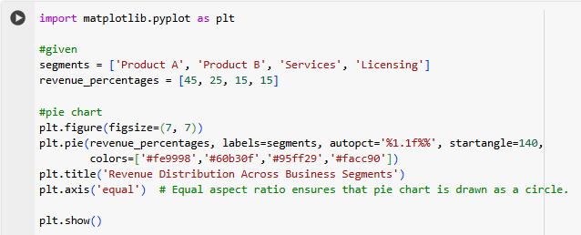

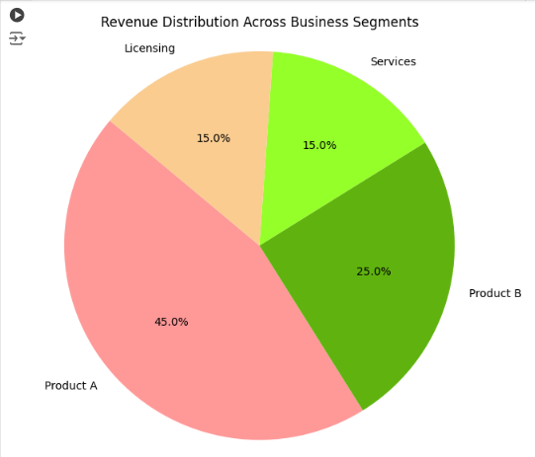

**4.Suppose you're a sales manager for an e-commerce company, and you**

**want to create a figure with subplots to compare the sales performance of**

**different product categories over time. You have sales data for four product**

**categories: Electronics, Clothing, Home & Garden, and Sports & Outdoors. Share**

**your conclusion/analysis.**

**Input:**

months = np.arange(1, 13)

electronics_sales = np.array([25000, 28000, 31000, 27000, 30000, 32000, 35000,

36000, 38000, 39000, 41000, 42000])

clothing_sales = np.array([15000, 16000, 17000, 18000, 19000, 20000, 21000, 22000,23000, 24000, 25000, 26000])

home_garden_sales = np.array([18000, 19000, 20000, 21000, 22000, 23000, 24000,25000, 26000, 27000, 28000, 29000])

sports_outdoors_sales = np.array([12000, 13000, 14000, 15000, 16000, 17000, 18000,19000, 20000, 21000, 22000, 23000])

