Lab 26 – Pandas Dataframe

**1.Write a Pandas program to create a dataframe from a dictionary and**

**display it.**

Sample data: score={'Math':[78,85,96,80,86], 'English':[84,94,89,83,86],'Hindi':[86,97,96,72,83]}

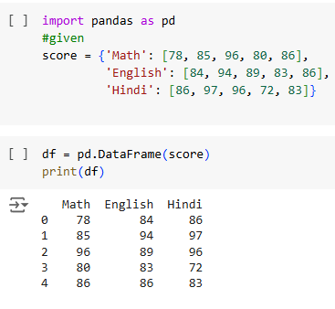

**2.Write a Pandas program to create and display a DataFrame from a specified dictionary data which has the index labels.**

**Sample Python dictionary data and list labels:**

exam_data = {'name': ['Anastasia', 'Dima', 'Katherine', 'James', 'Emily', 'Michael', 'Matthew', 'Laura', 'Kevin', 'Jonas'],

'score': [12.5, 9, 16.5, np.nan, 9, 20, 14.5, np.nan, 8, 19],

'attempts': [1, 3, 2, 3, 2, 3, 1, 1, 2, 1],

'qualify': ['yes', 'no', 'yes', 'no', 'no', 'yes', 'yes', 'no', 'no', 'yes']}

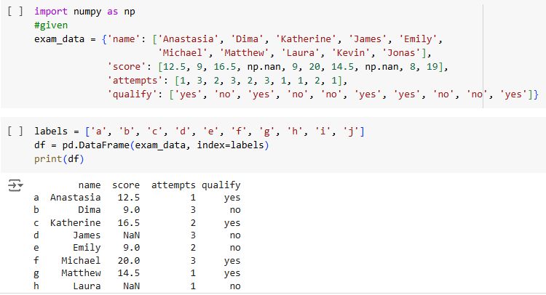

**3.Write a Pandas program to get the first 3 rows of a given DataFrame.**

***Sample DataFrame*:**

exam_data = {'name': ['Anastasia', 'Dima', 'Katherine', 'James', 'Emily',

'Michael', 'Matthew', 'Laura', 'Kevin', 'Jonas'],

'score': [12.5, 9, 16.5, np.nan, 9, 20, 14.5, np.nan, 8, 19],

'attempts': [1, 3, 2, 3, 2, 3, 1, 1, 2, 1],

'qualify': ['yes', 'no', 'yes', 'no', 'no', 'yes', 'yes', 'no', 'no', 'yes']}

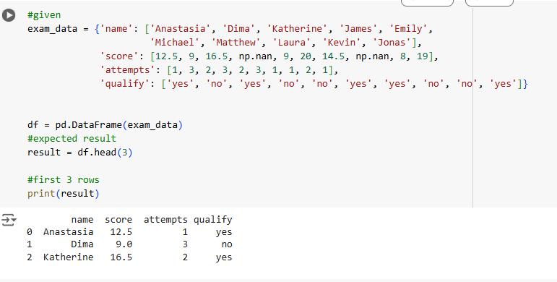

**4.Write a Pandas program to select the 'name' and 'score' columns from the following DataFrame.**

**Sample Python dictionary data and list labels:**

exam_data = {'name': ['Anastasia', 'Dima', 'Katherine', 'James', 'Emily',

'Michael', 'Matthew', 'Laura', 'Kevin', 'Jonas'],

'score': [12.5, 9, 16.5, np.nan, 9, 20, 14.5, np.nan, 8, 19],

'attempts': [1, 3, 2, 3, 2, 3, 1, 1, 2, 1],

'qualify': ['yes', 'no', 'yes', 'no', 'no', 'yes', 'yes', 'no', 'no', 'yes']}

