# Conditional Formatting

**1. Apply conditional formatting to highlight cells in the Sales column (D) with values greater than or equal to 150.**

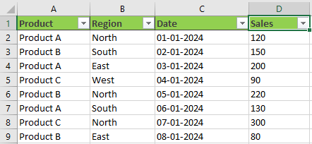

**Solution**

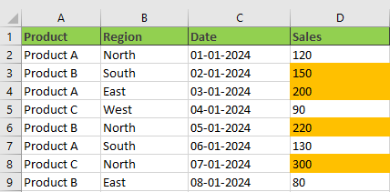

**2. Apply conditional formatting to highlight the entire row for entries where the Product is "Product A".**



**Solution**

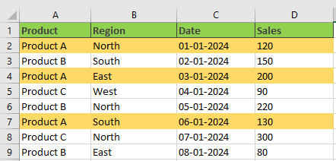

**3. Apply conditional formatting to highlight cells in the Date column (C) that fall within January 2024.**

**\*\*Added the months Feb and Mar\*\***

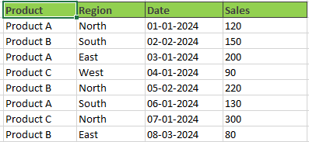

**Solution**

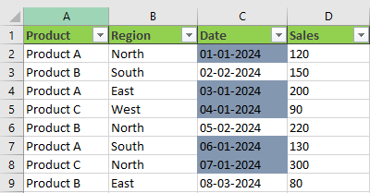

**4. Apply conditional formatting to highlight the top 3 sales values in the Sales**

**column (D).**



**Solution**

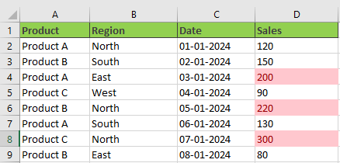

**5. Apply conditional formatting to highlight sales for "Product B" in the "North" region**.



**Solution**

