# *HLookup*

**1. Use HLOOKUP to find the sales for Product A in March.**

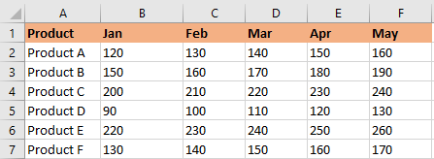

**Solution**

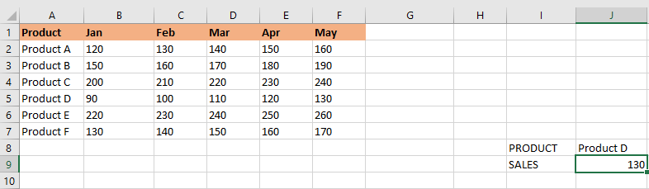

**2. Use HLOOKUP to find the sales for Product D in May.**

**Solution**

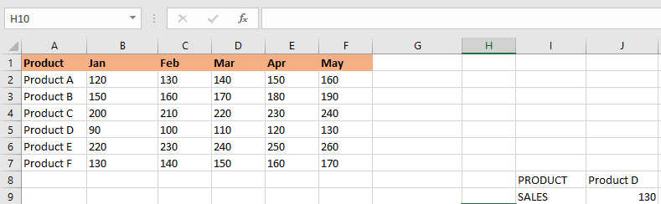

**3.Use HLOOKUP to find the sales for Product C in February.**

**Solution**

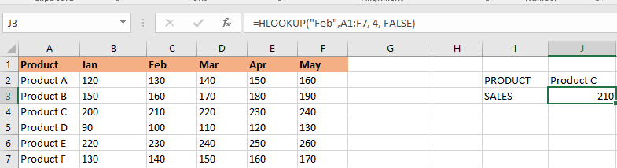

**4. Use HLOOKUP to find the sales for each month for a product, then calculate the total sales for that product.**

**Solution**

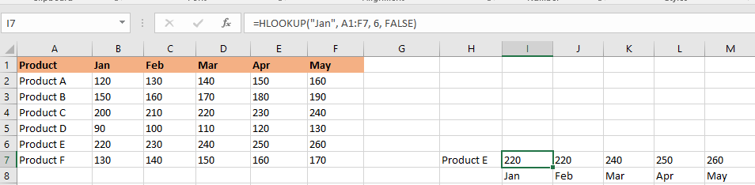

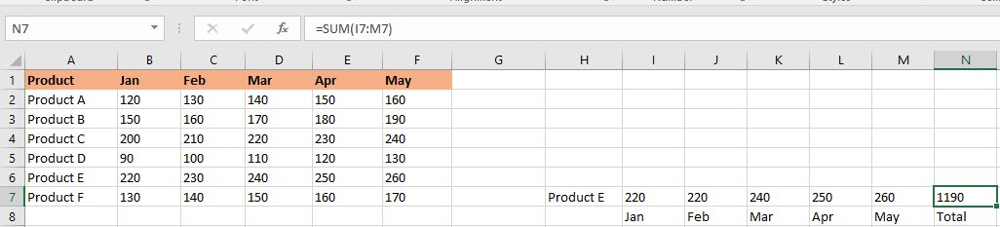

**5. Use HLOOKUP to find the maximum sales value for Product B across all months.**

**Solution**

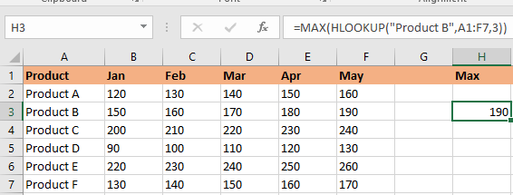

**6. Use HLOOKUP to find the minimum sales value for Product F across all months.**

**Solution**

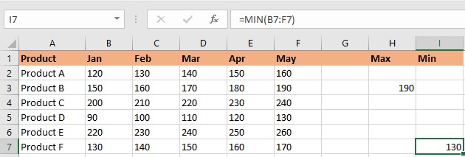

**7. Use HLOOKUP to find the average sales value for Product E across all months.**

**Solution**

