**Sort and Filter**

**1. Sort the dataset alphabetically by the Product name in column A.**

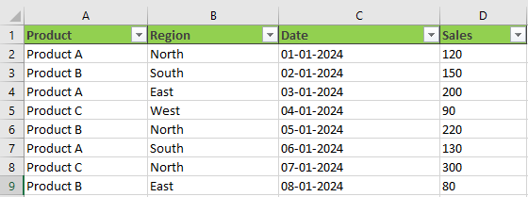

**Solution**

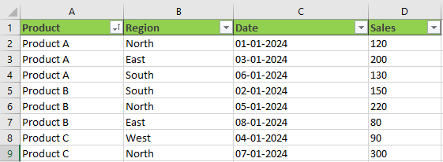

**2. Sort the dataset by Sales in descending order.**



**Solution**

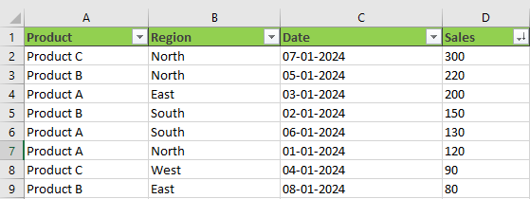

**3. Sort the dataset first by Region in alphabetical order, and then by Sales in ascending order within each Region.**

**Solution**

**By Region**

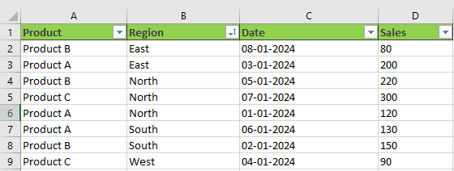

**By Sales**

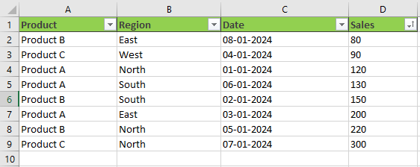

**4. Apply a filter to display only the rows where the Product is "Product B".**



**Solution**

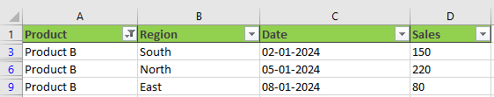

**5. Apply a filter to display only the rows where the Sales are greater than 150.**



**Solution**

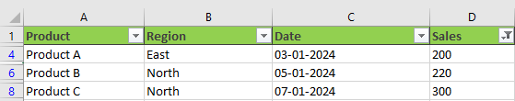

**6. Apply a filter to display only the rows where the Date is in January 2024**

**\*\*Added Feb and Mar because all the data was of Jan\*\***

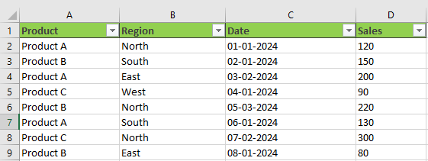

**Solution**

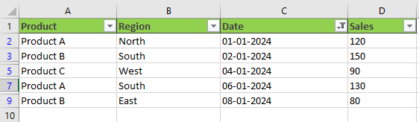

**7. Sort the dataset first by Date in chronological order, and then by Sales in descending order within each Date.**

**Solution**



