# *VLookUp*

**1. Use VLOOKUP to find the product names for each ProductID in the Orders worksheet.**

**Solution**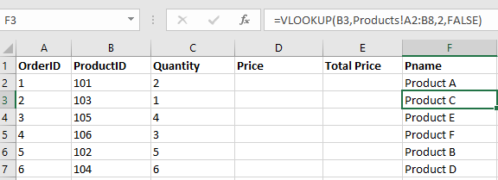

**2. Use VLOOKUP to find the price for each ProductID in the Orders worksheet, then calculate the TotalPrice by multiplying the Quantity by the Product Price.**

**Solution**

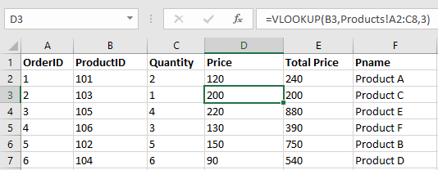

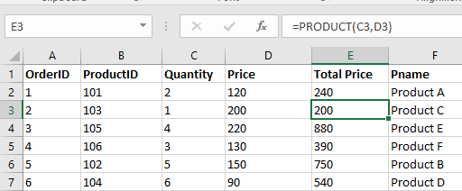

**3. Use VLOOKUP to check if there are any ProductIDs in the Orders worksheet that do not exist in the Products worksheet.**

**Solution**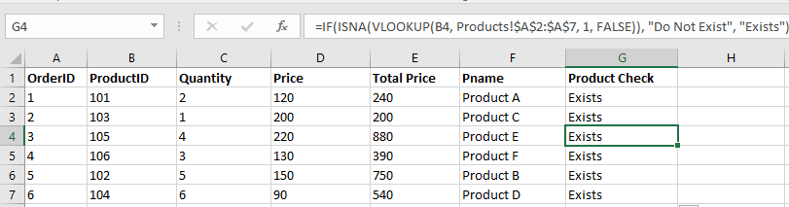

**4. Assume a discount of 10% is given on all products. Use VLOOKUP to find the original price and then calculate the discounted price.**

**Solution**

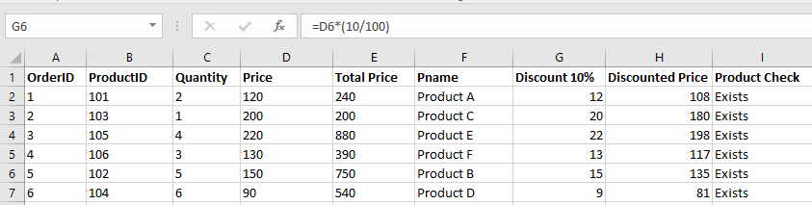

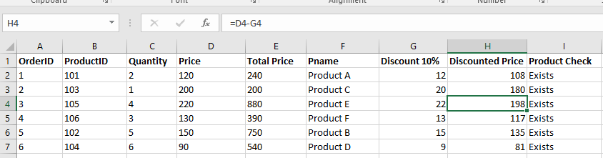

**5.Use VLOOKUP to find the price for each ProductID and then calculate the order value. Find the maximum order value from the list.**

**Solution**

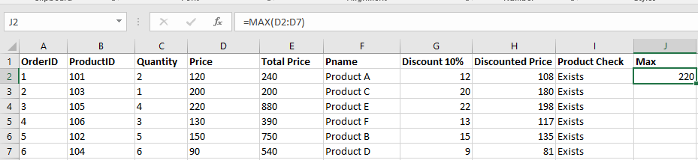

**6. Use VLOOKUP to find out which products from the Products worksheet have not been ordered.**

**Solution**

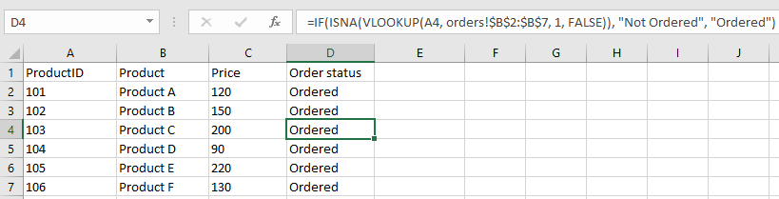

**7. Use VLOOKUP to find the Product name and summarize the total quantity sold for each product.**

**Solution**

