Game Design Document

Fill up the following document

1. Write the title of your project.

A Way Back Home

1. What is the goal of the game?

The goal of this game is to find a way to go back home.

1. Write a brief story of your game.

William is lost in his town, he is so young that he doesn’t know the way

back to his home. You have to help him get back home by the clues which

you will find on the roads and with the help of arrow keys. Do not step on

obstacles, you will lose 1 life out of 5 lives.

1. Which are the playing characters of this game?

* Playing characters are the ones who respond to the user based on the input from the user.
* Cars, monkeys, dinos, wizards, etc., are the playing characters in the game.

|  |  |  |
| --- | --- | --- |
| Number | Character Name | What can this character do? |
| 1 | William (boy) | Jump, walk, run |
| 2 | William’s mother | Walk |

Which are the Non-Playing Characters of this game?

* Non-Playing characters are the ones that don't have an action or behavior when the user interacts with the game.
* Hurdles, stones, bananas, coins, etc., are non-playing characters in the game.

|  |  |  |
| --- | --- | --- |
| Number | Character Name | What can this character do? |
| 1 | Puddles | Obstacle |
| 2 | Stones | Obstacle |
| 3 | Paper (clues) | Point |
| 4 | Logs | Obstacle |
| 5 | Person 1 on street | Walk |
| 6 | Person 2 on street | Walk |
| 7 | Clouds | Sprite |
| 8 | Pathway | Sprite |

Draw your imagination of this game. What does this game look like?

* Draw the game either on your computer or on paper.
* Add images of the game scenes to show each of the playing and non-playing characters at least once.

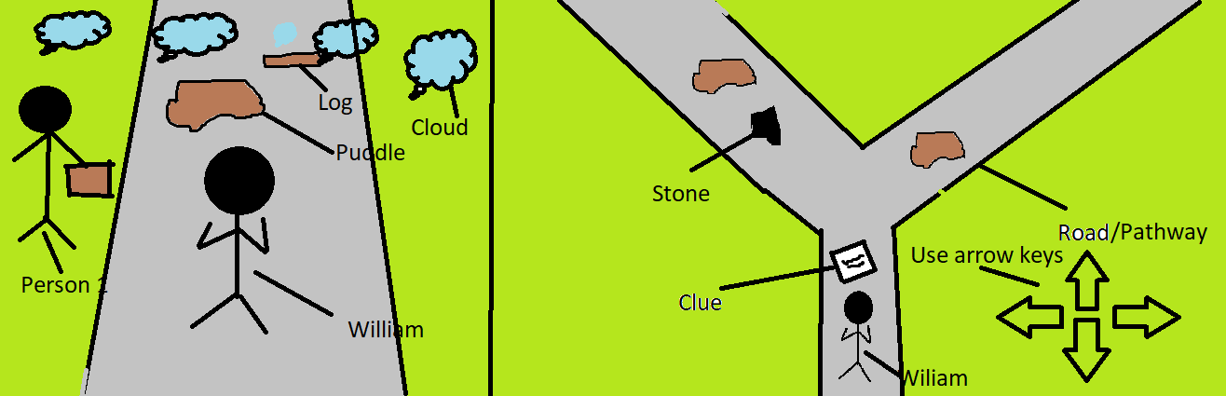

How do you plan to make your game engaging?

Speed up the game after a point.

Make William move with the help of arrow keys

Add sound & background music