CN LAB WEEK 4

SHREYA SRIKRISHNA
ROLL NUMBER 1

Q1 Switching Cisco IOS Command Modes This exercise demonstrates how to log into a router and how to work with the different Cisco IOS command modes. It is important to understand the different modes so you know where you are and what commands are accepted at any time.

The connection is as shown below.
KEY:
NETWORK 1: PC1 & R1 (ROUTER) (fast Ethernet connection , interface f0/0)
NETWORK 2 : PC2 & R2 (ROUTER) ( fast Ethernet connection , interface f0/0)
NETWORK 3 : R1 & R2 (Serial Connection , interface s1/0)

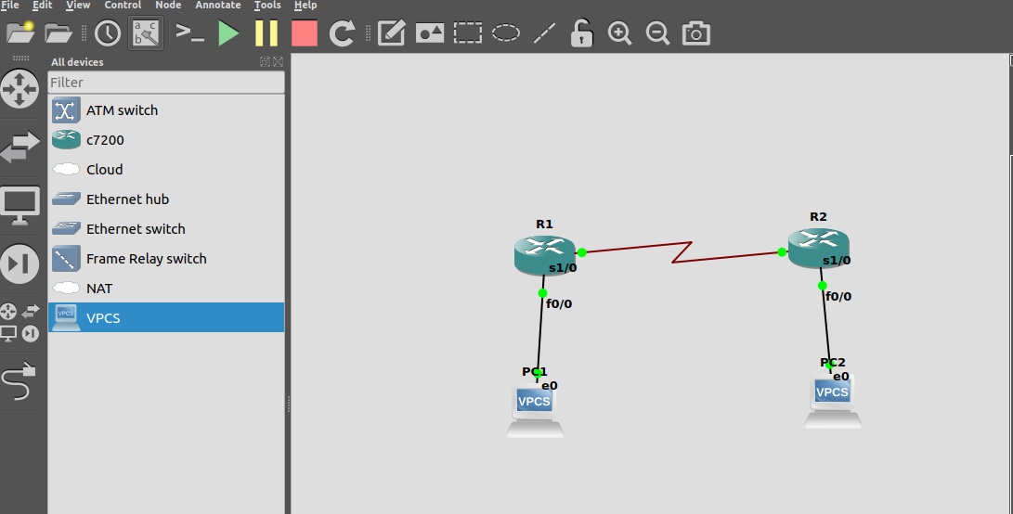
At first we only configure PC1, PC2 with their appropriate IP addresses and gateways. We also assign interfaces f0/0 and s1/0 of both routers R1 And R2. However neither of the routers have any information about the other networks as of now.

Therefore when we try to ping PC2 from PC1, “destination host unreachable” error is given as these hosts are in different subnets and neither router has any forwarding information to be able to send the packets to the other network.

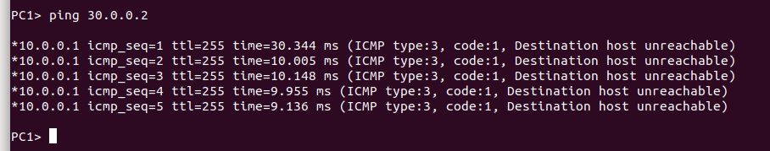
Now we provide router R1 with the destination network information and check if that is enough to send a packet through.

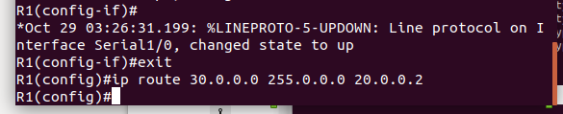

The error we get this time is a timeout error as R1 knows where to send its echo request message but sice R2 is still not configured with the network 1 information, there is no message echoed back from router 2. Thus we get timeout error messages.

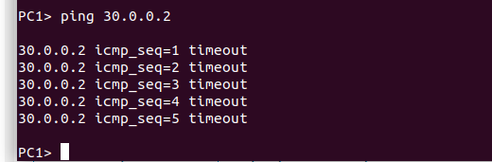

Now we configure R2 with the network information of network 1 and then try sending a packet.
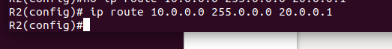

This time the communication is successful as now both routers have information about the other networks and can forward packets to the respective destinations.

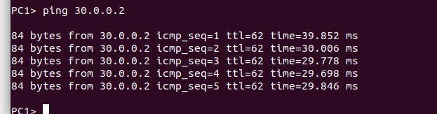

ADDITIONAL EXERCISE

The connection is as shown below.
KEY:
NETWORK 1: PC1,PC2 , SWITCH1 & R1 (ROUTER) (fast Ethernet connection , interface f0/0)
NETWORK 2 : PC3, PC4 , SWITCH2 & R2 (ROUTER) ( fast Ethernet connection , interface f0/0)
NETWORK 3 : R1 & R2 (Serial Connection , interface s1/0)

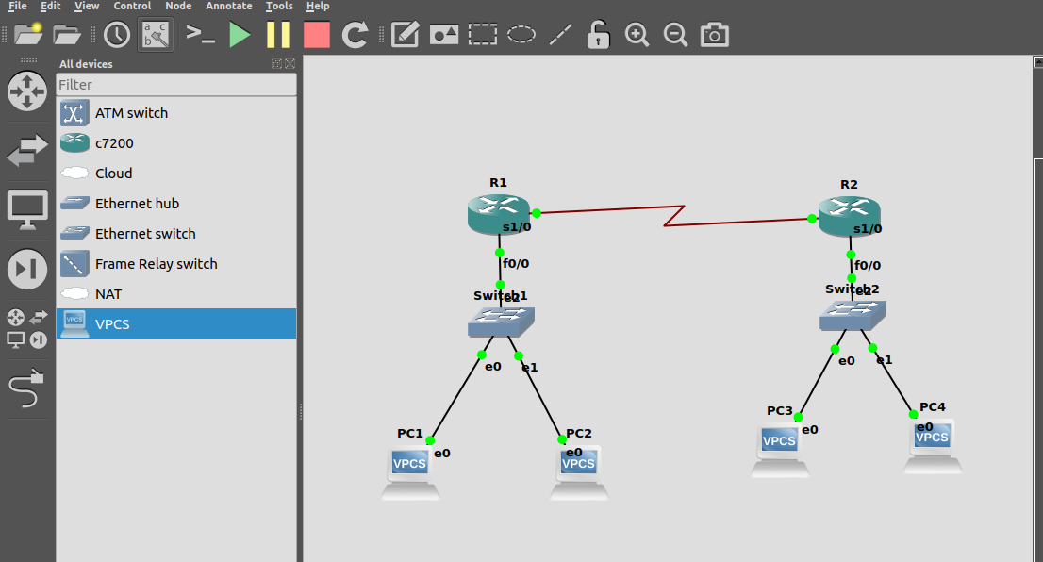

We first configure the interfaces f0/0 and s1/0 of both routers along with configuring all 4 PCs with their IP addresses as shown below.

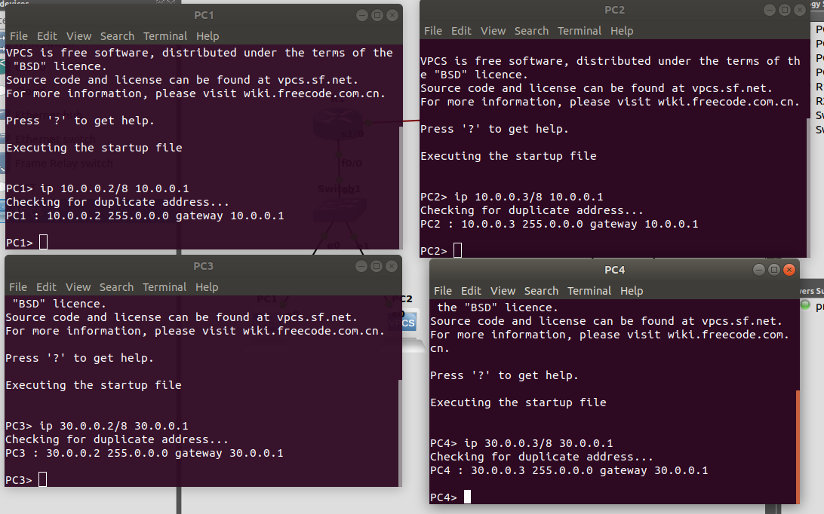
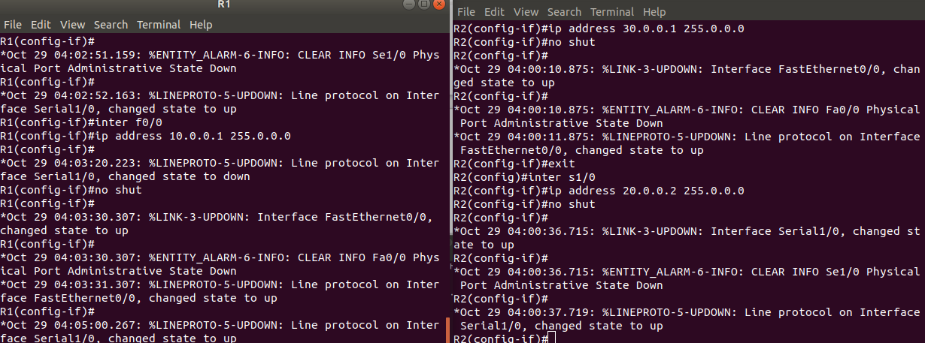

Pinging wihtin a network works perfectly as we dont need any forwarding information.
Thus pc1 pinging pc2 (within network 1) works without any error as shown below.

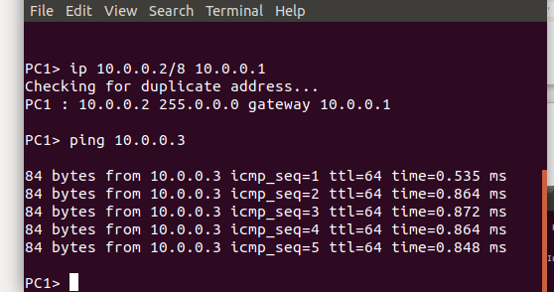

When we try to ping from PC1 to PC4 without configuring the routers, we get “destination host unreachable” error as neither router has any forwarding information to be able to send the packets to the other network.

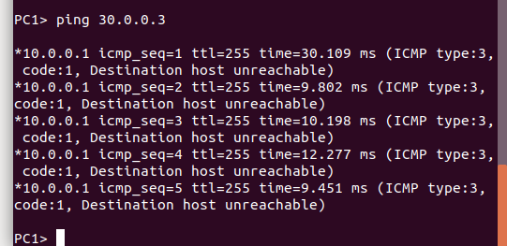

Now we configure router R1 with the destination network information and check if that is enough to send a packet through.

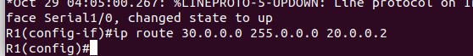

The error we get this time is a timeout error as R1 knows where to send its echo request message but sice R2 is still not configured with the network 1 information, there is no message echoed back from router 2. Thus we get timeout error messages.

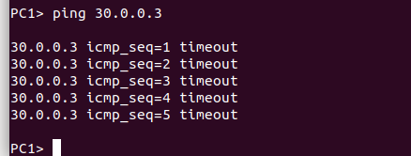

We proceed to configure router R2 with the destination network information of network 1.

This time the communication is successful as now both routers have information about the other networks and can forward packets to the respective destinations.

