Lab1 – Computer Networks Lab

Name: Rhea Adhikari
Reg No: 190905156
Roll No: 23

Q1) Implement a UDP server-client socket which allows communication beteween the 2 processes.

client.c

#include <stdio.h>
#include <strings.h>
#include <sys/types.h>
#include <arpa/inet.h>
#include <sys/socket.h>
#include<netinet/in.h>
#include<unistd.h>
#include<stdlib.h>
#define PORT 5000
#define MAXLINE 1000

int main()
{
char buffer[100];
int sockfd, n,len;
struct sockaddr_in servaddr, cliaddr;

char *message = "Hello Server";

bzero(&servaddr, sizeof(servaddr));
servaddr.sin_addr.s_addr = htonl(INADDR_ANY);
servaddr.sin_port = htons(PORT);
servaddr.sin_family = AF_INET;

sockfd = socket(AF_INET, SOCK_DGRAM, 0);
sendto(sockfd, message, MAXLINE, 0, (struct sockaddr*)&servaddr, sizeof(servaddr));
len=sizeof(cliaddr);

n=recvfrom(sockfd, buffer, sizeof(buffer), 0, (struct sockaddr*)&cliaddr,&len );
buffer[n]='\0';
printf("Message from server is : %s \n",buffer);
getchar();

close(sockfd);
}

server.c

#include <stdio.h>
#include <strings.h>
#include <sys/types.h>
#include <arpa/inet.h>
#include <sys/socket.h>
#include<netinet/in.h>
#define PORT 5000
#define MAXLINE 1000

int main()
{
char buffer[100];
int servsockfd, len,n;
struct sockaddr_in servaddr, cliaddr;
bzero(&servaddr, sizeof(servaddr));

servsockfd = socket(AF_INET, SOCK_DGRAM, 0);
servaddr.sin_addr.s_addr = htonl(INADDR_ANY);
servaddr.sin_port = htons(PORT);
servaddr.sin_family = AF_INET;

bind(servsockfd, (struct sockaddr*)&servaddr, sizeof(servaddr));

len = sizeof(cliaddr);
n = recvfrom(servsockfd, buffer, sizeof(buffer),0, (struct sockaddr*)&cliaddr,&len);
buffer[n] = '\0';
puts(buffer);

sendto(servsockfd, buffer, n, 0, (struct sockaddr*)&cliaddr, sizeof(cliaddr));
getchar();

close(servsockfd);
}
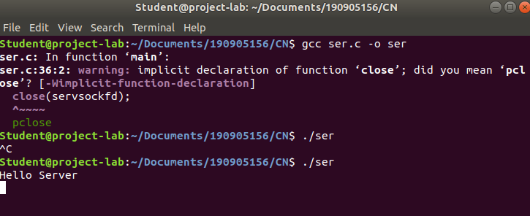
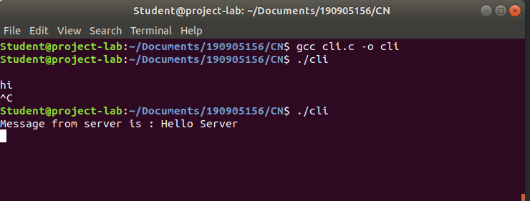

Q2) Implement a TCP server-client socket which allows communication beteween the 2 processes.

Client.c

#include <netdb.h>
#include <stdio.h>
#include <stdlib.h>
#include <string.h>
#include <sys/socket.h>
#define MAX 80
#define PORT 8080
#define SA struct sockaddr
void clifunc(int sockfd)
{
char buff[MAX];
int n;
for (;;) {
bzero(buff, sizeof(buff));
printf("Enter the string : ");
n = 0;
while ((buff[n++] = getchar()) != '\n')
;
write(sockfd, buff, sizeof(buff));
bzero(buff, sizeof(buff));
read(sockfd, buff, sizeof(buff));
printf("From Server : %s", buff);
if ((strncmp(buff, "exit", 4)) == 0) {
printf("Client Exit...\n");
break;
}
}
}

int main()
{
int sockfd, connfd;
struct sockaddr_in servaddr, cli;

// socket create and verification
sockfd = socket(AF_INET, SOCK_STREAM, 0);
if (sockfd == -1) {
printf("socket creation failed...\n");
exit(0);
}
else
printf("Socket successfully created..\n");
bzero(&servaddr, sizeof(servaddr));

// assign IP, PORT
servaddr.sin_family = AF_INET;
servaddr.sin_addr.s_addr = inet_addr("127.0.0.1");
servaddr.sin_port = htons(PORT);

// connect the client socket to server socket
if (connect(sockfd, (SA*)&servaddr, sizeof(servaddr)) != 0) {
printf("connection with the server failed...\n");
exit(0);
}
else
printf("connected to the server..\n");

// function for client
clifunc(sockfd);

// close the socket
close(sockfd);
}

server.c

#include <stdio.h>
#include <netdb.h>
#include <netinet/in.h>
#include <stdlib.h>
#include <string.h>
#include <sys/socket.h>
#include <sys/types.h>
#define MAX 80
#define PORT 8080
#define SA struct sockaddr

// Function designed for chat between client and server.
void servfunc(int sockfd)
{
char buff[MAX];
int n;
// infinite loop for chat
for (;;) {
bzero(buff, MAX);

// read the message from client and copy it in buffer
read(sockfd, buff, sizeof(buff));
// print buffer which contains the client contents
printf("From client: %s\t To client : ", buff);

bzero(buff, sizeof(buff));
// Read server message from keyboard in the buffer
n=0;
while ((buff[n++] = getchar()) != '\n')
;
// and send that buffer to client
write(sockfd, buff, sizeof(buff));

// if msg contains "Exit" then server exit and session ended.
if (strncmp("exit", buff, 4) == 0) {
printf("Server Exit...\n");
break;
}
}
}

// Driver function
int main()
{
int sockfd, connfd, len;
struct sockaddr_in servaddr, cli;

// socket create and verification
sockfd = socket(AF_INET, SOCK_STREAM, 0);
if (sockfd == -1) {
printf("socket creation failed...\n");
exit(0);
}
else
printf("Socket successfully created..\n");
bzero(&servaddr, sizeof(servaddr));

// assign IP, PORT
servaddr.sin_family = AF_INET;
servaddr.sin_addr.s_addr = htonl(INADDR_ANY);
servaddr.sin_port = htons(PORT);

// Binding newly created socket to given IP and verification
if ((bind(sockfd, (SA*)&servaddr, sizeof(servaddr))) != 0) {
printf("socket bind failed...\n");
exit(0);
}
else
printf("Socket successfully binded..\n");

// Now server is ready to listen and verification
if ((listen(sockfd, 5)) != 0) {
printf("Listen failed...\n");
exit(0);
}
else
printf("Server listening..\n");
len = sizeof(cli);

// Accept the data packet from client and verification
connfd = accept(sockfd, (SA*)&cli, &len);
if (connfd < 0) {
printf("server acccept failed...\n");
exit(0);
}
else
printf("server acccept the client...\n");

// Function for chatting between client and server
servfunc(connfd);

// After sending exit message close the socket
close(sockfd);
}

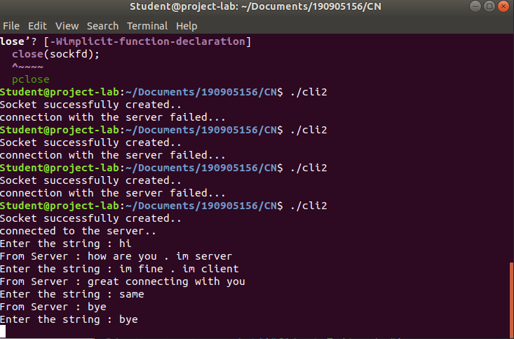
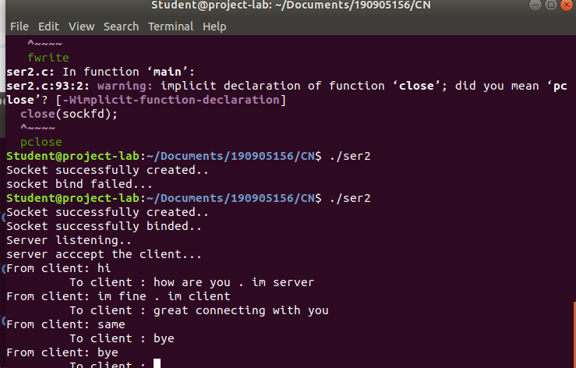

Exercise problems:
1. Write a UDP client-server program where client sends rows of a matrix to the server combines them together as a two dimensional matrix and display the same.
2. Write a TCP client which sends a string to a server program. Server displays the string along with client IP and ephemeral port number. Server then responds to the client by echoing back the string in uppercase. The process continues until one of them types “QUIT”.
3. DayTime Server: Where client sends request to time server to send current time. Server responds by sending the current time . [Hint: read man pages of asctime() and localtime()] . Display server process id at client side along with time.

