CN Lab 2
Name:Rhea Adhikari
Class :Section D
Reg No:190905156
Roll No:23

Q) Socket Programming in ‘C’ using TCP- Concurrent Client-Server Programs
Solved Example
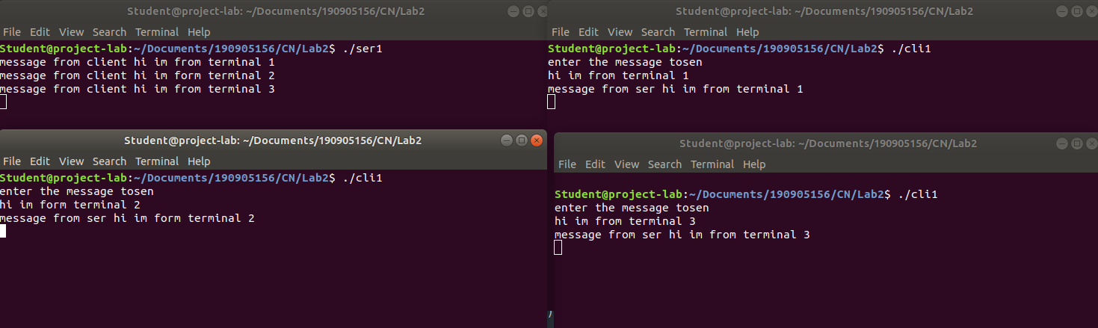
client.c
#include <stdio.h>
#include <stdlib.h>
#include <unistd.h>
#include <errno.h>
#include <string.h>
#include <sys/types.h>
#include <sys/socket.h>
#include <netinet/in.h>
#include <netdb.h>
#include <arpa/inet.h>
#include <sys/wait.h>
#include <signal.h>
int main()
{
int sd,nd,n,len,reult,n1;
struct sockaddr_in seraddress, cliaddr;
char buf[256], buf1[256];
sd=socket(AF_INET, SOCK_STREAM,0);
seraddress.sin_family=AF_INET;
seraddress.sin_addr.s_addr=INADDR_ANY;
seraddress.sin_port=htons(10200);
len=sizeof(seraddress);
connect(sd,(struct sockaddr*)&seraddress,len);
printf("enter the message tosen \n");
gets(buf);
n=write(sd,buf,strlen(buf));
n1=read(sd,buf1,sizeof(buf1));
buf1[n1]='\0';
printf("message from ser %s\n",buf1);
getchar();
}

server.c

#include <stdio.h>
#include <stdlib.h>
#include <unistd.h>
#include <errno.h>
#include <string.h>
#include <sys/types.h>
#include <sys/socket.h>
#include <netinet/in.h>
#include <netdb.h>
#include <arpa/inet.h>
#include <sys/wait.h>
#include <signal.h>
int main()
{
int sd,nd,n,len,reult;
struct sockaddr_in seraddress, cliaddr;
char buf[256];
sd=socket(AF_INET, SOCK_STREAM, 0);
seraddress.sin_family=AF_INET;
seraddress.sin_addr.s_addr=INADDR_ANY;
seraddress.sin_port=htons(10200);
bind(sd,(struct sockaddr*)&seraddress,sizeof(seraddress));
listen(sd,5);
len=sizeof(cliaddr);
while(1)
{
nd=accept(sd,(struct sockaddr*)&cliaddr,&len);
if (fork()==0){
close(sd);
n=read(nd,buf,sizeof(buf));
buf[n]='\0';
printf("message from client: %s\n",buf);
n=write(nd,buf,strlen(buf));
getchar();
close(nd);
}
}
}

1) Write a TCP concurrent client server program where server accepts integer array from
client and sorts it and returns it to the client along with process id.

Server.c
#include <stdio.h>
#include <stdlib.h>
#include <unistd.h>
#include <errno.h>
#include <string.h>
#include <sys/types.h>
#include <sys/socket.h>
#include <netinet/in.h>
#include <netdb.h>
#include <arpa/inet.h>
#include <sys/wait.h>
#include <signal.h>

int cmpfunc(const void *a, const void *b){
return (*(int *)a - *(int *)b);
}

int main(){
int sd, nd, len, n;
struct sockaddr_in seraddress, cliaddr;
int arr[20];
int arr_size = 0;

sd = socket(AF_INET, SOCK_STREAM, 0);
seraddress.sin_family = AF_INET;
seraddress.sin_addr.s_addr = INADDR_ANY;
seraddress.sin_port = htons(10200);

bind(sd, (struct sockaddr *)&seraddress, sizeof(seraddress));listen(sd, 5);

len = sizeof(cliaddr);

while (1){
nd = accept(sd, (struct sockaddr *)&cliaddr, &len);
printf("Connected to client");
if (fork() == 0){
close(sd);
int pid = getpid();
n = read(nd, &arr_size, sizeof(int));
n = read(nd, arr, arr_size * sizeof(int));
//Sort
qsort(arr, arr_size, sizeof(int), cmpfunc);
n = write(nd, &pid, sizeof(int));
n = write(nd, arr, arr_size * sizeof(int));
getchar();
close(nd);
}
}
}
client.c
#include <stdio.h>
#include <stdlib.h>
#include <unistd.h>
#include <errno.h>
#include <string.h>
#include <sys/types.h>
#include <sys/socket.h>
#include <netinet/in.h>
#include <netdb.h>
#include <arpa/inet.h>
#include <sys/wait.h>
#include <signal.h>

int main(){
int sd, len, n;
struct sockaddr_in seraddress, cliaddr;
int arr[20];
int arr_size, pid;

sd = socket(AF_INET, SOCK_STREAM, 0);
seraddress.sin_family = AF_INET;
seraddress.sin_addr.s_addr = INADDR_ANY;
seraddress.sin_port = htons(10200);
len = sizeof(seraddress);

connect(sd, (struct sockaddr *)&seraddress, len);

printf("Enter number of elements: \n");
scanf("%d", &arr_size);
printf("Enter elements: \n");
for (int i = 0; i < arr_size; i++){
scanf("%d", &arr[i]);
}

n = write(sd, &arr_size, sizeof(int));
n = write(sd, arr, arr_size * sizeof(int));
n = read(sd, &pid, sizeof(int));
n = read(sd, arr, arr_size * sizeof(int));

printf("\nSorted array: ");
for (int i = 0; i < arr_size; i++){
printf("%d ", arr[i]);
}

printf("\nProcess ID: %d\n", pid);
getchar();
}
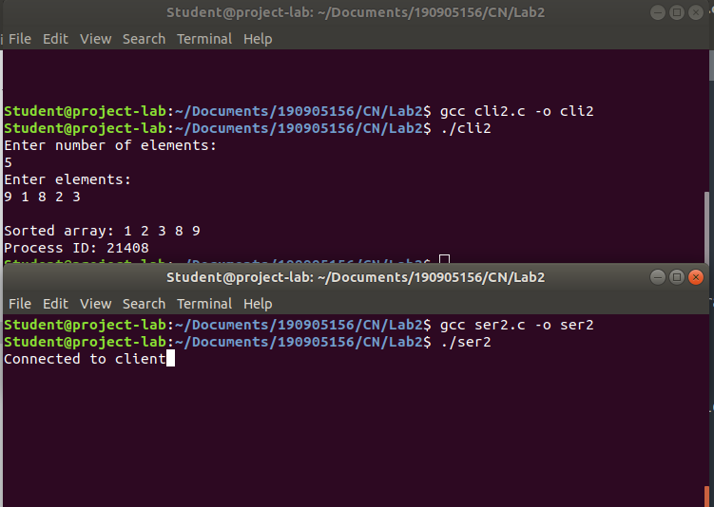
2. Implement concurrent Remote Math Server .To perform arithmetic operations in the
server and display the result at the client. The client accepts two integers and an
operator from the user and sends it to the server. The server then receives integers and
operator. The server will performs the operation on integers and sends result back to
theclient which is displayed on the client screen. Then both the processes terminate.
Server.c
#include <stdio.h>
#include <stdlib.h>
#include <sys/types.h>
#include <sys/socket.h>
#include <arpa/inet.h>
#include <netinet/in.h>
#include <unistd.h>
#define PORT 5000

int calc(int a, int b, char operator)
{
switch(operator)
{
case '+':
return a + b;
break;
case '-':
return a - b;
break;
case '/':
return a / b;
break;
case '*':
return a * b;
break;
default:
return 0;
break;
}
}

void servfunc(int sockfd, struct sockaddr_in server_address)
{
struct sockaddr_in client_address;
int clientfd, a, b, res, size = sizeof(client_address);
char op;
while (1)
{
clientfd = accept(sockfd, (struct sockaddr *)&client_address,
&size);
if (fork() == 0)
{
printf("Child process created with clientfd %d\n",
clientfd);
close(sockfd);
read(clientfd, (int *)&a, sizeof(int));
read(clientfd, (int *)&b, sizeof(int));
read(clientfd, (char *)&op, sizeof(char));
res = calc(a, b, op);
write(clientfd, (int *)&res, sizeof(int));
close(clientfd);
printf("Child process terminated with clientfd %d\n",
clientfd);
exit(0);
}
else
close(clientfd);
}
printf("server closing\n");
}

int main()
{
int sockfd;
struct sockaddr_in server_address;
bzero(&server_address, sizeof(server_address));
server_address.sin_family = AF_INET;
server_address.sin_port = htons(PORT);server_address.sin_addr.s_addr = htonl(INADDR_ANY);
sockfd = socket(AF_INET, SOCK_STREAM, 0);

int res = bind(sockfd, (struct sockaddr *)&server_address,
sizeof(server_address));

if(res < 0)
{
printf("Server unable to bind\n");
exit(0);
}
else
printf("Server bound successfully\n");

res = listen(sockfd, 2);

if(res < 0)
{
printf("Server unable to listne\n");
exit(0);
}
else
printf("Server listening successfully\n");

servfunc(sockfd, server_address);
close(sockfd);
}

client.c
#include <sys/types.h>
#include <sys/socket.h>
#include <stdio.h>
#include <netinet/in.h>
#include <arpa/inet.h>
#include <unistd.h>
#include <stdlib.h>
#define PORT 5000

void clifunc(int sockfd)
{
int a, b;
char c;

printf("Enter The expression as you would on a Calculator: \n");
scanf("%d%c%d", &a, &c, &b);
write(sockfd, (int *)&a, sizeof(int));
write(sockfd, (int *)&b, sizeof(int));
write(sockfd, (char *)&c, sizeof(char));

int res;

read(sockfd, (int *)&res, sizeof(int));
printf("%d %c %d = %d\n", a, c, b, res);
printf("client closing\n");
}
int main(int argc, char const *argv[])
{
int sockfd;
int len;
struct sockaddr_in server_address;
int result;
char ch;
sockfd = socket(AF_INET, SOCK_STREAM, 0);
bzero(&server_address, sizeof(server_address));
server_address.sin_family = AF_INET;
server_address.sin_port = htons(PORT);
server_address.sin_addr.s_addr = htonl(INADDR_ANY);
len = sizeof(server_address);
result = connect(sockfd, (struct sockaddr *)&server_address,
len);

if(result == -1)
{
printf("connection error\n");
exit(0);
}

clifunc(sockfd);
close(sockfd);
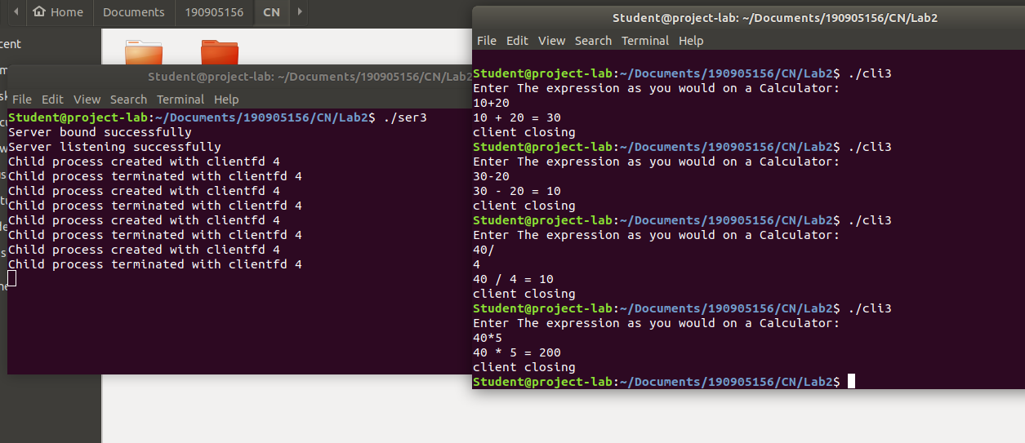
}

3. Implement simple TCP daytime server using fork.
client.c
#include <stdlib.h>
#include <time.h>
#include <sys/types.h>
#include <sys/socket.h>
#include <stdio.h>
#include <netinet/in.h>
#include <arpa/inet.h>
#include <unistd.h>

int main()
{
int sockfd;
int len;
struct sockaddr_in address;
struct tm * timeinfo;
int result;
char *reply;
int hour,mins,sec,pid;

sockfd = socket(AF_INET, SOCK_STREAM, 0);

address.sin_family = AF_INET;
address.sin_addr.s_addr = inet_addr("127.0.0.1");
address.sin_port = 9734;
len = sizeof(address);

result = connect(sockfd, (struct sockaddr *)&address, len);

if(result == -1)
{
perror("oops: client2");
exit(1);
}

printf(" Sending request to get the time\n");

read(sockfd, &hour , 1);
read(sockfd, &mins , 1);
read(sockfd, &sec , 1);
read(sockfd, &pid , 1);
printf("%d:%d:%d", hour, mins, sec);
printf(" The process id is: %d",pid);

close(sockfd);
exit(0);

return 0;
}
server.c
#include <sys/types.h>
#include <sys/socket.h>
#include <stdio.h>
#include <netinet/in.h>
#include <arpa/inet.h>
#include <unistd.h>
#include <stdlib.h>
#include <time.h>

int main()
{
time_t rawtime;
struct tm * timeinfo;
char *reply;
int server_sockfd, client_sockfd;
int server_len, client_len;
struct sockaddr_in server_address;
struct sockaddr_in client_address;
int hour,mins,sec,pid;

server_sockfd = socket(AF_INET, SOCK_STREAM, 0);

server_address.sin_family = AF_INET;
server_address.sin_addr.s_addr = inet_addr("127.0.0.1");
server_address.sin_port = 9734;
server_len = sizeof(server_address);
bind(server_sockfd, (struct sockaddr *)&server_address, server_len);

listen(server_sockfd, 5);
while(1)
{
char ch;

printf("server waiting\n");

client_len = sizeof(client_address);
client_sockfd = accept(server_sockfd, (struct sockaddr *)&client_address, &client_len);

char * ip_add =inet_ntoa(client_address.sin_addr);
int port=client_address.sin_port;

printf("IP:%s PORT:%d\n", ip_add,port);

time ( &rawtime );
timeinfo = localtime ( &rawtime );
reply = asctime(timeinfo);
printf ( "The current date/time is: %s", reply );

hour = timeinfo->tm_hour;
mins = timeinfo->tm_min;
sec = timeinfo->tm_sec;
pid = getpid();

write(client_sockfd, &hour, 1);
write(client_sockfd, &mins, 1);
write(client_sockfd, &sec, 1);
write(client_sockfd, &pid, 1);

}

return 0;
}
