Rhea Adhikari
190905156
Section: CSE – D
Roll no: 23

1.) Write a program to print the lines of a file that contain a word given as the program argument (a simple version of grep UNIX utility)

#include <stdio.h>
#include <unistd.h>
#include <sys/stat.h>
#include <fcntl.h>
#include <stdlib.h>
#include <string.h>

int main(int argc, char *argv[])
{

int FD;
int i=0;
int lines=0;
char ch[100];
char chr;

if(argc<2)
{
printf("Insufficient Arguments\n");
exit(1);
}

if( (FD=open(argv[1],O_RDONLY))==-1)
{
printf("File not found\n");
exit(1);
}

while((read(FD,&chr,1))>0)
{
if(chr!='\n')
{
ch[i]=chr;
i++;
}

else
{
lines++;
ch[i]='\0';
i=0;
printf("Line:%d \t %s \n",lines,ch);

}
}
printf("Total no.of lines = %d\n",lines);
exit(0);

}

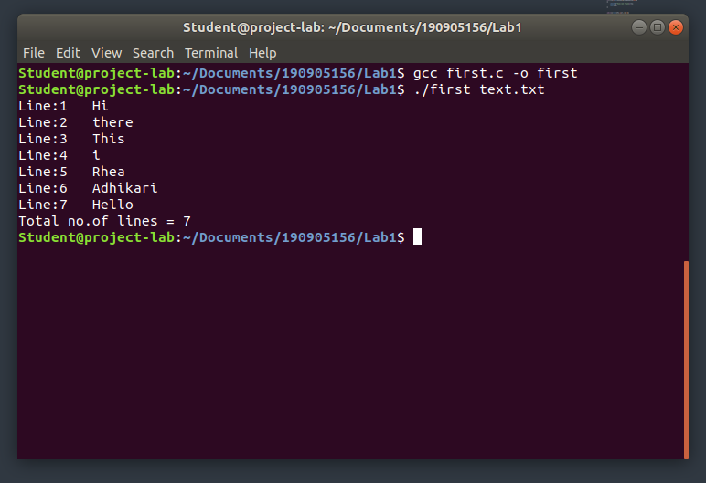
2.) Write a program to list the files given as arguments, stopping every 20 lines until a key is hit. (a simple version of more UNIX utility)

#include <stdio.h>
#include <unistd.h>
#include <sys/stat.h>
#include <fcntl.h>
#include <stdlib.h>
#include <string.h>

int main(int argc, char *argv[])
{

int FD1,FD2,i=0,k=0,p=0;
char ch[100],ch2[100],chr;

if(argc!=3)
{
printf("Insufficient Arguments\n");
exit(1);
}

if( (FD1=open(argv[1],O_RDONLY))==-1)
{
printf("File not found\n");
exit(1);
}

while((read(FD1,&chr,1))>0)
{
if(chr!='\n')
{
ch[i]=chr;
i++;
}

else
{
k++;
p++;
ch[i]='\0';
i=0;
printf("Line:%d \t %s \n", p,ch);
if(k==20)
{
fgetc(stdin);
k=0;
}
}
}
close(FD1);

if( (FD2=open(argv[2],O_RDONLY))==-1)
{
printf("File not found\n");
exit(1);
}

p=0;

while((read(FD1,&chr,1))>0)
{
if(chr!='\n')
{
ch2[i]=chr;
i++;
}

else
{
k++;
p++;
ch[i]='\0';
i=0;
printf("Line:%d \t %s \n", p,ch2);
if(k==20)
{
fgetc(stdin);
k=0;
}
}
}
exit(0);
}

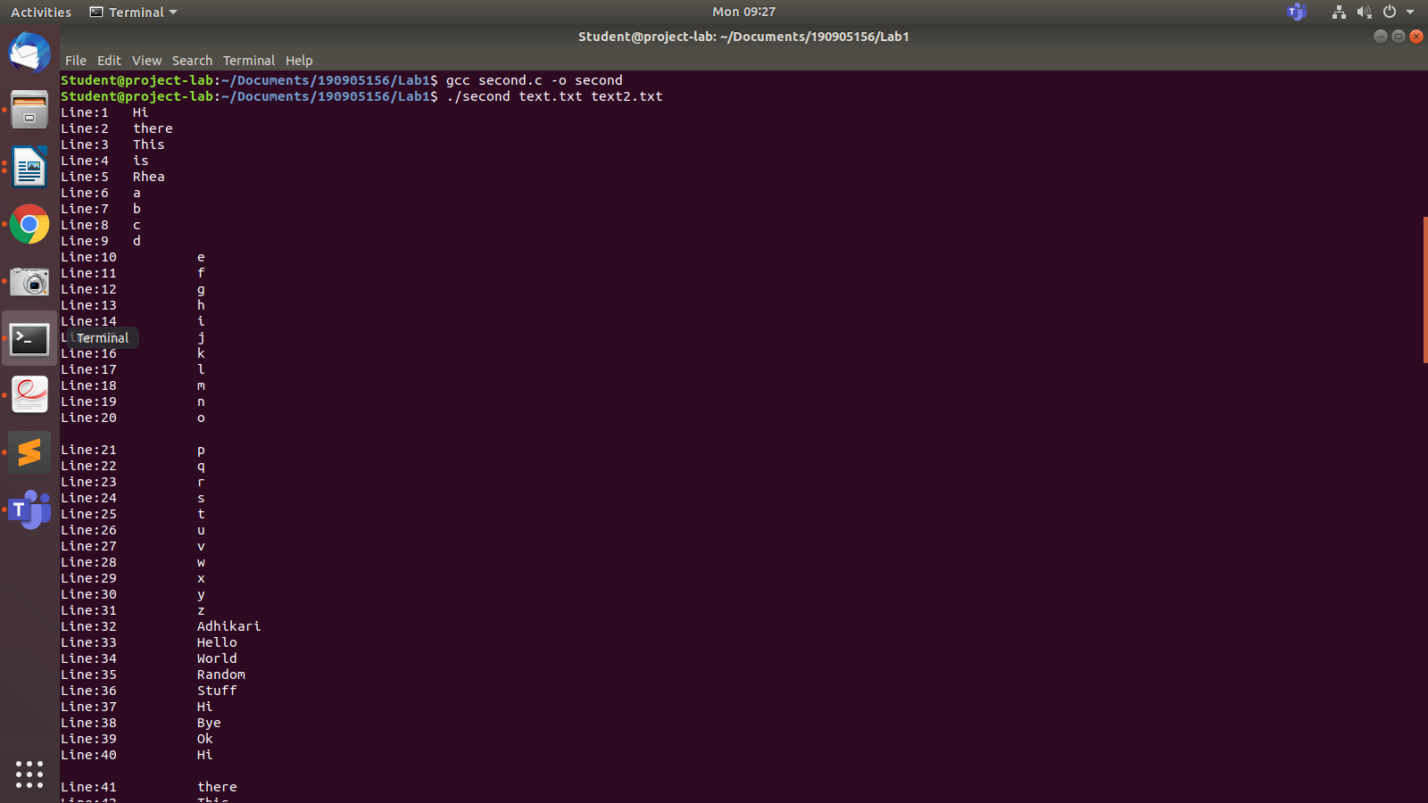
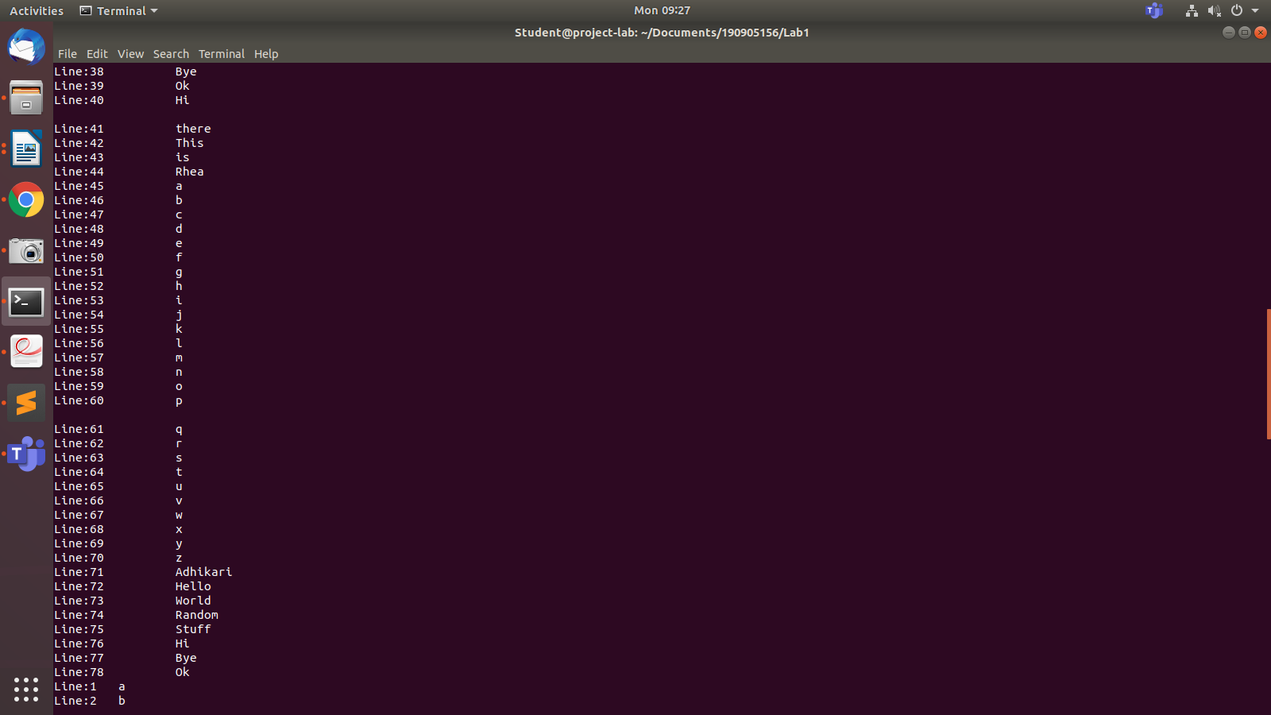

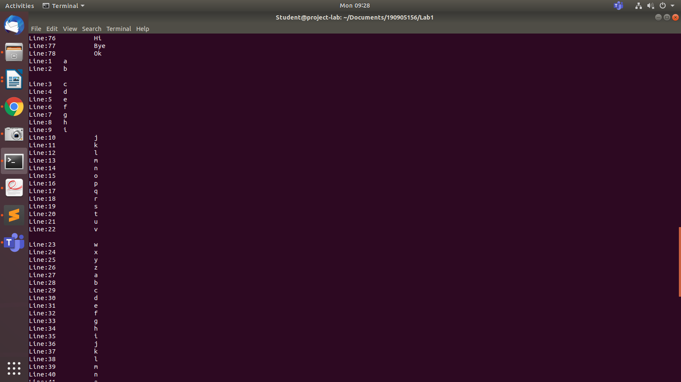
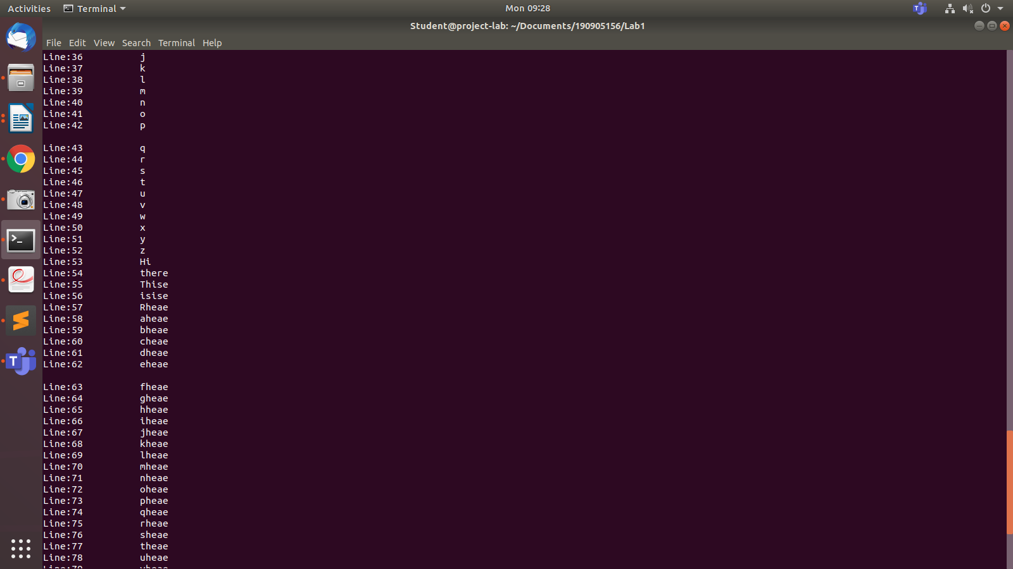
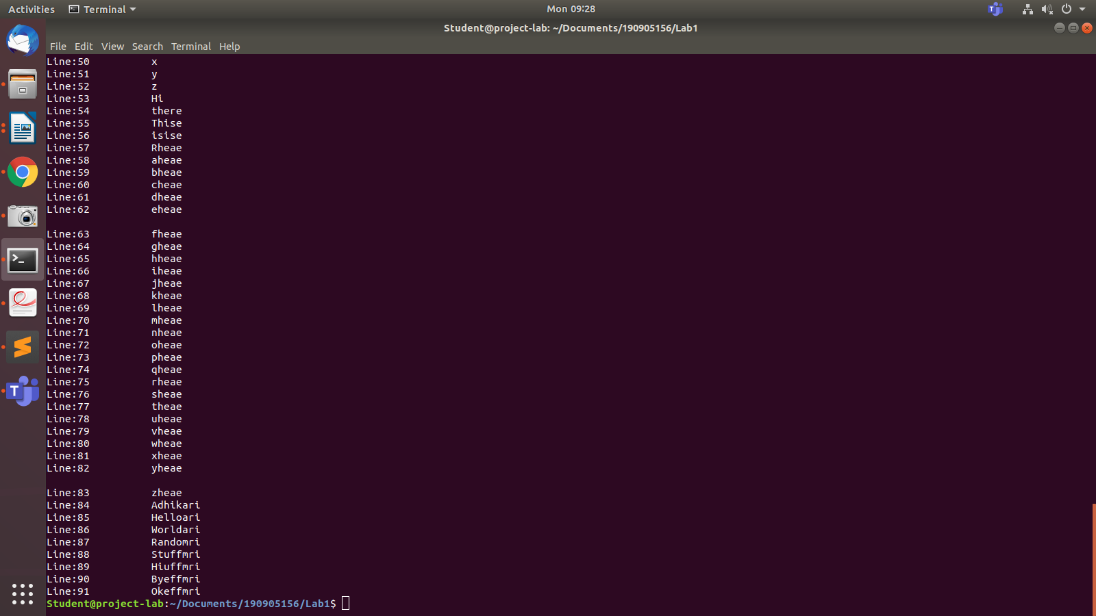
3.) Demonstrate the use of different conversion specifiers and resulting output to allow the items to be printed.

#include<stdio.h>
#include<stdlib.h>

int main()
{
int a=100;
float b=100.99;
char c='a';
char str[]="Rhea Adhikari";
printf("Integer : a=%d\n",a);
printf("Float : b=%f\n",b);
printf("Character : c=%c\n",c);
printf("String : str=%s\n",str);
printf("Scientific Notation: %e\n", b);
printf("Octal for 100: %o\n", a);
printf("Hexadecimal for 100 : %x\n",a);
}

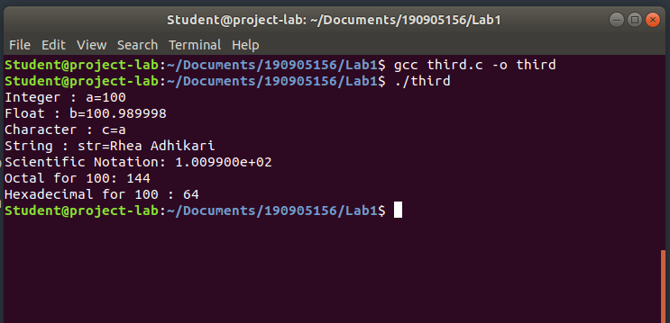

4.) Write a program to copy character-by character copy is accomplished using calls to the functions referenced in stdio.h.

#include<stdio.h>
#include<unistd.h>
#include<sys/stat.h>
#include<fcntl.h>
#include<stdlib.h>

int main(int argc, char *argv[])
{
char c;
int in,out;

if(argc!=3)
{
printf("Insufficient Arguments\n");
exit(1);
}

in=open(argv[1],O_RDWR);
out=open(argv[2],O_WRONLY|O_CREAT, S_IRUSR|S_IWUSR);

if( in==-1 || out==-1)
{
printf("File not found\n");
exit(1);
}

while(read(in,&c,1) == 1)
{
write(out,&c,1);
}

printf("Contents of file have been copied!\n");
exit(0);

}

Before copy
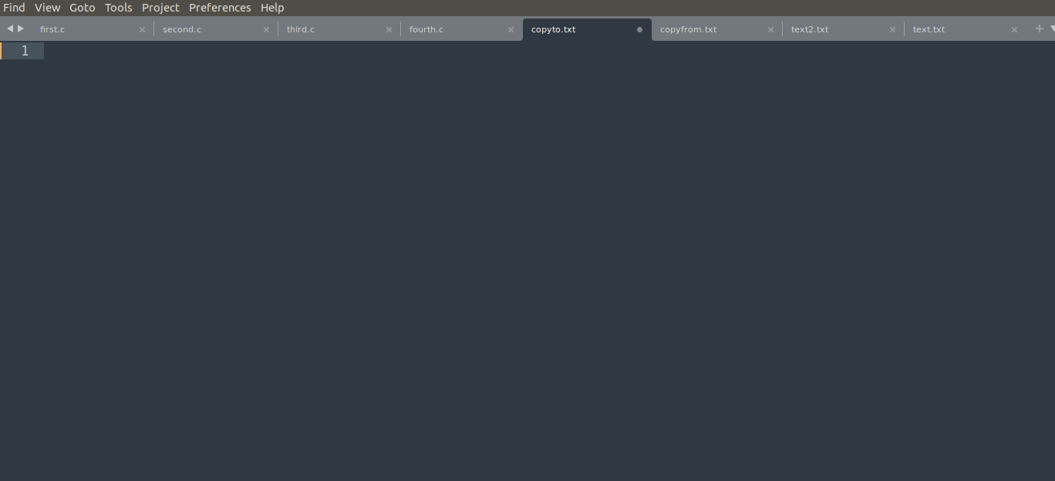
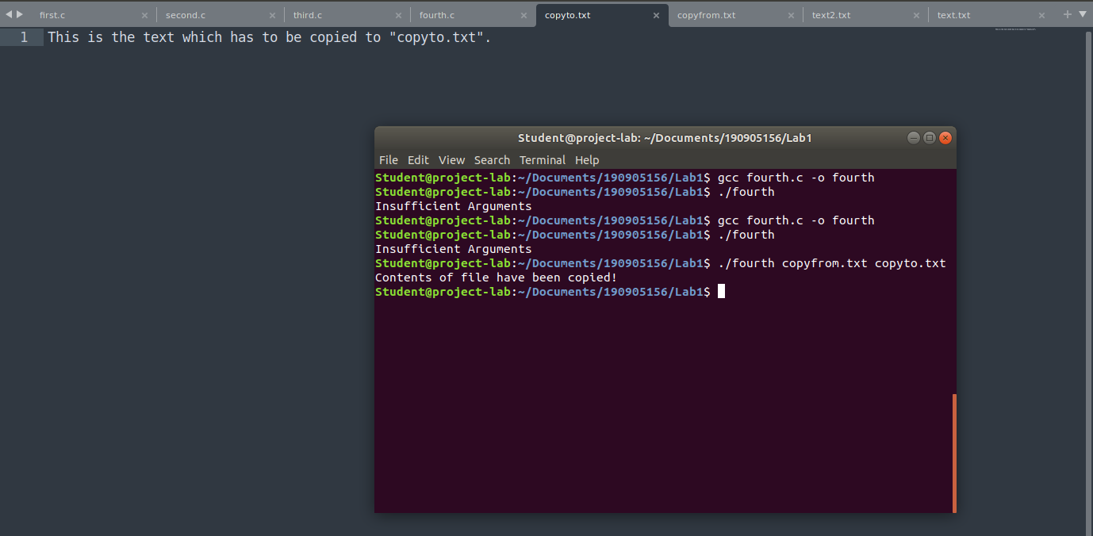
After copy

