CD Lab 2
Name: Rhea Adhikari
Reg No: 190905156
Section D
Roll No:23

Solved Exercise

Q) Program to remove single and multiline comments from a given ‘C’ file.

#include <stdio.h>
int main()
{
FILE *fa, *fb;
int ca, cb;
fa = fopen("sample.c", "r");
if (fa == NULL){
printf("Cannot open file \n");
exit(0);
}

fb = fopen("output.c", "w");
ca = getc(fa);
while (ca != EOF)
{
if(ca==' ')
{
putc(ca,fb);
while(ca==' ')
ca = getc(fa);
}
if (ca=='/')
{
cb = getc(fa);
if (cb == '/')
{
while(ca != '\n')
ca = getc(fa);
}
else if (cb == '*')
{
do
{
while(ca != '*')
ca = getc(fa);
ca = getc(fa);
} while (ca != '/');
}
else
{
putc(ca,fb);
putc(cb,fb);
}
}
else putc(ca,fb);
ca = getc(fa);
}
fclose(fa);
fclose(fb);
return 0;
}

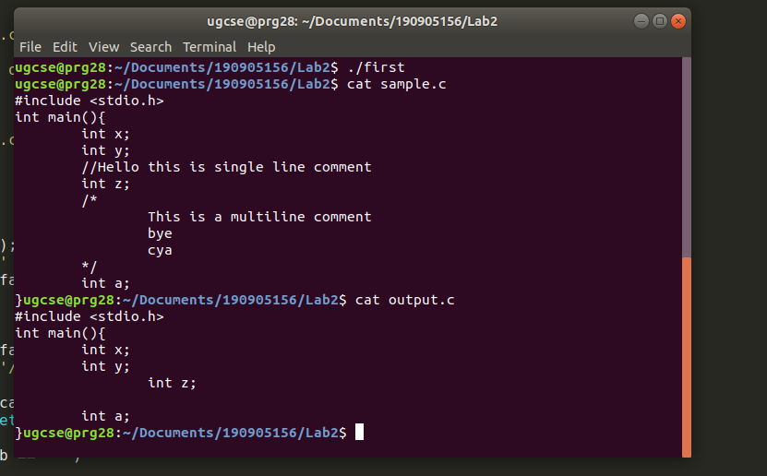
Q1) That takes a file as input and replaces blank spaces and tabs by single space and
writes the output to a file.

#include <stdio.h>
#include <stdlib.h>
int main()
{
char c1,c2;
FILE *f1,*f2;
f1= fopen("input.c","r");
f2= fopen("output.c","w");
if(f1 == NULL || f2 ==NULL)
{
printf("Input or the Output file does not exist \n");
return 1;
}
c1=fgetc(f1);
while(c1 != EOF)
{
if(c1 == '/')
{
c2 = getc(f1);
if(c2 == '/')
{
putc(c1,f2);
putc(c2,f2);
c1 = getc(f1);
while(c1 !='\n')
{
putc(c1,f2);
c1 = getc(f1);
}
}
else if(c2 == '*')
{
putc(c1,f2);
putc(c2,f2);
c1 = getc(f1);
do
{
while(c1 != '*')
{
putc(c1,f2);
c1 = getc(f1);
}
putc(c1,f2);
c1 = getc(f1);
} while(c1 != '/');
}
}
if(c1 == '"')
{
putc(c1,f2);
c1 = getc(f1);
while(c1 != '"')
{
putc(c1,f2);
c1 = getc(f1);
}
putc(c1,f2);
c1 = getc(f1);
}
if(c1 == ' ' || c1 == '\t')
{
putc(' ',f2);
while(c1 == ' ' || c1 == '\t')
{
c1 = getc(f1);
}
}
putc(c1,f2);
c1 = getc(f1);
}
fclose(f1);
fclose(f2);
return 0;
}
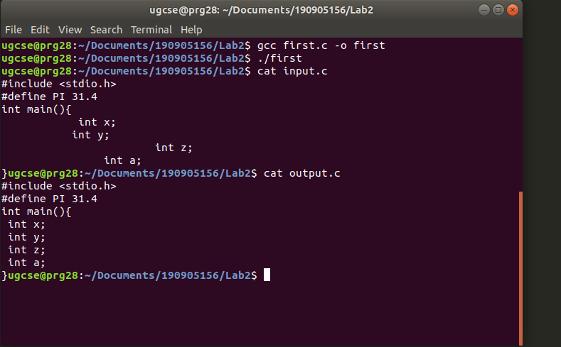

Q 2) To discard preprocessor directives from the given input ‘C’ file.

#include <stdio.h>
#include <stdlib.h>
#include <string.h>
int main()
{
char c1,c2;
FILE *f1,*f2;
f1= fopen("input.c","r");
f2= fopen("output.c","w");
if(f1 == NULL || f2 ==NULL)
{
printf("Input or the Output file does not exist \n");
return 1;
}
c1=fgetc(f1);
while(c1 != EOF)
{
if(c1 == '/')
{
c2 = getc(f1);
if(c2 == '/')
{
putc(c1,f2);
putc(c2,f2);
c1 = getc(f1);
while(c1 !='\n')
{
putc(c1,f2);
c1 = getc(f1);
}
}
else if(c2 == '*')
{
putc(c1,f2);
putc(c2,f2);
c1 = getc(f1);
do
{
while(c1 != '*')
{
putc(c1,f2);
c1 = getc(f1);
}
putc(c1,f2);
c1 = getc(f1);
} while(c1 != '/');
}
}
if(c1 == '"')
{
putc(c1,f2);
c1 = getc(f1);
while(c1 != '"')
{
putc(c1,f2);
c1 = getc(f1);
}
putc(c1,f2);
c1 = getc(f1);
}
if(c1 == '#')
{
while(c1 != '\n')
c1 = getc(f1);
}
putc(c1,f2);
c1 = getc(f1);
}
fclose(f1);
fclose(f2);
return 0;
}
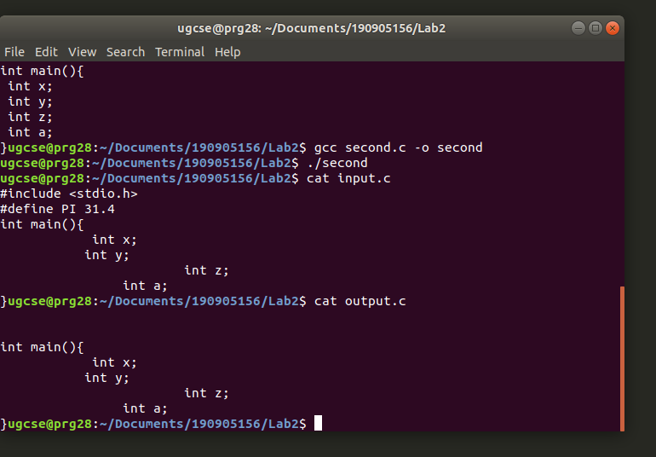

Q3) That takes C program as input, recognizes all the keywords and prints them in
upper case.

#include <stdio.h>
#include <stdlib.h>
#include <string.h>
#include <ctype.h>
int main()
{
char keys[10][20] = {"float","printf","scanf","for","char","if","else","do","while","int"};
char buffer[100];
FILE *f1;
int c1,bufferCounter = 0;
f1 = fopen("input.c","r");
if(f1 == NULL)
{
printf("Cannot open file\n");
exit(0);
}
c1 = getc(f1);
while(c1 != EOF)
{
if(isalpha(c1))
{
buffer[bufferCounter++] = c1;
}
else
{
buffer[bufferCounter] = '\0';
bufferCounter = 0;
for(int i = 0 ; i < 10 ; i++)
{
if(strcmp(keys[i],buffer) == 0)
{
int j = 0;
while(buffer[j])
{
putchar(toupper(buffer[j]));
j++;
}
printf("\n");
break;
}
}
}
c1 = getc(f1);
}
fclose(f1);
return 0;
}

