OS Lab2

Name: Rhea Adhikari
Reg No: 190905156
Roll No:23
Section D

1.) Write a C program to emulate the ls -l UNIX command that prints all files in a current directory and lists access privileges, etc. DO NOT simply exec ls -l from the program.

#include <unistd.h>
#include <stdio.h>
#include <sys/stat.h>
#include <sys/types.h>
#include <dirent.h>

int main()
{
DIR * dir;
struct stat statbuf;
struct dirent * entry;

if((dir = opendir(".")) == NULL)
{
printf("Cannot open directory \n");
return 0;
}

chdir(".");
while((entry = readdir(dir)) != NULL)
{
lstat(entry->d_name,&statbuf);

if(!S_ISDIR(statbuf.st_mode))
{
printf("%s : ",entry->d_name);
printf((S_ISDIR(statbuf.st_mode)) ? "d" : "-");
printf((statbuf.st_mode & S_IRUSR) ? "r" : "-");
printf((statbuf.st_mode & S_IWUSR) ? "w" : "-");
printf((statbuf.st_mode & S_IXUSR) ? "x" : "-");
printf((statbuf.st_mode & S_IRGRP) ? "r" : "-");
printf((statbuf.st_mode & S_IWGRP) ? "w" : "-");
printf((statbuf.st_mode & S_IXGRP) ? "x" : "-");
printf((statbuf.st_mode & S_IROTH) ? "r" : "-");
printf((statbuf.st_mode & S_IWOTH) ? "w" : "-");
printf((statbuf.st_mode & S_IXOTH) ? "x" : "-");
printf("\n");
}
}
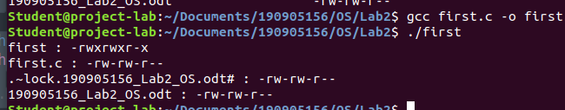
}

2.) Write a program that will list all files in a current directory and all files in subsequent subdirectories.

#include <unistd.h>
#include <stdio.h>
#include <dirent.h>
#include <string.h>
#include <sys/stat.h>
#include <stdlib.h>

void printdir(char *dir, int depth)
{
DIR *d;
struct dirent *entry;
struct stat statbuf;

if((d = opendir(dir)) == NULL)
{
fprintf(stderr,"Cannot open directory: %s\n",dir);
return;
}

chdir(dir);

while((entry = readdir(d)) != NULL)
{
lstat(entry->d_name,&statbuf);

if(S_ISDIR(statbuf.st_mode))
{
if(strcmp(".",entry->d_name) == 0 ||strcmp("..",entry->d_name) == 0)
{
continue;
}

printf("%*s%s/\n",depth,"",entry->d_name);

printdir(entry->d_name, depth+4);
}
else {
printf("%*s%s\n",depth,"",entry->d_name);
}
}

chdir("..");
closedir(d);
}

int main()
{
printf("Scan of current directory:\n");
printdir(".",0);
printf("Completed.\n");
exit(0);
}
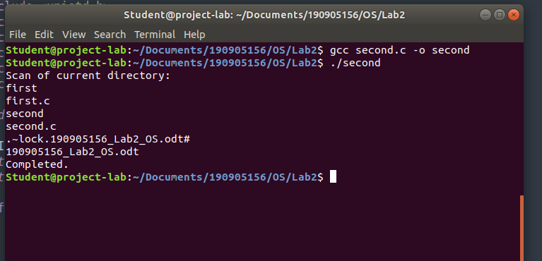

3.) How do you list all installed programs in Linux?

apt list
OR
dpkg –l

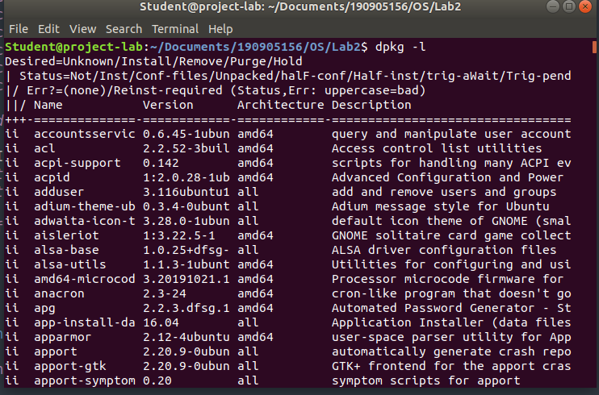

4.) How do you find out what RPM packages are installed on Linux?

