Lab4 – Computer Network Design using SWITCH and ROUTERS in GNS3

Name: Rhea Adhikari
Reg No: 190905156
Roll No: 23
Section: CSE-D
Batch: D1

1. Switching Cisco IOS Command Modes

This exercise demonstrates how to log into a router and how to work with the different Cisco
IOS command modes. It is important to understand the different modes so you know where you are and what commands are accepted at any time.
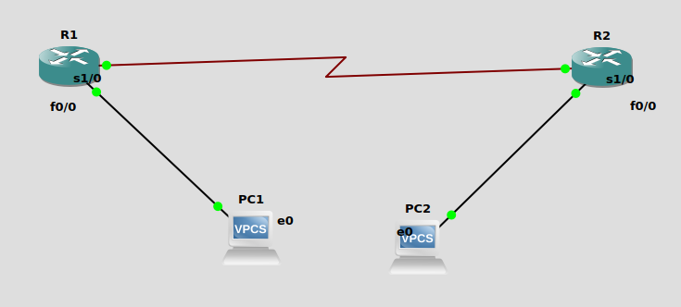

I made the network structure and assigned IP addresses to every interface.

R1:
s1/0: 10.0.0.1 255.0.0.0
f0/0: 20.0.0.1 255.0.0.0

R2:
s1/0: 10.0.0.2 255.0.0.0
f0/0: 30.0.0.1 255.0.0.0

PC1:
20.0.0.2 Gateway: 20.0.0.1

PC2:
30.0.0.2 Gateway: 30.0.0.1

I pinged PC2 from PC1, but there was a timeout.

This is because the packets are going through the gateway but not getting routed completely. For this,we need to configure the routers with the destination network and next hop’s IP
address.

Pc2 to s1/0 of r2

pc1 to s1/0 of r1

Now the routes have been established.

We ping PC1 from PC2 again, and this is the response:

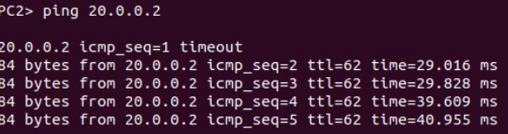
We can see ICMP messages being passed from PC1
(20.0.0.2) to PC2(30.0.0.2).

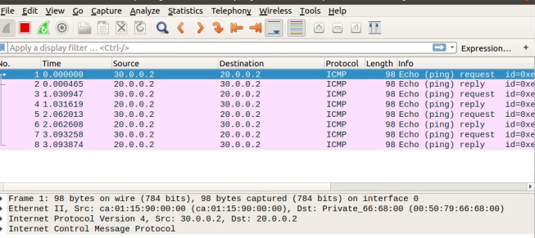
2) Next Page

Configure the below network topology as shown in Figure 7.8 and check the connectivity
by pinging from PC0 to PC2.

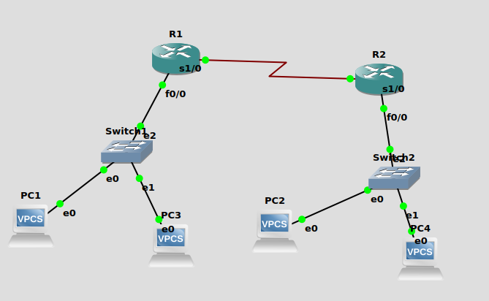

Since there are multiple PCs on each network, we use a switch to help us forward the data to the destination device.

I first constructed the network topology and assigned IP addresses to every interface.

R1:
s1/0: 10.0.0.1 255.0.0.0
f0/0: 20.0.0.1 255.0.0.0

R2:
s1/0: 10.0.0.2 255.0.0.0
f0/0: 30.0.0.1 255.0.0.0

PC1:
20.0.0.2 Gateway: 20.0.0.1

PC2:
30.0.0.2 Gateway: 30.0.0.1

PC3:
20.0.0.3 Gateway: 20.0.0.1

PC4:
30.0.0.3 Gateway: 30.0.0.1

- I configured the routers with their respective routes (destination network ID and next hop IP address).

- First, to check whether the individual network with ID 30.0.0.0 is working, I
pinged PC4 (30.0.0.3) from PC32(30.0.0.2) and i could clearly see ICMP
messages being exchanged between the two devices which confirmed the
exchange of data.

- Next, to check whether my routers are working properly, I pinged PC1
(20.0.0.2) from PC2(30.0.0.2), and again, Wireshark showed me ICMP
messages getting exchanged from address 30.0.0.2 to 20.0.0.2 and vice versa.

