Rhea Adhikari

Q)DHCP
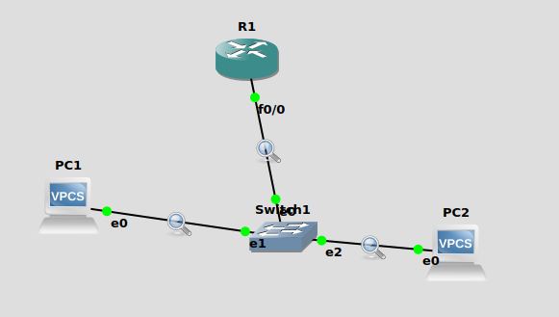

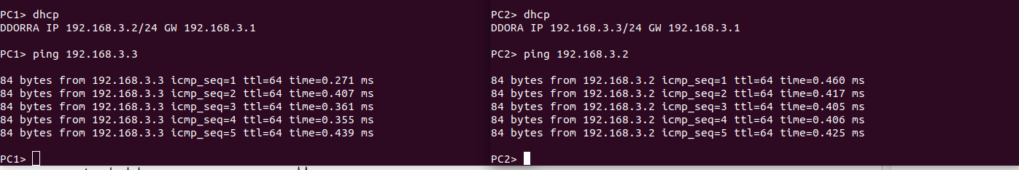

On writing dhcp in the individual PC’s we get a dynamically allocated ip address which can now be used.

