CN Lab 8
Rhea Adhikari
190905156

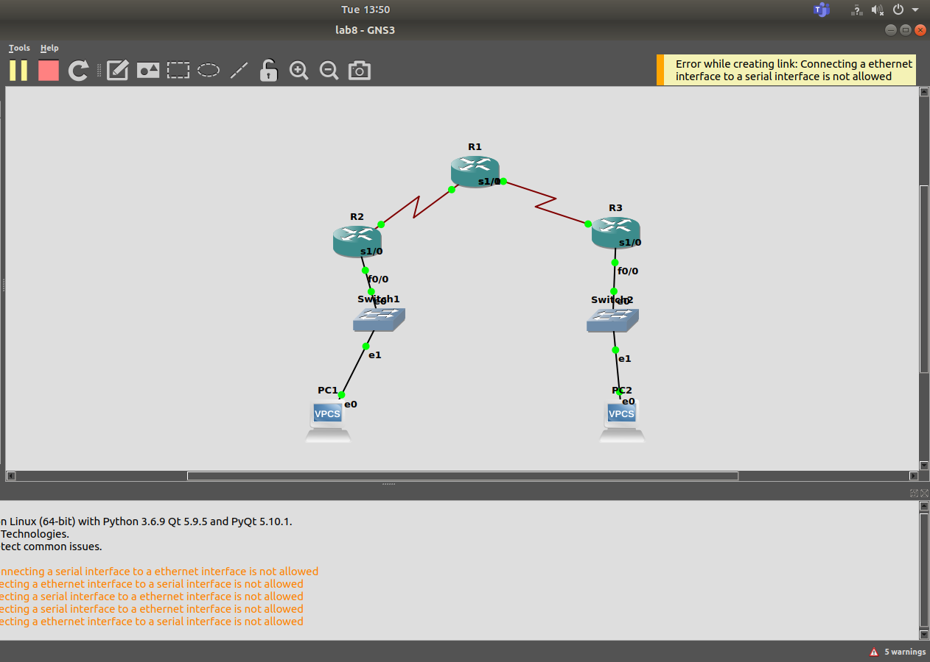

IP route at R1 gives me all the 4 network addresses hence its fine.
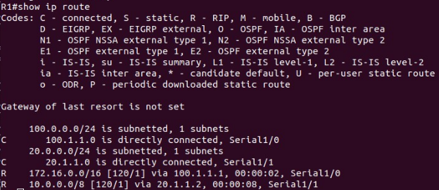

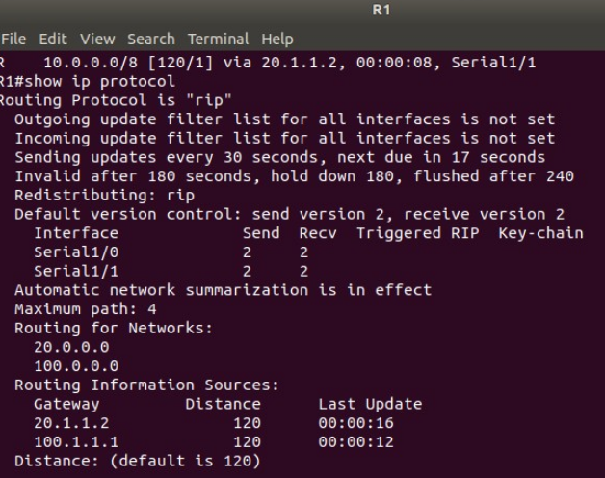

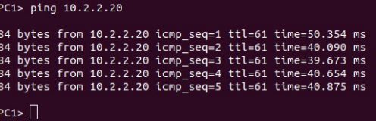
We try pinging PC2 ping 10.2.2.20 from PC1

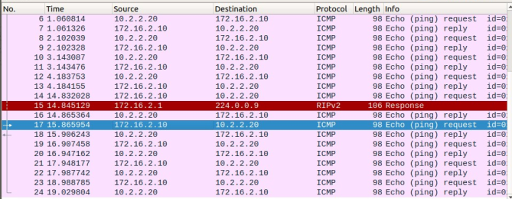

Packets are exchanged from 172.16.2.10 and 10.2.2.20.

