OS Lab3
Name:Rhea Adhikari
Reg No:190905156
Roll No:23
Section CSE-D

Q1)Write a program to find the inode number of an existing file in a directory. Take the input as a filename and print the inode number of the file.

#include <sys/types.h>
#include <sys/stat.h>
#include <unistd.h>
#include <stdio.h>

int main(int argc, char *argv[])
{
struct stat sb;
int ret;
if (argc < 2)
{
printf("Please enter a filename as well in the input.\n");
return 1;
}
ret = stat(argv[1], &sb);
if (ret)
{
perror("stat");
return 1;
}
printf("Inode number of %s : %ld\n", argv[1], sb.st_ino);
return 0;
}
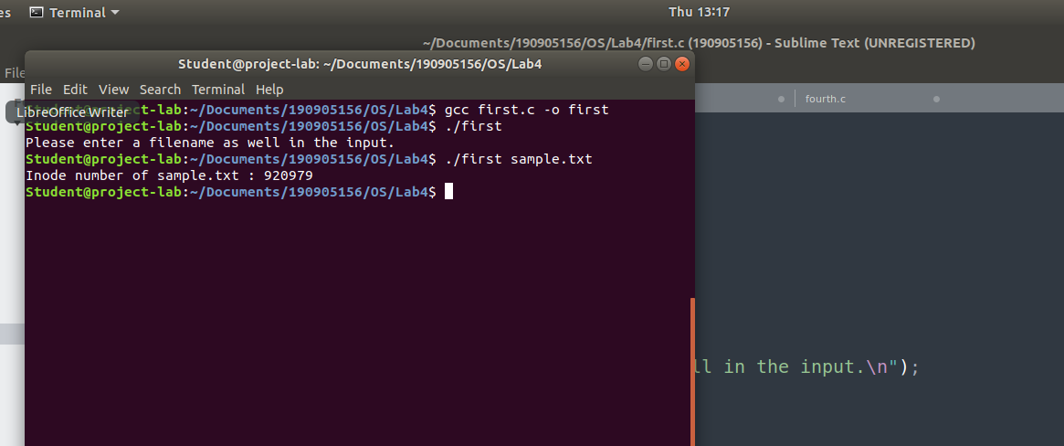
Q2)Write a program to print out the complete stat structure of a file.
#include <sys/types.h>
#include <sys/stat.h>
#include <unistd.h>
#include <stdio.h>
#include <time.h>
#include <stdlib.h>
#include <dirent.h>
#include <string.h>

char *formatDate(char *str, time_t val)
{
strftime(str, 36, "%d.%m.%Y %H:%M:%S", localtime(&val));
return str;
}

int main(int argc, char *argv[])
{
struct stat sb;
if (argc < 2)
{
printf("Insufficient arguments!\n");
return 1;
}
int ret;
char date[36];
ret = stat(argv[1], &sb);
if (ret)
{
perror("stat");
return 1;
}

printf("No.of hard links - %d\n", sb.st_nlink);
printf("User ID - %d\n", sb.st_uid);
printf("Number of Blocks - %lld\n", sb.st_blocks);
printf("Last access time - %s\n", formatDate(date, sb.st_atime));
printf("Last modification time - %s\n", formatDate(date, sb.st_mtime));
printf("Last change time - %s\n", formatDate(date, sb.st_ctime));
printf("Group owner - %d\n", sb.st_gid);
printf("Device ID - %d\n", sb.st_dev);
printf("INO Number - %llu\n", sb.st_ino);
printf("File mode - %hu\n", sb.st_mode);
printf("File size - %lld\n", sb.st_size);
printf("Blocksize - %d\n", sb.st_blksize);

DIR *dp;
struct dirent *entry;
struct stat statbuf;
if ((dp = opendir(".")) == NULL)
{
printf("Cannot open directory \n");
return 0;
}
chdir(".");
while ((entry = readdir(dp)) != NULL)
{
lstat(entry->d_name, &statbuf);
if (!S_ISDIR(statbuf.st_mode))
{
if (strcmp(entry->d_name, argv[1]) == 0)
{
printf("Permissions\t");
printf((statbuf.st_mode & S_IXUSR) ? "x" : "-");
printf((statbuf.st_mode & S_IRGRP) ? "r" : "-");
printf((statbuf.st_mode & S_IWGRP) ? "w" : "-");
printf((statbuf.st_mode & S_IXGRP) ? "x" : "-");
printf((statbuf.st_mode & S_IROTH) ? "r" : "-");
printf((statbuf.st_mode & S_IWOTH) ? "w" : "-");
printf((statbuf.st_mode & S_IRUSR) ? "r" : "-");
printf((statbuf.st_mode & S_IWUSR) ? "w" : "-");
printf((statbuf.st_mode & S_IXOTH) ? "x" : "-");
printf((S_ISDIR(statbuf.st_mode)) ? "d" : "-");
printf("\n\n");
}
}
}
}
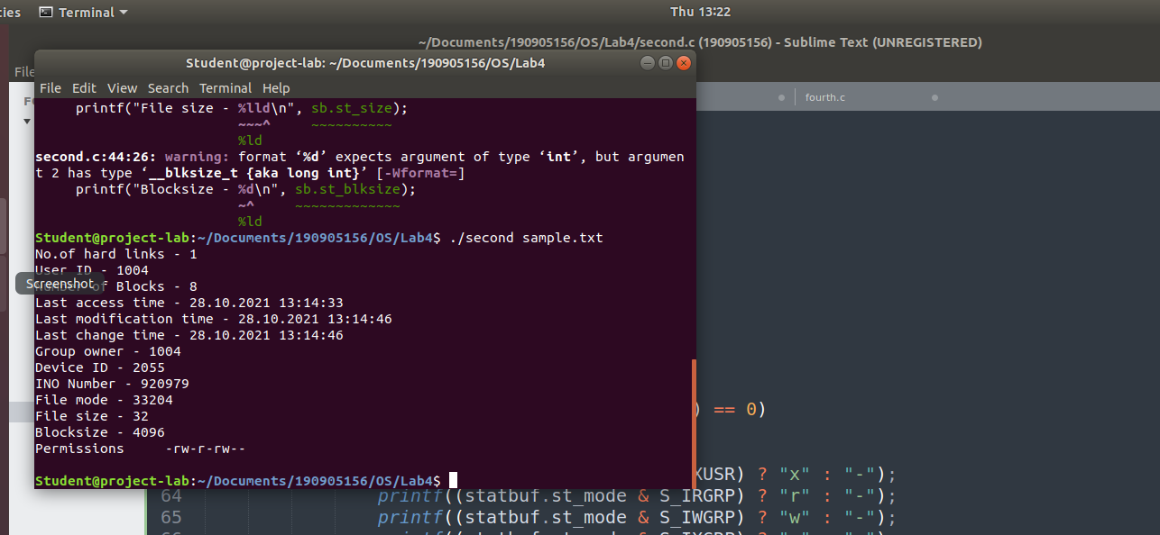
Q3)Write a program to create a new hard link to an existing file and unlink the same. Accept the old path as input and print the newpath.

#include <sys/types.h>
#include <sys/stat.h>
#include <unistd.h>
#include <stdio.h>
#include <inttypes.h>
#include <stdlib.h>
void main(int argc, char *argv[])
{
if (argc < 2)
{
printf("Insufficient arguments\n");
return;
}

char new_path[100] = "new_path_problem3.c";
struct stat start;

int ret1 = stat(argv[1], &start);

printf("Number of hard links:%ld\n", start.st_nlink);
system("ls");
printf("Linking..\n");

int ret2 = link(argv[1], new_path);

struct stat intermediate;

int ret3 = stat(argv[1], &intermediate);

printf("Number of hard links:%ld\n", intermediate.st_nlink);
printf("New path:%s\n", new_path);
system("ls");

int ret4 = unlink(argv[1]);
struct stat ending;
int ret5 = stat(new_path, &ending);

printf("Unlinking...\n");

printf("Number of hard links after unlinking:%ld\n", ending.st_nlink);

system("ls");
}
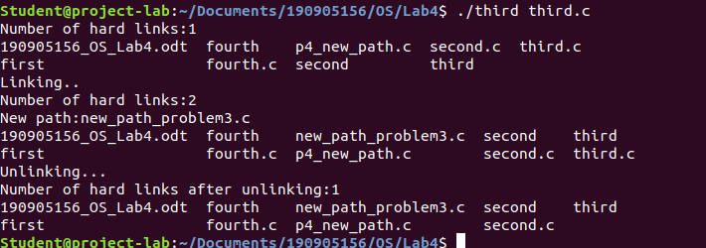
Q4)Write a program to create a new soft link to an existing file and unlink the same. Accept the old path as input and print the newpath.
#include <sys/types.h>
#include <sys/stat.h>
#include <unistd.h>
#include <stdio.h>
#include <inttypes.h>
#include <stdlib.h>
void main(int argc, char *argv[])
{
if (argc < 2)
{
printf("Insufficient arguments\n");
return;
}
char new_path[100] = "new_path_problem4.c";
struct stat start;
int ret1 = stat(argv[1], &start);
system("ls");
printf("Linking..\n");
int ret2 = symlink(argv[1], new_path);
struct stat intermediate;
int ret3 = stat(argv[1], &intermediate);
printf("New path:%s\n", new_path);
system("ls");
int ret4 = unlink(argv[1]);
struct stat ending;
int ret5 = stat(new_path, &ending);
printf("Unlinking...\n");
system("ls");
}
