Lab5

Name:Rhea Adhikari
CSE-D
D1
190905156

Q1) Configure the below DNS Server and DNS Client. Test the setup. Analyze the
Interaction.

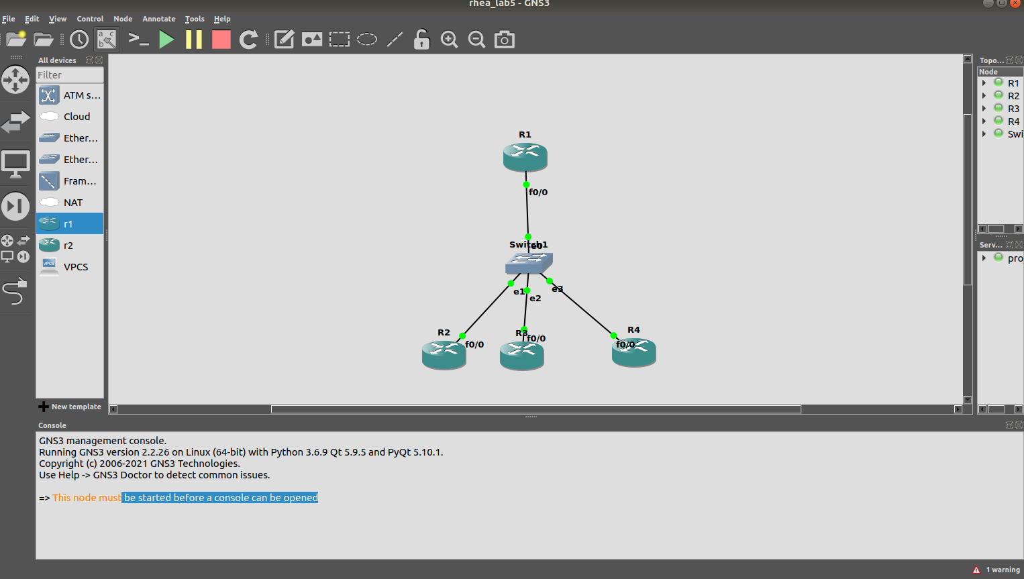

R1 is DNS Server
R2,R3,R4 are DNS Clients
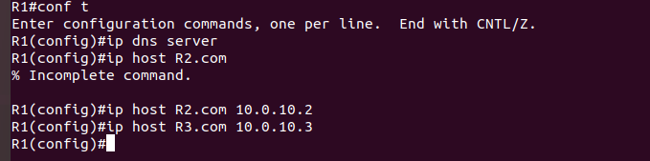

R1 is setup as DNS Server and is given host names for r2,r3,r4 (future lookups)

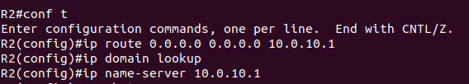
Now we config r2,r3,r4 to have default gateway as r1 and also have dns server as r1

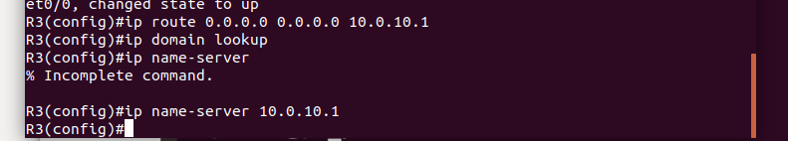
Now since we have provided the default gateways for r2,r3,r4 and also provided the ip address for hostnames in r1 , when we try to ping from either of these router to another using host names translation is done successfully and message can be sent as well.
