Lab5 – OS Lab

Name: Rhea Adhikari
Reg No: 190905156
Roll No: 23

- Write a producer and consumer program in C using the FIFO queue. The producer should write a set of 4 integers into the FIFO queue and the consumer should display the 4 integers.

producer.c
#include<stdio.h>

#include<stdlib.h>

#include<unistd.h>

#include<sys/types.h>

#include<limits.h>

#include<fcntl.h>

#include<sys/msg.h>

#include<sys/stat.h>

#include<string.h>

#define FIFO_NAME "my_fifo"
#define BUFFER_SIZE 1000

int main(int argc, char * argv[]) {
int pipe_fd;
int res;
int open_mode = O_WRONLY;
int n = 0;
char buffer[BUFFER_SIZE + 1];

if (access(FIFO_NAME, F_OK) == -1) {
res = mkfifo(FIFO_NAME, 0777);
if (res != 0) {
fprintf(stderr, "Could not create file%s\n", FIFO_NAME);
exit(EXIT_FAILURE);
}
}

printf("Process %d opening FIFO O_WRONLY\n", getpid());
pipe_fd = open(FIFO_NAME, open_mode);
printf("Process %d result %d\n", getpid(), pipe_fd);

if (pipe_fd != -1) {
printf("Enter 4 numbers\n");

while (n < 4) {
scanf("%s", buffer);
res = write(pipe_fd, buffer, BUFFER_SIZE);

if (res == -1) {
fprintf(stderr, "Write Error on Pipe\n");
exit(EXIT_FAILURE);
}
n++;
}
(void) close(pipe_fd);
} else
exit(EXIT_FAILURE);

printf("Process %d Finished\n", getpid());
exit(EXIT_SUCCESS);
}

consumer.c
#include<stdio.h>

#include<stdlib.h>

#include<unistd.h>

#include<sys/types.h>

#include<limits.h>

#include<fcntl.h>

#include<sys/msg.h>

#include<sys/stat.h>

#include<string.h>

#define FIFO_NAME "my_fifo"
#define BUFFER_SIZE 1000

int main(int argc, char * argv[]) {
int pipe_fd;
int res;
int open_mode = O_RDONLY;
int n = 0;
char buffer[BUFFER_SIZE + 1];
memset(buffer, '\0', sizeof(buffer));

printf("Process %d opening FIFO O_RDONLY\n", getpid());
pipe_fd = open(FIFO_NAME, open_mode);
printf("Process %d result %d\n", getpid(), pipe_fd);

if (pipe_fd != -1) {
do {
res = read(pipe_fd, buffer, BUFFER_SIZE);
printf("%s\n", buffer);
n++;
} while (n < 4);

(void) close(pipe_fd);
} else
exit(EXIT_FAILURE);

printf("Process %d Finished, %d bytes read\n", getpid(), n);
exit(EXIT_SUCCESS);
}

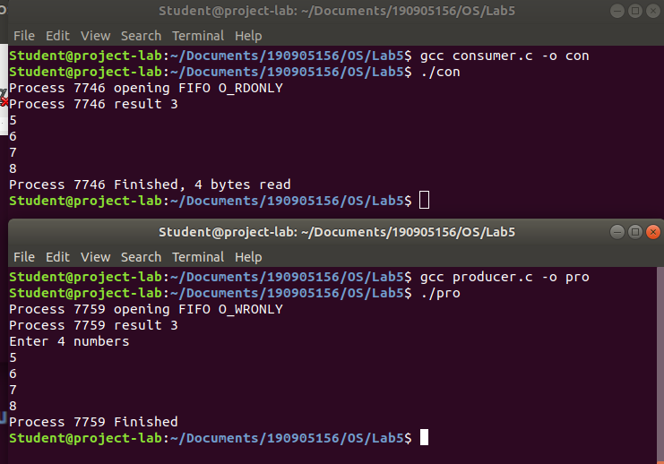

- Demonstrate creation, writing to, and reading from a pipe.

#include<stdio.h>
#include<stdlib.h>
#include<unistd.h>
#include<sys/types.h>
#include<sys/ipc.h>
#include<sys/msg.h>
#include<string.h>

int main(int argc, char *argv[])
{
int n;
int fd[2];
char buf[1025];
char *data="Hello there this is Rhea";
pipe(fd);
write(fd[1],data,strlen(data));

if(n=read(fd[0],buf,1024)>=0)
{
buf[n]=0;
printf("Read %d bytes from pipe\"%s\"\n",n,buf);
}

else
perror("Read");
exit(0);
}
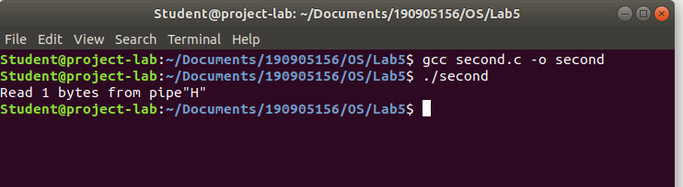
- Write a C program to implement one side of FIFO.
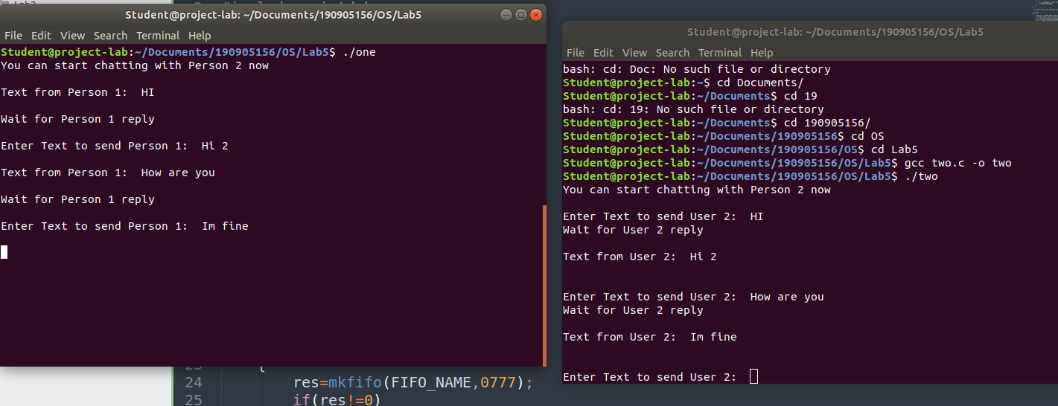
one.c

#include<stdio.h>
#include<stdlib.h>
#include<unistd.h>
#include<sys/types.h>
#include<limits.h>
#include<fcntl.h>
#include<sys/msg.h>
#include<sys/stat.h>
#include<string.h>

#define FIFO_NAME "my_fifo"
#define BUFFER_SIZE 10000

int main(int argc, char *argv[])
{
int pipe_fd;
int res;
int open_mode1=O_WRONLY;
int open_mode2=O_RDONLY;
int n=0;
char buffer[BUFFER_SIZE+1];

if(access(FIFO_NAME,F_OK)==-1)
{
res=mkfifo(FIFO_NAME,0777);

if(res!=0)
{
fprintf(stderr, "Could not create file%s\n",FIFO_NAME);
exit(EXIT_FAILURE);
}
}

printf("You can start chatting with Person 2 now\n");

while(1)
{
pipe_fd=open(FIFO_NAME,open_mode2);

printf("\nText from Person 1: ");
res=read(pipe_fd,buffer,BUFFER_SIZE);
printf("%s\n",buffer );
close(pipe_fd);

printf("Wait for Person 1 reply\n");
pipe_fd=open(FIFO_NAME,open_mode1);

printf("\nEnter Text to send Person 1: ");
fgets(buffer,BUFFER_SIZE,stdin);
res=write(pipe_fd,buffer,BUFFER_SIZE);

close(pipe_fd);

}

(void)close(pipe_fd);

printf("Process %d Finished\n",getpid());
exit(EXIT_SUCCESS);
}

two.c

#include<stdio.h>
#include<stdlib.h>
#include<unistd.h>
#include<sys/types.h>
#include<limits.h>
#include<fcntl.h>
#include<sys/msg.h>
#include<sys/stat.h>
#include<string.h>
#define FIFO_NAME "my_fifo"
#define BUFFER_SIZE 10000

int main(int argc, char *argv[])
{
int pipe_fd;
int res;
int open_mode1=O_WRONLY;
int open_mode2=O_RDONLY;
int n=0;
char buffer[BUFFER_SIZE+1];

if(access(FIFO_NAME,F_OK)==-1)
{
res=mkfifo(FIFO_NAME,0777);
if(res!=0)
{
fprintf(stderr, "Could not create file%s\n",FIFO_NAME );
exit(EXIT_FAILURE);
}
}

printf("You can start chatting with Person 2 now\n");

while(1)
{
pipe_fd=open(FIFO_NAME,open_mode1);
printf("\nEnter Text to send Person 2: ");
fgets(buffer,BUFFER_SIZE,stdin);
res=write(pipe_fd,buffer,BUFFER_SIZE);

close(pipe_fd);

printf("Wait for Person 2 reply\n");
pipe_fd=open(FIFO_NAME,open_mode2);

printf("\nText from Person 2: ");
res=read(pipe_fd,buffer,BUFFER_SIZE);
printf("%s\n",buffer );
close(pipe_fd);

}
(void)close(pipe_fd);

printf("Process %d Finished\n",getpid() );
exit(EXIT_SUCCESS);
}

4.) Write a C program reading and writing a binary file in C.

#include<stdio.h>
#include<stdlib.h>

int main()
{

FILE* fptr;
int num=0;
fptr=fopen("demo.bin","wb+");

printf("Enter few numbers : \n");

for(int i=0;i<4;i++)
{

scanf("%d",&num);
fwrite(&num,sizeof(int),1,fptr);
}

printf("Writing operation over.\n");
fclose(fptr);

fptr=fopen("demo.bin","rb");

for(int i=0;i<4;i++)
{

fread(&num,sizeof(int),1,fptr);
printf("%d\n",num);
}

}

