Lab7 – Message Queue and Shared Memory

Name: Rhea Adhikari
Reg No: 190905156
Roll No: 23
Batch: D-1

Q) Process A wants to send a number to Process B. Once received, Process B has to check whether the number is palindrome or not. Write a C program to implement this interprocess communication using a message queue.

1a.c
#include<stdio.h>
#include<stdlib.h>
#include<unistd.h>
#include<sys/types.h>
#include<limits.h>
#include<fcntl.h>
#include<sys/msg.h>
#include<sys/stat.h>
#include<string.h>
#include<sys/msg.h>
#include<sys/ipc.h>
#include<errno.h>

#define MX_LEN 512

struct myMessage
{
long int my_msg_type;
int msg;
};

int reverse(int x)
{
int y = 0;
while(x > 0)
{
y *= 10;
y += x % 10;
x /= 10;
}
return y;
}

int main(int argc, char const *argv[])
{
int running=1;
struct myMessage some_data;
long int msg_to_receive=0;
int msgid;
int num;
msgid=msgget((key_t)1234,0666|IPC_CREAT);

if(msgid==-1)
{
fprintf(stderr, "msgget failed with error%d\n",errno );
exit(EXIT_FAILURE);
}

while(running)
{
if (msgrcv(msgid,(void*)&some_data,BUFSIZ,msg_to_receive,0)==-1)
{
fprintf(stderr, "msgrc failedwith error %d\n",errno );
exit(EXIT_FAILURE);
}

printf("Number received: %d\n",some_data.msg);

if(some_data.msg == reverse(some_data.msg))
printf("Number received is a palindrome\n");
else
printf("Number received is not a palindrome\n");
if(some_data.msg==-1)
running=0;
}
if(msgctl(msgid,IPC_RMID,0)==-1){
fprintf(stderr, "msgctl(IPC_RMID) failed\n");
exit(EXIT_FAILURE);
}
exit(EXIT_SUCCESS);
}

1b.c

#include<stdio.h>
#include<stdlib.h>
#include<unistd.h>
#include<sys/types.h>
#include<limits.h>
#include<fcntl.h>
#include<sys/msg.h>
#include<sys/stat.h>
#include<string.h>
#include<sys/msg.h>
#include<sys/ipc.h>
#include<errno.h>
#define MAX_TEXT 512

struct my_msg_st
{
long int my_msg_type;
int msg;
};

int main(int argc, char const *argv[])
{
int running=1;
struct my_msg_st some_data;
int msgid;
int num;
msgid=msgget((key_t)1234,0666|IPC_CREAT);

if(msgid==-1)
{
fprintf(stderr, "msgget failed with error%d\n",errno );
exit(EXIT_FAILURE);
}

printf("Enter -1 to quit\n");

while(running)
{
printf("Enter a number ");
scanf("%d",&num);
some_data.my_msg_type=1;
some_data.msg=num;
if (msgsnd(msgid,(void*)&some_data,MAX_TEXT,0)==-1){
fprintf(stderr, "msgsnd failed\n" );
exit(EXIT_FAILURE);
}
if(num==-1)
running=0;
}

exit(EXIT_SUCCESS);
}
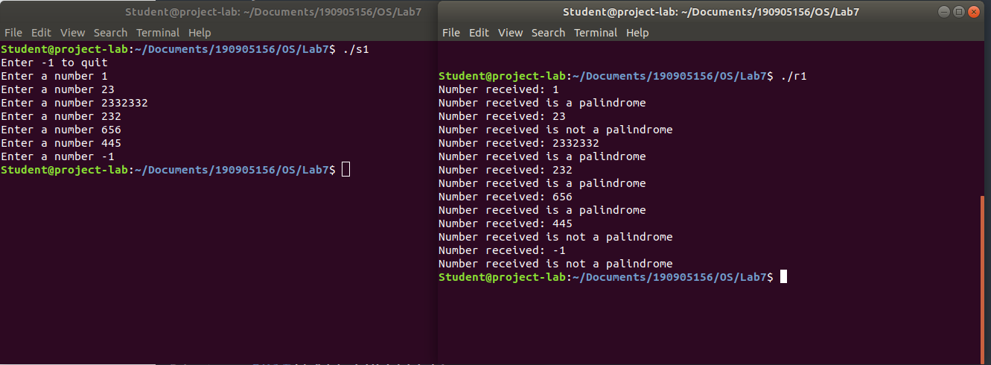
Q) Implement a parent process, which sends an English alphabet to a child process using shared memory. The child process responds with the next English alphabet to the parent. The parent displays the reply from the Child.

#include<stdio.h>
#include<stdlib.h>
#include<unistd.h>
#include<sys/types.h>
#include<sys/ipc.h>
#include<sys/shm.h>

struct sharedStr
{
int status;
char alphabet;
};

int main(int argc, char const *argv[])
{
/*
Status codes
0 -> nothing written yet by parent process
1 -> alphabet written by parent process
2 -> answer written by child process
-1 -> exit
*/
int shmid = shmget((key_t)1234,sizeof(struct sharedStr),0666|IPC_CREAT);
pid_t pid = fork();

if(pid < 0)
{
printf("Error in fork()\n");
exit(-1);
}

else if(pid == 0)
{ //child process
struct sharedStr* shared_memory = shmat(shmid,(void*)0,0);

if(shared_memory == (void*)-1)
{
printf("shmat() failed\n");
exit(-1);
}

printf("Memory attached at %p for child process\n",shared_memory);

while(1)
{
if(shared_memory->status < 0)
{
// printf("Exit code received %d\n",shared_memory->status);
if(shmdt(shared_memory) == -1)
{
printf("shmdt failed\n");
exit(-1);
}

break;
}

if(shared_memory->status == 1)
{
char c = shared_memory->alphabet;
printf("\n");

if((int)c >= 65 && (int)c <= 90)
{ //uppercase
c = ((c - 'A' + 1)%26) + 'A';
}

else if((int)c >= 97 && (int)c <= 122)
{ //lowecase
c = ((c - 'a' + 1)%26) + 'a';
}

else
{
printf("Non-alphabetic character received\n");
//do nothing
}
shared_memory->alphabet = c; //write to shared memory
shared_memory->status = 2;
}
}
}

else
{ //parent process
sleep(1);
struct sharedStr* shared_memory = shmat(shmid,(void*)0,0);

if(shared_memory == (void*)-1)
{
printf("shmat() failed\n");
exit(-1);
}

printf("Memory attached at %p for parent process\n",shared_memory);
shared_memory->status = 0;

while(1)
{
if(shared_memory->status == 1)
{
// printf("Waiting for child process\n");
continue;
}

if(shared_memory->status == 2)
{
printf("%c\n",shared_memory->alphabet);
}

shared_memory->status = 0;
char c,nl;
printf("Enter an alphabet (0 to exit) : \n");
scanf("%c",&c);
if(c != '0')
printf("Next alphabet= ");
scanf("%c",&nl);

if(c == '0')
{
shared_memory->status = -1;
printf("Exiting...\n");

if(shmdt(shared_memory) == -1)
{
printf("shmdt failed\n");
exit(-1);
}

if(shmctl(shmid,IPC_RMID,0) == -1)
{
printf("shmctl failed\n");
exit(-1);
}
break;
}

shared_memory->alphabet = c;
shared_memory->status = 1;
}
}
return 0;
}
