OS Lab
Rhea Adhikari
190905156
Batch D1
Lab8

1.) Modify the above Producer-Consumer program so that, a producer can produce at the most 10 items more than what the consumer has consumed.

#include <stdio.h>
#include <pthread.h>
#include <semaphore.h>

int buffer[5], f, r;

sem_t mutex, full, empty;

void *produce(void *arg)
{
for (int i = 0; i < 15; i++)
{
sem_wait(&empty);
sem_wait(&mutex);
printf("Item produced is: '%d'\n", i);
buffer[(++r) % 10] = i;
sleep(1);
sem_post(&mutex);
sem_post(&full);
}
}
void *consume(void *arg)
{
int item;
for (int i = 0; i < 10; i++)
{
sem_wait(&full);
sem_wait(&mutex);
item = buffer[(++f) % 10];
printf("Item consumed is: '%d'\n", item);
sleep(1);
sem_post(&mutex);
sem_post(&empty);
}
}
int main()
{
pthread_t t1;
pthread_t t2;
sem_init(&mutex, 0, 1);
sem_init(&full, 0, 1);
sem_init(&empty, 0, 10);
pthread_create(&t1, NULL, produce, NULL);
pthread_create(&t2, NULL, consume, NULL);
pthread_join(t1, NULL);
pthread_join(t2, NULL);
}
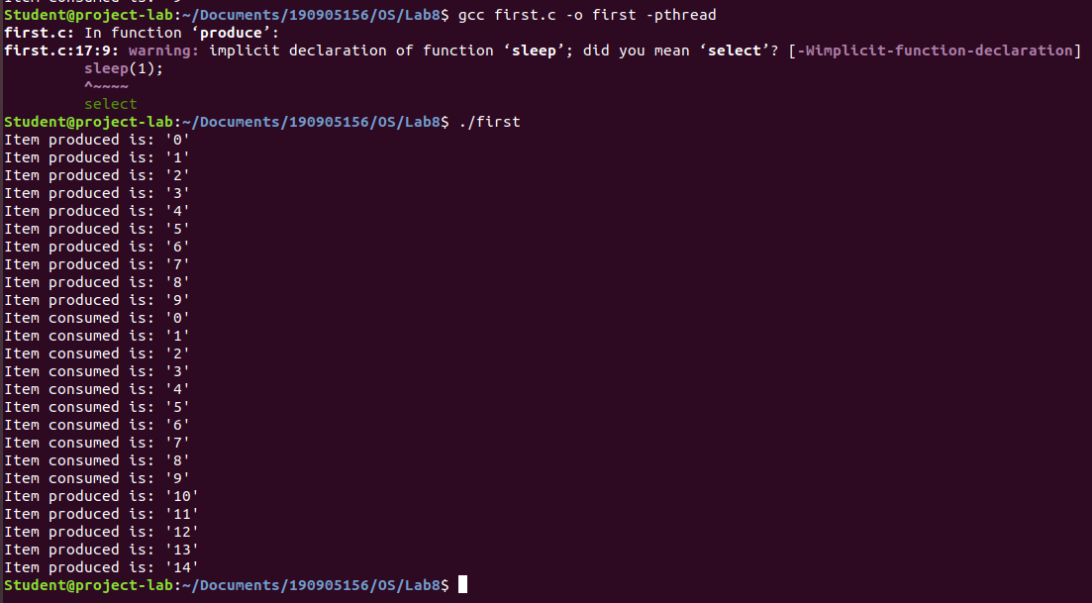

2.) Write a C program for the first readers-writers problem using semaphores.

#include <pthread.h>
#include <semaphore.h>
#include <stdio.h>

sem_t wrt;
pthread_mutex_t mutex;
int cnt = 1;
int numReader = 0;

void *writer(void *wno)
{
sem_wait(&wrt);cnt *= 2;
printf("Writer %d modified cnt to %d\n", (*((int *)wno)), cnt);
sem_post(&wrt);
}

void *reader(void *rno)
{
pthread_mutex_lock(&mutex);
numReader++;
if(numReader == 1)
sem_wait(&wrt);
pthread_mutex_unlock(&mutex);
printf("Reader %d: read cnt as %d\n",*((int *)rno),cnt);
pthread_mutex_lock(&mutex);
numReader--;
if(numReader == 0)
sem_post(&wrt);
pthread_mutex_unlock(&mutex);
}

int main()
{
pthread_t read[10],write[5];
pthread_mutex_init(&mutex, NULL);
sem_init(&wrt,0,1);
int a[10] = {1,2,3,4,5,6,7,8,9,10};
for(int i = 0; i < 10; i++)
pthread_create(&read[i], NULL, reader, &a[i]);
for(int i = 0; i < 5; i++)
pthread_create(&write[i], NULL, writer, &a[i]);
for(int i = 0; i < 10; i++)
pthread_join(read[i], NULL);
for(int i = 0; i < 5; i++)
pthread_join(write[i], NULL);
pthread_mutex_destroy(&mutex);
sem_destroy(&wrt);
return 0;
}

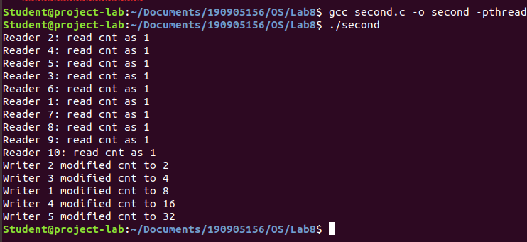

3.) Write a Code to access a shared resource which causes deadlock using improper use of semaphore.

#include <pthread.h>
#include <stdio.h>
#include <semaphore.h>

sem_t s1,s2;

void *functionOne(void *p)
{
sem_wait(&s1);
sem_wait(&s2);
printf("Thread 1\n");
sem_post(&s1);
}

void *functionTwo(void *p)
{
sem_wait(&s2);
sem_wait(&s1);
printf("Thread 2\n");
sem_post(&s2);
}

int main()
{
pthread_t threads[2];
sem_init(&s1,0,1);
sem_init(&s2,0,1);
pthread_create(&threads[0],0,functionOne,0);
pthread_create(&threads[1],0,functionTwo,0);
pthread_join(threads[0],0);
pthread_join(threads[1],0);sem_destroy(&s1);
sem_destroy(&s2);
}

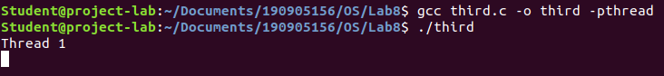
4.) Write a program using semaphore to demonstrate the working of sleeping barber problem.

#include <stdio.h>
#include <pthread.h>
#include <semaphore.h>
#include <stdlib.h>
#include <unistd.h>

sem_t customer,barber;

pthread_mutex_t seat;

int free1 = 10;

void *br(void *args)
{
while(1)
{
sem_wait(&customer);
pthread_mutex_lock(&seat);

if(free1<10)
free1++;
sleep(2);

printf("Cutting completed : free seats : %d\n",free1);
sem_post(&barber);

pthread_mutex_unlock(&seat);
}
}

void *cr(void *args)
{
while(1)
{
pthread_mutex_lock(&seat);

if(free1 > 0)
{
free1--;

printf("Customer waiting : free seats : %d\n",free1);
sem_post(&customer);
pthread_mutex_unlock(&seat);
sem_wait(&barber);
}
else
pthread_mutex_unlock(&seat);
}
}
int main()
{
pthread_t threads[2];
sem_init(&barber,0,1);
sem_init(&customer,0,1);
pthread_mutex_init(&seat,0);
pthread_create(&threads[0],NULL,br,NULL);
pthread_create(&threads[1],NULL,cr,NULL);
pthread_join(threads[0],NULL);
pthread_join(threads[1],NULL);
sem_destroy(&barber);
sem_destroy(&customer);
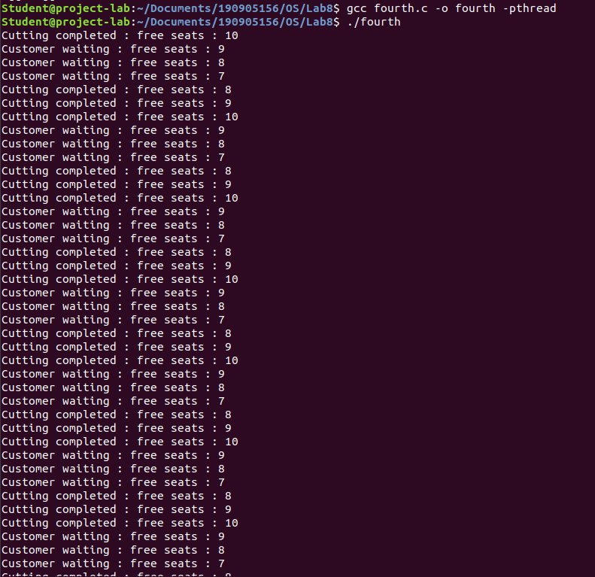
pthread_mutex_destroy(&seat);
}

